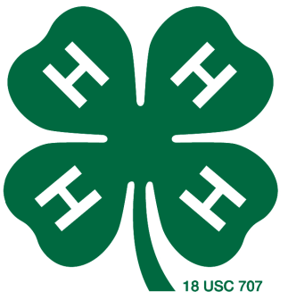
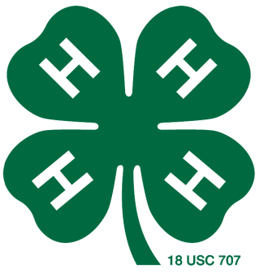
Leon County 4-H
Steer Project

County Show Superintendent
Scott Pistone spistone@txfb-ins.com 979-412-1402

County Validation
Monday, November 15, 2021
4:00 – 6:00 pm at Buffalo Animal Hospital

2021-2022 Major Shows
Major show steers have already been validated for the
2021-2022 major shows.
Major show entries will be due in November. Watch for details.
Validation for 2022-2023 Year- June, 2022

More information:
https://lcyls.blogspot.com/
https://leon.agrilife.org/4-h/4-h-livestock-project-resources/
https://texasyouthlivestock.com/
https://leon.agrilife.org/major-shows/

