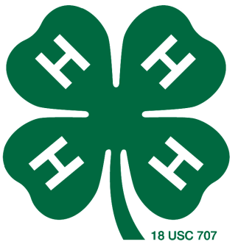
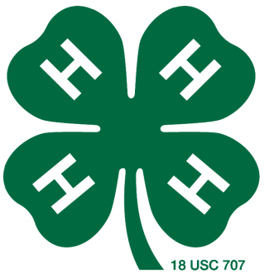
Leon County 4-H
Halter Heifer Project

Major Shows
Tag Order Deadline – September 2nd
Fees - $20 per tag
Due to the extension office at the time of order

Major Livestock Show Heifer Validation
October 22nd
Extension Office

Major show entries will be due in November. Watch for details.

Leon County Youth Livestock Show
Validation:
November 15, 2021 from 4-6:00pm at Buffalo Animal Hospital

More information:
https://lcyls.blogspot.com/
https://leon.agrilife.org/4-h/4-h-livestock-project-resources/
https://texasyouthlivestock.com/
https://leon.agrilife.org/major-shows/

