https://www.facebook.com/GreggCounty4H/
Schedule of Programs - Events - Meetings

September 2022
1 New 4-H Year Begins Enroll at https://v2.4honline.com/#/user/sign-in
10 3D Archery Tournament Fairway Farms San Augustine, TX
12 4-H Youth Council, 4-H Members, Club Manager, and Adult Leaders Meeting 5:30 PM
14 Shiloh 4-H Club Meeting 6 PM Parkview Baptist Church
16-17 District 5 Officer Planning Retreat – Piney Woods Baptist Camp Woodlake, TX
19 Shamrock 4-H Club Meeting 5:30 PM CEO
19 Learn Today, Lead Tomorrow Training 5:30 PM CEO
19 Shooting Sports Project 4-H Club - Shotgun Practice 6 PM ET Rifle & Pistol Club
20 Outdoor Archery Practice 5 PM - CEO
20 Deadline to Register on 4-HOnline Junior Master Photographer Workshop I Dallas, TX
21 D4 4-H Shooting Sports Coaches Certification Registration Deadline
22 4-H Adult Leaders Program Area Committee Budget meeting on Zoom 5:30 pm
24 4-H Community Service Master Gardener Plant Sale 9 AM Longview Arboretum
24 Junior Master Photographer Workshop I Dallas, TX Contact: d-bruton@tamu.edu
26 Deadline to submit Harvest Festival Entry Forms to CEO
http://www.harvestfestivallivestockshow.com/forms/
26 Bluebonnet 4-H Club Meeting – University Academy
27 Harvest Festival Rabbit Validation @ Hallsville HS 4 PM – 7 PM
27 Indoor Archery Practice 5 PM CEO

October 2022
3-8 National 4-H Week – Open House 4-H Project Focus 3:00 PM – 6:30 PM CEO
3 4-H Project Focus Leadership 3:00 PM – 6:30 PM CEO
3 Shooting Sports Project 4-H Club - Shotgun Practice 6 PM ET Rifle & Pistol Club
4 4-H Project Focus Agriculture & Natural Resources 3:00 PM – 6:30 PM CEO
5 4-H Project Focus Food & Nutrition 3:00 PM – 6:30 PM CEO
6 4-H Project Focus STEM 3:00 PM – 6:30 PM CEO
7 4-H Dance FIT 6:00 PM -8:30 PM
8 One Day 4-H Service Day
10 4-H Youth Council, 4-H Members, Club Manager, and Adult Leaders Meeting 5:30 pm
11 District 5 Gold Star Award Banquet The Barn Nacogdoches
12 Shiloh 4-H Meeting 6 PM Parkview Baptist Church
13 Outdoor Archery 5 PM CEO

October 2022
15 Robotics Project Leader & Youth Training 9:30 AM – 3:30 PM CEO
15 D4 4-H Shooting Sports Coaches Certification – Bowie County
17 Shamrock 4-H Club Meeting 5:30 PM CEO
17 Shooting Sports Project 4-H Club - Shotgun Practice 6 PM ET Rifle & Pistol Club
20 Indoor Archery Practice 5 PM CEO
  - D5 Junior Leadership Lab (Grades 3RD – 8TH) Piney Woods Baptist Camp Woodlake
24 Bluebonnet 4-H Club Meeting – University Academy
24 Deadline to Register on 4HOnline D5 Shooting Sports Coach Training
  - Harvest Festival & Livestock Show http://www.harvestfestivallivestockshow.com/schedule/
25 Outdoor Archery Practice 4:30 PM - CEO
29-30 D5 Shooting Sports Coach Training 5H Shooting Range – Frankston, TX

November 2022
3 Indoor Archery Practice 5 PM CEO
5 Learn Today, Lead Tomorrow Training Hybrid Only 10 AM
5 County Food Show 10 AM – 12 PM & Mock Food Challenge 1:00 PM CEO
7 Shooting Sports Project 4-H Club - Shotgun Practice 6 PM East Texas Rifle & Pistol Club
9 Shiloh 4-H Club Meeting 6 PM Parkview Baptist Church
11 Happy Veterans Day County Holiday
12-13 Show Star Series – Rusk County Expo
14 Shooting Sports Project 4-H Club - Shotgun Practice 6 PM ET Rifle & Pistol Club
21 Shamrock 4-H Club Meeting 5:30 PM CEO
28 Bluebonnet 4-H Club Meeting – University Academy
28 4-H Youth Council, 4-H Members, Club Manager, and Adult Leaders Meeting 5:30 PM

For more information about Gregg County 4-H, contact us at 903-236-8429:
E-mail arvitta.scott@ag.tamu.edu & makenzie.banks@ag.tamu.edu

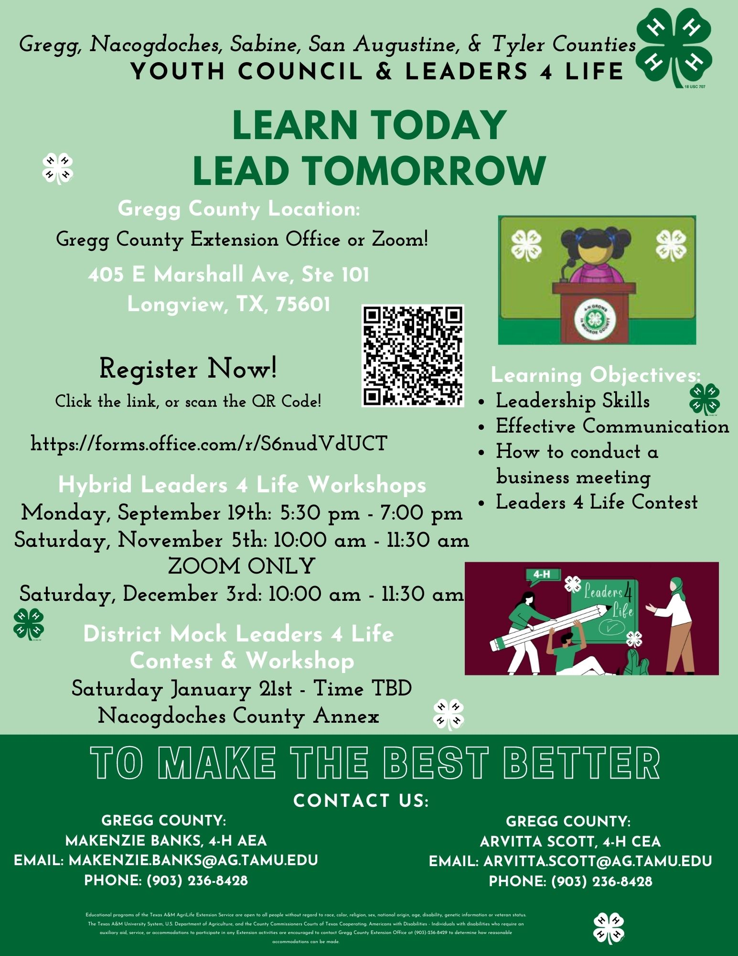

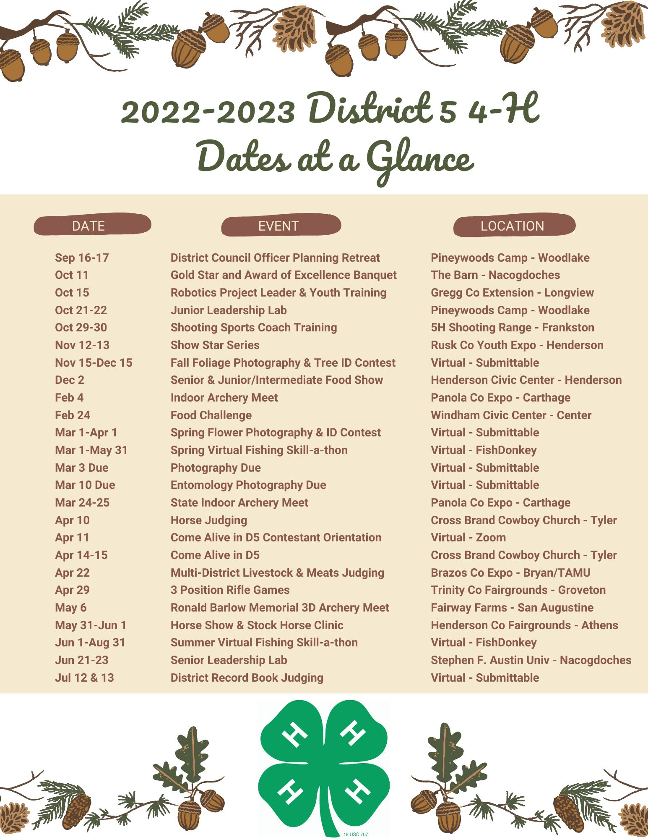
For District 5 events, contests, and training registration information:
Follow us on Facebook at District 5 Texas 4-H
Visit our website at https://d54-h.tamu.edu

