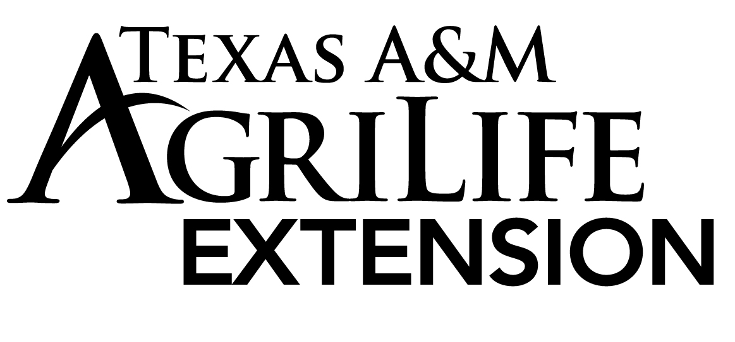



**Todd Vineyard**

**ToddT**

Texas AgriLife Extension Service

County Extension Agent

Agriculture and Natural Resources

206 S. State Street, Suite A

Decatur, Texas 76234

Ph: 940.627.3341 Fax: 940.627.8070

**Ag. News**

Submitted: 5-17-2018

**Indoor Hay Storage: Dry Matter Loss and Quality Changes**

Because of the harsh winter and drought conditions we are low on hay inventories. You never know how you will benefit from storing hay until you test it. There is no doubt if you store hay out of the weather you will dramatically decrease yield losses. Quality; however will change, but not as much as you think. The following information was developed by Dennis R. Buckmaster, Assistant Professor of Agriculture Engineering.

Mechanically-induced losses during forage harvest are visible and are commonly recognized as a source quantity and quality loss. Although invisible, similar losses occur during hay storage because of microbial respiration on the hay. This respiration results in dry matter loss as well as quality reduction.

The dry matter lost during storage consists of the most nutritious parts of the hay (nonstructural carbohydrates). As a result, hay quality is affected in a manner which decreases its potential intake and digestibility. Heat generation, also associated with the respiration, reduces protein availability.

Moisture content also decreases during storage. Given enough time in storage (usually two months or more), most hay will reach approximately 12 percent moisture if baled at less than 25 percent moisture. If not treated with an effective preservative, hay baled above 25 percent moisture poses the threat of severe heat production and a barn fire.

Forages are made up of dry matter (DM) and water. While the water has no nutritional value, it can have economic value because hay is often sold by weight on an “as is” basis rather than on a dry matter basis. Hay buyers and sellers should have hay sampled for dry matter content because this, in combination with the weight and quality, determines the amount of nutrients being transferred.

Chemical preservatives change the storage process. Although the changes in treated hay would be similar to those discussed here, this fact sheet applies specifically to untreated alfalfa hay.

**Dry Matter Loss in Baled Hay**

Dry matter loss is a direct result of microbial activity. During this microbial activity the soluble carbohydrates in the hay are consumed. The amount of dry matter loss is directly related to heat generation, which in turn is related to moisture content. For hay baled near 12 percent moisture, very little loss occurs. As baling moisture rises, the amount of storage dry matter loss increases. This dry matter loss results in less feed and lower quality feed. Trade-offs occur between storage losses and harvest losses; but, in general, hay baled at 15 to 18 percent moisture will maximize the overall nutrient yield.

Consider one ton of alfalfa hay baled at 18 percent moisture (82 percent DM) is placed into storage. The amount of dry matter going into storage is 1,640 lbs. (2,000 x 82 percent DM). With a dry matter loss of 2.5 percent, only 1,600 will be available after storage. At 12 percent moisture (88 percent DM), the total weight as removed from storage would be 1,820 lbs. while the initial weight was 2,000 lbs. From a hay sellers perspective (in this example), the price needs to be at least 10 percent higher after storage than at baling because of the weight change.

**Quality Effects**

The dry matter consumed during hay storage is primarily nonstructural carbohydrate which is readily used by ruminant animals. The fibrous plant components are retained and, as other dry matter is lost, their concentration increases. A slight amount of crude protein is lost during storage, but protein is lost at a slower rate than carbohydrates; thus, crude protein concentration increases slightly during storage.

The NDF concentration will also increase, which in return will decrease quality because intake of the alfalfa by ruminant animals will now be lower. Acid detergent fiber (ADF) also increases; this indicates that digestibility of the hay after storage will be slight lower than that of the freshly baled hay. Although the increase in CP content appears to be a good consequence, the total amount of protein removed from storage is less than the amount put into storage.

Another quality change occurring during storage of alfalfa hay, or any hay for that matter, concerns the acid detergent insoluble protein (ADIP) (this is sometimes called ADIN or ADF-N if expressed on a nitrogen rather than a protein basis). This protein is unavailable to ruminant animals. Formation of ADIP is directly related to heat development.

Hay producers and feeders need to be aware of changes occurring to hay during storage. In a feeding program, it would be best to take forage samples near the time of feeding rather than at the time of baling so as to more accurately reflect what the animal would be getting. Similarly, purchased hay should be sampled at the time of the purchase for a better indication of the quantity of dry matter being purchased as well as the quality of the purchase.

For more information please contact Texas A&M AgriLife Extension, Wise County at 940-627-3341.