

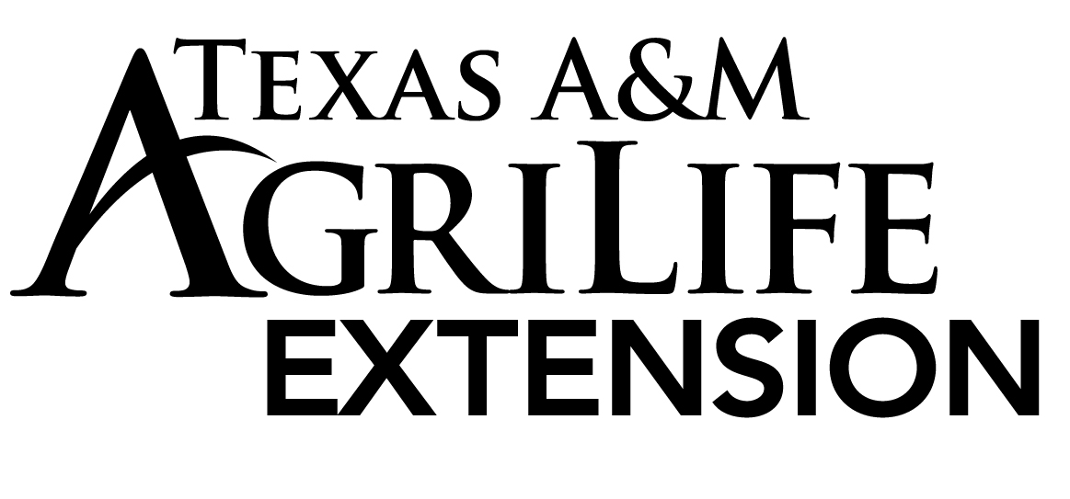

**Todd Vineyard**

**Todd T**

Texas A&M AgriLife Extension Service

County Extension Agent – Agriculture & Natural Resources

206 S. State Street, Suite A

Decatur, Texas 76234

Ph: 940.627.3341 Fax: 940.627.8070

**Ag. News**

Submitted: 11/22/17

**North Texas Pecan Show**

Archer, Cooke, Clay, Grayson, Montague and Wise Counties are hosting our first North Texas Pecan Show to be held in Montague. The North Texas Pecan Show is an opportunity for any county resident with a pecan tree to learn more about pecans and compete for “bragging rights” for the best pecans in the county! The event is scheduled for Monday, December 4th at 1:00 pm at the Montague County Annex at 11339 State Hwy 59 North, Montague, TX 76251.

At 9 a.m. show officials will begin processing the pecans which includes cracking, weighing, and classifying so the judge can make his evaluations. Beginning at 1 p.m. Dr. Bill Ree, Extension Program Specialist, will be there to judge the Pecan Entries that day along with a very educational presentation on Late Season Pecan Problems in association with Pecan Scab, Pecan Weevils, Web Worms and Pecans not filling.

If you are interested in entering your harvested crop of 2017 there are some rules and dates to be aware of to enter. If you are wanting to attend as a homeowner or grower please RSVP by November 30th to 940-894-2831 or [justin.hansard@ag.tamu.edu](mailto:justin.hansard@ag.tamu.edu).

Rules for the 2017 North Texas Pecan Show:

1. Pecans must be from the current year crop (2017) and have been grown by the entrant.  Pecans should be shown in the county where they were grown.  Out of county entries are permitted if there is no county pecan show where they were grown (pecans can be entered in only one county pecan show). The Grower must be the Exhibitor.
2. The grower may submit only one entry per variety.  Any number of different seedlings, known hybrids or natives may be entered.  All the nuts in the entry must be of the same variety (nuts from different trees are permitted so long as they are of the same variety). Entries with mixed varieties will be disqualified.  Pecan varieties will be judged in one of the three divisions:

A. Commercial Division   B. Natives Division  C. Classic and New Division

1. Pecan varieties have been assigned to each division.  The NATIVES DIVISION includes entries for the smallest pecan determined by the greatest number of nuts per pound.
2. The grower must enter 50 nuts of a single variety.  The finest nuts should be carefully selected in preparing an entry.  Nuts should be uniform in shape, size and general appearance.  Consistent show winners select nuts one by one for their entry.  Entries with nuts that have been cut, sanded, polished or otherwise altered will be disqualified.  Avoid entering green nuts or those affected by pests or disease. The entry must be securely bagged or boxed and include a tag or label with the County where pecan is grown, entrant’s name, address, telephone number, email (if applicable) and the variety of pecan.  This will help the winning entries for that county continue to Regional.
3. Pecan entries will be accepted until Thursday, November 30th at the County Extension Office for each county.
4. Pecans winning their varieties will continue on to Regional and then State.
5. $5/variety entered or a maximum of $20/producer or homeowner for as many varieties they would like to enter. If you don’t know your variety, it will be labeled and put in the correct category.

For more information please call the Extension Office at 940-627-3341.