

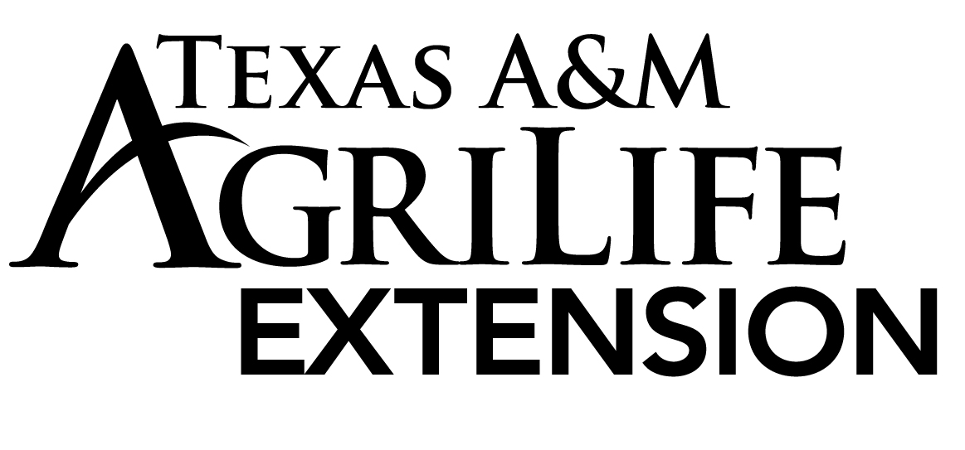

**Todd Vineyard**

**Todd T**

Texas A&M AgriLife Extension Service

County Extension Agent – Agriculture & Natural Resources

206 S. State Street, Suite A

Decatur, Texas 76234

Ph: 940.627.3341 Fax: 940.627.8070

**Ag. News**

Submitted: 11/16/17

**Pesticide Applicator License - 5 Hour CEU Program**

All TDA Pesticide Applicator License holders who need to obtain Continuing Education Units for their Pesticide Applicator License need to be at the Decatur Civic Center, Thursday, December 7, 2017. Participants will receive 5 hours of CEU’s consisting of 1 hour of Laws and Regulations, 3 hour of Integrated Pest Management (IPM) and 1 hours of general. The program will begin at 8:30 a.m. and will run until 3:00 p.m.

This year we will have high quality speakers and diverse topics:

• **Range Ecology and Management for all Native Grassland Owners**

Ricky Linex, USDA, Natural Resources Conservation Service, Weatherford, TX

• **Management of Pests of Cattle, Sheep, Goats, Pigs and Horses**

Dr. Charles Allen, Professor, Extension Entomologist & IPM Coordinator, San Angelo, TX

• **Current and Emerging Techniques for Feral Hog Control**

Joshua Gaskamp, Wildlife & Range Consultant, Noble Research Institute, Ardmore OK

• **Fever Ticks in Cattle and Fly Bait Control**

Dr. Sonja Swiger, Assistant Professor and Extension Agronomist, Vernon, TX

• **Laws and Regulations**

Katherine Newton, Texas Department of Agriculture, Dallas, TX

The registration fee for the program is $45, due by Monday, December4, 2017. Lunch included. Checks need to be payable to: Extension Livestock Committee and sent to Texas A&M AgriLife Extension Service, 206 S. State Street, Decatur, 76234.

For more information call the Extension Office at 940-627-3341. The event is sponsored by the Texas A&M AgriLife Extension and Wise County Extension Forage and Livestock Committee.