January 2018
Walker County Agriculture Update

Greetings from the Walker County, Texas A&M AgriLife Extension office!

“We as children went up the mountain to find feed for livestock, like goats, cows and horses, and because in the winter time we would light the fire in the house, we would climb the mountain to collect firewood as well. Because of that, I suppose I became used to climbing mountains.” -Tamae Watanabe
Howdy!
HOT OFF THE PRESS:
As cold as it has been outside, we all need something warm. I am going to attempt to bring back my “normal” newsletter style for this edition. Over the past months since Hurricane Harvey, our Rebuild Texas efforts required the shift to a slightly less personalized newsletter version which I really don’t care for so much. I think it is time to bring this newsletter back to the proper format. I hope you enjoy this return to my version of normalcy.

Upcoming Events:

Walker County Annual CEU Recertification Conference (6 TDA, CEU’s APPROVED)
Friday, January 12th, 2018
(7:00-7:50 AM) Registration
Walker County Storm Shelter (455 SH75 N, Huntsville, TX)
$40.00/participant with lunch, $30.00/participant without lunch
RSVP by 01/10/17 to (936) 291-1901 ex 3

We have another great CEU recertification coming up this month to start the year! Our 2018 program topics and presenters are ready to provide you with valuable information:
Protection of Groundwater & Surface Water Resources presented by Dr. Diane Boellstorff, Associate Professor & Extension Water Resources Specialist
Identification & Control options for Common Weeds & Brush (+) Product & Research Updates from Dr. Scott Nolte, Assistant Professor & Extension State Weed Specialist
Calibration of Spray Equipment discussion with Dr. Mark Matocha, Assistant Professor & Extension Specialist
Pesticide Laws & Regulations Update given by Dr. Don Renchie, Extension Program Leader for Agricultural & Environmental Safety
Modification & Environmental Impacts Utilizing Management Tools: Fire, Mechanical, Chemical with Dr. Barron Rector, Associate Professor and Extension Range Specialist

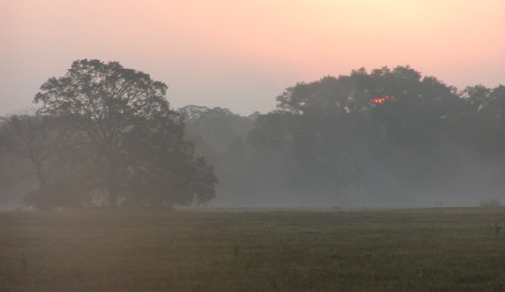
New Landowner Information program
Thursday, February 1st @ 6:30 PM-approx. 8:00 PM
Walker County AgriLife Extension Office
102 Tam Road,
Huntsville, TX 77320
$10.00 /person (RSVP to 936-435-2426 for seating)

One of the many challenges faced by new landowners’ is obtaining pertinent information or how to find said information. I am sure you will find the topics of this discussion useful. We have a great introduction to landowner assistance and information planned for this educational meeting. Joining us will be Floyd Nauls from the NRCS (Natural Resource Conservation Service), and Jessica Gonzalez with FSA (Farm Service Agency) to discuss conservation management or farm program options with the group. Also scheduled to speak is Jorden Herrin with TFS (Texas A&M Forest Service) who will inform participants of services available for our forest landowners. I also plan to spend some time explaining what TX A&M AgriLife Extension can offer in the way of educational resources and information benefiting our new landowners.

I encourage you to call the Extension Office at (936) 435-2426 to reserve your seat in the classroom.

The Edible Yard Symposium
Friday & Saturday, February 16th & 17th, 2018
Friday, February 16th $20 (Workshops/Demonstrations – Lunch on Your Own)
-8:30 AM -10:00 AM Registration at the Walker County Storm Shelter (455 Hwy 75 North), Huntsville, TX
Saturday, February 17th Symposium $60 (Lunch included)
-8:30 AM -9:30 AM Registration at the Walker County Storm Shelter (455 Hwy 75 North), Huntsville, TX
You can Register online at the Walker County Master Gardeners Facebook page/ Eventbrite Link or
email: edibleyardsymposium@gmail.com $80.00 for both days.
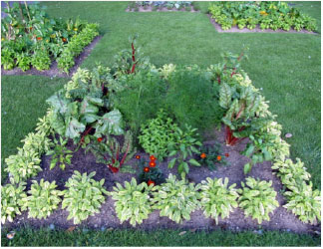
Have you ever wondered if you could create an attractive home landscape of edible plants instead of our more common ornamental versions? The answer is yes! The Walker County Master Gardeners would like to invite everybody to attend our Edible Yard Symposium. Join us to learn more about creating a home landscaped yard that is both attractive and useful! Information will also be presented to educate you on edible natives that are commonly found in or around your landscape.

The Friday session will include several demonstrations and workshops on how to landscape with edibles and other very interesting, fun topics.
Photo Credit: Alabama Cooperative Extension Service

Featured speakers for the Saturday symposium will include:
Judy Barrett
Judy Barrett is the author of several gardening books. Her book, What Can I Do With My Herbs? was published by Texas A&M Press in the spring of 2009. What Makes Heirloom Plants So Great? (2010). Recipes From and For The Garden (2012). YES! You Can Grow Roses (2013). Her newest book, Easy Edibles: How to grow and enjoy fresh food, came out in the fall of 2015. A new book is in the works.

School for Beginning Beekeepers
Sponsored by: Walker County Beekeeping Association
February – April 2018 (9:00 AM until Noon)
2018 Class dates are Feb 17th, March 3rd & 17th, April 7th & 28th
Walker County AgriLife Extension Office
102 Tam Road, Huntsville, TX 77320
$50.00 /person make checks payable to: Walker County Beekeepers Association
(RSVP to 936-661-0663 leave message if no answer)
Registration fee includes: Annual Membership to WC Beekeeping Association, Book, Refreshments

The Walker County Beekeepers are a very active group which has grown by leaps and bounds over the past several years. If you are interested in learning about beginning beekeeping this is your chance to learn from those who are knowledgeable of management and handling of domestic bees. This association is very interested in education new beekeepers! The WC Beekeepers meet monthly January through October on the last Thursday of the month, 6:30 PM at the Katy and E. Don Walker Sr. Education Center, 1402 19th Street, Huntsville, TX 77320. Contact Larry Fuchs (936) 661-0633, ltf.farms@gmail.com for more information.

In This Issue:

Winter Supplementation of Cattle

We need to talk about feeding cattle..
Whenever it gets cold like this, I remember the days of feeding and haying cattle off an old plate-metal decked equipment trailer. Riding that cold open-sided trailer behind the tractor was an experience set I will never forget. We didn’t own a round baler in those days so all the hay that Lepley & Sons cattle operation put up and fed was small square bales. I would have been no more than ten years old at the time.

I remember we would load the hay on the front of the trailer and place the sacks of cubes toward the back to be fed on fresh ground or in troughs depending on which pasture we fed in.

The trailer had an old, very loose, pin hitch; every mud hole and bump caused it to bounce around making an infernal noise that all the cattle could hear regardless of where they were in the pastures. No calling horn required for that operation. Every four-legged domestic beast would come running for the tractor and trailer making that racket.

Our hay baler was unique to the East Texas area of that period in that it was a wire-tie machine. Cutting one of these bales open required heavy-duty fence pliers. Operating pliers under these conditions would constantly catch my loose thin cotton glove and bind up. This would then require having to pull off the other glove to free the offending pliers. Remember, this is all happening as the trailer bounces up and down through the frozen mud holes and bone chilling wind.

The other aspect of this situation to know is that a wire-tie baler can produce very heavy bales if the operator so desires. Dad most definitely did.

Since the hay was stacked on the front of the trailer, invariably the stack would loosen traveling through the frozen holes out in the pasture. As you may guess, at some point in the process the stack would begin to fall as I removed bales to feed them. By this time, I usually had one to three 90-pound square bales of hay on top of me as I worked to free my cotton glove from the pliers. I don’t remember owning a pair of leather gloves until much later in life.

In past months I have had several conversations with people about life experiences and how they affect our views and perception of issues. Personal experience is valuable and must be earned the hard way. We all bring those earned life lessons to each subject discussion from that point on. My appreciation of sturdy leather working gloves is something my kid will probably never understand.

Winter Supplementation of Cattle
By Reggie Lepley

I have been seeing a lot of calves on the ground in recent weeks, so we are well into the calving season for many producers. The goal of winter feeding is a two-part issue. First, we need to be able to provide energy supporting lactation for the calves on the ground, and longer term we need to keep condition on the cows for an efficient rebreeding in the spring. Our beef cattle specialists tend to emphasize the rebreeding aspect as that supports the overall increase or maintenance of your cattle enterprise’s efficiency.

The idea general target is for cows to calve in a body condition score of 5 or better. We are past that initial target deadline of early winter and calving, so I hope that your cattle fit the range of scores to make your winter feeding less stressful. Cattle that go into this part of the year in low condition do not gain jumps in condition score without great financial cost. You don’t ever want to be in that situation at all. The following specific information is directed to the newer cattle owners as our old hands have probably already experienced learning the hard way: Make sure your cattle go into the winter season conditioned where they need to be.

If you would like to review what cattle look like based on breed type and condition score, take a moment to view this link from the Texas A&M AgriLife Research & Extension Center in Vernon. Photo-Guide to Body Condition Scoring Beef Cattle.

Your feed should match the cattle which are consuming it under current conditions. If a cow is lactating the nutritional requirements will be different than those for dry cattle. The quality of your hay and supplemental feed will make all the difference in the world as to how your cattle will winter. This link will take you to our publication on Factors and Feeds for Supplementing Beef Cows.

Lactating cattle need around 11.5% protein and 62-63% total digestible nutrients, or TDN (Total Digestible Nutrients). Dry cows in late gestation need about 8% protein and 55% TDN. Dr. Jason Banta, Extension Beef Cattle Specialist takes the body condition score goals one step further based on the age of your cattle.

Banta says, “2-and 3-year-old cows should have a body condition score of 6 or better at calving. Cows 4-years-old and older should be in a body condition score of 5 or greater at calving.”

We have a video where Dr. Banta discusses the variations of supplemental feeding for beef cattle. I would recommend taking a few minutes to review the information on this AgriLife Supplemental Feeding for Beef Cattle video which included general recommendations of pounds to feed per animal.

If you are needing protein and energy, there are supplemental feeds which can meet your needs. Cost needs to be evaluated based on the nutrient required. You don’t ever want to find yourself paying for something you don’t really need. Those who have tested their hay for nutrient quality can run the ForagVal online calculator to determine (exactly) what supplement amounts are needed. I have the ForagVal calculator linked off our Walker County AgriLife Extension web page. Take it for a test drive if you have your Acid Detergent Fiber (ADF), Crude Protein (CP) and livestock weight range numbers.

Let me try to proactively clear up a little confusion. If you are paying attention, you will have noticed that I mentioned TDN earlier in this information set and then switched reference to ADF in the ForagVal paragraph. It can be a bit confusing until you realize that TDN is an older and somewhat “fuzzy” reference to quality where ADF is the more refined method. I am not going to get into the specifics of why and how for the purposes of this article; however, you need to know that there is a generally direct inverse relationship between TDN & ADF numbers. As TDN increases, ADF will decrease and vice versa. Low ADF numbers are good. Look at these charts from the 2015 & 2016 Walker County Hay Evaluation programs to visualize the relationship. ADF numbers are the recommended method of evaluating nutrient digestibility of forages including hay.

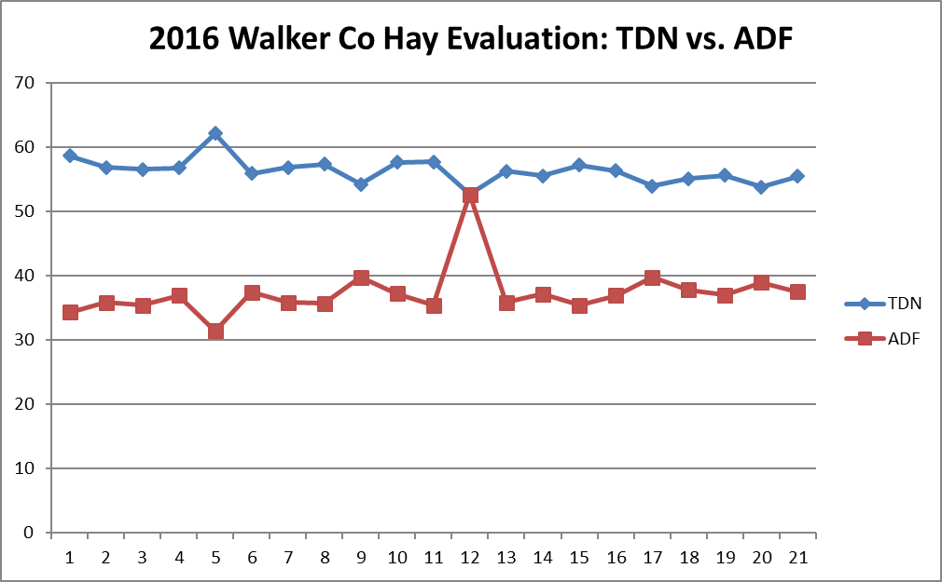
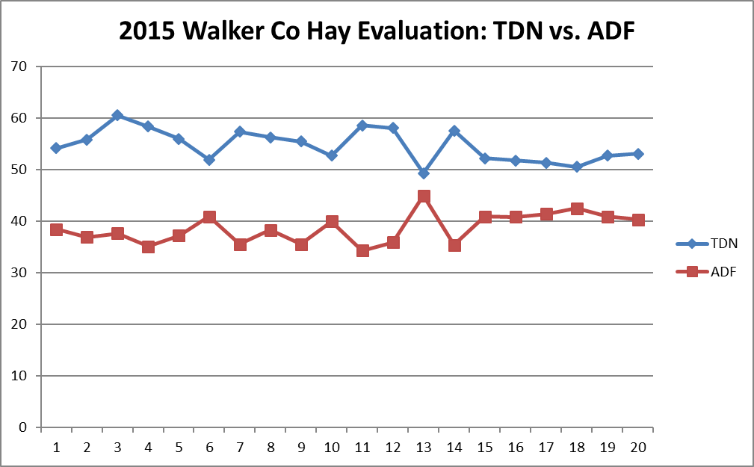
Back to my hay feeding story from earlier: When I mentioned every four-legged domestic beast running all out for the hay trailer, I included my dad’s cow horse. In recalling this story, I am reminded why I always seemed to have a love/hate relationship with that horse. The animal possessed a contrary soul at best.

The horse liked nothing more than to jump onto the moving trailer with me and eat hay I had not yet thrown off.

Due to the constant side to side, and up and down motion of the trailer, the horse would splay his legs out like a tent and dare me to move him while he ate. The slick plate-metal floored trailer full of hay wasn’t big enough for all of us. I distinctly remember the effort trying to get that horse out of the way, one cloth glove securely jammed and swinging an old pair of very cold fence pliers, the other hand freezing cold and turning blue, all without slipping or being pushed off the trailer and into the mud where I would have surely been run over by the cows.

Between the rattling trailer slewing about through the freezing wind and mud, me sliding around under falling bales of hay wearing only one glove, and the horse insisting on being the first to eat off the buffet; feeding cows in the cold is something I will never forget. No matter how hard I try.

Isn’t it funny how we now consider those the good times?
Provisions from the American Disability Act will be considered when planning educational programs and activities. Please notify the Walker County Extension Office if you plan on attending an Extension Educational program and need specialized services. Notification of at least three to five days in advance is needed, so that we may have ample time to acquire resources needed to meet your needs.
Educational programs of the Texas A&M AgriLife Extension Service are open to all people without regard to race, color, religion, sex, national origin, age, disability, genetic information or veteran status. The Texas A&M University System, U.S. Department of Agriculture, and the County Commissioners Courts of Texas Cooperating

- Writing this has reminded me of several other cattle feeding stories from my early days. I had forgotten just how much ammunition I have available on this topic. At some point I should tell you about trespassing deer hunters mixing with feeding round bales on East Texas hills, or skunks and tar paper hay barns. Those are outstanding stories for some time further down the road.

If you have questions or would like more information regarding Extension Educational Programs, call us at (936) 435-2426.
Reggie Lepley
Reggie Lepley,
County Extension Agent – Agriculture & Natural Resources
Walker County
(936) 435-2426

