**C:\Users\Janice.Alexander\AppData\Local\Microsoft\Windows\Temporary Internet Files\Content.IE5\T17ETI7G\MC900298667[1].wmfC:\Users\Janice.Alexander\AppData\Local\Microsoft\Windows\Temporary Internet Files\Content.IE5\T17ETI7G\MC900298667[1].wmf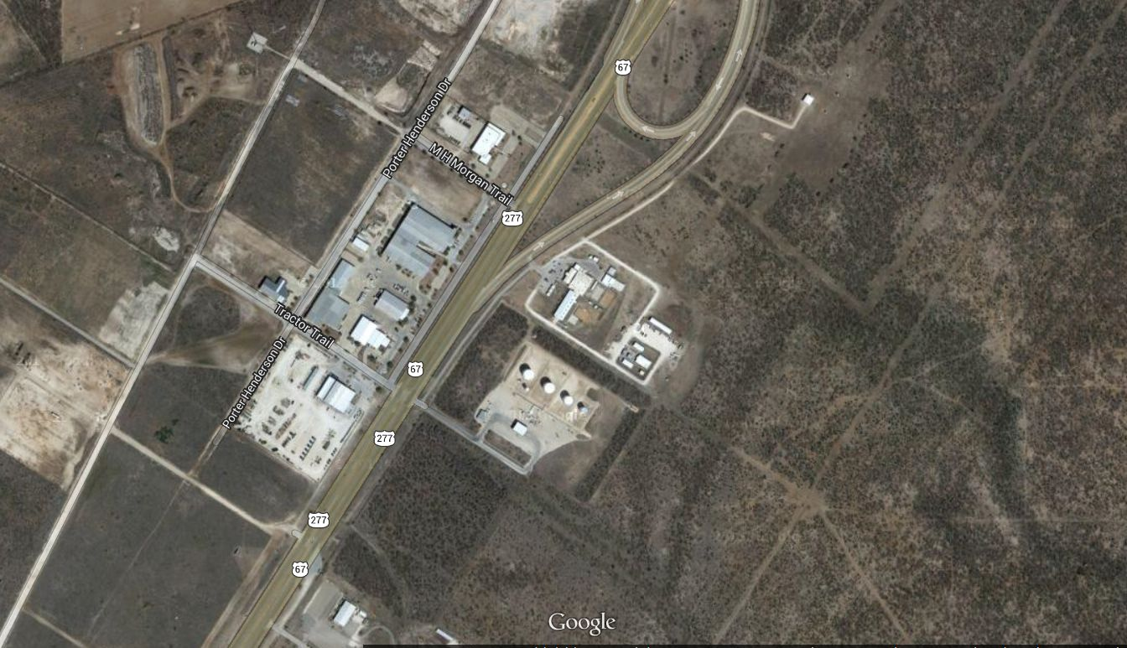

Below is an overhead shot of the NEW Shooting Sports facilities off Hwy 67 North and Hwy 277 North on the east side of San Angelo. We have not found a GPS system that can get you to the proper location, so we have provided this map for your convenience. More detail instructions are found on additional page. If you have questions – please feel free to contact the Tom Green Extension office / TGC 4-H headquarters at (325) 659-6525 during regular business hours.

South – Hwy 67 & Hwy 277

Loop 306 is less than ½ mile

*Hwy 67 North – goes to Ballinger / Brownwood.*

*Hwy 277 North – goes to Bronte / Abilene.*

*Hwy 67 South – goes to Mertzon / Big Lake.*

*Hwy 277 South – goes to Christoval / Sonora.*

*Loop 306 East – connects Hwy 87 to Eden / Brady with Hwy 67/277.*

*Hwy 87 North will cross Hwy 67 & 277 downtown.*

Tom Green 4-H Bldg/Center

Tom Green 4-H Shooting Sports Facilities

Roy K Robb Detention Ctr

N Hwy 67

**Tom Green 4-H Shooting Sports Facilities**

N Hwy 277