Let’s Glow Back to School
Center 4-H is Hosting a Dance/School Supply Drive
Who: Shelby County 4-H members and a friend (3rd-12th grade)
When: Friday, August 15th from 7:00-10:00pm
Where: JOI Ranch (located 5 miles on FM 2026), Center, TX
Attire: Favorite Neon, White Clothing
Admission: School Supplies (To be donated CASA)
~Chaperoned by 4-H Adult leaders~
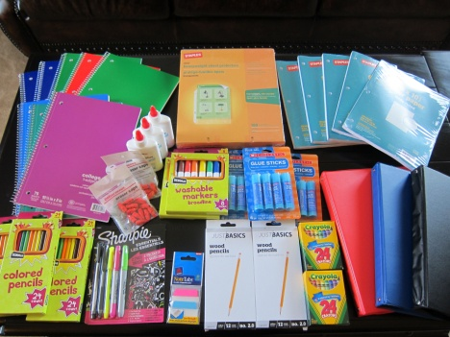
Let’s LiGhT uP ThE nIgHt!
For those not attending that want to donate supplies, you can drop them off at the County Extension office.
Educational programs of the Texas A&M AgriLife Extension Service are open to all people without regard to race, color, religion, sex, national origin, age, disability, genetic information or veteran status. The Texas A&M University System, U.S. Department of Agriculture, and the County Commissioners Courts of Texas Cooperating.

