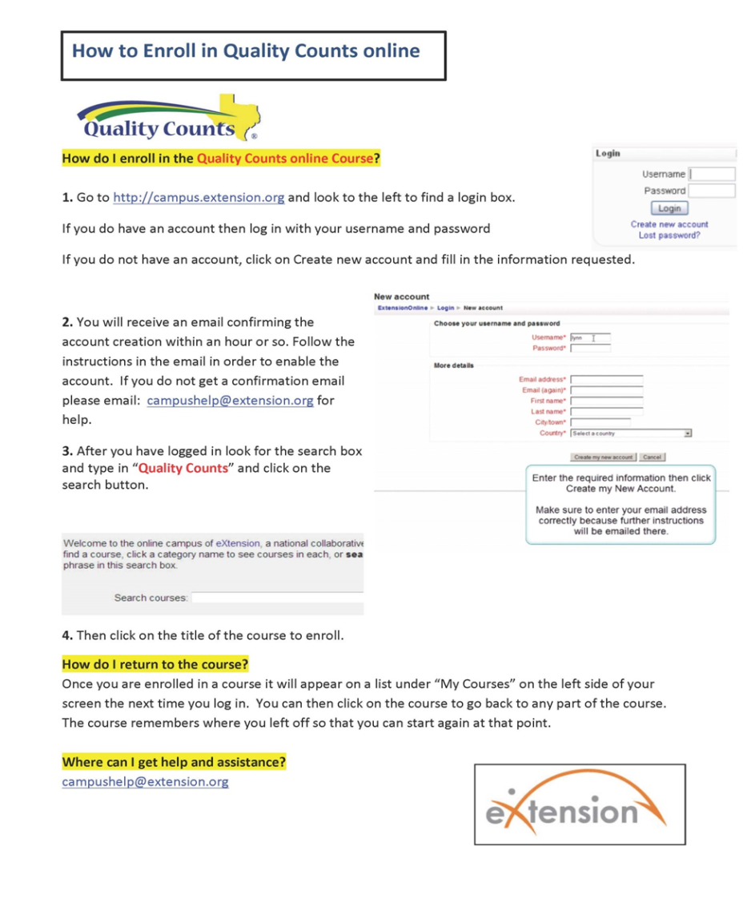
Quality County Online:

If you plan on competing in the County or any major stock show and have not completed the Quality Counts Training and Testing, you must get this done. This is an online training that basically covers livestock feeding and medication as well as ethic topics.
"Texas Trail", the online delivery component of Quality Counts, has found a new home. The online modules are now available on the eXtension online campus at campus.extension.org. Hosting Texas Trail on the eXtension campus allows greater flexibility with maintaining the online modules and tracking their use.
To the right is a one page document that outlines the process of creating an account on the eXtension campus and enrolling in the Quality Counts course in order to access the modules.
Quality Counts Certification Numbers

http://campus.extension.org

“Quality Counts” Training/Testing
There is a junior level as well as a senior level test. Juniors must pass your test only once during their 4-H career at which time you will be issued a certificate of completion number. When you become a senior you must take and pass a senior test at which time you will be issued another completion number.
• Juniors 9-13 years of age as of September 1st of current year.
• Seniors 14-19 as of September 1st of current year

ENTER THE EXACT NAME YOU USE FOR MAJOR SHOW ENTRIES
Choose 4-H and FFA If you are unsure which you will show under
Once the training is reviewed, then take the test. You may take it as many times as needed. AFTER YOU PASS THE TEST, PRINT OUT THE CERTIFICATE AND KEEP UP WITH IT. MEMBERS WILL HAVE TO HAVE THAT CERTIFICATE NUMBER TO ENTER STOCK SHOWS IN November. Call J.D. if you have any questions

Quality Counts Verification
Required for all Texas Major Livestock Shows
Quality Counts verification is required for all youth exhibiting livestock (market and/or breeding) at major livestock shows in Texas (including the Ft. Worth Livestock Show, San Antonio Stock Show & Rodeo, Houston Livestock Show and Rodeo, Star of Texas Fair in Austin, San Angelo Livestock Show, Sandhills Stock Show in Odessa, State Fair of Texas in
Dallas, and Heart ‘O Texas Fair in Waco). The verification process will require junior exhibitors to pass an online test that measures their knowledge on quality assurance and character education content items.
Since the Quality Counts program has been in existence statewide, it has reached an average of 30,000 youth per year through the 4-H and FFA programs. The program outcomes clearly demonstrate youth being more knowledgeable of best management practices associated with livestock projects. More importantly, the program’s impact has demonstrated positive changes in personal character attributes as well as adoption of livestock best management practices.
Quality Counts has been supported and endorsed by every major livestock show in Texas. These livestock shows have been instrumental in helping the program statewide and have also been a strong partner regarding the educational content developed for the Quality Counts program. In addition, these livestock shows have fully endorsed this verification process.
Youth are able to go online to take the test and become verified. A verification number will need to be provided at the time of making an official entry into a Texas major livestock show. Thus, youth will need to have completed and passed the test before the major livestock show entry deadline. A passing score has been determined to be 80%.
Youth educators and the major livestock shows in Texas believe strongly in Quality Counts. Collectively, they are confident that this significant step of requiring youth to be “Quality Counts Verified,” will strengthen and enhance the youth livestock program in Texas.

8/1/16 S/J. D./Lvst Show Update Mtg Materials/quality counts packet

