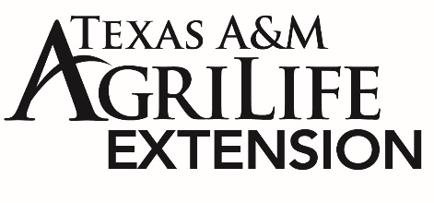
MEDIA ADVISORY
Contact: Sarah Latham– Texas A&M AgriLife Extension
Sarah.Latham@ag.tamu.edu

Act F.A.S.T. to prevent a stroke!
Did you know that 80 percent of strokes are preventable? According to the Centers for Disease Control and Prevention, stroke is the fifth leading cause of death in the United States and a major cause of long-term disability affecting about 795,000 individuals each year. In observance of National Stroke Awareness Month, Dr. Sumathi Venkatesh, a Health Specialist with Texas A&M AgriLife Extension Service, offers some insight into stroke risk factors and prevention measures.

Regular blood supply is vital for a healthy brain—an important organ in our body that regulates our thoughts and actions. A stroke occurs when oxygen and blood flow to the brain is prevented either by a blood clot that is blocking an artery (ischemic stroke) or by the rupturing of a weakened blood vessel (hemorrhagic stroke). When blood flow to a part of the brain is obstructed, it could affect specific functions corresponding to that region, resulting in cognitive impairment, physical disability, or loss of major body functions. In more severe cases such as a brain stem stroke, paralysis or even death could occur.

One of the main risk factors for a stroke, especially a hemorrhagic stroke, is high blood pressure. When blood pushes the arteries with high force for a prolonged period, it can damage the walls of the arteries, causing them to rupture. Likewise, high levels of blood cholesterol and blood sugar could damage the blood vessels. Therefore, routine medical monitoring and the maintenance of an ideal weight through physical activity and a healthy diet are critical measures to prevent some of the most important stroke-related comorbidities such as obesity, hypertension, diabetes, and heart disease.
You could save a life by learning the F.A.S.T. warning signs of a stroke. If you experience or witness Face drooping, Arm weakness, and Slurred speech, then it is Time to call 911. Other signs of concern are sudden numbness or weakness, confusion or trouble understanding, vision problems, loss of balance and coordination, and sudden severe headaches without any known problems. If you notice one or more of the warning signs, seek immediate medical attention to detect the underlying causes and begin a treatment plan. Visit the American Stroke Association at https://www.stroke.org/ for more information and resources on stroke awareness and management. For programs on healthy cooking, physical activity, heart health, diabetes, and blood pressure management, contact your Rains County Extension Office at (903) 473-4580.

# # #
Contact: Sumathi Venkatesh, Extension Program Specialist
Email: Sumathi.venkatesh@ag.tamu.edu

