My Tree Is Covered In Tiny Holes!, January 9-15
Occasionally I will receive calls from worried homeowners who have discovered a tree in their yard that is covered with tiny holes. These tiny holes can resemble insect damage from wood boring insect pest such as pine beetles to the untrained eye. These holes can range in the hundreds on a tree and can quickly frighten homeowners. However, these holes are not causing any damage to the tree and surprisingly is caused by a small woodpecker called the yellow bellied sapsucker, Sphyrapicus varius, which is a common winter resident in Polk County. Sapsuckers will tap for sap running inside a tree trunk creating ring of holes around a tree and multiply rings will create rows of holes. This is very different from wood boring insects which will create holes that will appear random in placement and will be deeper.
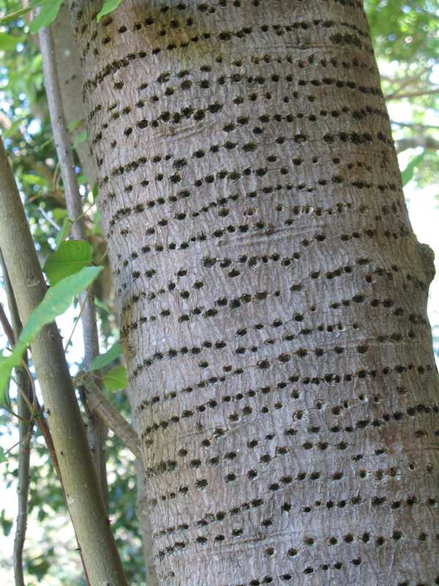
Image Credit: https://www.missouribotanicalgarden.org/Portals/0/Gardening/Gardening%20Help/images/Pests/Nuisance_Birds1041.jpg
Yellow bellied sapsucker is one of the smallest woodpecker you will see in the forest. During this time of year, it is also one of our most common even though they will only be present until early spring when the migrate back north to their breeding grounds. Breeding grounds or summer range includes the vast forest of Canada and parts of the upper midwest and northeast. The woodpecker prefers young deciduous forest but can be found in all forest types in Polk County. A variety of trees are utilized for tapping sap holes, but birch and maple trees are preferred. In addition to feeding on sap, insects are also utilized as a food source. The oldest recorded individual was approximately 8 years old. Conservation status is considered secure with populations having increased during the second half of the last century. There may even be more yellow bellied sapsuckers now then 300 years ago due to habitat change caused by humans. The current population is estimated at 10 million.
Historically, sapsuckers were considered pest because of the obvious damage they cause to trees. However, trees do not seem to be affected by the numerous holes, since the holes are small and shallow they heal quickly, and it appears to be cosmetic damage more than effecting the health of the tree. Now, if you still want to prevent sapsuckers form tapping holes in your trees you can discourage the activity by wrapping the trunk in burlap or hardware cloth. However, sapsuckers have small beaks and when the sap is really flowing they may still tap holes through burlap or hardware cloth.
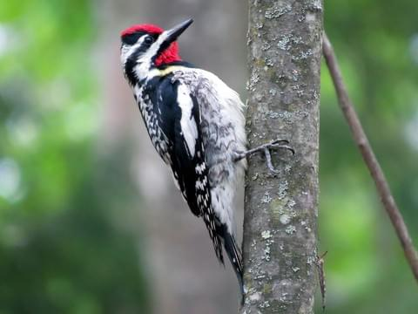
Image Credit: https://www.allaboutbirds.org/guide/Yellow-bellied_Sapsucker/id
Matthew R. March, MNRD
County Extension Agent- Agriculture & Natural Resources
Polk County | Texas A&M AgriLife Extension Service
602 E Church St Ste 127 Livingston, TX 77351
Phone: (936) 327-6828
______________________________________________________________________________

Cedar Fever Explained, January 16-22

(Article originally published by Texas A&M Forest Service)
Cedar fever season is almost upon us, and at a time when having a fever – or even catching a slight cold – is borderline taboo, it’s more important than ever to understand the symptoms and the source of this common, central Texas allergy. For starters, cedar fever isn’t a flu or a virus – it’s an allergic reaction to the pollen released by mountain cedar trees. In Texas, the predominant species of mountain cedar is the Ashe juniper. “Cedar fever is the worst west of I-35, where you have primarily juniper mixed in with oaks and some other species,” said Jonathan Motsinger, the Central Texas Operations Department Head for Texas A&M Forest Service. “And because all of those junipers are producing pollen at the same time, you’re going to get a higher concentration of pollen in the air.”
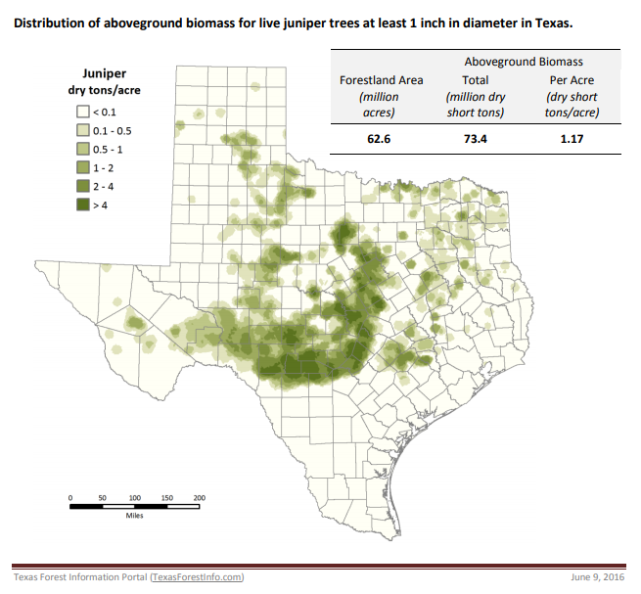

This is one of the primary factors contributing to cedar fever – the sheer quantity and density of Ashe junipers in central Texas. According to Robert Edmonson, a biologist for Texas A&M Forest Service, the pollen from Ashe junipers isn’t particularly allergenic or harmful – it’s just so concentrated that, even if you aren’t generally susceptible to allergies, it could still affect you. “There’s just so much pollen in the air,” said Edmonson, “it absolutely overwhelms the immune system. It’s like trying to breathe in a dust storm.”
Since that pollen is wind disseminated, cedar fever can affect individuals far removed from areas with a high-concentration of juniper trees. And the source isn’t limited to Ashe junipers: in more eastern parts of the state, there are also eastern redcedars that pollinate around the same time—between December and January—and they can induce a similar response from people’s auto-immune systems.
Besides the sheer quantity of pollen released, cedar fever is mostly problematic because of when that pollen is released. Most trees pollinate in the spring, when we’re expecting to have allergies. Ragweed pollen and mold spores can contribute to allergies in the fall, but very few plants pollinate during the winter. Cedar trees are the exception—they are triggered by colder weather—and in Texas, their favorite time to release pollen is right after a cold front. “Following a cold front,” said Edmonson, “the air dries out, we get some wind, and the pressure is different. Under those conditions, every single pollen cone on a juniper tree will open at one time, and it looks like the trees are on fire. It looks like there’s smoke coming off of them.” While this creates for some fascinating, and borderline mesmerizing, imagery, it can also lead to some serious misery. And for people new to the central Texas region, or unfamiliar with cedar fever as a whole, it can lead to genuine confusion since the pollination period of mountain cedar trees is smack dab in the middle of flu season. It’s not uncommon for people experiencing cedar fever to mistake their symptoms as a cold or the seasonal flu, especially given the variety of symptoms triggered by cedar fever. These include fatigue, sore throat, runny nose, partial loss of smell, and – believe it or not – some people actually do run a fever.
This year is going to be particularly problematic, since many of the above symptoms align with the novel, pandemic-inducing coronavirus. But there are a few tell-tales to look out for. First of all, if you are running a fever, cedar pollen will rarely cause your body temperature to surpass 101.5°F. If your fever exceeds that temperature, then pollen likely isn’t the cause. There are also a few symptoms of cedar fever that aren’t linked to the coronavirus, like itchy, watery eyes, blocked nasal passages, and sneezing. But there is one “dead giveaway” that, according to Edmonson, should always steer you clear. “If your mucus is running clear,” he “then it’s an allergy. If it’s got color, then it’s probably a cold or the flu.”
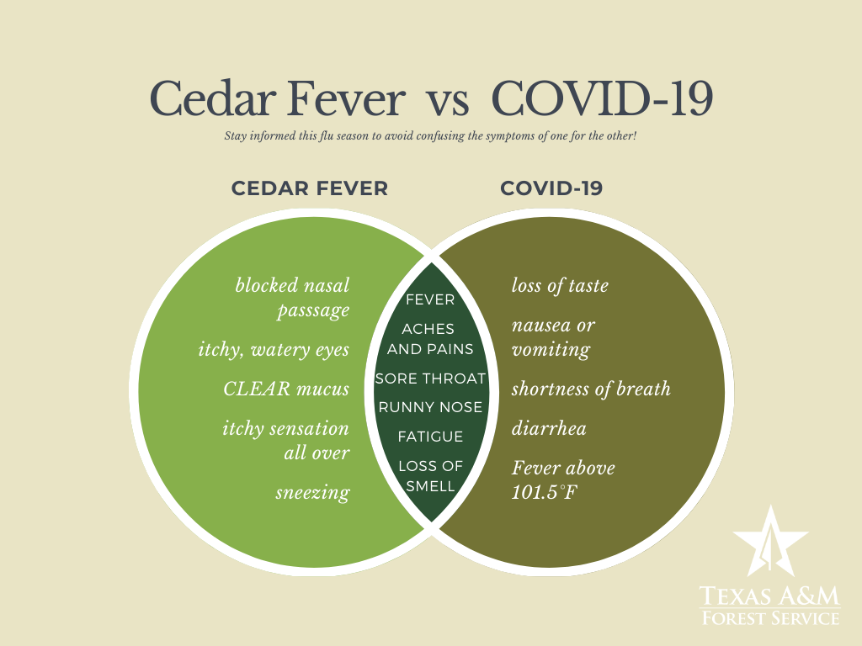
You can treat cedar fever by taking allergy medications and antihistamines, but you should consult with your physician or health care professional before taking new medications. You can also try and anticipate the pollen by tuning in to your local news station: many of which will give you the pollen count and can predict when it’s going to be particularly bad. On those days, it’s smart to keep windows and doors closed, to limit the amount of time you spend outdoors, and to change air conditioning filters in your car and in your home.
Removing cedar trees from your property isn’t recommended primarily because the pollen is airborne and—since they often wait to release their pollen until it’s cold, dry, and windy—that pollen can blow for miles. It’s also important to note that only male juniper trees release pollen. “The male trees have pollen cones,” said Motsinger, “and the female trees have berry-like cones, which are very inconspicuous, but that’s what’s pollenated from the male trees.” While junipers are notorious for releasing their fever-inducing allergens, they also have immense health benefits. Their berries, for instance, are used to make medicines and oils that can treat a variety of ailments, from an upset stomach to a snake bite. They are also high in nutrition and vitamins, providing a sustainable source of food for wildlife and soil enrichment, and they grow in a terrain that isn’t particularly hospitable to other species of tree. Most importantly, though, they provide the mental, physical, and environmental health benefits of trees and forests everywhere. Ultimately, mountain cedars are really only singled out for the unusual time of year in which they pollinate. “There are plenty of trees that produce copious amounts of airborne pollen,” explained Edmonson. “Coniferous trees do it, and oak trees can be just as bad in the spring. You get this light dusting of green everywhere, and that’s all pollen.”
While cedar fever might sound and seem particularly hostile, Ashe junipers are really just a species like any other, feeling out the conditions, and waiting for the perfect moment to release their pollen in order to set their offspring up for success come springtime. For more information about how to identify Ashe junipers and/or eastern red cedars in your own backyard, check out the Texas A&M Forest Service’s Texas Tree ID webpage or the My Tree ID mobile app. You can also see the distribution of junipers across the state via our Forest Distribution App, which can identify the distribution of native tree species across the state of Texas.
Matthew R. March, MNRD
County Extension Agent- Agriculture & Natural Resources
Polk County | Texas A&M AgriLife Extension Service
602 E Church St Ste 127 Livingston, TX 77351
Phone: (936) 327-6828

Crape Myrtle Murder, January 23-29
Every winter homicide is committed across the south to one of our favorite loving ornamentals. Despite all the recommendations and advice from professionals, crape myrtles are brutally topped or “pruned” every winter. Crape myrtle usually do not need pruning, and if a tree does need to be pruned it should never be topped, which is when you cut all the new growth from the previous year. So why are carpe myrtles topped every winter? There appears to be a misconception among uninformed individuals that crape myrtles need to be pruned to produce a healthy tree. This misconception likely comes from the fact that when you see every neighbor on the street topping their trees, then topping must be the correct management for crape myrtles. This misconception runs so deep that many professional landscaping companies even commit crape myrtle murder.
To start, crape myrtle murder should be avoided because it is unhealthy for the tree. Severe pruning will decrease cold hardiness along with increasing sucker growth or unwanted sprouts. Topping encourages abundance of young shoots along with shoots growing on angles instead of vertical. These young angled shoots provide food and cover for unwanted pest such as bark scale. Young shoots also have the tendency to break when in full bloom and be more susceptible to storm damage. Topping also delays blooming.
Besides heath benefits, many landscapers believe crape myrtles are more aesthetically appealing when they are not pruned. Crape myrtle when allowed to mature and reach their potential produce beautiful canopies and trunks. Crape myrtle bark will peel revealing strikingly eye appealing wood on older trunks. Trees that are consistently topped will never reveal their true beauty. Yes, crape myrtles are most know for their flowers, however their peeling bark, wood color, and branching structure is just as impressive.
There are certain instances when pruning is recommended, but never to the extent of topping or chopping off all last year’s growth. Suckers, cross branches, rubbing branches, branches at eye level, and branches rubbing against structures should be pruned. Dead and twiggy growth should also be pruned as it will improve the aesthetic appearance of the canopy structure. Pruning should occur in early spring before new growth.
Lastly, many homeowners prune their crape myrtles because they are too tall for their location. This issue should have never occurred if the right cultivator was planted. By doing a little homework you can find a cultivator that matches the height restrictions in your landscape. Cultivators range in height from 2 to 30 feet. Make sure you stay on the right side of the law by not committing crape myrtle murder this winter.
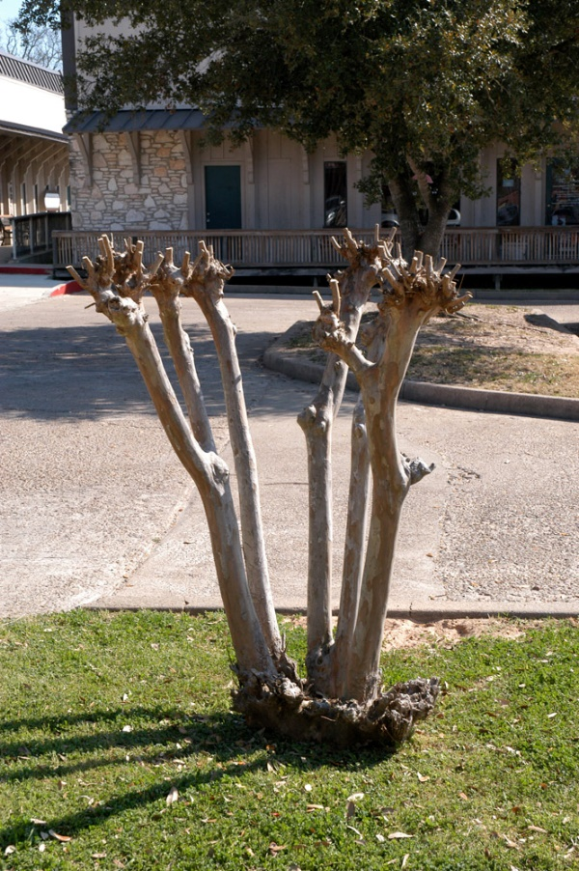
Image Credit: https://aggie-horticulture.tamu.edu/plantanswers/publications/crape_murder/crape_murder1.jpg
Matthew R. March, MNRD
County Extension Agent- Agriculture & Natural Resources
Polk County | Texas A&M AgriLife Extension Service
602 E Church St Ste 127 Livingston, TX 77351
Phone: (936) 327-6828

Chicken Feed, January 30- February 5
Raising backyard poultry is an enjoyable and rewarding hobby providing meat and eggs. But let’s be honest, the most enjoyable experience in raising backyard poultry is watching the chickens pecking the ground while foraging for seeds and insects. I mean who doesn’t giggle when an unfortunate grasshopper crosses path with a flock of chickens which instinctively go crazy at the sight of a potential meal. Poultry owners tend to just feed chicken scratch (a mix of ground up grains) since the chickens enjoy scratch and it mimics their natural foraging behavior of scratching and pecking on the ground. Unfortunately, chicken scratch and/or letting your birds naturally forage for food will cause their nutritional needs to fall short. You may not notice the nutritional deficiencies, but your production (eggs and meat) will drastically be reduced. Additionally, nutritional deficiencies can cause more serious health issues such as growth disorders and essential nutrient deficiencies.
If you will be starting your birds from chicks there are some special considerations to consider. For example, a young growing bird will require more protein in their diet then mature birds. You should always start your chicks on chick starter feed. After starting on chick starter, you will typically transition to a starter with a lower protein percentage after a couple of weeks or stay on the same chick starter for the first 2-4 weeks and then transition to a grower feed. You will need to consult with the feed label or feed company on specific recommendations and guidelines for their product of feed you are feeding.
A chick that is destined to be a layer will require a different grower then a meat bird. First let’s talk about layers. Layer birds will need to remain on a grower feed until they reach 16-18 weeks of age. At this point they will reach maturity and will need to transition to a layer diet. Feeding a layer diet to your layer birds is critical to maintaining bird health and ensuring a quality egg product. Layer birds utilize a tremendous amount of energy and nutrients to produce an egg nearly daily. Layer feeds ensure birds are receiving the correct amount of energy and vitamins such as calcium to ensure strong shell formation.
The name of the game in meat bird production is feeding high protein feeds to ensure muscle growth (breast meat). After transitioning from a chick starter after 2-3 weeks birds should be fed a grower and then eventually a finisher feed. The main difference between a grower and finisher is protein percentage. Grower feed will have higher protein levels then finishers because younger birds can utilize higher protein feeds without effecting other aspects of their health. Many grower that are harvesting their meat birds at a young age will remain on a grower feed for the eternity of the production cycle after transitioning off of chick starter.
Besides selecting what type of feed, producers must also select if the feed is a mash, crumble, or pellet. Mash feed is when all the feed ingredients are milled, think of ground coffee beans. Pellet feed is mash feed that has been processed into a pellet by adding a binder and heat to produce a pellet. Crumble is basically an intermediate between mash and pellet feed. Utilization of feed is greatest in mash feeds; however, you sacrifice a lot of waste. The opposite if for pellet feed, utilization decreases, but the birds waste less feed. In an ideal world we would feed mash feeds, but this is impractical for backyard flocks. A good recommendation is to start your chicks on mash and then transition to crumbles. Pellets can be fed if you do not have a good feeder or waste is an issue.
You may have noticed chicken scratch was never mentioned as a feed source. This does not mean you can’t feed chicken scratch, but you must understand your birds will not be meeting their nutritional requirements. Think of chicken scratch as being like ice cream and layer feed being a nutritious meal that contains vegetables. Now compare that to your kids, across they are going to pick ice cream every time, but as a parent you know they need their vegetables.
Matthew R. March, MNRD
County Extension Agent- Agriculture & Natural Resources
Polk County | Texas A&M AgriLife Extension Service
602 E Church St Ste 127 Livingston, TX 77351
Phone: (936) 327-6828

Texas A&M AgriLife Extension provides equal opportunities in its programs and employment to all persons, regardless of race, color, sex, religion, national origin, disability, age, genetic information, veteran status, sexual orientation, or gender identity. The Texas A&M University System, U. S. Department of Agriculture, and the County Commissioners Courts of Texas Cooperating. Anyone needing special assistance at an Extension Program should contact the Texas AgriLife Extension Office at (936) 327-6828 at least one week prior to the program or event.

