La Nina, Winter Drought, and Implications for 2021 Growing Season, December 5-11
Even long-term periods of drought are marked by heavy rainfall events that can improve drought conditions in the short term. With the above thought in mind I would like to discuss our current situation in Polk County, outlook for the rest of winter and what to except for 2021 growing season. Polk County has received minimal precipitation since the end of September causing most of the county to be in moderate drought with the southern end of the county being in severe drought until last week when several cold fronts brought much needed rain. However, this relief appears to be short lived and just a heavy rainfall event in a long-term drought that is expected to last at least through winter.
So why is climatologist predicting long term drought for Polk County? As crazy as this sounds weather across North America is affected by ocean temperatures in the central Pacific. El Nino is associated with a band of warm ocean water causing below normal temperatures and wetter conditions across Texas. In contrast, La Nina is associated with a band of cool ocean water causing warm and dry conditions across Texas. La Nina is currently occurring and is expected to persist through the upcoming winter. As a result, Polk County can expect temperatures to be well above average and precipitation well below normal. Additionally, this trend is expected across Texas with it being stronger the further west and south you go. Across weather is unpredictable and climatic conditions can change but the safe bet is to expect an ongoing and potential significant drought for Polk County in the coming months.
When looking at implications I except we will experience decreased grass production and hay availability. Winter months are not our major grass growing season, however producers that depend on winter forage (ryegrass, oats, etc,) will see decreased production resulting in the need to feed more hay. This will cause an increased demand in hay compared to normal winters, especially as we get into February when winter forages become important. Additionally, most of Texas was already in drought prior to this winter and hay supplies may be limited across the state as we get further into winter. Wildfire potential may also increase across east Texas this winter and there has already been increased fire activity in November.
Looking ahead to the 2021 growing season a winter drought could have long term impacts for next year. Winter is when we receive surplus precipitation leading to surplus soil moisture which benefits grass growth during spring and into summer. If soil moisture is limited come the start of the growing season, we can expect decreased grass production this spring leading to an increase demand for hay this summer if the drought continues into summer months. Winter is also when many of our rivers and reservoirs fill up before the dry summer months. Just remember the devasting drought of 2011 can be traced back to drought conditions that begun during the previous winter and fall.
Do not let the current wet conditions fool you. This drought appears to be far from over and you need to begin preparing for a dry winter and potentially a dry spring. 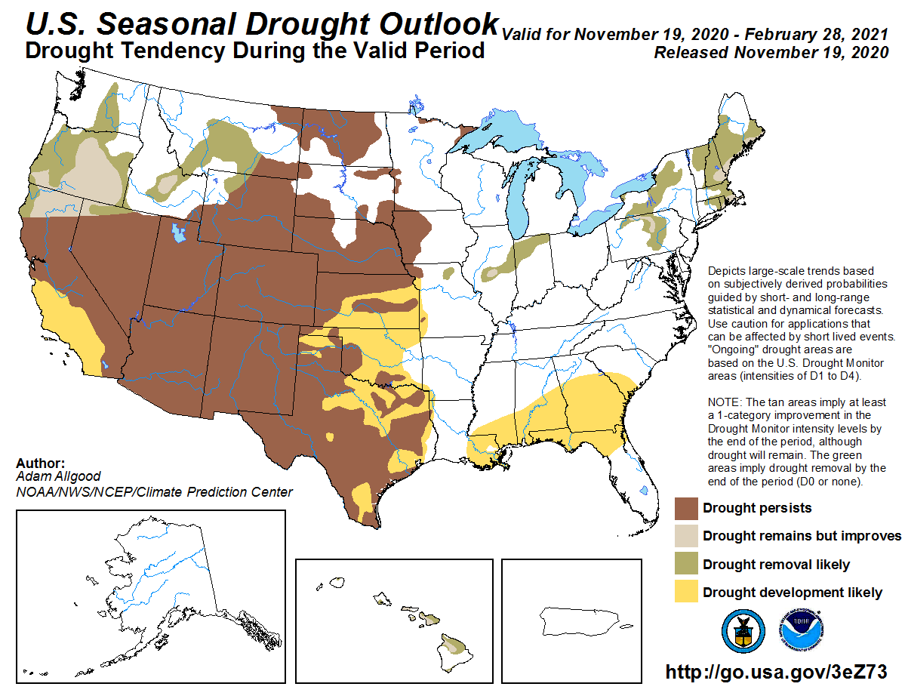
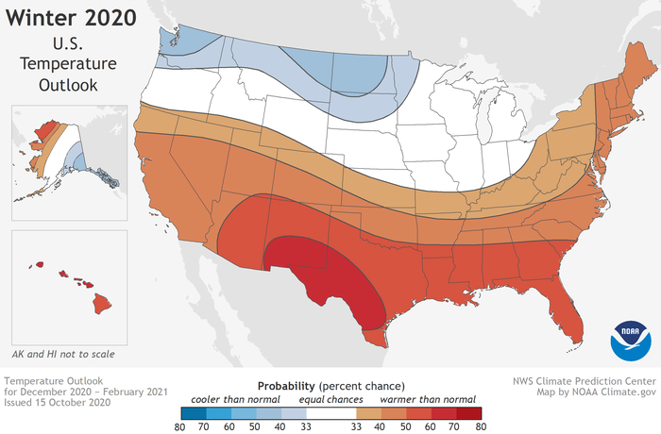

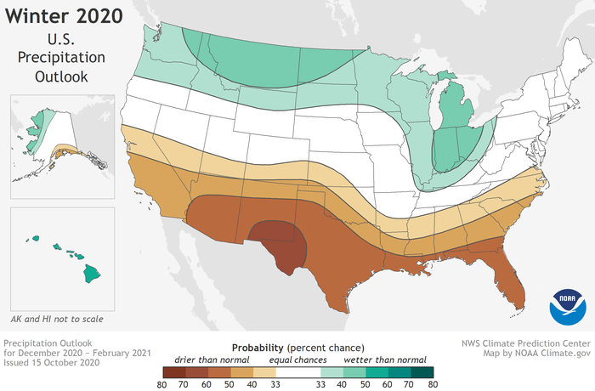
Matthew R. March, MNRD
County Extension Agent- Agriculture & Natural Resources
Polk County | Texas A&M AgriLife Extension Service
602 E Church St Ste 127 Livingston, TX 77351
Phone: (936) 327-6828
______________________________________________________________________________

Controlling Invasive Vines, December 12-18

East Texas seems to be the epicenter of nonnative invasive plants in the United States. There must be no short of at least several hundred nonnative plants growing and reproducing naturally throughout our forests. This includes all classes of plant from grasses to trees. Today, I want to focus on two nonnative “vines” that can quickly invade and dominate a site. Kudzu, Pueraria montana, is a true vine, while Japanese Climbing Fern, Lygodium japonicum, is technically a fern, but forms vine type mats.
Kudzu grows 35-100 feet tall and forms dense infestations. Kudzu spreads by seeds and by nodes from sprawling vines. Control is most effective when treating young vines that are short. Control becomes very costly and not as effective when the vine is 100 feet tall instead of 10 feet tall. Prescribed fire and mechanical control are potential options. Prescribed fire should occur in the spring followed by a summer herbicide application. Mechanical option consists of individual plant treatments by removal of root crowns. Ground cuttings will need to occur in multiply years to achieve control. An application of herbicides containing picloram, metsulfuron methyl, or aminopyralid should be applied between July and early September via foliar leaf spray method. Basal spray method of vines with stems less then 2 inches in diameter should occur form January to April. Basal spray should be a mixture of herbicides containing triclopyr and diesel. The mixture should be 1 part triclopyr to 3 part diesel. Injection of herbicides containing picloram or glyphosate directly into the stem is appropriate for very large stems.
Japanese climbing fern can reach 90 feet in height and forms impenetrable mats. Japanese climbing fern is very hard to control as it persists through regrowth from underground rhizomes and microscopic spores. These spores are easily carried by vectors, (animals, equipment, humans, etc.) to new sites. Minimal disturbance of sites containing Japanese climbing fern is necessary to reduce the risk of spreading spores to a new site. Unlike kudzu, control options for Japanese climbing fern are limited. Mechanical options are ineffective and prescribed fire intensifies infestations. The only chemical option is foliar leaf spray of glyphosate during the months of July to September. But glyphosate is a nonspecific herbicide and will kill any other vegetation growing on the site.
If you are needing to manage one of these two “vines” more detailed information is available from the extension office. The office can provide detailed application rates and instructions on the different application methods.
Japanese Climbing Fern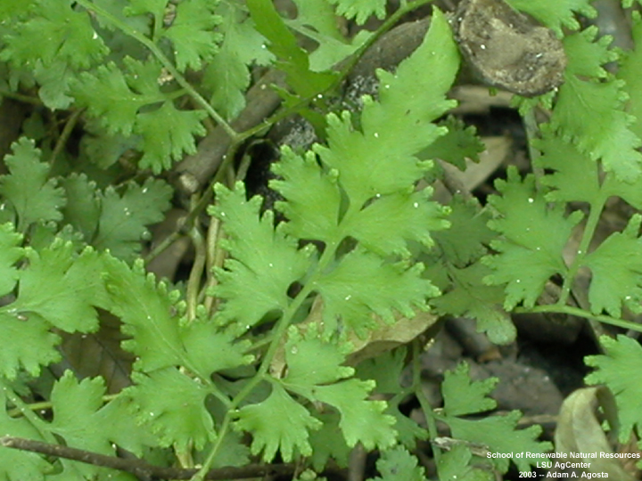
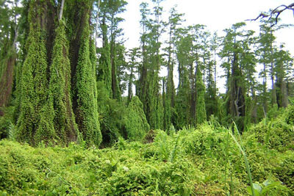
Image Credit: Mandy Tu/The Nature Conservancy

Matthew R. March, MNRD
County Extension Agent- Agriculture & Natural Resources
Polk County | Texas A&M AgriLife Extension Service
602 E Church St Ste 127 Livingston, TX 77351
Phone: (936) 327-6828

Do not Forget Your Soil Test, December 19-25
Next year spring garden is the last thing on most peoples mind this time of year. Many gardeners wait until March or even later to start preparing their spring garden. This is a costly mistake that will set you up for failure. In fact, now is the time to start planning and preparing your garden for spring. The first step is to conduct a soil test.
Conducting a soil test is crucial for anybody growing crops rather that be a 10X10 foot garden or a 100acre corn field. A soil test determines what nutrient levels are in the soil and will allow you to calculate what type and how much fertilizer to apply. A soil test will also calculate soil pH and will show if there are any excessive amounts of toxic nutrients in the soil such as Boron. A common misconception is a soil test is not needed because I had a successful garden last year applying fertilizer such as triple 15 and I should have the same success this year if I apply triple 15 at the same rate. This is farthest from the truth as nutrient level vary in soil from year to year. Additionally, a soil test allows you to apply the exact type and amount of fertilizer to match the plants need. Overapplying fertilizer is bad for the environment as excess fertilizer will end up in streams and certain fertilizers such as potassium, are a finite resource.
A soil test should be conducted well in advance of planting. This allows you time to collect the soil, send off the sample, receive the results, and apply the fertilizer. It is also a good practice to apply fertilizer at least several weeks before planting to allow time for the fertilizer to incorporate into the soil. A lime application, used to raise soil pH, should be applied at least several months prior to planting. So, December is the perfect month to conduct a soil test for a spring garden.
For collecting the sample, you can obtain sample bags from the extension office or you can use plastic bags. You should collect a composite sample which means you will collect 10 to 15 samples from your garden, combine those samples and then submit one composite sample. The composite sample should contain 1 pint of soil. A composite sample ensures one part of your garden will not be overrepresented in the results. For example, a low spot will have different nutrients then a dry spot. A composite sample will ensure soil is represented from all areas of your garden. You may want to consider several composite samples if testing soil for a large garden.
A shovel can be used to take samples; however, a soil probe works better. A soil probe is available at the extension office for your use. Soil should be collected to a depth of 6 inches. Organic material such as sod should be removed from the sample. Detailed instructions on taking a sample is available at the extension office. For 90% of gardens a routine soil test with be sufficient. A routine test determines soil pH, salinity, nitrates, and levels of primary nutrients. More detailed tests can be conducted if warranted.
Samples can be submitted to the soil testing labs at Texas A&M, SFA, or a lab of your preference. Once you receive the results the extension office can help calculate a fertilizer recommendation. As a friendly reminder, do not forget you soil test this holiday season!
Matthew R. March, MNRD
County Extension Agent- Agriculture & Natural Resources
Polk County | Texas A&M AgriLife Extension Service
602 E Church St Ste 127 Livingston, TX 77351
Phone: (936) 327-6828

Swine Breeds, December 25 - January 1
It was not that long ago nearly every farmer, rancher, or household in the country had a handful of slaughter pigs they raised every year to supply meat for their family. Most people now purchase pork form the grocery store due to the convenience, but raising hogs is still popular amongst some individuals. Additionally, there is a growing interest in raising more of your own food. One of the first steps in raising swine is selecting a breed. Maternal breeds are characterized by their ability to produce litters, while carcass breeds are known for their ability to produce a quality meat product.
Examples of common maternal breeds includes Chester white, landrace, and Yorkshire. Chester white originated in Pennsylvania and are known for their mothering ability, durability, and soundness. Chester white are white in color with droopy medium sized ears. Landrace are also white in color and have droopy ears but are know for being heavy milkers and farrowing large pigs. Landrace is also popular due to its high percentage of carcass weight in the ham and loin. Yorkshire is the most recorded breed in North America and are white in color and have erect ears. Yorkshires are known for their muscle, with a high proportion of lean meat and low backfat along with soundness and durability.
Examples of common carcass breeds includes duroc, Hampshire, Poland China, and spotted. Duroc is the second most recorded breed of swine and are the reddish pigs with drooping ears. Duroc value is in prolificacy and longevity along with product quality, carcass yield, and fast growth. Hampshire are easily recognized by their white belt around their shoulder and front legs. Their head and rear third of body is black. Hampshire are know for producing lean muscle, high carcass quality, and minimal backfat and large loin eyes. Poland China originated in Ohio and are known for a quiet disposition along with being a large frame breed. As the name suggest, spotted is recognized by black and white spots. Females are known for their productivity, docility, and durability along with feed efficiency and carcass quality.
Another option is to raise uncommon breeds or what is called heritage breeds. Heritage breeds are traditional livestock breeds that have been raised for centuries and were the breeds raised before the common production breeds that make up the industry today. Heritage swine breeds have the potential to perform well in small or backyard operations as they are more adapted to less intensive management operations. Some example breeds are guinea hog, Hereford, large black, saddleback, and tamworth.
Selecting a breed can be a very daunting task as you may want characteristics found in multiply breeds. For this reason, crossbreeding is very popular in swine operations. Many producers cross a maternal breed to a carcass breed so that their offspring will exhibit both maternal characteristic and carcass quality.
Breed information cited from https://www.pork.org/
Matthew R. March, MNRD
County Extension Agent- Agriculture & Natural Resources
Polk County | Texas A&M AgriLife Extension Service
602 E Church St Ste 127 Livingston, TX 77351
Phone: (936) 327-6828

Texas A&M AgriLife Extension provides equal opportunities in its programs and employment to all persons, regardless of race, color, sex, religion, national origin, disability, age, genetic information, veteran status, sexual orientation, or gender identity. The Texas A&M University System, U. S. Department of Agriculture, and the County Commissioners Courts of Texas Cooperating. Anyone needing special assistance at an Extension Program should contact the Texas AgriLife Extension Office at (936) 327-6828 at least one week prior to the program or event.

