Texas A&M AgriLife Research New Clover Cultivars, November 7-13
Texas A&M AgriLife Research has been working on releasing new cultivars of clover for east Texas cattle producers. If you are looking to diversify your cool season forage options, I would recommend trying one of these two new cultivars.
Blackhawk Arrowleaf Clover is a new cultivar that was released by Texas A&M AgriLife Research, Overton, TX in 2013. Blackhawk has multiple disease tolerance compared to Apache and Yuchi cultivars. Blackhawk is slightly earlier in maturity than Apache arrowleaf and is in full bloom around May 10 at Overton, TX.
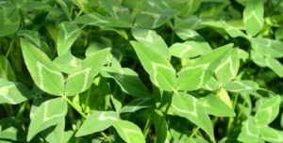
- Test soil and follow lime and fertilizer recommendations
- Soil pH should be 6.0 to 6.5
- Plan acreage needed (0.5 to 0.8 acre/cow + calf)
- Graze or hay warm season grasses to about 2-inch height before planting.
- Disturb sod with light disking and plant 10 lbs/acre
- Arrowleaf clover will provide grazing from March to June
- Will also provide about 100 lb nitrogen/acre that will be available to warm-season grasses through nutrient cycling
- Not a reseeding system if grazed until June.

Neches White Clover is a new cultivar that was released by Texas A&M AgriLife Research, Overton, TX in 2010. Neches flowers early compared to La S-1 and slightly earlier than Durana. Neches is in full bloom by mid-April at Overton, TX. Forage yield is generally equal to La S-1 and RegalGraze.
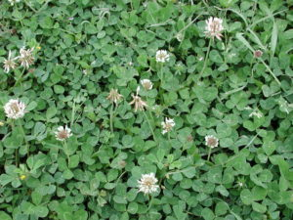
- Best adapted to bottomland and high moisture soils
- Not recommended for upland soils
- Test soil and follow lime and fertilizer recommendations
- Soil pH should be 6.0 to 7.5
- Plan acreage needed (0.5 to 0.8 acre/cow + calf)
- Graze or hay warm season grasses to about 2-inch height before planting.
- Disturb sod with light disking and plant 3-4 lbs/acre
- White clover will provide grazing from April to July
- Will also provide about 125 lb nitrogen/acre that will be available to warm-season grasses through nutrient cycling
- White clover is a perennial but often does not persist under hot, dry summers in the SE US
- Often managed as a reseeding annual

If you are interested in growing cool season clovers, I would recommend reviewing AgriLife Extension Cool Season Forage Legume Management Guide. This guide can be found at https://foragefax.tamu.edu/files/2013/05/viewpdf_2937_96373.pdf
Article was originally posted in Forage Fax and authored by Vanessa Corriher-Olson, AgriLife Forage Extension Specialist, Overton, TX
Matthew R. March, MNRD
County Extension Agent- Agriculture & Natural Resources
Polk County | Texas A&M AgriLife Extension Service
602 E Church St Ste 127 Livingston, TX 77351
Phone: (936) 327-6828
______________________________________________________________________________

Moist Soil Management Units, November 14-20

Moist soil management units are a great tool for landowners to increase habitat for waterfowl and other water loving birds and animals on their property. Moist soil management units are vey popular with duck hunters, because when managed properly they can attract ducks for miles around.
You may be asking what the difference is between a moist soil management unit and a pond? Water is water, right? Well the key difference is moist soil management units are a practice that encourages growth of seed producing native wetland plants by mimicking the seasonal wet and dry cycles of natural wetlands. In other words, moist soil management units are drained in the spring, management such as disking, mowing, burning, or shredding occurs during the summer, and is followed by refilling with water in the fall. This is obviously different form your standard pond which has a relatively level water depth throughout the year. Another major difference is moist soil management units are very shallow. Shallow water encourages utilization by ducks as it makes food easily available. The deeper the water the harder it is for ducks to forage on food sources. Teal prefer water that is 4 to 8 inches deep, while if you want to attract dabbling ducks such as mallards, water should not be deeper than a foot or so. Moist soil management units are very cost effective once established, however initial hurdles include infrastructure cost such as levees, ditches, and water pumps, and finding a reliable water source. Moist soil management units can be supplemented by planting nonnative crops like millet to provide high energy food sources that ducks require. Even though supplemental planting may attract more ducks, the practice is considerably more costly then managing native vegetation.
East Texas is also home to what we call green tree reservoirs. Green tree reservoirs are basically moist soil management units in bottomland hardwood forest. These bottomlands hardwood forest historically flooded during the fall and winter which was the historical habitat for ducks in east Texas. Recommended guidelines for green tree reservoirs are hardwoods be at least 40 years old, be a minimum of 10 acres, flat to provide even water depth, and water depth be no deeper then 18 inches. It is critical water depth does not reach over 18 inches and the reservoir is drained by February to ensure damage does not occur to trees.
Moist soil management units are an excellent wildlife management practice for not only attracting ducks but providing habitat for the plethora of migrant shorebirds and wading birds that overwinter in Texas.
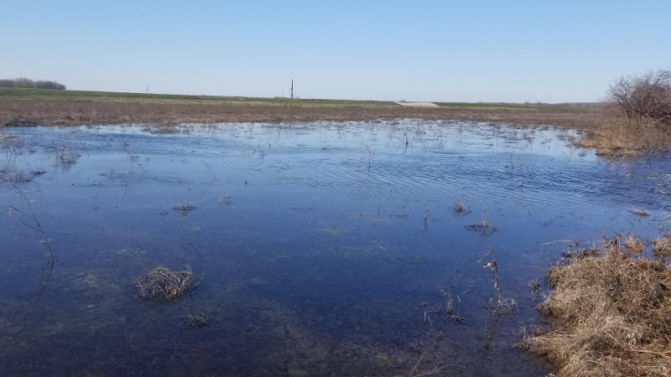

Matthew R. March, MNRD
County Extension Agent- Agriculture & Natural Resources
Polk County | Texas A&M AgriLife Extension Service
602 E Church St Ste 127 Livingston, TX 77351
Phone: (936) 327-6828

Controlling Squirrels Around Your House, November 21-27
As we all know squirrels are abundant in Polk County amongst all our hardwood trees. However, as I suspect many of you reading this article have experienced how squirrels can become a nuisance around your house, especially if you live in town. There are three species of tree squirrels in Polk County: fox squirrels, gray squirrels, and southern flying squirrels. Fox squirrels range throughout Texas while gray squirrels and southern flying squirrels are restricted to the eastern third of the state. Tree squirrels feed on a variety of plant material from nuts to berries and make nesting sites in cavities. Tree squirrels become a pest when they feed on ornamental or other high value plants and when they construct nesting cavities in attics and other manmade structures. Squirrels can cause costly damage to structures by damage insulation, electrical wires, and gnawing on wood.
There are several control options for around your house. Exclusion works by squirrel proofing your attic and trees. This method is popular as it does not harm the squirrels and is legal in urban areas compared to shooting. Squirrel proofing consists of trimming tree limbs back 10 feet from the edge of your roof. Additionally, metal flashing can be placed around the trunks of trees to discourage climbing. By trimming trees and discoursing climbing you are essentially making the attic inaccessible to squirrels. You can also close openings that squirrels use to access attics such as vents with sheet metal, hardware cloth, or steel wool. Trapping can be effective in control by reducing numbers. Cage traps are a popular option when baited with fruit, peanut butter, seeds, or vanilla extract. Shooting can also reduce numbers but is not recommended around the house especially in urban areas. You should always follow Texas Park and Wildlfie Department Rules and local ordinances when it comes to trapping, relocation, and shooting of squirrels.

Matthew R. March, MNRD
County Extension Agent- Agriculture & Natural Resources
Polk County | Texas A&M AgriLife Extension Service
602 E Church St Ste 127 Livingston, TX 77351
Phone: (936) 327-6828

Adding Avocados to Your Diet, November 28- December 4
Avocados, though widely consumed in Texas, are mostly grown in California, Florida, and Hawaii in the United States. Mexico actually leads world production of avocados with over 1 million metric tons annually produced.
Although they are not widely produced in Texas there are some climates in Texas that support avocado growth. Texas counties in the Lower Rio Grande Valley have climates that are suitable for commercial production of avocados.
A wide range of soil types are suitable for avocado tree growth, however, the most suitable soil is coarse and well drained. While the soil type is important, the most limiting variable is climate more specifically severe cold. West Indian types are the most susceptible to the cold, tolerating almost no sub-freezing temperatures. The most cold-hardy are Mexican types that will tolerate temperatures of 19 to 20 degrees as mature trees.
Avocados grow on tropical evergreen trees that can reach 40 to 80 feet in height. Defined by large, leathery, and deep green leaves avocado trees live for 2 to 3 years. During the flowering season each spring, the mature trees will shed aging leaves.
The unique flavor and popularity of Tex-Mex food contribute to the consumption of avocados in Texas along with the nutritional benefits of the fruit. Like bananas, avocados are high in potassium and are considered a good source of vitamins K, E, and B. Avocado flesh is about 15% oil or fat, which is mostly monounsaturated fat.
There are many ways to add avocados to your diet, sliced raw, guacamole, and mashed! For great, tasty, and healthy recipes, check out https://dinnertonight.tamu.edu/avocado-nutrition/
Article was originally posted Path to The Plate, Texas A&M AgriLife Extension, https://pathtotheplate.tamu.edu/
Matthew R. March, MNRD
County Extension Agent- Agriculture & Natural Resources
Polk County | Texas A&M AgriLife Extension Service
602 E Church St Ste 127 Livingston, TX 77351
Phone: (936) 327-6828

Texas A&M AgriLife Extension provides equal opportunities in its programs and employment to all persons, regardless of race, color, sex, religion, national origin, disability, age, genetic information, veteran status, sexual orientation, or gender identity. The Texas A&M University System, U. S. Department of Agriculture, and the County Commissioners Courts of Texas Cooperating. Anyone needing special assistance at an Extension Program should contact the Texas AgriLife Extension Office at (936) 327-6828 at least one week prior to the program or event.

