Texas Doves, August 29-September 4
September 1st may just seem like any other 1st of the month for many Texans, but for Texas hunters it is practically a holiday. While many Texans are paying the 1st of the month bills, hunters are hitting the dove fields as part of an annual ritual to kick off the 2020-2021 hunting season. Texas is blessed with an abundance of 40 million mourning dove and white wing dove which are pursued by upwards of 300,000 hunters. These hunters contribute $300 million annually to the Texas state economy. Texas dove hunting is world-renowned; however, Texas can also boast its diversity of species belonging to the order of birds called Columbiformes, which includes doves and pigeons. Texas has recorded 10 native species of doves and pigeons which does not include nonnative species such as Eurasian collared dove or the rock pigeon.
Mourning dove and white wing dove are the two most abundant and recognizable species. Mourning dove can be found across Texas from the desert to forest and from rural fields to city parks. They are year around residents with populations increasing during the winter as birds from more northern locations migrate south. White wing dove was originally a bird of desert thickets and only common in the southern third of Texas. However, the bird has adapted to roosting in towns and feeding in surrounding fields and has expanded its range to across most of Texas except for the far northern reaches of the panhandle and the forest of deep east Texas. The only other dove species hunted in Texas is the white tipped dove, which is one of the most widespread dove species in the western hemisphere, but its northern range limit is the Rio Grande valley of south Texas where it is a year around resident.
Texas is home to two small species of dove about the size of a sparrow that many people call ground doves or Mexican doves. The Inca dove and common ground dove can easily be overlooked as they scratch for seeds in clumps of grass until they are flushed. Both species can be found throughout most of Texas becoming more common in the southern half. Inca dove is a more southwestern desert bird while the common ground dove range extends across the southeastern U.S.
Band tailed pigeon is restricted to the mountain forest in far western Texas. While the red billed pigeon is found in the thick brush along the Rio Grande River in south Texas. Red billed pigeon is considered a Texas specialty as it is found nowhere else in the U.S. Ruddy quail dove and ruddy ground dove are considered vagrant species along the southern border in Texas meaning they are not permanent residents but are occasionally spotted. Lastly, white crowned pigeon is a resident of Caribbean islands, but in October 2018 an individual was recorded in Galveston.
So rather you or a dove hunter or not I challenge you to get out and ID the native dove species found here in Polk County. That would include the mourning dove, Inca dove, common ground dove, and the occasional white wing dove.

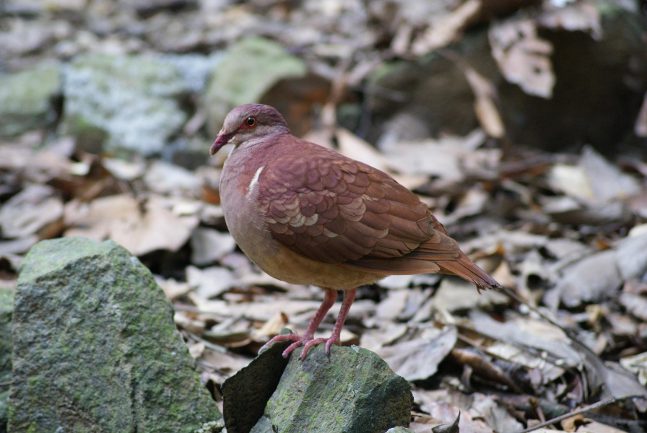
Image: ruddy quail dove
https://www.audubon.org/field-guide/bird/ruddy-quail-dove#photo1

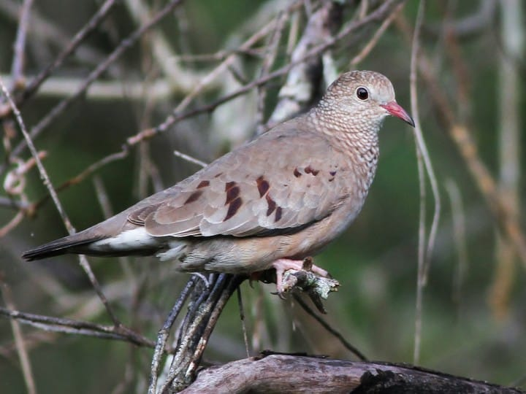
common ground dove
https://www.allaboutbirds.org/guide/Common_Ground_Dove/id

Matthew R. March, MNRD
County Extension Agent- Agriculture & Natural Resources
Polk County | Texas A&M AgriLife Extension Service
602 E Church St Ste 127 Livingston, TX 77351
Phone: (936) 327-6828
______________________________________________________________________________

Quick Tips For Pecans, September 5-11

This is the time of year where I receive calls about pecan trees not producing fruit. Pecans are a funny in the fact that they thrive in Polk County, but getting an improved variety to consistently produce yields can be difficult and challenging. To make things even trickier pecans tend to produce an abundant harvest one year and then go years before the next harvest. Below are some quick tips to better mange pecan trees for homeowners or small orchards.

1) Water may be the most limiting factor in nut production, especially in arid regions of the state. Even here in east Texas a 3-week dry spell in July can be detrimental to that year’s crop. A good rule of thumb is a mature pecan tree needs 1 to 2 inches of water per acre per week during the hottest parts of summer.

2) You should take a long consideration into variety selection. You need to pick varieties that are adapted for humid east Texas and are pecan scab resistant. Pecan scab is the number one reason for a failed crop in Polk county and is a fungus that appears as black spots on the leaves and husk. Kanza, Lakota, Elliott, Apalachee, Caddo and Oconee are preferred varieties for Polk County.

3) Ideal site will have deep, well drained soils. Trees can survive on the shallow soils found in many locations in Polk County, but will struggle to produce a crop and will require more frequent watering.

4) Pecans need ample amounts of sunlight. Medium sizes trees need spacing of 50 to 60 feet while large mature trees need to be spaced 75-100 feet apart at a minimal. Pruning of pecans and other trees and your backyard should occur every winter to ensure adequate sunlight.

5) Pecans typically need an application of nitrogen and zinc every year. Due to acidic soils in Polk County a lime application is likely needed every 2-4 years.

6) Pecans are a favorite food of many insects. You should inspect your trees and nuts regularly for pest problems including cutting open the developing nut. Learn what looks normal so you can recognize the unusual.

7) Fungicides are generally unavailable and uneconomical for control of pecan scab for homeowners or small orchards. Culture management includes pruning your trees to allow sunlight and wind into the canopy to reduce growing conditions for the fungus. Also, dead branches, fallen husks, and leaves should be raked and either removed or burned every fall as these materials allow the fungus spore a site to overwinter.

It can be very frustrating to get your pecan tree to produce consistently. But, by following the tips above your chances increase. Remember to always provide adequate sunlight, water frequently, fertilize annually, and plant pecan scab resistant varieties.

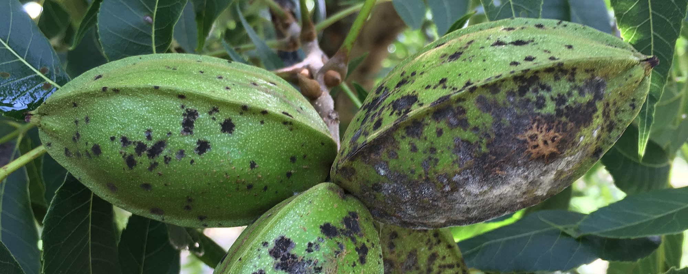
Pecan Scab
https://www.noble.org/news/publications/ag-news-and-views/2018/april/how-to-identify-and-control-pecan-scab/

Matthew R. March, MNRD
County Extension Agent- Agriculture & Natural Resources
Polk County | Texas A&M AgriLife Extension Service
602 E Church St Ste 127 Livingston, TX 77351
Phone: (936) 327-6828

Apples, September 12-18
If you asked a homeowner what fruit tree they desire to have in their backyard they pick peaches 9 times out of 10. But a popular second choice is usually apples. Unfortunately, apples are not well suited for Texas, especially the popular varieties such as granny smith or red delicious. However, these are the varieties typically sold at big box stores and after a year or two the tree either dies or if it does survive never produces fruit. I typically do not recommend apple trees be planted in Polk County, but if you are determined to give apples a chance do your homework first.

Variety selection is essential as you will need to select a variety with the appropriate amount of chill hour requirements. Fruit trees need a specific amount of cold weather to ensure leaves and blooms emerge normally in the spring. For Polk County you need to select a variety that has 500 or less chill hours. This would include varieties such as anna, dorsett golden, mollies delicious, and pink lady. Fuji, gala, and mutus varieties are marginal for Polk County as we may not receive enough chill hours every winter for these varieties to set fruit. It should be noted most commercial apples do best in areas with 1,000 to 2,200 chill hours. Apples require cross pollination so you will need to plant more then one variety with similar chilling hours.

An ideal site would have deep well drained soils with a pH of 6.5 to 7.0. Most soils in Polk County have a pH of 5.5 or lower so you will need to apply lime to your soil to raise the pH. Apples are grafted on root stock and you will need to select a root stock that will not require a trellising system. Dwarfing rootstock such as M7 and MM111 are common amongst homeowners.

Apple pruning and training of branches can be somewhat confusing and if you want more details you can call the office. But in general, apples are trained in a central leader system that resembles a Christmas tree shape to increase sunlight and maximize production. Irrigation is important and will vary depending on the age of the tree and growing conditions, but on light soils during dry conditions each tree may require upwards of 40 gallons of water per week. You should not allow the crown of the tree to get wet during irrigation as this can help spread soil borne pathogens in which apples are very susceptible. Calcium deficiency is a common nutritional issue which can be resolved by calcium spray applications. As with any crop, weed control is very important and you should constantly be monitoring for insects and other pest.

If you are considering planting apples, I would not recommend it. However, if you do your homework, plant the appropriate variety, and put in the management required you can grow apples in Polk County.

Matthew R. March, MNRD
County Extension Agent- Agriculture & Natural Resources
Polk County | Texas A&M AgriLife Extension Service
602 E Church St Ste 127 Livingston, TX 77351
Phone: (936) 327-6828

Cattle Branding, September 19-25
Branding of one’s cattle has been part of the Texas and western heritage since the first cattle were put out to range. It goes without saying the obvious reason for branding your cattle is to recognize ownership. Brands also help to deter cattle rustlers and help ID your cattle at an auction barn if they were to be stolen. Brands can also be used to ID individual cattle in a heard to assist with management and recordkeeping. This is done by branding numbers that correspond to that animal. When branding your cattle, you have two options hot brand or freeze brand.
A hot brand or fire brand has been the standard method for branding cattle for centuries. While some producers still use irons that are placed in a fire a growing number use electric hot brands. The downside of an electric hot brand is you will need a reliable electrical source at your working pens. Hot brands work by killing the hair follicle cells that should result in the branded hide being of a light tan color. It should resemble in color new leather. The brand should be held firmly on the hide for 3-6 seconds while rocking the handle slightly. You should never brand wet animals, place brands/numbers at least one inch apart or further and avoid brands with multiply narrow points.
Freeze branding has become popular as is it has been shown to reduce stress and be less painful. A freeze brand works by killing the pigment portion of the hair folic. After branding the hair will regrow but will grow back without any pigment (appears white). For this reason, freeze brands can be illegible on white, gray, or other light-colored cattle and is not recommended. Freeze brands have become very popular on black skinned cattle such as angus. Freeze branding is more expensive then hot brands, requires more materials, and branding site needs to be clipped. Alcohol and dry ice or liquid nitrogen is used to reach the cold temperatures needed to conduct a freeze brand. 95% alcohol will be required as less pure alcohol will not remain a liquid when placed in the dry ice. For alcohol and dry ice, the brand will need to be held on the hide for 40-60 seconds and for liquid nitrogen 10-25 seconds. Holding the brand on for to long will result in killing of the hair cell follicles and will appear as a hot brand.
Brands are registered by the county clerk in Texas. You will need to register your brand with the county clerk for each county you cattle will be located in. Texas brands must be re-registered on a 10-year period. More information can be found at http://www.tscrabrands.com/FAQ.html#how
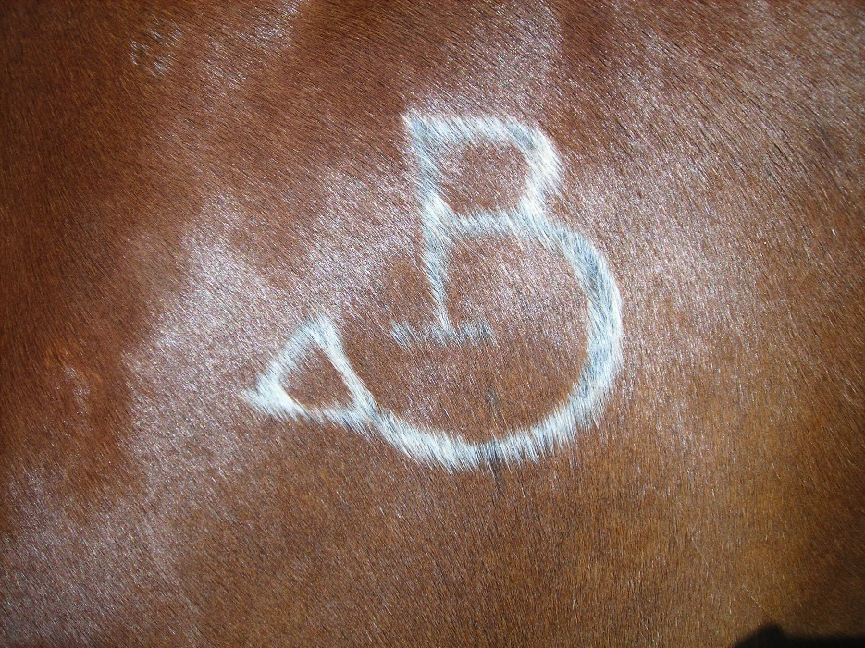
Freeze Brand
https://en.wikipedia.org/wiki/Freeze_brand

Matthew R. March, MNRD
County Extension Agent- Agriculture & Natural Resources
Polk County | Texas A&M AgriLife Extension Service
602 E Church St Ste 127 Livingston, TX 77351
Phone: (936) 327-6828

Black Rot In Cabbage, September 26- October 2
By this time of the year cool season gardens are planted and hopefully healthy and growing. Cabbage is a standard in cool season gardens and is a moderately easy crop to grow and will typically produce a plentiful crop. However, just like with any crop there are some insects and diseases that can cause detrimental impacts to your cabbage. I recall one such disease that almost wiped out my entire cabbage crop in my cool season garden a few years back. The culprit was black rot, which is a bacterial disease caused by the pathogen Xanthomonas campestris.

Black rot is a significant disease of cabbage and other crucifer crops worldwide which includes broccoli, cauliflower, Brussels sprouts, Chinese cabbage, kale, radish, turnip, mustard, rutabaga, watercress, and arugula. In cabbage it can affect any stage of growth and results in symptoms that resemble nutritional deficiencies. One of the most devastating impacts is the head of infected cabbage will remain small and quality will be reduced making in unfit for marketing. Symptoms begin with yellowing of the leaf margin which follows with characteristics v-shaped lesions. The leaf margins will eventually turn brown and die making the symptoms very noticeable. From this point the bacteria then continues through the leaf veins eventually spreading throughout the plant. In severe infections blacking of tissue occurs within the cabbage head, steams, and roots.

The pathogen most commonly enters the leaf via hydathodes on the leaf margin. Hydathodes are pores that extrude plant sap droplets early in the morning. Damage to the leaf from insect feeding, hail, or mechanical injury will also allow the pathogen to enter the leaf. The pathogen thrives in warm and wet climates; thus, a warm and wet winter will result in a higher chance of back rot in your cabbage. The pathogen also can be found in water pores, which allow it to come in contact with other leaves and plants during watering. The pathogen will survive in the soil from year to year if cabbage plant debris is present.

Management after black rot is found is very difficult to impossible. There is no treatment for individual infected plants; however copper based products are effective in reducing spread from infected to healthy plants. Thus, the best strategy to control black rot is prevention. This includes starting with clean seed and using clean transplants. You should hot water treat your seeds by soaking seeds for 25 minutes in 122ºF water. If growing your own transplants, ensure your greenhouse has been properly cleaned prior to starting transplants. One of the most effective prevention strategies is to rotate your cabbage and other crucifer crops. Because the black rot pathogen can survive in debris in the soil, it is important to rotate away from crucifer crops for a minimum of three years, especially if black rot has been a problem.

Hopefully, you never have to deal with black rot in your cabbage crop. But if you are unfortunate to have this problem remember prevention is the best management strategy. This includes clean seeds, clean transplants, and crop rotation.

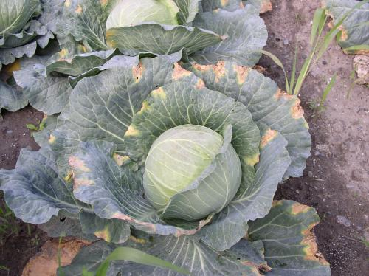

Matthew R. March, MNRD
County Extension Agent- Agriculture & Natural Resources
Polk County | Texas A&M AgriLife Extension Service
602 E Church St Ste 127 Livingston, TX 77351
Phone: (936) 327-6828

Texas A&M AgriLife Extension provides equal opportunities in its programs and employment to all persons, regardless of race, color, sex, religion, national origin, disability, age, genetic information, veteran status, sexual orientation, or gender identity. The Texas A&M University System, U. S. Department of Agriculture, and the County Commissioners Courts of Texas Cooperating. Anyone needing special assistance at an Extension Program should contact the Texas AgriLife Extension Office at (936) 327-6828 at least one week prior to the program or event.

