**Fall Toxic Plants, October 3-9**

This is the time of year and which I will occasionally receive calls about toxic plant poisoning in livestock related to the consumption of acorns or coffee senna plant. Now, poisoning of livestock is a relatively uncommon to rare occurrence, but it does happen. Factors effecting acorn or coffee senna poisoning, or poisoning from plants in general, is caused by a multitude of causes such as environmental conditions, plant growth stage, livestock class and condition, range condition, and supplemental feeding.

Acorn poisoning is obviously related to the dropping of acorns by oaks trees in the fall. Livestock poisoning from acorns can occur every fall, but typically becomes more of an issue when there is a bumper acorn crop which results in a large number of acorns dropping at one time. Gallotannins is the compound that causes acorns to be toxic and can affect cattle, sheep, goats, horses, and dogs. Symptoms of acorn poisoning do not occur till upwards of one week after consumption. Symptoms include depression, constipation with blood, rough hair coat, abdominal pain, and frequent urination then no urination. Management incudes providing supplemental feed during the fall acorn drop to discourage livestock from foraging on acorns. However, livestock are attracted to acorns and if there is a large acorn crop supplemental feed may not discourage consumption of acorns. If you have a pasture with a large number of acorns it may be wise to remove cattle for the several weeks in the fall during the height of the acorn drop. More importantly, if you have a pasture with a history of acorn poisoning the only guaranteed way to prevent future poisoning is to remove your livestock form the acorns.

Coffee senna, *senna occidentalis,* belongs to the senna group of plants. This group contains several species that can be found in Polk county, all toxic, however coffee senna seems to cause the highest number of reported poisonings. Coffee senna is typically found in disturbed sites around working pens, barns, and other areas where livestock congregate. For this reason, the plant is usually localized in a pasture. The toxic agent is unknown, but can affect cattle, horses, goats, and sheep. It is believed the entire plant is toxic. Symptoms from coffee senna poisoning include diarrhea, weakness, dark urine, alert downers, and death. Management includes removal of plant either mechanically or though herbicide. Another option is to remove livestock form parts of the pasture where there is large stands of coffee senna. Producers must be careful not to introduced new livestock into a pasture with coffee senna as introduced livestock have been known to forage heavily on coffee senna. Lastly, if there is coffee senna in your working pens make sure to provide supplemental feed when penning livestock even if it is just for a few hours.

Toxic plants are almost always present in pastures to at least some degree. However, developing a management plan and practicing good animal husbandry usually reduces the threat of livestock consuming toxic plants.



Coffee Senna, Image Credit: Plants of Texas Rangelands

**Matthew R. March, MNRD**

County Extension Agent- Agriculture & Natural Resources

Polk County | Texas A&M AgriLife Extension Service

602 E Church St Ste 127 Livingston, TX 77351

Phone: (936) 327-6828

**______________________________________________________________________________**

**Laurel Wilt, October 10-16**

The other week a homeowner called me to discuss laurel wilt and how she believed the disease was killing her red bay trees. This was a disease I had not previously been made aware of and after doing some research found it has been reported in Polk County.

Laurel wilt is caused by a fungus, *Raffaelea lauricola,* that is transmitted by the red bay ambrosia beetle, *Xyleborus glabratus*. The fungus can be found in the beetle’s mouthparts and is transmitted to susceptible tress while the beetle feeds on sapwood. Red bay Ambrosia beetle is native to southern parts of Asia and was first reported in the United States, Georgia specifically, in 2002. It is believed red bay ambrosia beetle was first introduced through wood crates or pallets in which the beetle was feeding on. Since it was first detected in 2002, the beetle has marched across the southeast making it eventually to Hardin County Texas in 2015 and being officially detected in Polk County in 2019. Currently the beetle has been detected in 10 east Texas counties and in the following states: Alabama, Arkansas, Florida, Georgia, Kentucky, Louisiana, Mississippi, North Carolina, Tennessee, and South Carolina.

While red bay ambrosia beetle has spread across the southeast so has the fungus it transmits causing a trail of death and destruction amongst certain trees. The fungus effects tress in the Lauraceae family which includes red bay, sassafras, pond spice, avocado, pond berry, and camphor. Symptoms of laurel wilt may go unnoticed during early stages of infection. Small strings of sawdust are typically the earliest symptoms. If you notice this around susceptible trees you should remove the bark and look for small black holes. The small black holes are a result of the trees defense against the fungus. As the fungus spreads through the tree’s sapwood symptoms will become more apparent. This includes wilted foliage with a purple tint until the tree begins to weaken and die from colonization of additional wood boring insects. Extensive and devasting damage resulting in mortality in weeks has been reported amongst stands of susceptible trees.

There is a critical ecological threat from laurel wilt. Significant population reductions amongst susceptible trees has been reported, such as 10% to 15% increase mortality in red bay trees in Florida and near complete mortality in South Carolina. The loss of red bay, sassafras, and other native susceptible trees will be detrimental to wildlife as these trees are important food sources for a variety of wildlife including songbirds, turkey, deer, and black bear.

Currently there are no chemical control options to control the beetle or the fungus. Thus, management needs to focus on reducing movement of the red bay ambrosia beetle in wood chips, mulch, and firewood. Wood material should never be transported from infected areas to non-infected areas. We can all do our part to help prevent laurel wilt from spreading to additional counties.



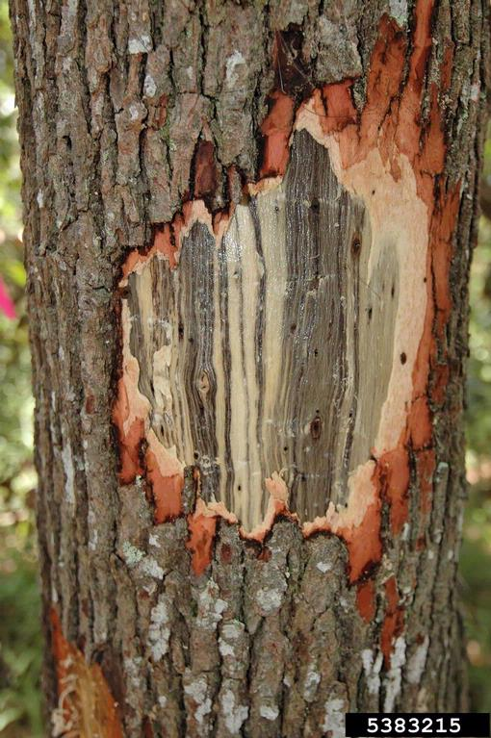

Red bay trunk with bark removed exposing sapwood with typical black staining caused by laurel wilt disease

#### Image Credit: [Ronald F. Billings, Texas A&M Forest Service , Bugwood.org](https://www.ipmimages.org/browse/detail.cfm?imgnum=5383215#collapseseven)

**Matthew R. March, MNRD**

County Extension Agent- Agriculture & Natural Resources

Polk County | Texas A&M AgriLife Extension Service

602 E Church St Ste 127 Livingston, TX 77351

Phone: (936) 327-6828

­

**Pond Stocking Strategies October 17-23**

Stocking strategies for a pond is a discussion item that deserves at least a 20-page article due to the complex factors that guide stocking strategies. However, there are some general rule of thumbs that I will review today.

The first thing you need to determine is the ponds surface acre. Small ponds, 1 surface acre or less will have different recommendations then ponds that are 1 surface acre or bigger. One of the main differences is largemouth bass, which are not recommended to be stocked in ponds that are 1 surface acre or less. To effectively manage a largemouth bass population, you need to balance the predator (bass) and prey (minnows) in the pond which is extremely difficult to achieve in a small pond.

The following game species combinations are options in ponds less than 1 surface acre: catfish (channel or blue), bluegill or hybrid sunfish, catfish and bluegill or hybrid sunfish, hybrid striped bass and hybrid striped bass and bluegill or hybrid sunfish. Once you select a species you then need to pick a forage source, typically flathead minnow, to also stock and determine stocking rates.

* Catfish (50-650) & flathead minnow (5-15 lbs.)
* Bluegill or hybrid sunfish (200-850) & flathead minnow (5-15 lbs.)
* Catfish (50-400), bluegill or hybrid sunfish (200-450) & flathead minnow (5-15 lbs.)
* Hybrid striped bass (200-850) & flathead minnow (5-15 lbs.)
* Hybrid striped bass (50-250) & bluegill or hybrid sunfish (300-550)

One of the most important aspect in managing small ponds is harvesting fish to ensure pond do not become overpopulated. You should aim to harvest 50% of numbers stocked before any restocking occurs.

A popular option for ponds of 1 surface acre & greater is largemouth bass stocked with bluegill or redear sunfish as a forage source. If you wish you can also stock blue or channel catfish in a largemouth bass pond. Stocking of hybrid striped bass is also an option. You need to avoid stocking hybrid sunfish in larger ponds due to reproduction issues. Before stocking you may want to fertilize your pond to increase available food sources. Stocking rates will vary depending if the pond is fertilized or not.

Fertilized:

* 100 largemouth bass (2-4”)
* 1000 sunfish (1-3”)
* 5-15 lbs. flathead minnows
* 100 catfish

Unfertilized:

* 50 largemouth bass (2-4”)
* 500 sunfish (1-3”)
* 5-15 lbs. flathead minnows
* 50 catfish

The above are general rule of thumbs, but there are some unwanted species that should never be stocked in any pond due to management issues. This includes gizzard shad, golden shiners, white crappie, flathead catfish, common carp, gar, buffalo, bullhead catfish, and green sunfish.

**Matthew R. March, MNRD**

County Extension Agent- Agriculture & Natural Resources

Polk County | Texas A&M AgriLife Extension Service

602 E Church St Ste 127 Livingston, TX 77351

Phone: (936) 327-6828

**Pumpkins, October 24-30**

Nothing more represents fall and the changing of seasons then pumpkins. Pumpkins have become part of our culture rather it is carving jack-o-lanterns or taking the kids to the pumpkin patch for a family photo. Most pumpkins now are used for jack-o-lanterns, other fall decorations, or pumpkin pies. However, historically pumpkins were used as a food source and not a decorative item. Native Americans ate pumpkins roasted, boiled and stewed, and they roasted the seeds for food as well.

You can grow your own pumpkins for next fall, but it requires advance planning and dedication. To have pumpkins ready for the first of October, you’ll have to commit to planting them in June and keeping them growing throughout the summer months, which will require regular watering especially if it is a dry summer. Pumpkin varieties mature at 70 to 120 days, depending on growing conditions. But if you are late to start, July would certainly be your last month of the year to plant pumpkins for a reasonable fall harvest. Some smaller varieties of pumpkins can be planted as late as July to ripen in time for Halloween. Connecticut Field is a good large variety pumpkin for Polk County and ripens at 120 days. If you prefer to grow medium pumpkins recommended varieties would be Howden or Jack O’ Lantern, which ripens in 105 and 110 days respectively. Small varieties for Polk County would be Baby Boo, Jack Be Little, and Small Sugar all which ripen in 90-95 days. Triple Treat is another recommended small variety, but it requires 110 days to ripen.

When selecting a site for your pumpkin patch it should receive at least 8 hours of direct sunlight for maximum production. If shading will occur, make sure it is afternoon shade. Pumpkin patches need to be on flat ground or in raised beds in rows 6 feet wide with plant 3 to 5 feet apart in the row. Rot is a common issue with pumpkins and using a barrier under ripening fruits to lift them off the soil will prevent rot. An old wooden shingle or a pile of pine straw would be ideal as they will not trap water. At harvest, cut the fruits from the vine, do not tear them. Leave a generous stem, also called a handle. Be careful not to injure the rind or break off the stem, as decay fungi will attack through wounds. Do not harvest pumpkins when the garden is wet and do not let harvested fruit get wet. Pumpkins can be stored for a very long time if handled correctly. To get the longest storage time possible, wash with soapy water to remove surface dirt. Then dip fruit in a dilute chlorine solution of 4 teaspoons bleach per gallon of water, or wipe with a clean cloth dipped in chlorine solution. Allow fruit to dry, but do not rinse until use.

Growing a pumpkin in Polk County is possible and can result in quite a fun experience for your family. This time next year you can be carving a jack o’ lantern from a pumpkin you grew.

**Matthew R. March, MNRD**

County Extension Agent- Agriculture & Natural Resources

Polk County | Texas A&M AgriLife Extension Service

602 E Church St Ste 127 Livingston, TX 77351

Phone: (936) 327-6828

**The Egg, More Than Just A Breakfast Staple, October 31- November 6**

Rather it is served scrambled, over easy, sunny side up, poached, or hard boiled, eggs or a staple of the breakfast table. But have you ever given much thought about what makes up an egg and why? The egg is more than just a nutritious food surrounded by a shell; it is an amazing sample of biology and life.

As we study the parts of the egg we will start from the center, the yolk, and work outwards. Working outwards from the yolk is the same process as which the egg is formed within a hen. The yolk is deposited into the hen’s reproductive tract first, followed by additional layers being added until the shell completes the process. The yolk is made up of proteins, fats, vitamins, and minerals and provides the food source for a developing embryo or chick. The yolk consists of concentric light and dark bands that is enclosed in what is called a vitelline membrane. This membrane helps keep the yolk together, but as the egg get older the membrane breaks down in the yolk becomes less plump and begins to flatten. The yolk provides all the nutrition a growing embryo would need, as the embryo grows the yolk gets smaller until it is consumed in its entirety by the embryo. If you ever look closely at a yolk you may see a very small white disc, this is where fertilization would take place. If a rooster is present with a hen you will see a red spot within the disc, commonly know as a blood spot.

As you can guess, the next major part is the egg white or albumen as it is technically called. The albumen is made up of four layers: chalaziferous (attaches albumin to yolk), inner thick layer, outer thick layer, and outer thin layer. The egg white consists primarily of water and proteins. Its function is to provide support to the yolk or embryo and provide proteins. If you ever looked closely at a cracked egg you will notice that the yolk is connected to two twisted cordlike structures. This is called the chalazae and is kind of like a spring system for the yolk while keeping it in place.

The last major part of the egg is the shell and its associated membranes. The shell is really an amazing structure. The shell is semipermeable, allowing air and water to be exchanged through pores, which is essential for the developing embryo. There is inner shell membrane and outer shell membrane that adhere together on the inside of the shell, except at the large end where an air pocket is created. If you place an egg up to a light source in a dark room, you can see the air pocket inside the shell. The shell itself is made up of several layers you can only see under a microscope, that is capped off with a cuticle layer. The cuticle layer helps to close the shell pores when the egg is laid to help protect the inside of the egg from bacteria. However, as the egg gets older the cuticle breaks down allowing air and water to move through the pores which corresponds to the needs of the developing embryo.

The egg really is one of natures wonders. Next time you crack open an egg see if you can ID some of the parts.

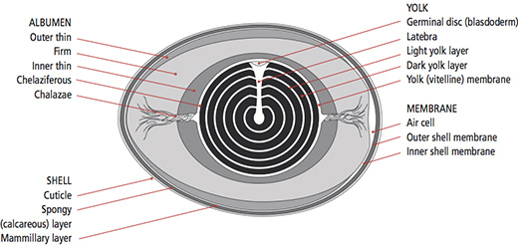

Image Credit: https://weblab.deusto.es/olarex/cd/UD/Incubator_EN_final/parts_of_the__egg.html

**Matthew R. March, MNRD**

County Extension Agent- Agriculture & Natural Resources

Polk County | Texas A&M AgriLife Extension Service

602 E Church St Ste 127 Livingston, TX 77351

Phone: (936) 327-6828

**Texas A&M AgriLife Extension provides equal opportunities in its programs and employment to all persons, regardless of race, color, sex, religion, national origin, disability, age, genetic information, veteran status, sexual orientation, or gender identity. The Texas A&M University System, U. S. Department of Agriculture, and the County Commissioners Courts of Texas Cooperating. Anyone needing special assistance at an Extension Program should contact the Texas AgriLife Extension Office at (936) 327-6828 at least one week prior to the program or event.**