**Asian Giant Hornet, August 1-7**

Asian giant hornet or the “murder hornet” as it has been nicknamed is a nonnative wasp species that was first discovered in Washington state in December 2019. Active trapping and monitoring has been occurring in Washington state and to date the Asian giant hornet has not been recorded outside of Pacific northwest. Because of the media attention, reports of Asian giant hornet have skyrocketed across Texas. However, there has been no confirmed reports in Texas and in fact state entomologists believe Asian giant hornet may never even reach Texas state lines. You may ask why is extension receiving so many reports of Asian giant hornet? The answer is there are several groups of native insect species that can be easily mistaken for Asian giant hornet.

Asian giant hornet is 1.5 to 2.0 inches in length making it the world’s largest hornet. They also have a distinctive yellow/orange head with black eyes. There is a striking contrast between the color of the head and color of the thorax. And lastly, the abdomen has alternating yellow/orange and brown bands. This social wasp will live in a colony with one queen and many workers. Adult queens live about a year and workers live on average 15 days. Asian giant hornet will not sting unless provoked. Colonies are underground usually in pre-existing cavities such as rodent burrows, tree trunks, or roots.

Cicada killer wasp is a group of native wasp species that is most mistaken as Asian giant hornet. This is a result of the large size and yellow banding of cicada killer wasp that is similar in appearance to Asian giant hornet. Female cicada killer wasp range between 1.2 to 1.6 inches in length. Cicada killer wasp have a smaller head in comparison to the width of their thorax than compared to Asian giant hornet. Additionally, the contrast of color between the head and thorax is more apparent in Asian giant hornet then cicada killer wasp. Banding on the abdomen is larger in cicada killer wasp. Cicada killer wasp routinely encounter humans as they commonly nest in loose soil around lawns, gardens, and flower beds. Males are territorial but cannot sting, however the female can and will sting when provoked.

Elm sawfly and pigeon termex horntail may be confused with Asian giant hornet. These two species do not have a pinched waist between the thorax and abdomen that is easily visible in the Asian giant hornet. Tarantula hawk wasp are large in size, (1.5 inches) but can be distinguished by a metallic blue body with orange wings.

If you see a wasp that you believe is an Asian giant hornet take a good quality picture or bring a specimen to the extension office. But just keep in mind at this time it is highly unlikely Asian giant hornet has made it to Texas.

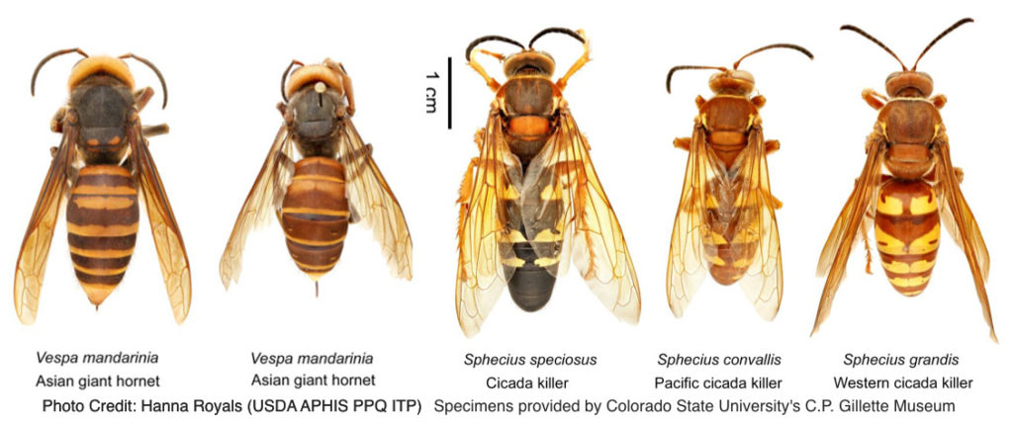

**Matthew R. March, MNRD**

County Extension Agent- Agriculture & Natural Resources

Polk County | Texas A&M AgriLife Extension Service

602 E Church St Ste 127 Livingston, TX 77351

Phone: (936) 327-6828

**______________________________________________________________________________**

**Carrots, August 8-14**

Carrots may not be the most popular vegetable in home gardens in Polk County, but they can make an excellent addition especially in fall gardens. As many of you likely know carrots are an excellent source of vitamin A and can be enjoyed both raw or cooked. A good rule of thumb is one-foot row of carrots will yield approximately 1 pound of carrots.

Carrots are suitable to many of our soil types in Polk County as they prefer loose sandy type soils that are well drained. Carrots will struggle in wet soils that are tightly compacted which will result in carrots that are stunted and misshaped. Also, debris in the soil such as rocks and large plant material can cause misshaped carrots so all debris should be removed prior to planting. Carrots should be planted in raised rows 1 to 2 feet apart. Multiply rows of carrots can be in one raised row depending on the size of the row.

You should select varieties that grow best in Polk County such as big top, purple dragon, royal chantenay, scarlet nantes, sweet treat, and touchon. These varieties will mature in 62-78 days. For a fall garden I would recommend planting occur by September 1st to ensure carrots mature before the first frost. Planting in the spring should occur as soon as possible after the last frost. This is because carrots thrive in cooler temperatures and high temperatures will result in yield decreases in addition to quality issues. Ideal temperature is 75 oF during the day and 55 oF at night. Plant spacing should be two inches or approximately ½ oz. of seed per 100 feet of row. Special care should be taken to ensure the seeds are not planted to deep. Planting depth of a ¼ to ½ inch is ideal. Carrots are slow to germinate and it may take up to 21 days for germination.

Management should include fertilizing per soil test results. Water the carrots when required to keep the soil moist to 3 inches. Weeds, crusting of soil, rocks, and soil compaction will cause stunted and/or misshapen carrots. Thus, a key in carrot management is to weed and hoe the soil lightly on a regular basis. Special care should be taken to not damage the root. Wireworms and cutworms are two common pest of carrots and can be controlled with available garden insecticides for homeowners. Fungus diseases and nematodes can also cause disease problems in carrots.

After about 70 or so days it will be time to harvest your hard work and enjoy a great source of vitamin A. Carrots should be harvested when the root at the soil line is 1 to 1 ½ inches in diameter. If handled properly carrots can keep up to serval weeks in the refrigerator.

**Matthew R. March, MNRD**

County Extension Agent- Agriculture & Natural Resources

Polk County | Texas A&M AgriLife Extension Service

602 E Church St Ste 127 Livingston, TX 77351

Phone: (936) 327-6828

­

**Quail of Texas, August 15-21**

Bobwhite quail are one of those iconic species that is valued by landowners, wildlife managers, conservationists, and hunters across the state. However, did you know Texas is home to three other species of quail? Bobwhite quail may steal most of the attention, but scaled quail, Gambel’s quail, and Montezuma quail all contribute to the quail and wildlife diversity in this great state.

When many people think of bobwhite quail, they picture a bird of grasslands. While that is not incorrect, bobwhite quail can be found in a variety of habitats across the state including pine savannah, rolling plains, cedar breaks, south Texas brush county, and coastal tall grass prairie. In fact, the only region of the state bobwhite quail does not make its home is the deserts of the Trans Pecos region of far western Texas. In addition to being the widest ranging of quail species in Texas, bobwhite is the most abundant in number.

The second most abundant and wide-ranging quail species in Texas is the scaled or cottontop as it is nicknamed. Scaled quail is found in roughly the western third of the state and is right at home in arid locations. Scaled quail are taller and lanker than bobwhite quail making them adapted to running from predators or hunters in the sparsely vegetative areas of west Texas. Scaled quail are just as likely to run then flush. Scaled quail can form coveys upwards of 50-75 individuals while bobwhite quail coveys may be 20-30 individuals at the most.

Our third most common species is the Gambel’s quail which founds its niche in riparian areas and arroyos (dried creek beds) along the Rio Grande River and its associated watersheds in the deserts of eight far western Texas counties. Gambel’s quail is the only quail species in Texas that is known to roost off the ground in the thick brush found along arroyos.

The above three species can be hunted in Texas, but our fourth and least common quail species, Montezuma quail, is protected. However, hunting is allowed in other southwestern states where populations are more robust. Montezuma quail are high desert birds that can be found in high elevation pinyon and alpine pine forests found in the mountain ranges of west Texas. They are most common in the Chisos, Davis, and Guadalupe mountains. There is also a disjunct population found in the limestone hills of southwest Texas around the Rocksprings area. Historically, Montezuma quail were more common and likely widespread in the hills of central Texas and the mountain ranges of west Texas.

Texas is home to an incredible amount of animal and plant diversity. This remains true for our four quail species which can be found from prairies in the east to alpine pine forest in the west.



**Matthew R. March, MNRD**

County Extension Agent- Agriculture & Natural Resources

Polk County | Texas A&M AgriLife Extension Service

602 E Church St Ste 127 Livingston, TX 77351

Phone: (936) 327-6828

**Winter Pasture Species Selection, August 22-28**

Winter pastures can be an essential tool in winter management for livestock. Warm season grasses are the backbone of forages found here in east Texas; however, they will go dormant after the first frost. Many producers choose to establish winter pastures with cool season annuals to allow cattle to graze green forage during the winter. Ryegrass and clover are the most popular forage for winter pastures in Polk County. However, cereal grains such as wheat, oats, barley, and rye are also an option. Understanding the biology of each of these forages will allow you to match a species to fit your livestock operation.

Cold hardiness is an important factor in certain areas of the state; however, Polk County winters typically do not get cold enough to make cold hardiness be a deciding factor on species selection. Cereal rye and wheat are the most cold tolerant of the cool season annuals. The most important factor to consider is maturity. Cereal rye and wheat mature early followed by oats. Ryegrass and legumes are late maturing. This is important to understand because maturity will determine when majority of yield or production will occur. For example, cereal rye and wheat will provide production during the fall and winter and drop off come early spring. Ryegrass and clover production will be the complete opposite. As late maturing cool season annuals, germination will still occur in the fall, but production will be minimal until early spring when temperatures begin to warm. In fact, ryegrass is considered more of a spring pasture grass then a winter pasture grass. Producers typically like to plant crops that will produce the most yield. Ryegrass will out yield any other forage listed here today, but again you must remember upwards of 90% of that production will occur during the spring. As a livestock producer you need to match a cool season annual that is high yielding during the months you want to graze it.

I like to suggest the following tips to producers to consider when selecting a cool season annual. Ryegrass is an excellent option for spring grazing and when managed properly can provide grazing well into April and even May. You can not count on ryegrass for grazing during the coldest months of winter. If you are wanting increased fall and winter production plant small grains, especially cereal rye or wheat. Clover equals spring grazing and since clover fixes nitrogen it will not require a nitrogen fertilizer application. Lastly, a mixture of a small grain, ryegrass, and clover will allow you to graze winter pastures from November through the spring.

If you are considering planting a winter pasture for your livestock, I would suggest calling the office to further review your options.

**Matthew R. March, MNRD**

County Extension Agent- Agriculture & Natural Resources

Polk County | Texas A&M AgriLife Extension Service

602 E Church St Ste 127 Livingston, TX 77351

Phone: (936) 327-6828

**Texas A&M AgriLife Extension provides equal opportunities in its programs and employment to all persons, regardless of race, color, sex, religion, national origin, disability, age, genetic information, veteran status, sexual orientation, or gender identity. The Texas A&M University System, U. S. Department of Agriculture, and the County Commissioners Courts of Texas Cooperating. Anyone needing special assistance at an Extension Program should contact the Texas AgriLife Extension Office at (936) 327-6828 at least one week prior to the program or event.**