**Top 3 Tree Issues, July 4-10**

It seems like every summer I get inundated with calls about dead or dying trees. And for whatever reason oaks and pine trees tend to be the subject of the call. In response, I thought I would review the top 3 inquiries /issues I encounter with dying trees, specifically oaks and pines.

#1 Root damage form construction or placement of impenetrable surfaces tend to be the underlying issue and nearly half of the calls I receive. Trees have root balls that extend out to at least as far as the diameter of the crown of the tree. Additionally, majority of water and nutrient uptake occurs by small roots near the edge of the root ball. Construction activity such as digging pipes, building fence, or foundation work can cut and severely damage roots. The other common issue is impenetrable surfaces such as driveways, sidewalks, decks, and pools that block water from reaching the small roots near the edge of the root ball. Effecting the roots in any degree will weaken the ability of the tree to withstand other stresses such as drought and insects.

#2 Polk County is blessed with plentiful rainfall most of the time. But we go through dry spells and even droughts. Many homeowners fail to realize the drought stress that can occur even during a 3-4-week dry spell. You mix a month-long dry spell during July heat in our soils can have significant soil moisture loss. Majority of time, trees can withstand short term dry spells, but if the tree is having additional stresses such as increased insect activity compounded with dry weather can quickly cause the tree to die. Many homeowners believe they are watering the tree effectively because they water the lawn. This could be furthest from the truth, as watering the lawn does not provide the deep watering needed for a large tree that can be provided by running a hose slowly all night.

#3 Homeowners quickly recognize wood boring insect damage on trees due to holes and sawdust around the trunk. This results in a call to the office to determine what insecticide to apply. Unfortunately, in most cases treating the wood boring insects will not save the tree. This is because wood boring insects move into the tree after the tree became sick and the wood rotted due to another underlying cause. Typically, the underlying cause has happened months if not years before. Homeowners need to observe trees for subtle changes to fix underlying issues before infestations of wood boring insects. With that being said, wood boring insects can cause trees to die in certain cases. When this occurs, a systemic insecticide can be used to help control infestations.

Polk County is blessed with large beautiful trees. As a homeowner, you should routinely observe your trees for subtle changes to ensure you catch issues before it becomes to late. By the time the leaves turn brown it is typically to late to reverse the eventual outcome.

**Matthew R. March, MNRD**

County Extension Agent- Agriculture & Natural Resources

Polk County | Texas A&M AgriLife Extension Service

602 E Church St Ste 127 Livingston, TX 77351

Phone: (936) 327-6828

**______________________________________________________________________________**

**Texas Deer Management Calendar, July 11-17**

We all know white tail deer hunting is a favorite past time of many Texas hunters. Hunters and landowners tend to focus on deer season when it comes to management, however year around management is required to successfully manage your deer herd.

Planning for the following deer season begins in January and February at the conclusion of the current season. Harvest data and hunter records should be reviewed for accurate recordkeeping. Data and records should be analyzed and compared with defined goals for the season. A post season deer survey can be conducted at this time along with conducting prescribed burns. High energy supplemental feed can also be provided during the period of winter stress, especially if winter food plots are unavailable. February is also the ideal time to top dress winter food plots with nitrogen. Browse surveys should be conducted in February and March to determine if the deer population is overutilizing available browse and to estimate population trends. Discing strips across your property during March will encourage growth of early successional plants (forbs) which are important browse for deer.

As spring progresses, management will shift to focusing on reducing stresses of summer which can be accomplished through warm season food plots. Soil test should be conducted in April along with ordering necessary fertilizer and seed. Warm season food plots should be established in May and June. July marks the beginning of observing deer numbers to determine harvest goals for the upcoming season. This includes recording incidental observations of deer during July and August and should include a formal spotlight deer survey in August. This data should be shared with your private and/or TPWD biologist to set harvest recommendations and to ensure managed land deer permits. July and August are the ideal time to repair and construct blinds, feeders, and roads. Supplemental feeding may be initiated in August if range conditions justify, however supplemental feeding should be started no later then September.

As hunting season nears, supplemental feeding should continue along with establishment of cool season food plots. One to three percent of land base should be established in cool season food plots. A soil test and ordering of fertilizer and seed should occur in August with establishment occurring in September. Harvest recommendations should be finalized and provided to hunters by September for bow season or for managed land deer permits and no later then the end of October for gun season. Recordkeeping and harvest data should be kept throughout the hunting season. Hunters should be monitored for accurate recordkeeping.

Deer season may only last a few months out of the year, but management should occur year around. More information can be found at <https://agrilifeextension.tamu.edu/library/wildlife-nature-environment/texas-deer-management-calendar/> and <https://wildlife.tamu.edu/>

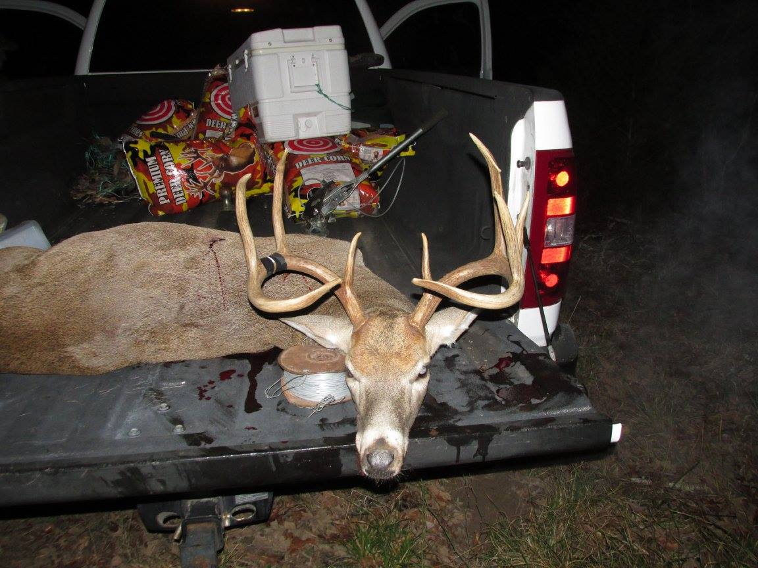

**Matthew R. March, MNRD**

County Extension Agent- Agriculture & Natural Resources

Polk County | Texas A&M AgriLife Extension Service

602 E Church St Ste 127 Livingston, TX 77351

Phone: (936) 327-6828

­

**Managing Beaver Damage, July 18-24**

Dare I say it, but I find beavers to be a very interesting and neat animal to observe in the wild. Now before you run me out of the county, I do realize that beavers cause damage to property that is both aesthetic andmonetary. As a landowner it is your responsibility to manage for beaver damage when necessary, while also understanding the important role beavers play in aquatic ecosystems throughout Polk County.

Beavers belong to the rodent family and hold the title of the largest rodent in North America. Beavers range throughout North America from far northern reaches of Canada all the way down to Mexico. Beavers make their place at home in a variety of aquatic habits including rivers, creeks, ponds, lakes, and marshes. Beavers can be found nearly statewide, but the largest populations are found in eastern Texas with its plethora of rivers, lakes, and wetlands. Beavers are known for the dams and “lodges” they construct from sticks. However, beavers do not need a traditional lodge for shelter and are known to dig burrows in steep banks. Beavers cut trees both to construct their dams and lodges, but also to consume the nutritious cambium layer of trees. Beaver dams are important for environmental reasons because they stabilize creek flow, slow runoff, and create ponds for aquatic animals such as waterfowl. However, as you can imagine or know from experience beavers can weaken levees from bank burrowing, flood valuable land as a result of dam construction, and cut down lumber rather that be valuable trees or lumber in the form of boat docks and fishing piers.

Control of beaver populations should begin at the first signs of damage. If a beaver colony is causing damage, once the colony becomes established it will be extremely difficult to control leading to increased cost. Trapping is the most common method of controlling beaver numbers, however in certain instances, such as around a valuable tree, an exclusion fence can be constructed to keep beavers out. The fence should extend from ground level to a height of 4 feet and be constructed of sheet metal or hardware cloth. Traps can be divided between live traps, leghold traps, conibear traps, and snares. Live traps are not a popular method except in urban areas where domestic animals may become accidentally trapped. Live traps can be baited with scent or fresh cut twigs. Leghold traps should be placed in a drowning set which allows a trapped beaver to swim to deeper water and locks to prevent the beaver from resurfacing. Conibear traps are the most common trap used to control beavers. Conibear traps are extremely versatile and thus can be used in a variety of situations. Conibear traps can be dangerous and novice trappers should use caution. Snares are another popular method and to effectively snare beavers the wire cable should be 40 inches long and 3/32 inches thick. The snare loop should be 8 to 10 inches in diameter.

For more adventurous control, beavers can be shot at night using a spotlight and shotgun with #4 buckshot or larger. A popular method is to break a beaver dam in the morning and spotlight the beavers at night when they come to repair the dam. There are no chemical or toxicants available for beaver control. Always remember to follow TPWD regulations for furbearers which beavers are classified as.

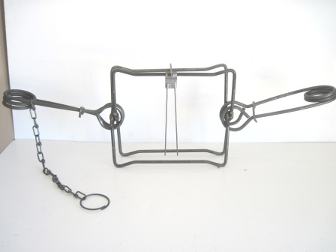

Conibear Trap

Credit: Dunns Fish Farms

**Matthew R. March, MNRD**

County Extension Agent- Agriculture & Natural Resources

Polk County | Texas A&M AgriLife Extension Service

602 E Church St Ste 127 Livingston, TX 77351

Phone: (936) 327-6828

**Mowing Recommendations for Turfgrasses, July 25-31**

Many homeowners fail to give any though on the impacts mowing has on their lawns. However, mowing creates stresses on turf and when combined with additional stresses such as drought and diseases can have significant impacts on the health of your lawn. Such impacts include but not limited to reduced root growth, discoloration, stand decline, increased weeds, brown patches, and dead spots.

Proper mowing begins with selecting cutting height. Different turf grass species will have different recommended heights. Cutting heights should be as followed: common Bermuda 5 to 3 inches, hybrid Bermuda 1 to 2.5 inches, centipede grass 1.5 to 2 inches, St. Augustine 2.5 to 4 inches, zoysiagrass 1 to 2 inches. Ideally, turf should be cut near the higher end of the recommended range as taller grass has a greater ability to outcompete weeds and have a deeper root system leading to a healthier lawn. Once height has been determined then frequency needs to be considered. No more than 1/3 of the total grass should be removed at one time no matter what the ideal height for that species is. For example, if your intended mowing height is 2 inches then you would need to mow before the plant exceeds 3 inches in height. If the grass is above 3 inches in height, then it would require multiply cuttings to achieve the ideal cutting height. With this rule in mind mowing frequency will not be a set interval, but instead a variable based on current environmental conditions such as time of year and rainfall. By following the 1/3 rule you will prevent scalping which can be detrimental to turfgrass health.

Grass clippings can return nitrogen to the soil, reducing the need to fertilizer. Clippings should be evenly dispersed across the area and should not be allowed to accumulate in rows. Clippings can also be collected and mulched. Mower maintenance is critical in lawn health. Dull blades cause damage to grass by crushing and leaving jagged uneven cuts instead of a clean smooth cut. Damage from dull blades increases grasses susceptibility to diseases and insects. Mowers should be extensively cleaned if being used in more then one lawn to ensure weeds, diseases, and insects are not transferred between lawns.

Lastly, there are several other recommendations you need to consider. If possible, avoid mowing when the grass is damp or wet from irrigation to prevent spreading fungal diseases. Mowing during peak summer heat can cause additional stresses. Mowing during winter when your warm season turf is dormant when winter weeds are actively growing can help to reduce weed pressure. I know it may be impossible in Polk County, but you should never mow when the soil is wet as it can causes soil compaction reducing vigor of your lawn.

Mowing may be viewed as a chore and a simple task to do. However, before you jump on the lawn mower this weekend remember some of the considerations reviewed today to ensure you lawn will remain green and healthy.



Mowing 1/3 rule. Credit: AgriLife Extension Mowing Recommendations for Warm Season Turfgrasses

**Matthew R. March, MNRD**

County Extension Agent- Agriculture & Natural Resources

Polk County | Texas A&M AgriLife Extension Service

602 E Church St Ste 127 Livingston, TX 77351

Phone: (936) 327-6828

**Texas A&M AgriLife Extension provides equal opportunities in its programs and employment to all persons, regardless of race, color, sex, religion, national origin, disability, age, genetic information, veteran status, sexual orientation, or gender identity. The Texas A&M University System, U. S. Department of Agriculture, and the County Commissioners Courts of Texas Cooperating. Anyone needing special assistance at an Extension Program should contact the Texas AgriLife Extension Office at (936) 327-6828 at least one week prior to the program or event.**