Kudzu Bug, May 2-8
Kudzu bug, Megacopta cribraria, a new non native insect has been found in Texas thanks to the keen eye of horticulture county extension agent Kim Benton in Cherokee County. Texas is now one of 14 states to have a verified population of kudzu bug. Kudzu bug was first reported in northeast Georgia in 2009 and has since expanded its range across the southeast.
Kudzu bug is native to Asia and which it is widely distributed along with its host plant kudzu. Even though it is unknown how this exotic bug arrived it quickly set up shop and made itself at home amongst invasive kudzu. However, it can also be found on other legumes. Within two years of the first reports in Georgia the bug had spread and infested every county in the state.
Kudzu bug is easily identifiable due to its four sided ovoid shape which is unlike any other insect you will find in east Texas. The bug is greenish brown and can be up to quarter inch long. The bug feeds exclusively on legumes where it will also reproduce. Kudzu bug prefers kudzu for feeding, but will also readily feed on soybeans. The life cycle of kudzu bug begins in April when bugs emerge and cluster on non food plants before moving to kudzu to feed and reproduce. The second generation of kudzu bug may feed on other legumes such as soybeans, sweet peas, cow peas, and lima beans. Interestingly, kudzu bug have been known to be a household pest, especially in the fall when the weather begins to cool in the bugs seeks warmer temperatures. The bug usually gathers on the outside of buildings, but has been known to make their way inside. These gatherings will be in the thousands and be easily visible to homeowners.
Where does that leave us? As the name implies many of you reading this article may think this bug is beneficial as it can consumes the invasive kudzu weed. Or, you may be worried this bug is going to cause extensive damage to my bean crop if the population explodes. Unfortunately, kudzu growth in Georgia seems to be undeterred by the presence of kudzu bug after an initial decrease in growth in 2009-2010. Surprisingly, kudzu bug problems in Georgia and other states appear to be declining due to a parasite wasp that attacks the eggs of kudzu bug and a fungus. Also, Texas is not home to large stands of Kudzu like Georgia and other southeastern states. With all that being said the potential for this new bug to become a significant pest may be minimal, but time will only tell. Please report any potential kudzu bug sightings to the extension office so we can gain a better understanding of the prevalence of this bug.
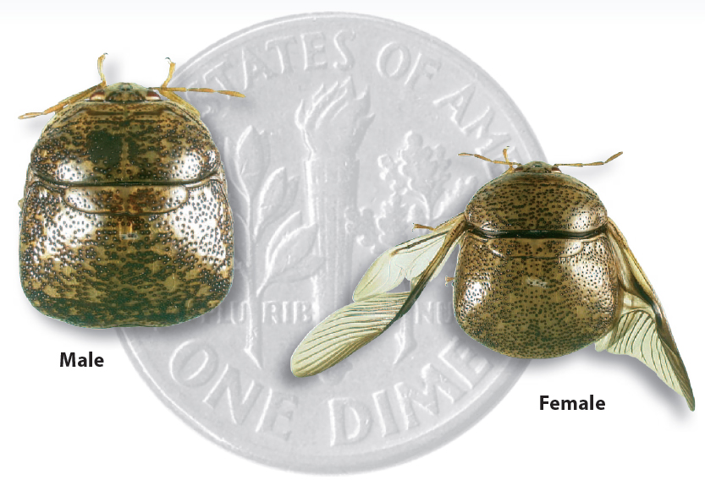
Photo by Dan Suiter

Matthew R. March, MNRD
County Extension Agent- Agriculture & Natural Resources
Polk County | Texas A&M AgriLife Extension Service
602 E Church St Ste 127 Livingston, TX 77351
Phone: (936) 327-6828
______________________________________________________________________________

Drives Should Be Vigilant of Slow Moving Vehicles, May 9-15

With the growing season in full swing tractors, hay equipment, and other large slow moving vehicles will become a common sight on both highways and rural roads throughout Polk County. Farmers and ranchers need to utilize roads to move between fields and have a legal right to utilize public roads. Now, you may think I am speaking to the choir as many of my readers grew up or involved in agriculture production. However, as Polk County continues to grow more and more of our residents have no experience with operating heavy equipment, thus making it extremely dangerous for both drivers on the road and equipment operators. This is especially true for weekend residents or retirees out of urban areas such as Houston. For this reason I would like to take some time today to review how to safely approach and pass slow moving vehicles.

I want to start this conservation by stressing to be patient. I understand getting stuck behind a tractor may cause some inconvenience especially if you are running late to a meeting. But, just remember farmers don’t like to travel down the road any more then you like getting stuck behind them and will allow you to pass the first chance they get. However, this may take a few minutes, so remember to be patient. So what should you do when you find yourself approaching a slow moving vehicle? First of all, you need to slow down! I cannot stress this enough especially if you are traveling down a highway. Also tractor operators may need to slow down to make a turn or shift gears so you may need to reduce speed to only a couple mph. You should take special care when passing as large equipment may not allow you to see clearly what vehicles may be approaching in oncoming lanes. Also, do not pass on hillsides or curves. You should not pass within 100 feet of an intersection, bridge, and designated no passing zones. Tractor operators may also pull over to the right hand side to make a left hand turn, not to allow you to pass. If a tractor pulls over to the right hand side of the road you should only pass after a hand signal is given or the tractor has come to a complete stop. You also need to take into account implements that may stick out wider than the tractor. When passing you need to take equipment width into account and you may need to utilize the left hand shoulder to pass wide implements.
The burden of responsibility not only falls on drivers, but also equipment operators. Operators need to ensure slow moving vehicle triangles are visible and in good condition. Also, flashers should be in working conditions and if traveling at night or in low light conditions all road lights should be in working condition. Keeping these items in working condition cost money and is an additional burden, but is the responsibility of operators to see that this happens.
As we move into the height of growing season, slow moving vehicles and tractors will become prevalent on our roads. So remember, to pack your patience and it is the responsibility of both drivers and operators to ensure everyone is safe on the road.
Matthew R. March, MNRD
County Extension Agent- Agriculture & Natural Resources
Polk County | Texas A&M AgriLife Extension Service
602 E Church St Ste 127 Livingston, TX 77351
Phone: (936) 327-6828

Clean, Drain, Dry Your Boat, May 16-22
Lake Livingston and its associated fisheries have become interwoven with the economy and outdoor recreation of Polk County. To ensure we can continue to reap the benefits of Lake Livingston we need to ensure protection from introduced non native species. To help combat introduction of non native plants and animals Texas Parks and Wildlife Department has embraced Clean, Drain, Dry You Boat.
Invasive species such as giant salvinia and zebra mussels can have profound impacts on fisheries and waterways. Giant salvinia can double in size in a week and can block boating and fishing access. On the other hand, zebra mussels can hinder water recreation, damage boats and affect water supplies. And on top of all that these non native invasive species compete with native aquatic vegetation, invertebrates, and fish. Unfortunately, Lake Livingston has already been infested with zebra mussels; however as recreational users we need to ensure we don’t introduce additional zebra mussels into Lake Livingston or transfer zebra mussels from Lake Livingston to a neighboring lake. This is why Clean, Dry, Drain You Boat has become so important. In fact, failure to drain all water from you boat and gear before approaching or leaving a public fresh water body is unlawful. Penalty for the first offense is a fine up to $500. Penalty for a repeat offense is a fine up to $2,000, and/or up to 180 days in jail.
To avoid breaking the law you need to follow the 3 steps below. Clean: Inspect your boat, trailer, and gear and remove all plant material, mud and foreign objects. Drain: Remove all water from the boat, including the motor, bilge, live wells and bait buckets. Dry: Open all compartments and allow the boat and trailer to dry for at least a week or more before entering another body of water. If the boat and trailer cannot be dried for at least a week, wash them with high pressure hot soapy water.
For further information and instructional video on how to properly Clean, Drain, Dry Your Boat can be found at https://tpwd.texas.gov/regulations/outdoor-annual/boating/clean-drain-dry-your-boat Status of lakes with zebra mussels can be found at https://tpwd.texas.gov/huntwild/wild/species/exotic/zebramusselmap.phtml If you are moving equipment or boats from infested to non infested lakes you need to take special caution. It is the responsibility of you as a recreational user of Lake Livingston and other public waterways in Texas to protect our natural resources.
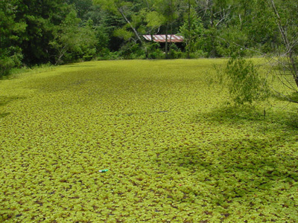
Giant Salvinia Texas Parks and Wildlife Department
Matthew R. March, MNRD
County Extension Agent- Agriculture & Natural Resources
Polk County | Texas A&M AgriLife Extension Service
602 E Church St Ste 127 Livingston, TX 77351
Phone: (936) 327-6828

Pond Management Resources, May 23-29
Phone calls and questions about pond management including stocking and aquatic plants are some of the most common inquiries received at the extension office. The extension office should always be your go to source if you have any questions about your pond, but there is also a plethora of informative information that can be found online and through other professional sources.
Texas A&M Agrilife Extension has put together a fabulous website called https://aquaplant.tamu.edu/ This website can be used as a source to research information on ID aquatic plants, managing an aquatic plant, or pond management. If you want to ID an aquatic plant the first step you will need to do is determine if it falls into four categories: algae, submerged, floating or emergent. Algae are microscopic plants that are thin and stringy or hair like in nature. Algae will not have a root system. Submerged plants are rooted plants in which all or the vast majority of vegetative material remains below the water surface. This would include such plants as coontail or hydrilla. Floating plants such as duckweed float on the surface water, but roots are not attached to the bottom. Lastly, emergent plants such as cattails and alligator weed are rooted firmly to the bottom and stand above the water surface. After you determine which category your aquatic plant falls into you can then search through pictures on the aqua plant website to help you ID your plant. Once you ID your plant you can then click on manage a plant tab that will provide you in depth details on how to manage your aquatic plant. This includes, but is not limited to physical management options, biological management options and herbicide control options. The pond management tab provides links and articles on a variety of topics. This includes common management practices such as liming, water testing, species profiles, stocking considerations, stocking rates, aeration, and sport fish management. It also includes some more unique articles on commercial aquaculture and aquaponics.
Another great website for aquaculture recourse is the Southern Regional Aquaculture Center https://srac.msstate.edu/ This website is maintained by Mississippi State, but it contains relevant information for east Texas. Following the publications tab to fact sheets will allow you access to weeks’ worth of reading material. For example the site contains 14 different fact sheets on catfish management from feeding to managing off flavor problems in pond raised catfish.
Lastly, private aquaculture business can be a great source of information. You just need to be cautious as these companies also want to sell you products. Boat Cycle and Memphis Net and Twine are popular companies used to purchase pond management equipment. Common pond stocking companies used in our region include but are not limited to Tyler Fish Farms, Overton Fisheries, Danbury Fish Farms, Henneke Fish Hatchery, and Duns Fish Farm.
Pond management from determining stocking rates and aquatic plant ID and control can be very difficult and sometimes a confusing process. The resources we reviewed today can be helpful, but as always you can call the extension office with any pond management questions you may have.
Matthew R. March, MNRD
County Extension Agent- Agriculture & Natural Resources
Polk County | Texas A&M AgriLife Extension Service
602 E Church St Ste 127 Livingston, TX 77351
Phone: (936) 327-6828

Lawn Maintenance Tips, May 30- June 5
Lawn maintenance is a year around commitment to achieve a lawn your neighbors would be envious of. Proper lawn maintenance skills and techniques can take years of practice to master. But, there are some simple tips all homeowners should follow to ensure a healthy lawn.
If first starting a lawn you need to select a turf grass appropriate for your site. This will take some research to determine the species and variety that best matches your soil type, shade tolerance, drought potential, traffic, cold sensitivity, and disease resistance needs. Your neighbor might have success growing a St. Augustine lawn, but growing conditions on your site might justify zoysia grass. Next, you will need to perform a soil test and build an adequate depth of at least 6 inches of healthy soil before planting seed or sod.
After you lawn becomes established there are simple maintenance tips you need to follow. Aerate once a year to improve drainage and reduce soil compaction. Irrigation is usually not a problem for most of the year in Polk County, but during dry periods you will need to irrigate. Irrigation should occur in the morning and wet soil to a depth of 4-6 inches. Soil should be allowed to dry out between watering to avoid fungal diseases. When mowing never take no more than one third of the grass blade off. Mower blades need to be kept sharp and only mow when the grass is dry. Mowing over leaves will allow leaves to decompose along with the grass clippings. Mulching blades will assist in properly shredding grass clippings. Over fertilizing can weaken you turf stand and can cause stand declines overtime. You should conduct a soil test at least yearly to ensure you are applying proper amounts of fertilizer.
Take all patch and brown patch may be the two most common diseases seen in Polk County. Prevention includes avoiding over fertilization and overwatering. Maintaining good drainage and raising mowing height to reduce stresses to your turf. Also, aerate at least once a year. Shade stress is another common issue. The best advice is to plant species suited for the amount of shade in your lawn. If you lawn is experiencing shade stress, raising the mowing height allows grass blades to remain taller thus capturing more sunlight.
Weeds are constant stress in turf. Herbicide options are available for most grass and broadleaf weeds. However, there are cultural practices that can reduce weed pressure while decreasing the use of herbicides. Turf grasses, when healthy have the ability to outcompete weeds. Weeds should never be allowed to flower and set seed as this will enhance the issue for years to come. Remove weeds routinely and reduce foot traffic and pet activity in shady areas.
Managing lawns sometimes seems like an overwhelming task and many homeowners become frustrated with poor results. By following the simple tips reviewed today you will be giving your lawn a fighting chance and ensure it is healthy for years to come.
Matthew R. March, MNRD
County Extension Agent- Agriculture & Natural Resources
Polk County | Texas A&M AgriLife Extension Service
602 E Church St Ste 127 Livingston, TX 77351
Phone: (936) 327-6828

Texas A&M AgriLife Extension provides equal opportunities in its programs and employment to all persons, regardless of race, color, sex, religion, national origin, disability, age, genetic information, veteran status, sexual orientation, or gender identity. The Texas A&M University System, U. S. Department of Agriculture, and the County Commissioners Courts of Texas Cooperating. Anyone needing special assistance at an Extension Program should contact the Texas AgriLife Extension Office at (936) 327-6828 at least one week prior to the program or event.

