**COVID-19 Relief For Polk County Ranchers and Farmers, June 6-12**

On May 19, 2020, USDA released details of the Coronavirus Food Assistance Program (CFAP). CFAP’s $19 billion package contains two primary components. First, USDA will partner with regional and local distributers to purchase $3 billion in fresh produce, dairy and meat and provide those commodities to those in need. The bulk of the program is designed to provide $16 billion in direct support to farmers and ranchers affected by the COVID-19 pandemic. Eligible commodities for the direct support include:

* Livestock: cattle, hogs, and sheep (lambs and yearlings only)
* Dairy
* Wool
* Non-specialty crops: malting barley, canola, corn, upland cotton, millet, oats, soybeans, sorghum, sunflowers, durum wheat, and hard red spring wheat.
* Specialty Crops -- Fruits: apples, avocados, blueberries, cantaloupe, grapefruit, kiwifruit, lemons, oranges, papaya, peaches, pears, raspberries, strawberries, tangerines, tomatoes, and watermelons
* Specialty Crops -- Vegetables: artichokes, asparagus, broccoli, cabbage, carrots, cauliflower, celery, sweet corn, cucumbers, eggplant, garlic, iceberg lettuce, romaine lettuce, dry onions, green onions, peppers, potatoes, rhubarb, spinach, squash, sweet potatoes and taro.
* Nuts: almonds, pecans, walnuts
* Other: beans, mushrooms

Signup will be from May 26 to August 28, 2020. Once signup begins, eligible producers should call their county Farm Service Agency (FSA) office to schedule an appointment.

To help affected producers navigate this new program, Agricultural and Food Policy Center (AFPC) at Texas A&M University co-directors Dr. Bart Fischer and Dr. Joe Outlaw, and Texas A&M AgriLife Extension Service economists Dr. David Andersons and Dr. Justin Benavidez authored a timely report. *Overview of the Coronavirus Food Assistance Program (CFAP)* is available at <https://www.afpc.tamu.edu/research/publications/files/699/RR-20-02.pdf>. The report provides an excellent overview of the program, provides clarification on payment rates and eligible commodities, payment limits, income tests, and payment reductions. It also provides payment calculations and examples by commodity.

The report’s lead author, Dr. Bart Fischer, notes that while CFAP provides a significant amount of aid, there are a number of losses not covered. A previous AFPC report, estimated Texas agricultural losses alone could exceed $8 billion. That report can be read at <https://afpc.tamu.edu/research/publications/files/698/RR-20-01.pdf>.

Dr. Fischer identified some areas of concern not addressed by CFAP:

* 2020 Row Crops: CFAP only provides assistance for crops held in inventory as of January 15, 2020. In other words, it provides no assistance for the 2020 crop year.
* Livestock: While livestock producers in general and cattle producers in particular are the biggest recipients of assistance from CFAP, the estimated support for cattle is still significantly less than half of the damages estimated by industry. While animals in inventory from April 16 to May 14, will be eligible for a CFAP payment, there likely will be calls to provide additional assistance to producers who had to depopulate animals in response to COVID-19. Also, those producing poultry on contract and paid by pounds produced may accrue significant additional losses.
* Others in the Supply Chain: CFAP provides no direct benefits to anyone in the supply chain after leaving the farm gate. For example, ethanol producers are under tremendous strain. Also, the merchandising supply chain for cotton has incurred significant carrying charges, logistical costs, and market disruptions not currently addressed by CFAP.

As Congress continues to debate the next steps, these and other issues will be in the forefront.

**Matthew R. March, MNRD**

County Extension Agent- Agriculture & Natural Resources

Polk County | Texas A&M AgriLife Extension Service

602 E Church St Ste 127 Livingston, TX 77351

Phone: (936) 327-6828

**______________________________________________________________________________**

**Composting, June 13-19**

Composting is a cost-efficient way to produce organic matter and nutrients for your garden, yard, or flower beds. Plus, it is environmentally friendly as it can divert 20 to 30 percent of your trash from ending up in a landfill! Composting is relatively easy process and in addition to providing nutrients for your plants, compost improves physical characteristics of soil, increases water holding capacity, and increases aeration.

To begin composting, first you will need to collect appropriate materials. This includes kitchen scraps, grass clippings, dry leaves, manure, and saw dust. You should not use animal by products from your kitchen such as grease, fat, meat trimmings, or dairy products. These kitchen scraps attract rodents and break down slowly. Grass clippings should be mixed with soil or dry plant material to prevent compaction as it settles. Another useful trick is to shred leaves as they will breakdown quicker. Never use cat and dog feces as they can carry disease organisms. Other materials commonly used in a compost pile include lawn sod, hay, non-noxious weeds, shredded newspaper, and small tree clippings.

Next you will need to build your compost pile. Compost bins can either be purchased or constructed out of wire fencing, cement blocks, bricks, or lumber. Those wishing not to use a bin can also create a free-standing compost pile. Compost piles should be placed in a secluded area, near the garden, in partial shade, and in a spot with good drainage. Compost piles should be layered with coarse materials on the bottom layers and compact materials on the top layers to allow oxygen to circulate. The first layers should be coarse plant material, followed by a second layer 6 to 10 inches thick of finer plant material such as leaves, grass clippings, and kitchen scraps. The third layers should consist of soil or manure and be 1 inch thick. Repeat second and third layers until the compost pile is 5 feet tall.

Management of your compost pile should focus on providing a favorable environment for microorganisms, thus encouraging decomposition. You should turn the pile often to increase amount of air in the pile and speed up the composting process. Compost piles should be turned weekly during the summer and monthly during the winter. Water may need to be added to ensure the compost pile is moist, however you should not be able to squeeze water out of the compost material.

After 90 to 120 days decomposition should be completed, and the finished product can be applied to your garden, lawn, or flower beds. To ensure you have a continues supply of compost, you may want to start several compost piles; one pile ready to use, one pile decomposing, and one pile being filled.



Layering of a compost pile: Texas A&M AgriLife Extension, Easy Gardening Composting

**Matthew R. March, MNRD**

County Extension Agent- Agriculture & Natural Resources

Polk County | Texas A&M AgriLife Extension Service

602 E Church St Ste 127 Livingston, TX 77351

Phone: (936) 327-6828

­

**Establishing Bahia Grass, June 20-26**

Bahia grass is our most common warm season improved variety of grass found in Polk County with Bermuda grass coming in a close second. Bahia grass has become naturalized and can be found in most pastures in the county. However, landowners occasionally wish to establish a new stand of bahia grass after a clear cutting or during a pasture renovation.

Several characteristics make bahia grass an ideal forage choice for your livestock operation. This includes its ability to tolerate a wide range of soils including upland sandy sites to poorly drained bottomlands and its ability to produce in soils with very low fertility. In other words, bahia grass is basically suitable for all soil types in Polk County. Bahia grass also greens up and remains green later into the fall then compared to Bermuda grass. Bahia grass is also known for its ability to tolerate continuous grazing and lack of weed issues due to extremely thick thatch that is formed suppressing weed growth.

Bahia grass is established from seed and can be established by either broadcasting or using a seed drill. Which every seeding method is utilized a well-prepared seed bed is required for establishment. Seed should either be covered or drilled with no more than ½ inch of soil and then rolled to ensure good seed to soil contact. Seeding rate is 12-15 lbs. per acre but can be increased if broadcasting or planting on poorly prepared soil. Ideal time for planting is during late spring after the last killing frost due to low weed pressure. However, optimal seed germination is when soil temperatures are between 85 to 95 degrees Fahrenheit. Bahia grass is known for having weak seedlings that result in poor germination and establishment if weed pressure is high. Every effort should be taken to ensure weeds are absent during planting. Once seedlings emerge, herbicide applications should not occur until the plant reaches 5 inches in height due to the possibility of herbicide damage. Prior to planting, a soil test should be conducted in appropriate application of fertilizer should occur. Once bahia grass begins to cover, an additional 60 lbs. of nitrogen per acre should be applied.

The most common question I hear from producers is what variety I should select. For the most part two varieties are planted in Polk County, Argentine and Pensacola. Argentine variety is known for long broad leaves, initiating growth later in the spring compared to other varieties, and lack of cold tolerance. However, Argentine has produced the same dry matter yield as coastal Bermuda in trials conducted in our region. Pensacola is the most common variety planted in our region and is known for long narrow leaves and cold tolerance. Main disadvantage of Pensacola is lower dry matter yield. Other varieties include Common, Paraguay, Paraguay 22, Tifton 9, and Wilmingont.

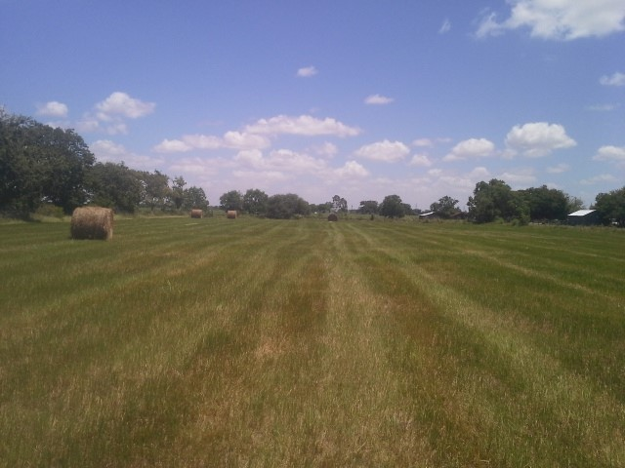

**Matthew R. March, MNRD**

County Extension Agent- Agriculture & Natural Resources

Polk County | Texas A&M AgriLife Extension Service

602 E Church St Ste 127 Livingston, TX 77351

Phone: (936) 327-6828

**Louisiana Pine Snake, June 27-July 3**

Did you know east Texas is home to one of the rarest snakes in North America? Louisiana Pine Snake, (*Pituophis ruthveni)* is an incredibly rare snake that is found in longleaf pine savannah habitat in deep east Texas and west central Louisiana. Louisiana pine snake is rarely seen for two reasons. First, it spends at least 60% of its time below ground and secondly, population numbers have dwindled as ideal habitat has vanished. In fact, Texas list the snake as threatened, while it has been proposed a candidate for federal protection on the endangered species act.

Louisiana pine snake is non-venomous and reaches lengths of 4-5 feet with the largest reported specimen being 5.8 feet long. Sexual maturity is reached at 4 feet in length which occurs when the snake is at least three years old. Unfortunately, the snake has one of the smallest clutch size (3-5 eggs) of any snakes in North America which has been a factor in population declines and recovery efforts. Even though clutch size is small, the eggs are very large, 5 inches long, and hatchlings range in length of 18-22 inches making them the largest hatchlings of any snake in North America. Along with spending the majority of time underground in burrows created by Braid’s pocket gopher, the snake’s movement is very short range and averages 10-20 feet a day. The species uses the tunnels to hunt for its favorite food, pocket gophers. The species has been known to predate on other prey such as rodents, cottontails, amphibians, and ground nesting birds. Average home range for males is 145 acres and 25 acres for females.

As you can expect Louisiana pine snake can be found in pocket gopher burrow systems, which are typically associated with sandy well drained soils found in herbaceous understory longleaf pine savannah. In these savannahs, snakes concentrate on low broad ridges with sandy soils. Snake abundance is directly correlated with abundant herbaceous ground cover and low-density tree canopy cover.

Historically, it is believed the Louisiana pine snake occurred across at least 9 Louisiana parishes and 14 Texas counties. Unfortunately, the snake is now only found in a handful of very small locations across Texas including Southern portions of Sabine National Forest and adjacent private land in Newton County and Southern portions of Angelina National Forest. Additionally, almost all records come from two separate areas measuring less than 4 miles in radius.

Threats to the species have included urban development, habitat conversion to agriculture, road construction, and mining that have caused loss and fragmentation of habitat. Pet trade may have also impacted populations. However, the number one reason for the species decline and impacts to recovery is loss of pine savannah. The majority of historic pine savannah has been replaced with commercial plantations which have poor understory plant communities, rendering them uninhabitable for pocket gophers and thus Louisiana pine snake. Additionally, the last remanding isolated tracts of pine savannah habitat is often degraded by fire suppression. Fires are necessary to maintain pine savannahs. Louisiana pine snake is adapted to fire just like the habitats they live in. Vehicle caused mortality has been documented and a known issue in sections of Angelina and Sabine National Forest.

However, there is still hope for the species. Many federal and state agencies are actively involved in improving habitat in the national forests. Additionally, many nonprofits conservation groups and government agencies encourage private landowners to conduct habitat restoration projects.

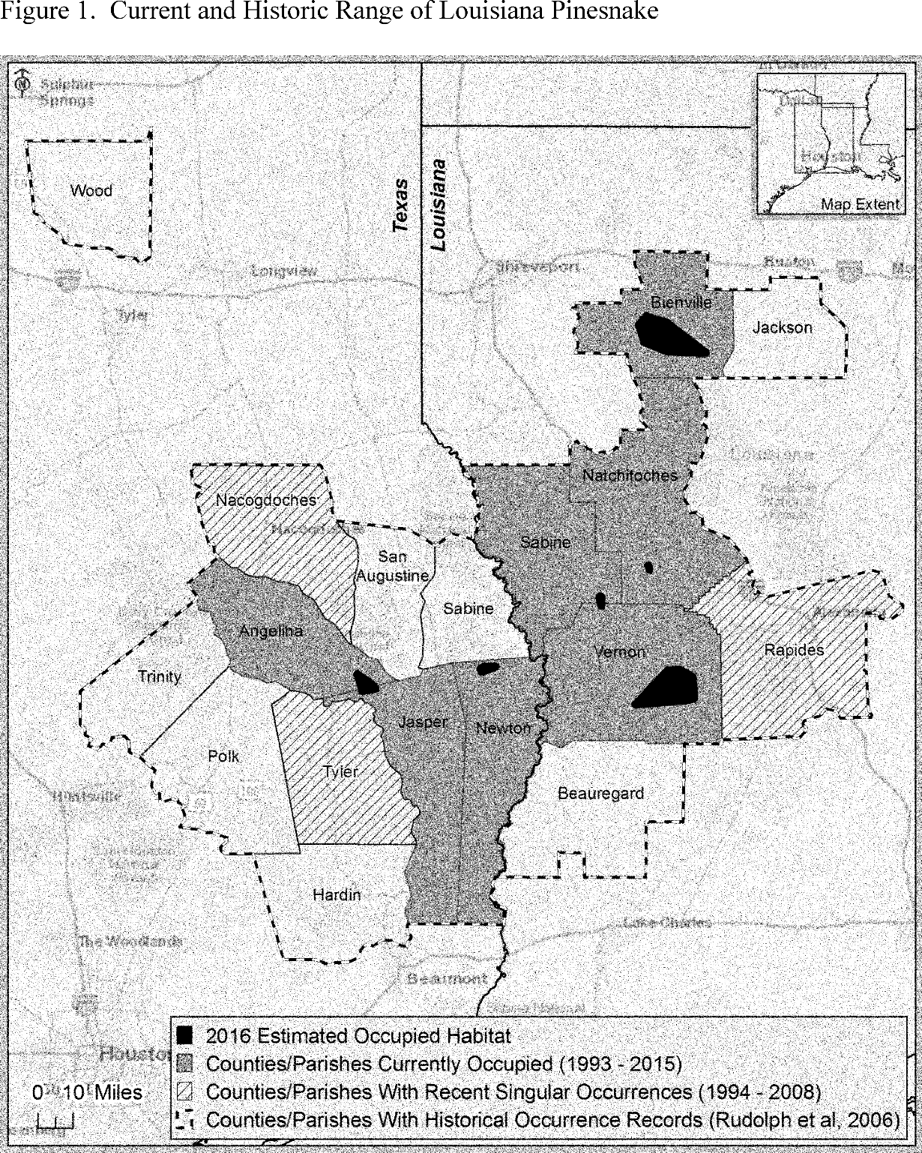

U.S. Fish and Wildlife Service

**Matthew R. March, MNRD**

County Extension Agent- Agriculture & Natural Resources

Polk County | Texas A&M AgriLife Extension Service

602 E Church St Ste 127 Livingston, TX 77351

Phone: (936) 327-6828

**Texas A&M AgriLife Extension provides equal opportunities in its programs and employment to all persons, regardless of race, color, sex, religion, national origin, disability, age, genetic information, veteran status, sexual orientation, or gender identity. The Texas A&M University System, U. S. Department of Agriculture, and the County Commissioners Courts of Texas Cooperating. Anyone needing special assistance at an Extension Program should contact the Texas AgriLife Extension Office at (936) 327-6828 at least one week prior to the program or event.**