**Pets, Livestock, Biting Insects, and COVID-19, April 4-10**

Between emails, social media, and news reports we are getting constantly bombarded with information about COVID-19. Unfortunately, you need to be vigilant about where you get you information especially on social media. There have been several “news articles” circulating on social media about COVID-19 relating to pets and biting insects. AgriLife had developed resources addressing these “news articles” and I would like to share this information with you today. AgriLife has and always needs to be your go to location to obtain relevant and researched based knowledge on issues such as COVID-19. AgriLife is not in the business to sell a product or spread rumors so you can be ensured information received from AgriLife is unbiased.

I first one to address pets. As of this point research suggest pets cannot spread COVID-19 to other animals or humans. Two dogs have been reported to have been infected in Hong Kong, however experts indicate dogs are not easily infected with the virus. Testing of pets is not recommended by the CDC or Texas Department of State Health Services. There is also no evidence currently to support the claim that the virus can be spread to people by touching skin or fur of pets. The porous nature of fur absorbs and traps pathogens making it very unlikely COVID-19 can be contracted by playing with or petting your pet. However, to err on the side of caution if you do become sick with COVID-19 it is probably a good idea to avoid contact with your pets if they will be contacting other people in your household.

There are coronavirus vaccines labeled for use in livestock and pets. However, these vaccines provide protection against different strains of coronavirus, not COVID-19. Also, these vaccines are not labeled for human use and will not protect a person against COVID-19. There are currently no livestock movement restrictions in the U.S., however if you are a producer it is recommended you obtain a travel authorization form from TDA. This form can be obtained by calling the extension office. Livestock auction barns and markets continue to remain open, but operations have been adjusted to follow CDC guidelines.

At this time there is no evidence to suggest COVID-19 is transmitted by biting insects such as mosquitoes and ticks. COVID-19 is transmitted through respiratory droplets either by direct contact or by touching a surface that has been contaminated. To be transmitted by mosquitoes and ticks the virus would need to survive, grow, and replicate inside biting insects which there has been no evidence to suggest this.

Remember the best protection against COVID-19 is to practice good hygiene and to follow social distancing procedures. And always follow guidelines and orders from local, state, and national officials.

**Matthew R. March, MNRD**

County Extension Agent- Agriculture & Natural Resources

Polk County | Texas A&M AgriLife Extension Service

602 E Church St Ste 127 Livingston, TX 77351

Phone: (936) 327-6828

**______________________________________________________________________________**

**Raising Easter Chicks, April 11-17**

I know many families enjoy purchasing Easter chicks for their children. If you are going to be purchasing Easter chicks or chicks in general this spring, I want to go over a few things. First, you need to understand chicks are a responsibility on your part to take care of as they get older. They will quickly outgrow the excitement of the adorable down feather stage.

Before you even go to purchase your chicks, you should set up their pen. 10 square feet is more then enough room for a handful of chicks. You should always provide clean drinking water and feed. Adding amino acids to the water can help boost the immune system of your chicks. Always feed chick starter as it will provide all the necessary nutritional requirements for your chicks to grow. Hen scratch does not provide the nutrition needed by chicks or mature chickens. You will also need to set up a heat lamp 3-5 feet above the pen, because during the first week chicks like temperatures at 95 degrees F. You will need to place a layer of shavings 3 inches deep. It is a good idea to turn on your heat lamp before purchasing your chicks as it will allow the shavings to warm up, this is especially important if the weather is cool.

When purchasing chicks look for signs of a healthy bird. Sick or weak birds will show signs of labored breathing, won’t be active, and will not eat or drink. Chicks that struggle to hatch or were left in the incubator to long will show signs of being sick or weak. They will also be susceptible to other diseases. Once you purchase your chicks you should get them home into their pen ASAP. You should also do your best to keep them warm and comfortable.

When placing chicks into the pen dip their beak into the water and feed. Next, you will need to observe their behavior. If the chicks are huddling together underneath the heat lamp, then the birds are cold, and you need to lower the heat lamp or add a second heat lamp. If the chicks are circling the edges of the pen and breathing heavy, then they are hot. The heat lamp will need to be raised to lower the temperature.

As the chicks grow you will need to adjust their environment. You can continue to increase the space of the pen to match their size. Temperature should be lowered by approximately 5 degrees F a week until they are 5 week old. During warmer weather you may not need to run heat lamps during the day after 2-3 weeks. Feed should be switched to a poult or finisher feed around 6 weeks of age until 16 weeks when feed should be switched to a layer feed. Chickens reach maturity and should start laying eggs around 18 weeks of age. Maturity will differ slightly between breeds.

Raising Easter chicks can be a fun and exciting experience for both children and adults. It gives children the opportunity to learn responsibility and to raise a living animal. And as a bonus in 18 weeks you will have fresh eggs!

**Matthew R. March, MNRD**

County Extension Agent- Agriculture & Natural Resources

Polk County | Texas A&M AgriLife Extension Service

602 E Church St Ste 127 Livingston, TX 77351

Phone: (936) 327-6828

­

**I Still Want a Spring Garden! 18-24**

By this point most spring gardens are in full swing and are nearing harvesting time for many of our spring vegetables. However, if you still want a spring garden to enjoy fresh home grown produce there are still some options available. Majority of vegetables cannot survive the hot Texas summers that will be arriving in the next month or so. For this reason, vegetables planted in late April need to be able to with stand hotter weather or have a short harvest date. If you are wanting a spring garden, you need to plant sooner than later and avoid any plantings after May 15th.

Ideal time to plant cucumbers and egg plants would be by April 15th. However, plantings are still feasible through late April. Cucumbers have an average harvest date of 30 days compared to egg plants which have an average harvest date of 90 days. For this reason, I recommend planting early producing varieties of egg plants in late April to ensure harvest occurs before the brutal heat of August. Southern peas can also still be planted due to their short harvest window of 30 days. Planting of peppers is still feasible; however, it can take up to 90 days to harvest peppers which means adequate watering will be critical to ensure a harvest. Radishes do not like warmer weather, however radishes can be harvested in as little at 2-3 weeks. If hot weather holds out till the end of May a successful harvest of radishes is possible.

Late April is an ideal time to plant three vegetables: okra, sweet potatoes, and pumpkins. Okra can be planted up till May 1st and will thrive during Texas summers if watering is adequate. Ideal planting date for sweet potatoes is April 1st -May 1st, while the ideal planting date for pumpkins is May 15th. Recommended okra varieties are Clemson Spineless, Emerald, Lee, and Cajun Delight. Recommended sweet potatoes varieties are Beauregard, Jewel, Cordner, Topaz, and Excel. Recommended pumpkin varieties are Big Max, Connecticut Field, Lady Godiva, Triple Threat, Big Tom, Funny Face, Jack-B-Little, Jack O Lantern, Munchkin, Mall Sugar, and Spirit Hybrid.

Watering will be a key issue for a late spring garden, so you need to have a plan in place to supply adequate amount of water. And as always you should perform a soil test to determine exact fertilizer requirements for your garden.

**Matthew R. March, MNRD**

County Extension Agent- Agriculture & Natural Resources

Polk County | Texas A&M AgriLife Extension Service

602 E Church St Ste 127 Livingston, TX 77351

Phone: (936) 327-6828

**Black Walnut, April 25-May 1**

Black walnut is considered by many to be one of our most prized native trees found in the forest of east Texas. Just like its cultivated cousin, black walnut produces an edible nut that is prized by both wildlife and humans.

Black walnut is the only native walnut found in east Texas. It can be found in rich bottomlands along streams and moist fertile hillsides. All though most common in our area of the State it can be found as far westward as the San Antonio River. Black walnut is easily recognizable by its impressive stature up to 100 feet and aesthetically appealing large open crown which makes it popular as a landscaping tree. Trunk can be 3 feet or more thick. Bark is dark brown with deep crevices. Black walnut is known for two by products: nuts and lumber. The fruit is a large rounded nut 1.5 to 2.5 inches in diameter enclosed in a solid green leathery husk that does not split even after ripening. Black walnut is famous for its chocolate brown heartwood that is highly prized for furniture, cabinet work, and gun stocks. One interesting characteristic of this tree is it is known to release a chemical compound through its roots inhibiting the growth of nearby plants reducing competition. Walnut hulls produce a brown dye that can stain your hands. Hulls are also known to produce a narcotic effect when crushed and were used by Native Americans and settlers to catch fish.

Black walnut can be confused with hickory trees, includes pecans, which belong to the same family of trees as walnuts. However, leaves can be used to easily identify between trees in this family. Walnuts leaves are made up of 15-23 leaflets while most hickory leaves are 12 leaflets or less. Pecans will have between 11 to 17 leaflets.

Texas is also home to two other walnut species. Texas walnut is a miniature version of black walnut and only reaches heights of 30 feet. Texas walnut can be found near sources of water in southwest and west Texas. Arizona walnut also can grow up to 30 feet tall but is restricted to western Texas.

Black walnut is a gorgeous tree and can be found in moist forest throughout east Texas. If you are looking for a large tee to add to your landscaping black walnut may just fit the bill.

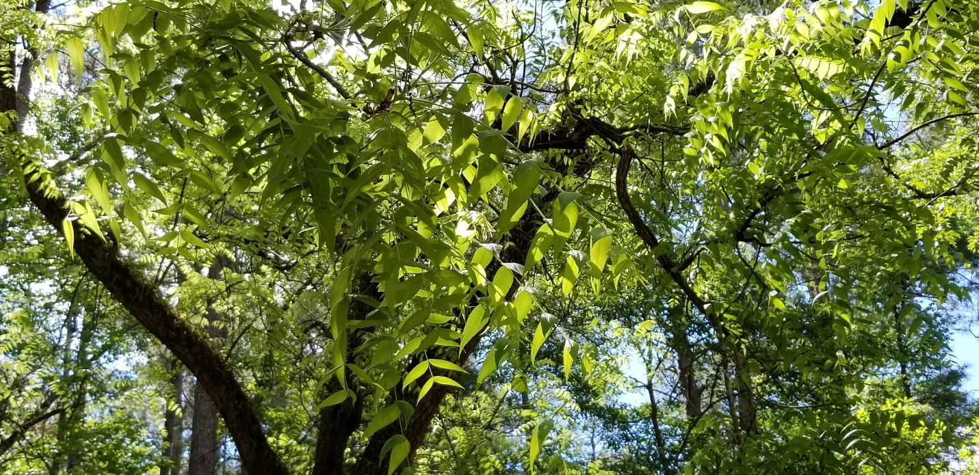

**Matthew R. March, MNRD**

County Extension Agent- Agriculture & Natural Resources

Polk County | Texas A&M AgriLife Extension Service

602 E Church St Ste 127 Livingston, TX 77351

Phone: (936) 327-6828

**Texas A&M AgriLife Extension provides equal opportunities in its programs and employment to all persons, regardless of race, color, sex, religion, national origin, disability, age, genetic information, veteran status, sexual orientation, or gender identity. The Texas A&M University System, U. S. Department of Agriculture, and the County Commissioners Courts of Texas Cooperating. Anyone needing special assistance at an Extension Program should contact the Texas AgriLife Extension Office at (936) 327-6828 at least one week prior to the program or event.**