Mexican Plum, March 7-13
Mexican plum is one of our native plum tree species found in Polk County. No, it does not produce a large plum like you would purchase in the grocery store, but it is in the same genus, Prunus, as cultivated plum trees. Though it does not produce large fruit, Mexican plum is a gorgeous deciduous tree and is widely planted as an ornamental.
Mexican plum can be found throughout central and east Texas, however 9 times out of 10 it will be found as a solitary tree. In the wild, the tree is found in wetter sites including creek bottoms and moist slopes. It also found in fence rows, woodland edges, pastures, and along roadsides. The tree tops out at 25 feet, resulting in a small tree for east Texas standards. The trunk is relatively short compared to the height of the tree which results in a short crown of dull green foliage. Mexican plum makes up for its short stature by its showy white flowers during late February and March. The flowers appear prior to the leaves and will cover the entire crown in a white blanket. Due to its showy flowers and because it blooms while most of the woods are still dormant, the Mexican plum is easily visible from a distance when it is blooming. If you are driving down the road during this time of year and see a solitary tree in a pasture blanketed with white flowers it is likely a Mexican plum. After blooming, simple, alternate leaves, 2 to 4 inches long appear and are pointed at the tip and rounded at the base. Leaves turn yellow or sometimes red in the fall. Just like its cultivated cousin, Mexican plum will produce a plum fruit that ripens in late summer. The fruit is slightly over an inch in diameter and dark purple red with a bluish bloom.
Mexican plum has numerous benefits for both humans and wildlife. Native Americans sun-dried the fruit for winter consumption and the fruit can also be eaten raw or turned into jelly. The fleshy part of the fruit can range in taste from sweet to inedible. Take care not to eat the seeds, pits, or leaves as they can be toxic. Wildlife benefits include pollinators such as butterflies and honeybees that are attracted to the flowers. The fruit is consumed by a variety of birds and mammals.
Mexican plum is not our only plum tree species found in Texas, but east Texas also. Another common wild plum tree found in east Texas is the flatwood plum. The flatwood plum and Mexican plum have similar looking leaves, flowers, and fruits. There are subtle differences, but unless you are a botanist it can be difficult. However, the flatwood plum is restricted to sandy creek banks and bottomlands. It is typically shorter in height and appears more as understory brush lacking the open crown appearance of Mexican plum.
If you are looking for a small ornamental tree to plant in your yard, I would highly recommend planting a Mexican plum. They can be purchased form commercial nurseries and not only will your landscaping pop with white flowers, but you can turn the fruit into tasty wild plum jelly!
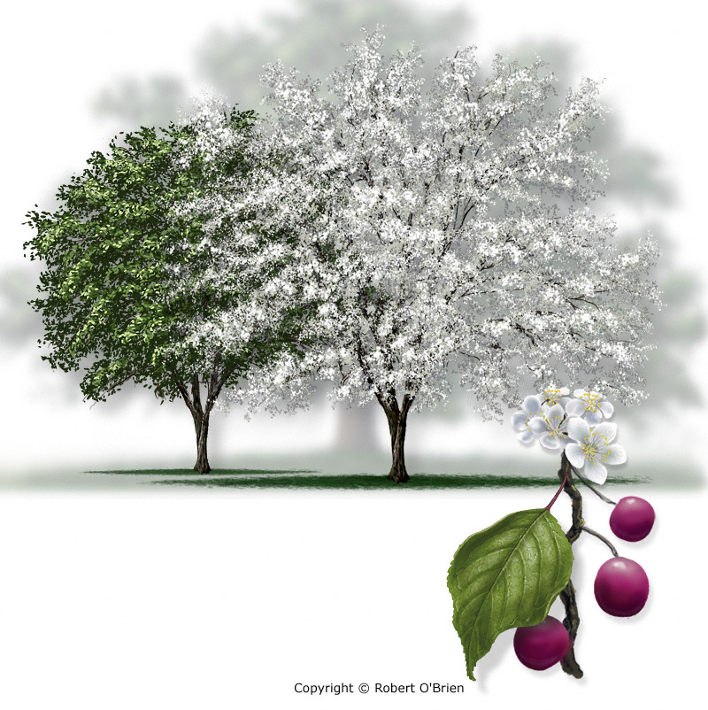
Image taken from Trees of Texas, Texas A&M Forest Service
Matthew R. March, MNRD
County Extension Agent- Agriculture & Natural Resources
Polk County | Texas A&M AgriLife Extension Service
602 E Church St Ste 127 Livingston, TX 77351
Phone: (936) 327-6828
______________________________________________________________________________

Backyard Soil Erosion, March 14-20

I occasionally receive calls from worried homeowners about erosion occurring in their yard. In most of these locations’ erosion has been a perpetual problem over the years and the issue was never addressed properly. I have noticed homeowners tend to avoid the issue because it starts out small and then call my office wanting a quick fix when the issue has become unavoidable. Also, homeowners tend to repeatedly try to re sod erosion areas with no success. Erosion issues can be complex and even in a backyard can require out of the box ideas to fix the issue.
Erosion can occur either through natural processes due to the geography or because of activity that removes the vegetation exposing the soil to water. Activities such as construction, can cause removal of vegetation and increase erosion. If you have an area in your lawn where erosion is occurring or if you are removing vegetation for any reason you need to take action to prevent future erosion. A small stream can quickly turn into a gully if preventative actions are not performed.
In majority of cases, if vegetation can be established erosion will either cease or slow down. Most of our popular turfgrasses such as St. Augustine and Bermuda due a poor job at curving erosion issues unless other actions are taken due to their shallow root system. However, if you are determined to establish typical turfgrasses in an erosion area I would suggest planting a cover crop to allow time for turfgrasses to become established. Cool season grasses such as rye or fescue is commonly planted in the fall to hold exposed soil until warm season turfgrasses have a chance to become established during the following summer. I would also take a long look at the site and determine if shallow root turf grasses are the best option. I routinely recommend to homeowners planting native bunch grasses in gullies or along banks. Native bunch grasses such as little bluestem, Indiangrass, and big bluestem can have roots up to 30 feet deep which do a far superior job at holding soil back compared to St. Augustine with a 1-inch root. The downside is native grasses cannot be mowed like typical turfgrasses and must be cut no shorter than 12 inches in height. I would also consider planting low growing woody vegetation in areas with high erosion.
Besides planting there are some physical actions we can take to slow down water and prevent erosion. Silt fencing is commonly used in construction sites to prevent erosion and can be used in your yard to allow time for turfgrasses to become established. A common practice is to lay erosion mats on slopes which will increase the chances of grass becoming established before the soil is washed away. Some alternative landscaping ideas are to add gravel or rocks to a gully which will hold back the soil. When done properly this can give the look of a gravel stream instead of just rocks thrown in your backyard. Another option is to bury a drainage pipe to carry the water underground instead of over the soil.
I highly recommend thinking outside of the box to curb erosion in your yard. Many times, some of the best options are to combine planting vegetation along with physical actions. For example, adding gravel to an area with erosion and then landscaping with native bunch grasses, cacti, and ornamental bushes. This not only curbs erosion but adds to the landscaping value of your lawn. If you have a specific erosion issue you would like me to look at give me a call and we can brainstorm some ideas.

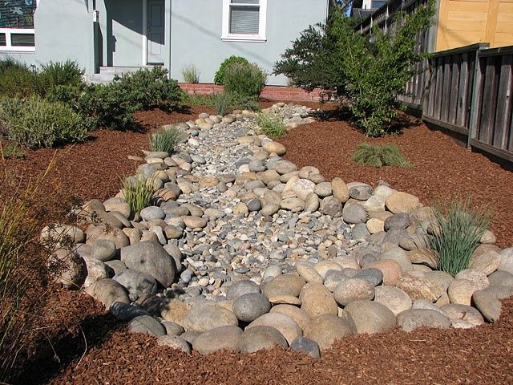

Matthew R. March, MNRD
County Extension Agent- Agriculture & Natural Resources
Polk County | Texas A&M AgriLife Extension Service
602 E Church St Ste 127 Livingston, TX 77351
Phone: (936) 327-6828

Mulch Volcano, March 21-27
Mulching around trees is about as common practice in landscaping as drivers stopping at a red light. Most homeowners and landscapers mulch either because they know the benefits or believe it is the right thing to do because they see everyone else doing it. However, this practice of following in your neighbor’s footsteps has resulted in bad mulching practices.
If you are going to mulch around your tree you need to understand the benefits and why we mulch. Mulch can either be organic or inorganic, (plant material or nonliving material) and comes in a variety of shapes, colors, and sizes. Bark or wood chips, both organic, are commonly used to mulch around trees. Organic mulch will eventually break down overtime and improve soil health by adding organic matter, improving soil structure, and nutrient availability. The downside to organic mulch is it will require being replenished compared to inorganic mulch. Other benefits of mulching include moderating root zone temperatures, encouraging moisture conservation, controlling weeds, preventing soil crusting, improving soil aeration, and reducing soil erosion. It also improves the aesthetic appearance of landscaping by creating a manicured appearance. For all its good benefits which improves the health of your tree, when mulch is applied improperly it can cause negative impacts.
Mulch volcano is the slang term for the common practice of placing mulch in a cone around and next to the trunk 8 to 12 inches high and extending up to 3 feet in diameter. This will result in restricting oxygen exchange with the roots. But of more concern is the moist environment that is created at the base of the stem that can cause cracking of bark creating an entry point for insects and fungal growth.
Proper application of mulch includes a layer no more then 2-3 inches thick. Also, avoid piling mulch up against the trunk of the tree. Instead, mulch several inches away from the trunk allowing air to move freely. Mulch should be applied in a ring at least 4 to 6 feet in diameter, however you can increase the ring size as large as you wish as it will further benefit the tree. If using rocks as mulch avoid using white or black, instead choose a natural color as it will decrease the effects of strong sunlight. Impermeable mulches such as plastic should never be used around a tree.
So, avoid the peer pressure of your neighbors to create a mulch volcano and follow the proper mulching steps. In the end your tree will be healthier, and you would have done your part to turn the tide on the mulch volcano.
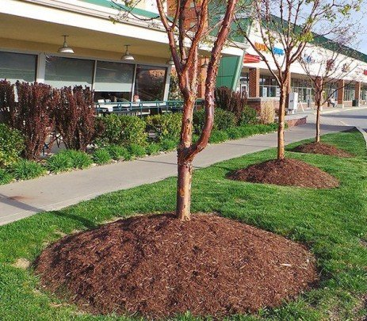
Mulch Volcano, Penn State Extension

Matthew R. March, MNRD
County Extension Agent- Agriculture & Natural Resources
Polk County | Texas A&M AgriLife Extension Service
602 E Church St Ste 127 Livingston, TX 77351
Phone: (936) 327-6828

Attracting Pollinators, March 28-April 3
Backyard pollinator gardens are growing exponentially in popularity for a variety of reasons. For one reason wildflowers are aesthetically appealing to many homeowners and attract a multitude of butterflies, bees, moths, hummingbirds, and other pollinators which can be enjoyable to watch. Additionally, many homeowners feel they are being environmentally conscious by not only providing food for pollinators, but also reducing their impact on the environment.
One of the first questions you may ask yourself when planting a pollinator garden is how big it should be. There is not a set size limit, as a pollinator garden can be as small as a few wildflowers in a square foot to as big as your entire yard. However, the more space you dedicate will allow you to increase the quantity and diversity of plants which can attract a larger number and variety of pollinators. You can be creative with the size of your pollinator garden. Maybe you dedicate a corner of your backyard where grass doesn’t grow or create raised beds dedicated specifically for pollinator plants. After you decided on a location you will then need to choose plants. I highly recommend sticking to native plants found in east Texas. Yes, nonnative or even native plants from other parts of the state may attract pollinators, but they can also be harmful to pollinators. For example, certain butterflies have been known to alter or delay migrating south for the winter because of nonnative ornamentals flowering. This has the potential to result in mortality when a strong cold front plummet temperatures to conditions butterflies can’t survive. Additionally, native plants will be adapted to our hot humid weather and will increase the chances your pollinator garden will be a success.
Options on what to plant are nearly unlimited, but I would aim to plant the largest variety as possible. This will ensure you will not only have plants blooming throughout the spring, summer, and fall, but you will also attract host specific pollinators. Certain pollinators are only attracted to certain plants and will not visit your garden if the specific plant is not present. I would recommend planting annual plants in areas you eventually want to mow during the year and perennial plants in areas that can remain “wild”. A mix of perennials and annual plants make for an excellent garden. Popular plants for our region include bee balm, milkweeds, Turk’s cap, obedient plant, eastern redbud, purple coneflower, Illinois bundleflower, buttonbush, Mexican plum, partridge pea, black eyed Susan, goldenrod, Carolina cherry laurel, and rattlesnake master to name a few. I would also recommend planting some native grasses as they provide food for caterpillars and a location for cocoons. Excellent options are little bluestem, broomsedge bluestem, Indian grass, and eastern gamagrass.
To ensure your garden is successful year after year you should delay mowing as long as possible, especially for annual plants. You should allow plants to remain standing after flowering is competed to allow seeds to mature. If not, your seed bank will become depleted and your garden will struggle to attract pollinators.
Matthew R. March, MNRD
County Extension Agent- Agriculture & Natural Resources
Polk County | Texas A&M AgriLife Extension Service
602 E Church St Ste 127 Livingston, TX 77351
Phone: (936) 327-6828

Texas A&M AgriLife Extension provides equal opportunities in its programs and employment to all persons, regardless of race, color, sex, religion, national origin, disability, age, genetic information, veteran status, sexual orientation, or gender identity. The Texas A&M University System, U. S. Department of Agriculture, and the County Commissioners Courts of Texas Cooperating. Anyone needing special assistance at an Extension Program should contact the Texas AgriLife Extension Office at (936) 327-6828 at least one week prior to the program or event.

