Chicken Wings, February 1-7
1.25 billion is the number of chicken wings expected to be consumed on Super Bowl Sunday! This number is almost hard to wrap your head around. I would like to take some time today to briefly review the poultry industry in the United States. Many consumers understand chickens are grown in large houses they see while driving down the road, but that is about the extent of their knowledge. Hopefully, after reading this article you will be a more educated consumer while enjoying those tasty wings during the Super Bowl.
To start, chicken companies are structured in a manner we call vertically integrated. This means the company owns or manages all steps in raising chickens form the hatchery to the processing plant. However, companies utilize private farms, the majority of which are family owned to grow the chickens after they leave the hatchery until the day they are processed. These farms are contract growers for the company and which they sign a contract to grow chickens for that company for a certain price. In return, the company provides technical support, chicks, and feed. Less than 10% of grow out houses or farms in this county are owned by the company itself. Vertical integration works very well in this country due to the large investment and capital it would take for an individual to produce a fertilized egg, hatch the chick, grow out the chicken, process, and market the product. More importantly, the vertically integrated model allows chicken prices to remain low while allowing both large companies such as Sanderson Farms and local farmers to remain profitably. Without vertical integration the cost it would take to produce a chicken would go through the roof and in the end the consumer would suffer the consequences at the grocery store. Additionally, companies can manage their product from start to finish ensuring a high quality and safe product for consumers.
Now that we have reviewed the structure of the chicken industry, I would like to take you through the steps it takes to produce a chicken wing. To start a fertilized egg is needed. Fertilized eggs are collected daily from what are called breeder houses. These houses are designed specifically for producing fertilized eggs for the hatchery and birds in breeder houses are managed for breeding instead of meat production. Fertilization occurs naturally and after eggs are collected, immediately placed in a refrigerator around 45^{O} F. Refrigeration stops growth of the embryo. The eggs are then transported in a refrigerated truck to a hatchery. At the hatchery the eggs will be placed in an incubator for 21 days. During this time the eggs are rotated with a machine to prevent the embryo from sticking to the shell. Also, embryos will be vaccinated with a machine called In-Ovo which vaccinates the embryo through the shell. Vaccinations are needed to ensure a healthy chick and protect against such viruses as Newcastle disease. After hatching, chicks are transported to grow out farms by environmentally controlled trucks. Chicks will remain at the grow out farms for around 45 days. During this time birds are kept in environmentally controlled houses which ensures the right temperature is met along with ventilation to keep the birds comfortable. Houses also protect chickens from predators and outside diseases. Chickens can eat and drink as much water as they desire. Feed is supplied by a regional feed mill that ensures the feed being delivered matches the nutritional requirements of the bird for its age ensuring healthy birds and maximum production. Once birds reach slaughter age, they will be caught by hand in loaded into a live haul truck and taken to the processing plant. Birds will be stunned and will become unconscious prior to exsanguination. Once in the plant every part of the bird will be processed, packaged, and marketed from the gizzard to the chicken paws.
This was a 30,000-foot view of the chicken industry, but I hope you gained a better understanding of where your chicken wing comes from. I know there are many different views and opinions about the poultry industry, and you may have questions, comments, or concerns, and I welcome the opportunity to visit with you and have a discussion.
Matthew R. March, MNRD
County Extension Agent- Agriculture & Natural Resources
Polk County | Texas A&M AgriLife Extension Service
602 E Church St Ste 127 Livingston, TX 77351
Phone: (936) 327-6828

______________________________________________________________________________

Avoiding Calving Problems and Assisting in Calving, February 8-14

Dystocia, the technical name for calving difficulty, is a fact of life for every rancher. Thankfully, for most operations calving difficulty is an uncommon occurrence and calves are routinely born unassisted without any difficulty. 50% of calving difficulty in a herd will be first calf heifers, 25% will be second calf heifers, and the remainder will be spread amongst the herd. Causes for calving difficulty is birthweight, small pelvic area and fetus conformation. Ranchers should focus on managing birthweights and pelvic area to reduce chances of calving difficulty.
Pelvic area will be affected by heifer selection and development. Smaller underdeveloped heifers will have a smaller pelvic area leading to an increased chance of calving difficulty when compared to a larger developed heifer. Ranchers should select heavy replacement heifers and ensure they are fed proper rations to achieve a proper growth weight of 1.5 to 1.75 lbs. a day. Heifers should weigh approximately 70% of their mature body wight by 14 months of age. After breeding at 14 months of age weight gain should decrease to 1 lb. during gestation. Ranchers should manage for heavy birth weights by monitoring protein intake during the gestation period as heavy birthweights will cause calving difficulty. Excessive protein intake has a greater effect on heavy birthweights then feed or energy intake. Heifers grazing on winter pastures should be monitored closely for excessive protein intake and grazing may need to be limited. Genetic influence is also a major contributing factor to birthweights. Ranchers should select for individual “easy calving bulls” instead of breeds know for calving ease or low birthweights. Ranchers should avoid breeding heifers to bulls with untested performance or unknown expected progeny differences (EPDs). Bulls should be selected with a low EPD (less than +5 lbs.) for birthweight and with acceptable bull’s calving ease score. Unfortunately, even when following best management practices calving difficulty can still occur and assistance may be needed.
In addition to large birthweights and small pelvic area, improper fetus conformation can lead to assistance being needed. Normal calving position of the fetus at the time of birth is the fetus lying in an upward plane with the two front feet entering the birth canal first. The head of the fetus should be between the two front legs with the nose appearing first. You should assist in the calving procedure only if the fetus is in the wrong conformation, the cow is struggling, has stopped attempting to deliver, or after an hour of no progress. During any assistance you should prevent overwhelming contamination of the birth canal by thoroughly cleaning the rear portion of the cow by liberally washing with soap and water. Additionally, whoever will be assisting should clean hands and arms with soap, water, and an antiseptic. When pulling a calf use chains or cotton rope. Chains are preferred because chains allow for more accurate placement and are less restrictive to circulation. A loop should be placed above the ankle and a half hitch below the ankle. This should occur on both front legs and a process called “walking the calf out” should be followed. This involves alternating pulling on each leg one at a time. Once the calf is pulled airways should be cleared by using a cloth to wipe excess mucus from the nose and vigorously rub the calf’s back to stimulate breathing.
If you do not have much experience pulling calves, I would recommend stopping by the office so we can have a more in-depth conversation. I would also recommend consulting your veterinary for knowledge and assistance.

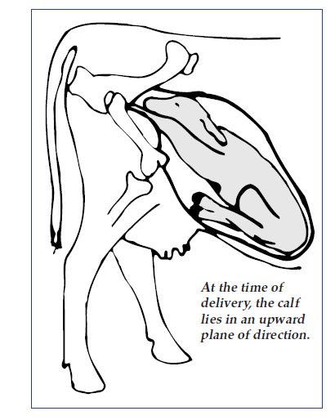
Image taken from: file:///C:/Users/matthew.march/Downloads/beef-assisting-difficult-calving.pdf

Matthew R. March, MNRD
County Extension Agent- Agriculture & Natural Resources
Polk County | Texas A&M AgriLife Extension Service
602 E Church St Ste 127 Livingston, TX 77351
Phone: (936) 327-6828

Being Fire Wise, February 15-21
It seems like every year wildfires or increasing in size and intensity creating these horrific walls of fire that turn homes and business into charred piles of rubble. Fortunately, large wildfires are extremely rare here in East Texas when compared to other western states. However, this doesn’t mean we are immune and even though it may be rare you should still take steps to protect your house and property. In most years East Texas receives plentiful moisture which allows for fuel (pine trees, brush, grass, etc.) to retain enough moisture to the point if a wildfire does get started it struggles to grow quickly out of control. But, when weather conditions are ideal, such as during the drought of 2011, large wildfires are a reality such as the Bearing Fire which burned 23,000 acres in Polk and Trinity County. Thankfully, through years of research a method called Fire Wise has been developed to protect your house from wildfires.
The basics of Fire Wise is centered around the home ignition zone which can extend up to 200 feet from your house. The purpose of the home ignition zone is to reduce the chances embers will ignite your house or flames will directly touch your house from the surface. The home ignition zone is divided into three zones. The immediate zone is 0 to 5 feet from you house and should be a non-combustible area which calls for removing easily combustible materials and preventing embers from entering your house. This includes cleaning your roof and gutters of pine needles and dead leaves, repairing or replacing shingles, and installing 1/8 inch metal mesh around vents and eaves. Patios and decks are easy ignition sources so metal mesh should be installed in areas below patios and decks. Do not store firewood in this zone and remove leaves and other flammable plants.
The next zone extends 5 to 30 feet from your house and is called the intermediate zone. The intermediate zone should decrease fire behavior and intensity by employing careful landscaping and creating breaks. Steps you can take include creating fuel breaks with driveways/paths, and space trees to have a minimum of eighteen feet between crowns. Vegetation under trees should be removed and lawns mowed to a maximum of four inches to prevent flames from reaching the tree canopy. Lastly, tree branches should be no closer than ten feet from the edge of a structure and always remove vegetation form around propane tanks.
The last zone and the furthest from your house at 30-100 feet (up to 200 feet) is the extend zone. The extend zone will not eliminate fire but reduce flame height. To achieve this, you need to remove dead trees, small pines, and heavy accumulations of ground litter. Spacing between crowns of trees should be at least 6-12 feet with distance increasing closer to your house.
Hopefully your house will never be threatened by a wildfire, but if it does, preparing your house by following the Fire Wise system can help increase the chance it is still standing once the flames have passed. More information can be found at https://www.nfpa.org/Public-Education/Fire-causes-and-risks/Wildfire/Preparing-homes-for-wildfire.
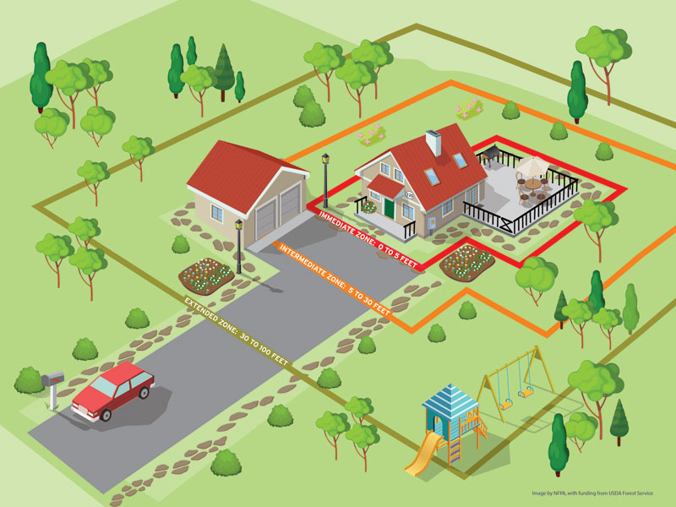
Image Taken From National Fire Protection Association
Matthew R. March, MNRD
County Extension Agent- Agriculture & Natural Resources
Polk County | Texas A&M AgriLife Extension Service
602 E Church St Ste 127 Livingston, TX 77351
Phone: (936) 327-6828

Aggie Horticulture, February 22-28
Have you ever wondered how to start a garden or needed help with fertilization and irrigation? What about selecting vegetable varieties for East Texas? Do you have questions about viability of growing certain fruit trees or starting a commercial ornamental operation? Well you are in luck! A wealth of vegetable and fruit resources are available in one comprehensive website. This website is Aggie Horticulture and can be found at https://aggie-horticulture.tamu.edu/. I would like to take same time to review the unbiased research based information available on this website.
If you are a novice vegetable gardener or want to research on growing a new crop, I would recommend checking out easy gardening fact sheets under vegetable resources. These guides provide a quick overview of everything you need to know to grow different vegetables including varieties, soil preparation, planting, fertilizing, watering, pest, diseases and harvesting. Guides include everything from ginger to okra and artichokes to sweet potatoes. Another useful vegetable resource is vegetable variety selector which you can search varieties for individual counties or regions of Texas. Maybe you are looking for information on vegetables so unique that you will be the only stand with it at the farmers market. If so, you need to check out the specialty crops of Texas tab which includes information on unique vegetables such as celeriac, Chinese radish, Jerusalem artichoke, and pigeon peas.
Another helpful resource for homeowners and small orchards is the fruit and nut fact sheets. These fact sheets give a basic overview of growing a variety of fruits and nuts. This includes common fruits such as peaches and blueberries, but also less common fruits such as mangos and pineapples. There is also information on peach and nectarine varieties, pecan grafting, pecan production, orchard management, and grapes.
If you are a small commercial operation or are considering staring a commercial operation, I would also recommend doing research on this website. Useful information includes small acreage horticulture crops, commercial crop production guides, and crop variety trials. Additionally, information is available on vineyard management and commercial ornamental production.
Okay, so you are not a vegetable gardener, don’t have peach trees, and are not interested in starting a commercial operation. Don’t worry there is still useful information for you at Aggie Horticulture. This includes a list and fact sheets on Texas Superstars for your landscaping. Texas Superstars are plants that have been selected due to their proven ability through observations and demonstration trials to perform well for Texas consumers. Texas Superstars are tested and selected for Earth-Kind Landscaping. You may be asking what Earth-Kind Landscaping is, well an entire section of the Aggie Horticulture website is dedicated to Earth-Kind Landscaping. Earth-Kind Landscaping uses research proven techniques to provide maximum garden and landscape enjoyment while preserving and protecting the environment.
No matter your level of knowledge when it comes to gardening, orchard management, or landscaping there is relevant information available for free at Aggie Horticulture. Just remember everything you read on the internet is not true and Aggie Horticulture offers an unbiased researched based information relevant for Texas.
Matthew R. March, MNRD
County Extension Agent- Agriculture & Natural Resources
Polk County | Texas A&M AgriLife Extension Service
602 E Church St Ste 127 Livingston, TX 77351
Phone: (936) 327-6828

Preserving You Harvest, February 29 – March 6
With the height of spring gardening season right around the corner it is only a matter of time before you are enjoying tasty and nutritious home-grown vegetables. Many gardeners run into a dilemma where they are rewarded with more vegetables then they can eat or give away to neighbors. If this is the case, vegetables can be preserved by either canning or freezing. Rather you are a seasoned pro or a novice at canning and freezing it is always a good idea to review preservation procedures to ensure spoilage doesn’t occur.
Canning involves processing vegetables at a high enough temperature to kill bacteria, yeast, and molds while creating an airtight seal to protect from contamination. First, you must remember specific steps and times vary between vegetables and a detailed instruction list is available at the extension office. Always attempt to begin canning vegetables sooner then latter after picking to ensure quality is retained and spoilage doesn’t occur before canning. If needed, vegetables should be cut to uniform size so cooking will occur evenly. Wash vegetables thoroughly and avoid bruising. Two types of packs may be used; hot pack or raw pack. Hot pack involves preheating vegetables before placing in cans, while in raw packs vegetables are packed into cans raw and boiling liquid is added immediately before closing jars. Only jars made specifically for canning should be used, if not cracking and potential food spoilage can occur. Jars should be cleaned with hot soapy water before canning and the metal seal disk can only be used once. Temperatures must reach 240 ⁰F as this temperature is essential for safely canning vegetables. Dial gauge pressure canner gauges need to be checked yearly for accuracy, while it is not necessary if using a weighted gauge pressure canner.
Just like in canning, when freezing vegetables, you should always use freshly picked vegetables and begin the freezing process immediately to ensure food quality and food safety. Wash vegetables thoroughly and cut to even and desired sizes before freezing. Blanching vegetables is one of the most important steps in freezing vegetables as it achieves two goals. First, it stops enzyme activity which prevents off flavor and texture. Secondly, heating will soften vegetables making them easier to pack. Boil 1 gallon of water for each pound of vegetables. Vegetables should be placed in a wire mesh or cheesecloth bag if not using a blancher. Boiling time will vary between vegetables and exact times are available from the extension office. Boiling vegetables for too long will result in a soft texture. Steam blanching is an option for pumpkin, sweet potatoes, winter squash, and broccoli. While, tomatoes for juices can be simmered. After removing the vegetables form the boiling water, they should be cooled immediately either by running cold water or placing in a container of iced water.
Canning and freezing of vegetables gives the home gardener the ability to preserve vegetables for future consumption. However, when steps are not followed properly food quality can decrease and the chances of harmful bacteria growth increases. To ensure a safe product it is always a good idea to review canning and freezing procedures yearly.
Matthew R. March, MNRD
County Extension Agent- Agriculture & Natural Resources
Polk County | Texas A&M AgriLife Extension Service
602 E Church St Ste 127 Livingston, TX 77351
Phone: (936) 327-6828

Texas A&M AgriLife Extension provides equal opportunities in its programs and employment to all persons, regardless of race, color, sex, religion, national origin, disability, age, genetic information, veteran status, sexual orientation, or gender identity. The Texas A&M University System, U. S. Department of Agriculture, and the County Commissioners Courts of Texas Cooperating. Anyone needing special assistance at an Extension Program should contact the Texas AgriLife Extension Office at (936) 327-6828 at least one week prior to the program or event.

