Poultry Lice and Mites, January 4-11
Lice and mites are the most common external parasites found on poultry. Infestations can quickly grow out of control and routine inspections of your birds is necessary to monitor for infestations. Lice and mites will have negative effects on production rather that is decreased meat production or egg production. Early detection is necessary due to restrictions on treatments available for food producing birds.
Poultry lice are tiny, wingless, 6 legged, flat bodied, insects with broad round heads. A female louse will lay 50 to 300 eggs at a time at the base of the feather. Multiply species effect poultry, but none of the species feed on blood, but rather they feed on skin scales and feathers. When inspecting your birds for lice examine the ventral area as this location is typically the starting site for infestations. Poultry lice cannot be transferred to humans and their entire life cycle occurs on the host bird. Birds with infestations may have feather damage which can cause a dull or roughened appearance.
Two types of mites can be found on poultry: northern fowl mite and chicken mite. The northern fowl mite is the most common external parasite on poultry and feeds by sucking blood. The northern fowl mite will remain on the host bird for its entire life cycle which last 2-3 weeks and is spread through bird to bird contact. While the northern fowl mite is more common during cooler temperatures, the chicken mite is primarily a warm weather pest. These mites also suck blood from poultry, but instead of living on the host like northern fowl mite, chicken mites feed at night and retreat to crevices in the poultry house during the day. Symptoms of mites are very similar to lice, however during inspections mites may not be noticeable since mites can survive off the bird and in the case of the chicken mite be nocturnal. Mites tend to congregate around the ventral region and darkening of white feathers will occur due to feces.
On a flock and production scale, lice and mites will decrease egg production, decrease weight gain, and decrease carcass quality. Additionally, birds can be overcome with these external parasites causing increase susceptibility to other diseases. Prevention is the best method for treatment which requires good sanitation and cleanliness of houses. You should also reduce the chance of vectors transferring lice and mites between houses and flocks. Avoid sharing equipment between flocks and minimize human contact between flocks. When moving between one or more houses or flocks, you should follow proper bio security procedures between flocks; change clothes, wash shoes, clean equipment, etc. During severe infestations, carbaryl (Sevin) can be used to treat walls, floors, and nest boxes in the house. Special attention needs to be taken to ensure the chemical does not contact feed. In a small-scale operation, a Sevin dust bath or application of a pyrethrin based spray can be applied directly to the birds. Remember to always read and follow the label before applying any pesticide and it is always a good idea to consult your veterinary.
Matthew R. March, MNRD
County Extension Agent- Agriculture & Natural Resources
Polk County | Texas A&M AgriLife Extension Service
602 E Church St Ste 127 Livingston, TX 77351
Phone: (936) 327-6828

______________________________________________________________________________

Gopher vs Mole, December 7-13

Longtime residents of Polk County can attest to the ever-ranging battle that has been occurring for years against gophers and moles tunneling through lawns and flower beds. These small mammals like to take up residence in lawns because of food sources and soft soil. Many homeowners can easily recognize damage caused by gophers and moles, but many do not understand the differences between the two. While both are considered subterranean mammals, they belong to two different orders (groups) of mammals and have different biology and life history. Eastern mole (Scalopus aquaticus) and Baird’s pocket gopher (Geomys brevicpes) are more than likely the two culprits causing tunnels and dirt mounds in your yard. While the eastern mole belongs to the order Soricomprpha (moles and shrews), Baird’s pocket gopher belongs to the order Rodentia (rodents).
Eastern moles are burrowing mammals with large front feet shaped like shovels to help them dig burrows. They also have a sharp pointed nose and lack visible eyes or ears. Moles spend nearly their entire lifetime underground where they consume earthworms, beetles, and other insect larvae. Since moles require soils that can be easily burrowed, moist sandy soils are preferred, and deep dry sands or heavy clay soils will be avoided. Moles cannot see and are active throughout the day and night. Moles get a bad rap for the damage they cause; however, their burrowing action can benefit plants by aerating the soil.
Pocket gophers like moles live in extensive underground tunnel systems. Pocket gophers have the ability and will dig their own tunnels but are also commonly found in the same tunnel systems that moles will use. Unlike moles, which are insectivores, pocket gophers consume seeds, tubers, and other vegetative material they can found in the soil. Pocket gophers are medium in size with tiny eyes and ears. They are equipped with long curved claws on the front feet which are used for digging. Pocket gophers lack the sharp pointed nose that is found in moles. Pocket gophers get their name from fur lined check pouches which are used for food storage and transport.
Identifying between a mole and a pocket gopher can be easy by observing the nose and front feet. Interestingly, you can ID what is creating tunnels in your lawn by examining the mounds created. Mole mounds will be exactly what it sounds like, mounds of dirt with no visible plug covering the entry to the tunnel. While gopher mounds will exhibit a definite indent on one side of the mound where the tunnel entry was plugged.
If you find your lawn being damaged by one of these two critters, it is essential you identify rather it is moles or pocket gophers if wanting to use bait to control the population. Gopher bait will obviously be effective on pocket gophers but will have little effect on moles. This is because gopher bait is plant based and since moles only eat insects they will not be attracted to the bait. You should also keep in mind in many cases lawns will have both moles and pocket gophers present.
Baird’s Pocket Gopher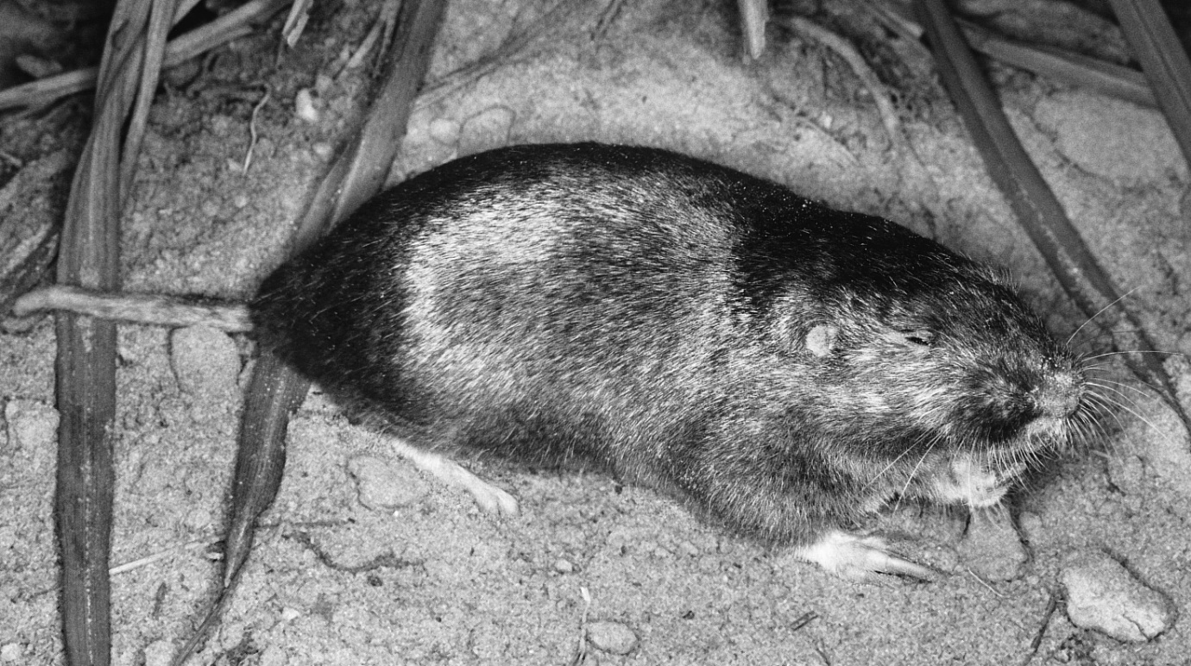
Eastern Mole
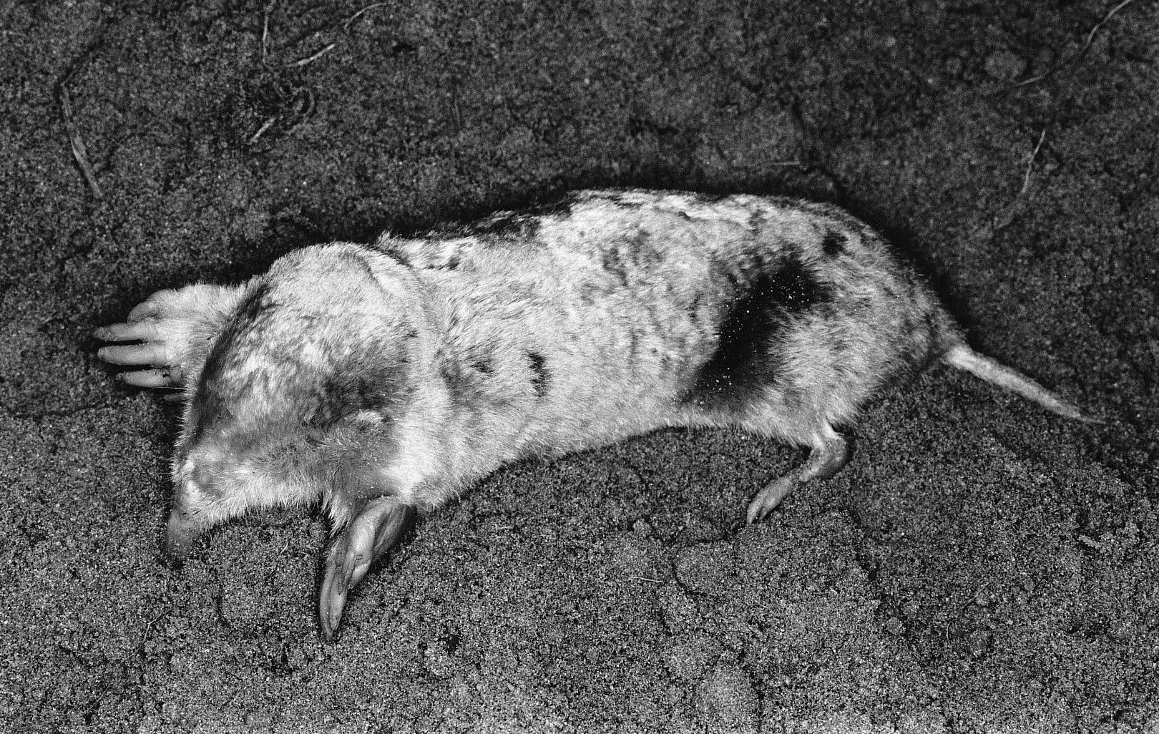
Images taken form: https://www.depts.ttu.edu/nsrl/mammals-of-texas-online-edition/
Matthew R. March, MNRD
County Extension Agent- Agriculture & Natural Resources
Polk County | Texas A&M AgriLife Extension Service
602 E Church St Ste 127 Livingston, TX 77351
Phone: (936) 327-6828

Soil Solarization, January 18-24
One of the biggest challenges for a homeowner in vegetable gardeners and flower beds is controlling unwanted weeds. Weeds are not only unsightly, but also reduce production by competing with desirable plants for water and nutrients. The first actions homeowners typically take to control weeds is spraying herbicides and/or mechanical removal. However, there is an alternative method you can add to your toolbox to manage weeds. In a nutshell, soil solarization is an environmentally friendly method to control weeds by covering the ground with transparent polyethylene and using the sun to raise the soil temperatures to kill weeds and weed seeds. Additionally, soil solarization kills bacteria, fungus, insects, nematodes, and mites. Soil solarization is such an important management tool in controlling weeds that the practice occurs on commercial vegetable farms. Soil solarization is essential in an organic operation, however you need to keep in mind weeds can still be a problem along with other pests.
To prepare your garden for solarization clear the area of plants and debris. Next add water by watering the soil deeply and follow the watering by covering the area with clear plastic. Make sure you use clear plastic as white or black plastic will not allow sunlight to penetrate the plastic which is necessary. Multiply products are available on the market, but painter’s plastic from the hardware store works just fine. Bury the edge of the plastic in the soil to ensure heat is trapped. Plastic should be left for at least 4 weeks before removal.
Soil solarization works best on heavy soils because they hold more water which allows steam to be produced. Steam production is required daily to achieve effective control. As you may know Polk County has its fair share of light sandy soil, so soil solarization may not be effective in many parts of the county. However, to overcome sandy soils lay drip irrigation lines under the plastic cover to add water regularly to encourage steam production. You should monitor the underside of the plastic for water beads in the morning. Once it appears the amount of water beads are decreasing you will need to add water through the irrigation drip lines to replenish water and thus create more steam. The ideal time to perform soil solarization is during the hottest part of the summer to ensure enough heat is created. It is recommended to performs solarization in July as this will allow enough time to plant a fall garden.
Soil solarization is important tool in managing weeds and other pests in your garden or flower beds. However, solarization kills beneficial organisms so adding compost after solarization is necessary to ensure you soil is ready to go. Solarization is essential in organic operations, but also has a place in more traditional settings.
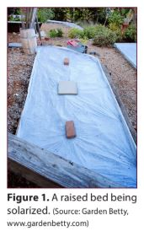
Matthew R. March, MNRD
County Extension Agent- Agriculture & Natural Resources
Polk County | Texas A&M AgriLife Extension Service
602 E Church St Ste 127 Livingston, TX 77351
Phone: (936) 327-6828

Fertilizing your garden, January 25-31
If you haven’t started to plan your spring garden, now is the time to start. Your first step will be to conduct a soil sample to determine type and quantity of fertilizer you should apply. Ideally, a soil test should be performed annualy, but a good rule of thumb is at least every two years. Submittal forms and sample bags are available to pick up at the extension office and we can assist with explaining the correct procedures to collect the sample. After submitting your sample, you will receive recommendations on what nutrients you soil is lacking and how much fertilizer needs to be applied. Interpreting a soil sample result can be confusing and if you have no prior experience, I suggest bringing it by the office so we can guide you to purchase the correct fertilizer. Today, I would like to spend some time explaining the basics of a fertilizer label and how to properly apply fertilizer to your garden.
Fertilizers are divided into two categories organic and inorganic. Organic fertilizer or naturally occurring such as poultry litter, manure, cottonseed, etc. While inorganic fertilizers or manmade products. Most of the fertilizers available at big box stores or inorganic. Organic fertilizers are usually lower in nutrient content and typically lack all the nutrients required for plants. For most home gardens, organic fertilizers can be used, but an application of an inorganic fertilizer may still be required to provide all the necessary nutrients. When looking at a fertilizer label three numbers will stand out such as 13-13-13. All fertilizer labels will have three numbers with dashes in between and these numbers represent the three macro nutrients required by plants (nitrogen, phosphorus, potassium). The numbers allow you to understand the percentage of that nutrient that is in that bag. Nitrogen will always be the first number, followed by phosphorus then potassium. For example, a 100 pound bag of 10-20-10 fertilizer contains 10 pounds of nitrogen, 20 pounds of phosphorus, and 10 pounds of potassium. When buying a fertilizer, you must also consider micronutrients. Micronutrients include such nutrients as sulfur, zinc, and iron. In most situations an application of micronutrients is not required. However, if you soil requires an application of micronutrients it is essential an application occurs as your vegetable production will suffer. Sulfur is one of the more common micronutrients needing to be applied and many products will include sulfur in their fertilizer mix.
Fertilizer can be applied using four methods: broadcast before planting, band, starter solution, and side dressing. Broadcast application involves evenly spreading the fertilizer over the garden and then mixing with the soil to a depth of 3 to 4 inches before rows are made. Band application occurs after rows are made and an application of fertilizer is applied in a strip or band beside the row before planting. Starter solution requires mixing 2 tablespoons of fertilizer in 1 gallon of water and pouring 1 cup of mix into each hole before transplanting plants such as tomatoes. Side dressing occurs after plants are established and should occur if you suspect nutrients have leached from the soil. Fertilizer is sprinkled along sides of the row and watered into the soil.
Understanding soil sample results and fertilizers can be very overwhelming and sometimes feels like it requires a PhD. So please, if you have any question or need help contact the extension office.
Matthew R. March, MNRD
County Extension Agent- Agriculture & Natural Resources
Polk County | Texas A&M AgriLife Extension Service
602 E Church St Ste 127 Livingston, TX 77351
Phone: (936) 327-6828

Texas A&M AgriLife Extension provides equal opportunities in its programs and employment to all persons, regardless of race, color, sex, religion, national origin, disability, age, genetic information, veteran status, sexual orientation, or gender identity. The Texas A&M University System, U. S. Department of Agriculture, and the County Commissioners Courts of Texas Cooperating. Anyone needing special assistance at an Extension Program should contact the Texas AgriLife Extension Office at (936) 327-6828 at least one week prior to the program or event.

