Purpletop, November 2-8
Purpletop (Tridens flavus) is a warm season native perennial grass that is commonly found throughout Polk County. This native grass may not be classified as one of the most important native grasses for wildlife or cattle grazing. But it is still an important grass that wildlife managers, landowners, and ranchers need to be able to recognize and understand its benefits.

Purpletop can be found in a variety of sites including roadsides, woodland openings, pine savannas, native meadows, and field edges. In fact, purpletop is abundant along certain roadways in Polk County including stretches of 59 between Leggett and Corrigan. Purpletop is adapted to a multitude of growing conditions including shade tolerance and soils that are well-drained, shallow, or rocky. It is most often found in loam or clay-loam soils. In Texas the grass can be found in the eastern 2/3rds of the state in areas that receive more than 30 inches of rainfall. The grass extends its range across the south and as far North as New England and west to Nebraska. Texas is home to two different varieties of purpletop, however identification between the two varieties is not easy to the untrained eye.

Purpletop can be easily identified by two characteristics. The first is its large and robust growth especially during late summer and fall. During this time period the plant produces a culm, which is the stem or stalk that bears the seed head or inflorescence. This culm can reach heights of up to six feet which makes it easily visible especially in large stands. The inflorescence, containing purple seeds, is also large and open compared to other grasses. The second characteristic is the greasy feeling one gets when rubbing their hands on the seeds. Thus, purpletop routinely goes by its nickname “grease grass”.

As discussed earlier, purpletop is not the highest valued native grass when it comes to wildlife or cattle, but it is rated as having fair value for both wildlife and cattle. Because of its fair value and its tendency to be abundant on certain sites in Polk County I believe this is a very important native grass for this county. Purpletop is sensitive to overgrazing so proper grazing management is required to ensure persistence of this grass in a pasture setting. A variety of wildlife utilize purpletop including several species of butterflies and small mammals. Due to the tendency of purpletop to establish large colonies and its robust size it provides significant cover for wildlife.
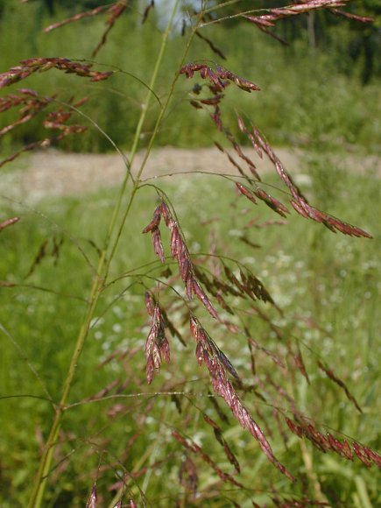
Image taken from https://www.illinoiswildflowers.info/grasses/plants/purpletop.htm

Matthew R. March, MNRD
County Extension Agent- Agriculture & Natural Resources
Polk County | Texas A&M AgriLife Extension Service
602 E Church St Ste 127 Livingston, TX 77351
Phone: (936) 327-6828

Bio Security, November 9-15

As livestock producer’s bio security may be the most important practice to ensure the long term sustainability of your operation. USDA defines bio security as doing everything you can to reduce the chances of an infectious disease being carried onto your farm by people, animals, equipment, or vehicles. Many producers choose not to follow bio security because it typically requires more money and time up front to implement bio security procedures. There is also the mindset that bio security is unimportant and a waste of time. However, this could be farthest from the truth. By following bio security procedures, you will reduce the risk that a disease will enter your operation. The last thing you want to do as a producer is introduce a disease that can cause production loss or possibly wipe out your operation.

Bio security will vary from operation to operation and from species to species being raised. However, there are some common procedures that can be followed. First is keep your operation a closed operation. This can be done by ensuring outside livestock does not encounter your livestock. The only way to completely ensure this occurs is to not purchase outside livestock form other producers. However, this is impractical because at some point you will need to obtain new stock. So, this brings us to the second procedure. If purchasing outside livestock, you should quarantine these animals when you first bring them onto your operation. When in quarantine these animals should not encounter your other livestock and should be monitored for any signs of diseases or sickness. If there are signs of diseases or sickness you should cull those individuals. The third procedure you should follow is purchasing your livestock form reputable sources. This will vary from species to species. For chickens this would be purchasing fowl from a hatchery that has been certified to be Avian Influenza and Pullorum-Typhoid clean by the National Poultry Improvement Plan. I would highly discourage purchasing poultry from bird markets or from the side of the road. If you are a cattle producer, you need to ensure cattle have been administered the proper set of vaccines and if purchasing bulls have been Trich tested. The fourth procedure I want to cover today is managing vectors. A vector can either be an animal or non-living item that transmits pathogens. I want to draw attention to managing nonliving vectors as most producers understand ticks, fleas, rodents, livestock, etc. can transmit pathogens. Nonliving vectors include but not limited to shoes, clothes, trailers, trucks, and farm equipment. These nonliving vectors can become contaminated with manure, blood, or other bodily secretions containing pathogens and thus transmit the pathogen to other livestock. In a good bio security management plan, you would ensure nonliving vectors are cleaned between flocks or herds of livestock. In other words, if you let your neighbor borrow your cattle trailer it is a good idea to clean out all the manure before hauling your cattle in the trailer.

Bio security should be number one on all livestock producer’s management plans. However, bio security usually takes additional time and money and thus routinely gets swept under the rug. But if bio security procedures are followed you greatly improve the chances your livestock will not come in contact with outside diseases.

Matthew R. March, MNRD
County Extension Agent- Agriculture & Natural Resources
Polk County | Texas A&M AgriLife Extension Service
602 E Church St Ste 127 Livingston, TX 77351
Phone: (936) 327-6828

Bee Keeping Appraisal Guidelines, November 16-22
Many new landowners come to my office seeking help in answering questions about “ag exemption” requirements and how do they go about receiving the exemption. In some cases, these new landowners have been misled and I end up ruining their day when I tell them their property will not qualify. Before I continue any further, I want to state that I am not a representative of Polk County Appraisal Office and that for specific cases or issues you should contact the Appraisal Office. However, I do want to discuss some common issues and situations I have witnessed with “ag exemption” when it comes to bee keeping.

“Ag exemption” is the slang term used when talking about property with agricultural production. However, an agriculture property is not exempt from property taxes but instead pays a rate based on Agriculture value. In other words, you will still pay property taxes, but the rate will be less. Other requirements for a property to qualify for agriculture valuation is the property may not be used for residential or commercial purposes and the agriculture must be a business and which you have sales. If you are wanting to claim an agriculture valuation for beekeeping you must manage, produce, and sale honey or bees. You can not keep bees for you own personal enjoyment or home honey production and claim an agriculture valuation.

If you are just starting beekeeping on a property, there is a 5 year requirement of previous production to qualify for agriculture valuation if the property was not already qualified. Thus, if you buy a property that currently does not have an agriculture valuation you will have to keep bees for five years before it qualifies. Also, you will need to establish history of beekeeping for those five years by keeping records and receipts. It is also a good idea after you receive beekeeping valuation to continue to keep records and receipts and to registry your hives with the Texas Apiary Service. A minimum of 5 acres and a maximum of 20 acres may qualify for beekeeping. However, Polk County has established degree of intensity depending on the number of acres. 6 hives are required for 5 acres, while every additional 2.5 acres requires 1 additional hive. Additional acreage less than 2.5 acres requires no more hives.

One of the most common misconceptions I see among landowners is that their 5 acre tract will qualify for beekeeping. This situation would be true if the entire property was dedicated just to beekeeping, however the majority of these 5 acre tracts have a house on the property. The house usually has a homestead exemption of 1 acre which must be subtracted form the acreage available for beekeeping. In other words, if you have a 5.9 acre tract with a 1 acre homestead you have 4.9 acres available for beekeeping. However, the 4.9 acres would not qualify because it is below the minimum threshold of 5 acres.

If you are thinking about purchasing a property and are planning on using beekeeping to obtain an “agriculture exemption”, I would highly encourage you to stop by the appraisal office or the extension office to review requirements and qualifications.

Matthew R. March, MNRD
County Extension Agent- Agriculture & Natural Resources
Polk County | Texas A&M AgriLife Extension Service
602 E Church St Ste 127 Livingston, TX 77351
Phone: (936) 327-6828

Sweet Potatoes, November 23-29
I know sweet potatoes are a staple at many Thanksgiving dinners, but I will have to admit not one scoop of sweet potatoes will end up on my plate. But if you are opposite of me and enjoy eating sweet potatoes you may be interested in growing some homegrown sweet potatoes in your backyard.

Sweet potatoes are a perennial plant, however in the U.S. they are treated as a warm season annual crop. The most common varieties planted in Texas are Beaurgard, Centennial, Jewell, and Vardaman. Before planting your sweet potatoes, you should select a site that has full sun, well drained, fine sandy loam soil, with a slightly acidic pH. When planting in soils that retain water, rot diseases become a big issue. It is always a good idea to perform a soil test to determine how much fertilizer to add to achieve maximum growth while ensuring you don’t waste your money over applying fertilizer. Soil should be worked into beds 8 inches high and 3 to 4 feet apart. Sweet potatoes grow best during hot days and warm nights but can withstand light frost if soil temperatures remain above 55ºF.

Propagation of sweet potatoes is unique when compared to other vegetables. Sweet potatoes are propagated from slips (vine cuttings) and can be produced at home, purchased at local feed stores, or ordered online through seed companies. Many gardeners choose to produce their own slips at home. This can be done by obtaining sweet potatoes from the grocery store and after scrubbing them clean cutting the potatoes in half. Suspend each half over a jar of water by inserting toothpicks so that half is submerged in the water. Place the jar near a window for sunlight and during the next few weeks shoots will form on the top. Optimal planting time is when soil temperature is over 65ºF if planting in the spring or if planting in the fall 150 days before anticipated 55ºF soil temperatures. As with any vegetable keeping the bed weed free will make for increased yield and quality. Sweet potatoes can fall victim to a variety of insects and diseases including leaf spots, nematodes, beetles, cutworms, and weevils.

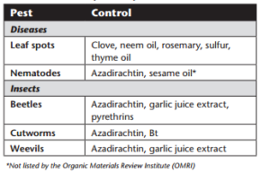

You should cease watering 3 weeks before harvest to ensure rotting doesn’t occur in the tubers. The skin can be easily bruised during harvest so special care should be taken to prevent impact with shovels when harvesting, also, avoid dropping the potatoes. Many home gardeners prefer to harvest immediately before or just after the first fall frost.

The process of growing sweet potatoes is unique when compared to other vegetables, however they can be an easy vegetable to grow for many home gardeners.

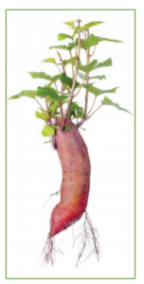
Sweet potato producing slips (Image taken from: https://agrilifeextension.tamu.edu/browse/featured-solutions/gardening-landscaping/sweet-potatoes/)

Matthew R. March, MNRD
County Extension Agent- Agriculture & Natural Resources
Polk County | Texas A&M AgriLife Extension Service
602 E Church St Ste 127 Livingston, TX 77351
Phone: (936) 327-6828

Texas A&M AgriLife Extension provides equal opportunities in its programs and employment to all persons, regardless of race, color, sex, religion, national origin, disability, age, genetic information, veteran status, sexual orientation, or gender identity. The Texas A&M University System, U. S. Department of Agriculture, and the County Commissioners Courts of Texas Cooperating. Anyone needing special assistance at an Extension Program should contact the Texas AgriLife Extension Office at (936) 327-6828 at least one week prior to the program or event.

