Common Toxic Plants, December 1-6
Many livestock owners put little thought into toxic plants that may be growing in the same pastures or pens we house our livestock. Majority of the time these plants are not consumed by livestock for a variety of reasons and their dangerous presence goes unnoticed. In fact, many toxic plants can be abundant but by following good animal husbandry you can ensure your livestock will remain healthy. However, when consumed symptoms can range from mild symptoms to nearly instant death. The list of potential toxic plants can range in the hundreds, but there are several plants species that tend to poison livestock in our region. As a livestock owner you should learn some of the more common toxic plants so you are able to recognize potential issues that may occur in your livestock.
Many of our toxic wildflowers are unpalatable to livestock due to their taste and will not be readily consumed unless livestock our in a state of severe starvation or pastures are overgrazed. In other words, do not force your livestock to eat unpalatable plants due to the lack of supplemental feed. Wildflowers that fall into this category include milkweeds, wild indigo, and bitter sneezeweed. A problem can arise if hay contains large number of these plants. Caution should be used when baling fields that contain these plants and hay from those fields should not be fed to horses.
Common grasses such as smut grass, dallisgrass, and native paspalums can have infestations of ergot poisoning. Ergot poisoning comes from a toxic substance produced from fungus that can be commonly found in these grasses seed heads. Cattle tend to recovery from ergot poisoning but tends to be destructive in horses. Caution needs to be taken when bailing hay fields that contain these grasses or rotating livestock on to pastures that have not been grazed.
Maples, silk tree mimosa, chinaberry, and chinese tallow can be very common in pastures. In most situations these trees will not be grazed, however one common mistake is to trim branches from these trees and place brush piles in a pasture. When this happens, livestock tend to consume the cut branches and can become ill. Horse have been known to readily consume maple leaves when present.
Oleander is a flowering ornamental shrub that is commonly planted in landscapes in southeast Texas. This plant is extremely toxic to livestock and should never be planted in pastures and livestock should never have access to cut branches.
Acorn poisoning is a common problem when large number of acorns fall at once. When this happens, you may want to remove livestock form the pasture or feed supplemental feed. Coffee Senna and several species of sennabean can be common in pastures in Polk County, especially in smaller pens and overgrazed pastures. To prevent poisoning, livestock should have an adequate amount of feed, remove mature plants, and follow proper grazing management.
A laundry list of plants found in Polk County can be toxic to livestock. However, in most situations sound grazing management and animal husbandry can mitigate the risk of toxic plants.

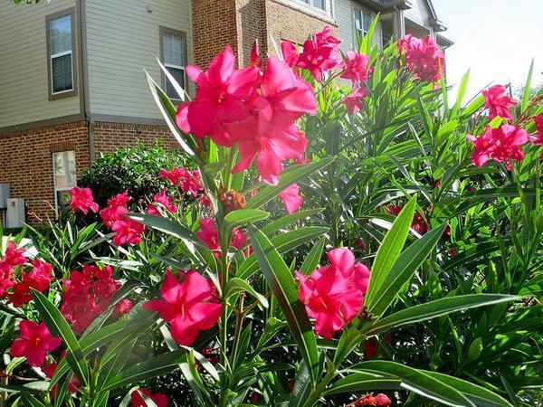
Oleander, a common ornamental plant found in southeast Texas, very toxic to livestock
Image taken from https://plants.ces.ncsu.edu/plants/nerium-oleander/

Matthew R. March, MNRD
County Extension Agent- Agriculture & Natural Resources
Polk County | Texas A&M AgriLife Extension Service
602 E Church St Ste 127 Livingston, TX 77351
Phone: (936) 327-6828

______________________________________________________________________________

Pruning 101, December 7-13

December not only marks the peak of the holiday season, but also the start of pruning season for most ornamental trees and shrubs. The ideal time of the year to prune most of our ornamentals is during the late dormant season. That would make late December to mid-February the ideal time to conduct your annual pruning. Before you begin chopping limbs it is a good idea to review pruning 101.
All trees and shrubs require pruning during their lifestyle for multiply reasons. These reasons include promoting healthy plants, sculpting to their desired purpose (such as a hedgerow), aesthetics, protecting people and property (dead limbs), and increasing visibility. Pruning can also help trees become more resistance to storms by developing a strong structure by forming an open canopy, a properly shaped crown, and removing dead branches. There are three common styles of pruning. Crown thinning is used primally on hardwoods and is the selective removal of branches to increase light penetration and air movement through the crown. Crown raising removes branches from the bottom of the crown to remove low hanging branches providing for better clearance. Lastly, crown reduction is used when a tree has grown too large for its space and is typically achieved by removing the top of the crown.
Cuts should also be made at the node which is the growth point of a branch. This may be where a twig attaches to a branch or where a larger branch attaches to the stem. You should take special caution to only make cuts on branch tissue and not stem tissue. This will help reduce the risk that decay, and other diseases may occur. When pruning live branches look for the branch collar that grows from the stem tissue at the underside of the base of the branch. On the upper surface, there is usually a branch bark ridge that runs (more or less) parallel to the branch angle, along the stem of the tree. A proper pruning cut does not damage either the branch bark ridge or the branch collar. Prune dead branches in much the same way as live branches. Making the correct cut is usually easy because the branch collar and the branch bark ridge can be distinguished from the dead branch, because they continue to grow. Make the pruning cut just outside of the ring of wound wood tissue that has formed, being careful not to cause unnecessary injury.
Pruning is a necessary task to ensure your ornamental trees and shrubs remain healthy and provide aesthetics for years to come. By following some simple tips reviewed above you can mitigate the risk of decay and diseases impacting your plants from improper pruning. More information on tree care can be found at https://agrilife.org/treecarekit/.

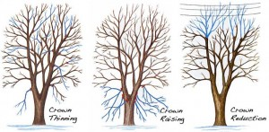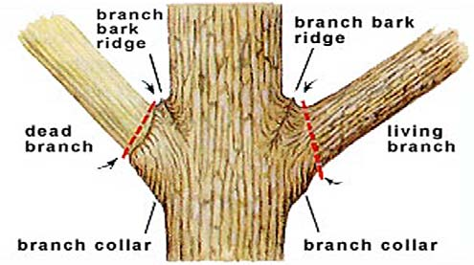
Images and information taken from: https://agrilife.org/treecarekit/planting-tree-maintenance/how-to-prune-a-tree/

Matthew R. March, MNRD
County Extension Agent- Agriculture & Natural Resources
Polk County | Texas A&M AgriLife Extension Service
602 E Church St Ste 127 Livingston, TX 77351
Phone: (936) 327-6828

Brown Patch, December 14-20
During this fall I witnessed several outbreaks of brown patch on homeowners’ St. Augustine Grass, in fact I even noticed it in the lawn outside of my office. Brown patch is a fungal disease that can affect both warm and cool season turf grasses. This includes hybrid Bermuda, common Bermuda, centipede grass, St. Augustine grass, zoysiagrass, fescue, perennial ryegrass, and poa species. In Polk County, homeowners rarely use cool season grasses as turf, so the problem tends to be in warm season grasses such as Bermuda and St. Augustine. Unlike most other disease that effect our warm season grasses during the spring through summer period, brown patch becomes a problem during fall through spring when the grass is emerging form dormancy.
Brown patch is caused by the fungus Rhizoctonia solani and tends to become an issue when evening temperatures are below 65 degrees F. and during periods of increased rainfall. Interestingly, symptoms vary between cool and warm season grasses. On cool season grasses a darkened border or smoke ring may develop at the outer margin of the patches. On warm season grasses irregular circular patches of blighted turf form which may be up to several yards in diameter. Infections that are still spreading, thus increasing the diameter of the patch, will have noticeable yellow leaves on the edge of the patch. Leaf sheaths will become rotted and the leaf blade can be easily removed from the runner. Brown path infections will typically disappear when air temperatures rise above 90 degrees F and during dry conditions.
Management should be focused on cultural practices to reduce the risk of infection instead of relying on fungicides. Do not over water and watering should only occur early in the day to allow grass to dry quickly. Avoid over fertilization in the spring and fall by conducting a soil sample test and applying the appropriate amount of fertilizer. Good drainage and aeration can also improve the root system which will reduce damage caused by brown patch. Fungicides may be used during large infections and an effective list of fungicides can be found at https://plantdiseasehandbook.tamu.edu/landscaping/lawn-turf/chemical-controls-for-turfgrass-diseases/
Brown patch may be confused with other fungal disease found in turf. Take all root rot can be diagnosed because leaf blades can not be easily removed from runners, unlike in brown patch. Also, take all root rot leaves will lack the slimy dark brown lesion at the base of the leaf which is typically in a brown patch infection. Symptoms form cinch bugs are similar to brown patch, however, cinch bugs can easily be ID by mixing two tablespoons of liquid dishwashing soap with a gallon of water and pouring the mixture evenly over a one square foot of the affected turf. If chinch bugs are present, they should be visible within minutes of pouring the mixture.

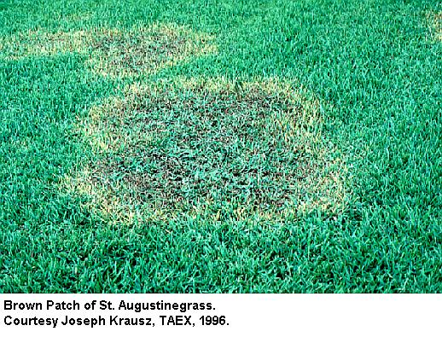
Matthew R. March, MNRD
County Extension Agent- Agriculture & Natural Resources
Polk County | Texas A&M AgriLife Extension Service
602 E Church St Ste 127 Livingston, TX 77351
Phone: (936) 327-6828

Hollys of the Piney Woods, December 21-27
The piney woods are home to an amazing diversity of trees and other plants and during the holiday seasons some of these trees make into our houses for decorations. No, I am not talking about Christmas trees, I am talking about holly trees or shrubs with their vivid bright red berries. Texas is home to approximately 16 species that belong in the holly family. Three of these species, yaupon (ilex vomitoria), possumhaw holly (Ilex decidua), and American holly (Ilex opaca) can be readily found throughout the piney woods and cuttings of the red berries can make festive additions to holiday decorations.
One of the most abundant understory shrubs in the piney woods is yaupon. Yaupon grows across the south from Florida to Texas and as far north as Virginia to Oklahoma. Yaupon is known for its dark green foliage and bright red berries. In fact, the shrub is so popular in landscaping that ornamental varieties exist including dwarf yaupon. Yaupon tends to create a dense thicket when not managed properly causing negative impacts to wildlife and livestock. The leaves and twigs contain caffeine and American Indians brewed tea with the plant creating a drink, which they drank in large quantities ceremonially which would cause them to vomit. Possumhaw holly or deciduous holly is easily recognizable in wintertime with its bare branches and numerous small red berries. Possuhaw holly tends to grow in wetter moister sites and is commonly found along stream banks and along ponds. Unlike yaupon, possumhaw holly is typically not found in large stands. American holly reaches what would be considered tree status and can reach heights of 60 feet. Just like yaupon, American holly is very attractive and thus ornamental varieties exist that can be purchased for landscaping. American holly typically only has one trunk and takes a pyramid shape.
With a little bit of knowledge and practice you can easily learn to ID the differences between the three species. To start possumhaw holly is deciduous, while yaupon and American holly are evergreen. American holly leaves will be oval and typically have leaf margins with sharp edges. While possumhaw holly and yaupon have obovate leaf shape and have smoother leaf margins.
If you are looking for decoration ideas to freshen and lively up your house this holiday season, consider taking some cuttings of holly. Its bright red berries are guaranteed to be a hit with your family and guests!
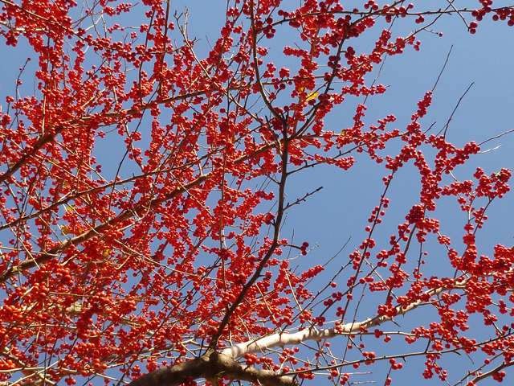
Possumhaw holly, Image take from: https://www.wildflower.org/gallery/result.php?id_image=41666
Matthew R. March, MNRD
County Extension Agent- Agriculture & Natural Resources
Polk County | Texas A&M AgriLife Extension Service
602 E Church St Ste 127 Livingston, TX 77351
Phone: (936) 327-6828

New Year Day Meal, December 28- January 3
As 2020 begins many of you will celebrate the new year by eating foods that are “suppose to bring you luck and prosperity in the new year”. Rather you believe in these superstitious foods or not is for you to decide. But, what I do know is I will be enjoying some delicious black eye peas come New Year Day along with millions of others. A quick google search reveals a laundry list of “New Years Day foods”, however I want to take the opportunity to discuss some of the more common dishes and where the food is produced. This will include black eyed peas, cabbage, cornbread, and pork.
Black eyed peas are a variety of the cowpea (Vigna unguiculata) or also known as the southern pea. Purple hull peas are also a variety of the cowpea. Black eyed peas grow well in drier climates and can produce fruit in regions where other crops require irrigation. For this reason, the top 10 states in black eyed pea production are all western or prairie states. North Dakota leads production with 26% of national cash receipts followed by Michigan, Montana, and Minnesota. Texas comes in at number 11 on the list, but only accounts for 0.6% of cash receipts. Nationwide roughly 1.6 to 1.8 million acres of dry beans are planted a year which includes black eyed peas. In Texas, nearly all commercial production occurs in the high plains region of the state.
Next item on the dinner table is cabbage. Cabbage is grown successfully in small vegetable operations throughout the country, however on a commercial scale 3 states make up approximately 75% of cash receipts nationally. To no surprise California takes 1st place at 46% of cash receipts nationally followed by Florida and New York. Even though considerably smaller in production then the first three states, Texas comes in at number 4 with an economically important cabbage industry. Though only 5,000 acres are planted in cabbage in Texas the value of production is 27 million. Large scale production occurs in the winter garden region southwest of San Antonio and the lower Rio Grande Valley.
Just in case you didn’t know, the main ingredient in cornbread is corn meal. Corn meal is made by gridding or crushing corn in a hammer mill. The midwestern states make up the corn belt in this country. Leading the way includes Iowa, Illinois, Nebraska, Minnesota, Indiana, and Kansas. Corn is one of the few crops that is grown commercially across the county form the eastern seaboard states to California and form the Rio Grande Valley in Texas to the plains of North Dakota. Texas ranks number 12 on the list with only 2.1% of national cash receipts, however 2.5 million acres are planted annually and have a production value of 775 million dollars.
When you compare top pork producing states with top corn producing states a trend quickly develops. States that led corn production also led pork production. This is because corn is a major ingredient in pig feed and it only makes logistical sense to have your pork farms near the corn fields. The three top pork producing states included Iowa, Illinois, and Minnesota. Texas ranks 14 on the national list with all commercial production occurring in the Panhandle.
So when you are sitting down to enjoy your New Years Day meal this year instead of wishing for luck and prosperity take a minute and think of where your food came from and how it may have even been grown by farmers right here in the great state of Texas!
Matthew R. March, MNRD
County Extension Agent- Agriculture & Natural Resources
Polk County | Texas A&M AgriLife Extension Service
602 E Church St Ste 127 Livingston, TX 77351
Phone: (936) 327-6828

Texas A&M AgriLife Extension provides equal opportunities in its programs and employment to all persons, regardless of race, color, sex, religion, national origin, disability, age, genetic information, veteran status, sexual orientation, or gender identity. The Texas A&M University System, U. S. Department of Agriculture, and the County Commissioners Courts of Texas Cooperating. Anyone needing special assistance at an Extension Program should contact the Texas AgriLife Extension Office at (936) 327-6828 at least one week prior to the program or event.

