Texas Leaf Cutter Ants, August 31- September 6
Fire ants are a known nonnative pest, but did you know we have a native Texas leaf cutting ant that is also know to be a pest in certain circumstances. The Texas leaf cutting ant (Atta texana) has several other common names including town ant, cut ant, parasol ant, fungus ant, and night ant. Texas leaf cutting ant can be found throughout Louisiana and the eastern half of Texas down to Mexico, but damage is frequently reported in the piney woods regions of Louisiana and Texas
Texas leaf cutting ants are rust to dark brown in color and size can vary greatly from 1/16 inch to 1/2 inch. Distinguishing characteristics of Texas leaf cutting ants are three pairs of prominent spines on their thorax and one pair of spines in the back of the head. Colonies can consist up to 2 million individuals with up to 4-5 fertile queens producing a continuous supply of eggs. Young queens will fly away from the colony on moonless nights in April, May, and June to establish new colonies. Individual colonies can exist for years and can grow 50 to 80 feet across. Colonies are recognized by numerous crater shaped mounds 5-14 inches in height and 1 to 1 ½ feet in diameter. Chambers below ground may reach 15 to 20 feet in depth. Colonies are easily recognizable and are typically seen along roadsides, open fields, and forest land in deep well drained sand or loam soils. Foraging trails are defined on the ground leading away from the colony. Texas leaf cutting ants forage by cutting leaves and carrying the fragments of leaves back to the nest. Once underground the leaf fragments are used to grow fungus gardens. The ants then eat the fungus which is their only know food source.
Considerable damage can occur within hours and may resemble damage by other leaf chewing insects. If you suspect damage from Texas leaf cutting ants search for a colony as a colony will typically be within sight of where the damage occurred. Also, search the ground for foraging trails which can help you locate the colony. Texas leaf cutting ants are known to forage on pine saplings and when abundant can nearly prevent natural pine establishment. Texas leaf cutting ants are known to strip small to medium trees of forage in a single night and can become a nuisance in landscaping.
Control is extremely difficult. First, most ant bait insecticides do not work because the ants strictly consume fungus and will not consume ant bait insecticides. Secondly, the large colonies with numerous openings make it difficult to apply contact insecticides. Dust or granular formulations such as Orthene, Sevin, or Terro may be used to temporarily protect plants but applications must be frequent. The only available bait labeled for control of leaf cutting ants is Amdro Ant Block which is a special formulation of hydramethylon. Ant activity will decline over a 4 to 6 week period, but a second application is needed half of the time 4 to 6 months later. For best control all mounds should be treated and always use fresh bait as Amdro Ant Block has a short shelf life.
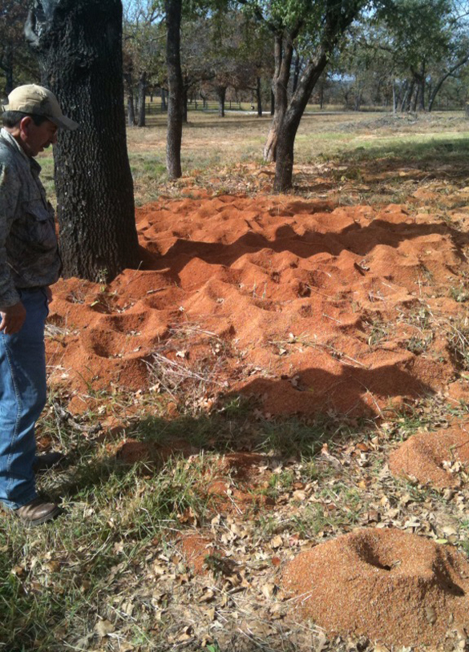
Leaf cutting ant colonies comprise many mounds. Image by Josh Blanek.

Matthew R. March, MNRD
County Extension Agent- Agriculture & Natural Resources
Polk County | Texas A&M AgriLife Extension Service
602 E Church St Ste 127 Livingston, TX 77351
Phone: (936) 327-6828

Fall Webworm, September 7-13

Fall Webworm (Hyphantria cunea) are a native pest of North America that causes easily recognizable damage and most often attacks sweet gum, oak, hickory, and pecan. However, fall webworm is known to attack over 88 plants including many fruit and nut trees, but does not attack needle bearing trees such as pines. Damage from fall webworm are large webs on foliage that make trees more susceptible to drought, diseases, and insects which can cause mortality. Very rarely does fall webworm infestations cause mortality on their own. Adult fall webworm moth’s wingspan is 1-1 ½ inches and can be identified by wings with white or sometimes small dark spots on the forewings. Larvae are approximately 1 inch in length, pale green or yellow, and covered with tufts of long white and black hairs. Larvae feed within the web and eat the tender parts of leaves.
Contrary to the name, fall webworm can also be found in the spring and will have 2-4 generations per year. The fall generation typically receives the most attention as this generation causes the most destructive damage. Pupae will overwinter in sheltered sites such as under tree bark. Moths then emerge in the spring and deposit egg masses on the underside of leaves. Each female will deposit one egg mass that will contain up to 600 eggs. Larvae build a silk web soon after hatching and will expand the web to consume more foliage. After molting six to seven times, larvae will leave the web to pupate to adults and deposit eggs initiating the next generation. The entire life cycle from egg to adult takes approximately 50 days.
Control on smaller trees can be achieved by physically removing webs, caterpillars, and egg masses. Webs found on smaller or lower branches may be pruned to remove infected areas. One option is to tear open the web, which allows access for beneficial predatory insects to help keep the population of fall webworm in check. There are several insecticide options for control, but it should be noted that since fall webworm are usually high in the canopy of trees, high pressure sprayers will achieve greater success then smaller lawn or backpack sprayers. Best control is achieved when insecticides are applied when webs and caterpillars are small. Insecticides with active ingredients such as spinosad, Bt, permethrin, cyfluthrin, bifenthrin, and esfenvalerate are effective. Insecticidal soaps can be effective when applied directly to caterpillars. Always remember to read and follow the label of any insecticide before application.
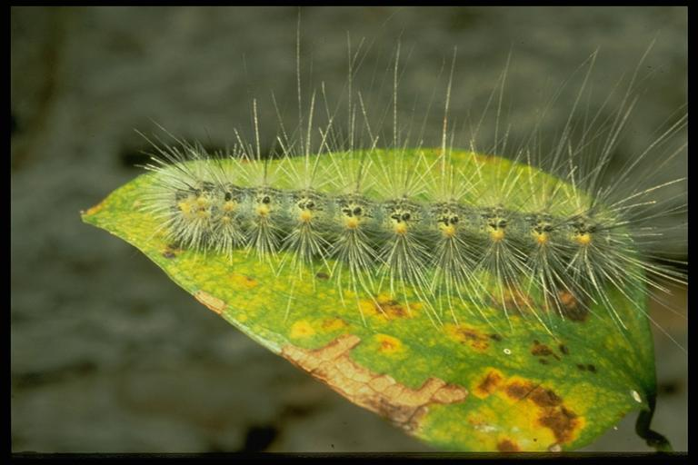
Fall webworm caterpillar. Photo by C. L. Barr.
Matthew R. March, MNRD
County Extension Agent- Agriculture & Natural Resources
Polk County | Texas A&M AgriLife Extension Service
602 E Church St Ste 127 Livingston, TX 77351
Phone: (936) 327-6828

Late Summer Pasture Weeds, September 14-20
As we enter the transitional period between late summer and early fall many of our pastures and hay fields will become choked with what I call late summer weeds. Late summer weeds have one defining trait that I use to lump these weeds together. This trait is these weeds will initiate growth in late spring through midsummer, but will typically not become an issue until August to October time period. Even though these weeds will be present throughout summer they typically go unnoticed until they reach the reproductive stage in late summer. These weeds go unnoticed when they are seedlings during early to midsummer because they are not a visible problem until late summer when they become taller and begin flowering in the reproductive stage.
The list of late summer weeds can be a long one, but for today I just want to focus on the more common weeds we found in our area. This list can include bitter sneezeweed, annual broom weed, Carolina horse nettle, one seeded croton, wooly croton or goat weed, goldenrod, snow on the prairie, silverleaf nightshade, and western ragweed. Even though these weeds are undesirable in an improved pasture setting some of these weeds are important for wildlife. Western ragweed is good forage for browsing wildlife, while one seeded croton and wooly croton seeds are consumed by dove, quail, and other seed eating birds. Weeds on this list can also be toxic to livestock in certain instances. This includes bitter sneezeweed, Carolina horse nettle, snow on the prairie, and silverleaf nightshade.
Management options include either mechanical removal or herbicide. Many producers choose to shred the weeds as it will provide instant removal and is relatively cheap when compared to herbicide. Shredding should always be done prior to the weeds setting seed because shredding after the weed set seeds is strictly for visual appearance and will not help with control. You should also except infestations of these weeds next summer even after a shredding. This is due to either the weeds are perennial and will re sprout from root stock or the weeds are annual and will germinate from seeds already in the seed bank from previous years. I have heard the saying before that one year of weeds provides seeds for seven years and that saying seems to be applicable for late summer weeds. If late summer weeds are a problem in a small area, such as around working pens, you may consider grubbing out individual plants prior to seeding. Grubbing can be highly effective on perennial weeds but is labor intensive. Herbicide treatments is the most reliable method for long term control of late summer weeds, but timing is critical. Herbicide treatments should be applied during early to midsummer prior to weeds setting seeds and it most cases when plants are in the seedling stage. Waiting till late summer when weeds mature and become a visible issue will require a higher rate of application and mortality will decrease. If late summer weeds have been a problem in previous years you should plan on an herbicide application. Below is a partial list of herbicide options for late summer weeds.
Bitter sneezeweed: Cimarron Max, Cimarron Plus, Chaparral, Grazon Next, Pasturegard
Annual broomweed: Cimarron Max, Cimarron Plus, Chaparral, Grazon Next, Pasturegard
Carolina horse nettle: Cimarron Max, Chaparral, Grazon Next, Surmount
One seeded and wooly croton: Cimarron Max, Cimarron Plus, Chaparral, Grazon Next, Pasturegard
Goldenrod: Cimarron Max
Snow on the prairie: Cimarron Max, Chaparral, Grazon Next
Silverleaf Nightshade: Cimarron Max, Chaparral, Grazon Next
Western ragweed: Cimarron Max, Chaparral, Grazon Next, Pasturegard

Matthew R. March, MNRD
County Extension Agent- Agriculture & Natural Resources
Polk County | Texas A&M AgriLife Extension Service
602 E Church St Ste 127 Livingston, TX 77351
Phone: (936) 327-6828

Backyard Turkeys, September 21-27
Raising turkeys in small flocks or in a “backyard setting” is very similar to raisings meat bird type chickens. However, there are some management differences between turkeys and chickens that need to be considered to successfully raise turkeys. Before you decide to raise turkeys in a small flock situation you need to understand the expenses will be higher than what it would cost you to purchase a turkey at the grocery store.
First, you must select which variety of turkeys you want to raise. Broad breasted white is the only variety grown commercial for meat in the U.S. and is the most common variety. Broad breasted white is an efficient breast meat producer and adult toms weight in at 35lbs while hens weigh in at 18lbs. Other varieties that can be found in the U.S. include black, bourbon red, bronze, narragansett, and white holland. Bronze variety is very similar to the broad breasted white variety except being bronze in color. One of the most important considerations in turkey management is housing. Due to predators, disease, and weather I highly recommend raising your turkeys in a structure. The structure or grow out house should be dry, well ventilated, and allow protection from predators. Turkeys are more resilient to weather extremes then meat type chickens. Adequate fans and siding that can be raised to allow ventilation is necessary for summer while during the winter siding should be closed to retain heat. Supplemental heat will be needed for poults, young turkeys, while it may not be necessary for older birds. Supplemental heat will increase production and make your older birds more comfortable during the winter but unless temperatures drop below freezing for an extended amount of time older birds will survive. Frost bite can occur on the tom’s wobbles and snoods. Litter can consist of sand, rice hulls, pine shavings, and straw. Pine shavings typically work the best and should be replaced when litter no longer remains dry. Lighting should be continues until around 5-6 weeks of age. After 5-6 weeks supplemental lighting can be used for 12-16 hours a day. Do not allow hens to be exposed to supplemental light after 12 weeks as egg laying may begin which will reduce the quality of fleshing.
Next you must obtain your poults by either breeding and incubating your own eggs or buying poults from a hatchery. Breeding turkeys can be a challenge on varieties with large breast meat yield such as the broad breasted white. For these varieties natural fertilization is nearly impossible, and birds must be artificially inseminated. Eggs should be collected daily form breeder hens and kept refrigerated until placed in an incubator. Incubation period for turkeys is 28 days. Poults will need supplemental heat for at least the first four weeks and a good rule of thumb is for week one start at 92-95 degrees and reduce by 5 degrees every week until temperature reaches 70 degrees. Toms and hens may be raised together, but it is recommended that you separate hens around 12 weeks of age. This will prevent toms from mounting hens at they mature which can cause damage to fleshing. Feed turkey starter with at least 26 percent protein for the first 12 weeks and then switch to turkey finisher. Standard poultry feeders work great for turkeys however bell type drinkers must be used. Turkeys cannot drink water from nipple drinkers and should never be used in a turkey house. Broad breasted white turkeys are raised to 16-18 weeks of age with hens being harvest at 16 weeks of age and toms closer to 18 weeks of age. Other varieties are raised longer due to decreased growth rates.
Lastly, turkeys have unique flock health management requirements when compared to meat type chickens. Poults should be vaccinated for fowl pox at 3-4 weeks of age with a second vaccination at 12 weeks of age. Common health issues include respiratory infections, worms, and external parasites. Cannibalism is a major issue in turkey flocks and can be combatted by debeaking one third of the upper beak. Even with debeaking, cannibalism can be an issue and options include separating toms from hens, avoid overcrowding, and avoid feeding mash feed.
If you are interested in raising turkeys stop by the office and we can further discuss management options.
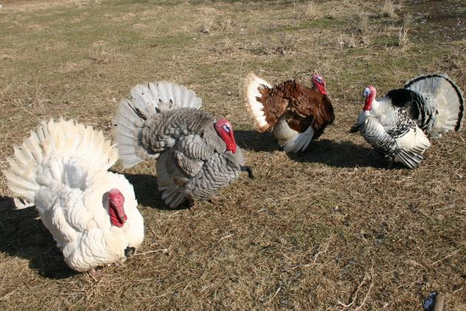White Holland, Slate, Bourbon Red, and Royal Palm turkey varieties. Source: John Anderson, The Ohio State University.
Matthew R. March, MNRD
County Extension Agent- Agriculture & Natural Resources
Polk County | Texas A&M AgriLife Extension Service
602 E Church St Ste 127 Livingston, TX 77351
Phone: (936) 327-6828

Little Bluestem, September 28 - October 4

During this time of the year one of the most important and widespread native grass found in Texas makes its presence known with an easily recognizable 2-4 foot blue to almost purplish culms (seed heads). The grass I am referring to is little bluestem (Schizachyrium scoparium). Little bluestem can be found throughout the state from pine forest, tall grass prairies, to mountains out west. Little bluestem is economically important for ranchers throughout the state due to its abundance and its grazing nutritional value rated as good.
Little bluestem is classified as a bunchgrass and is considered one of the “big four” tall grasses. Little bluestem is recognized by blue green leaves during the summer that turn reddish brown by late fall and unless grazed will remain throughout winter. During most of the growing season basal leaves will reach 12 to 18 inches tall creating a dense leafy base but come fall culms can reach heights of 6 feet. Little bluestem can be found in a widespread of habitats and soil types. It can be abundant both along roadsides and in certain native rangelands where it can make up 30 to 40 percent of herbaceous plant composition. Pinehill little bluestem is a variety of little bluestem unique to the sandy hills of east Texas. Little bluestem can be confused with other native grasses such as splitbeard bluestem and broomsedge bluestem, however their seeds are hairy then little bluestem.
Grazing of little bluestem can occur throughout the year even into winter when the plant is dormant. However, the highest protein levels are found in early summer, which can average 8 to 9 percent, but can be as high as 12 percent. Protein and mineral supplement are not needed during the growing season but should be provided during winter when protein levels can drop as low as 3 percent. Forage production can reach 1,500 to 4,000 lbs. of dry forage a year per acre. Little bluestem is rated as poor value as forage for wildlife, however it provides excellent nesting habitat for ground nesting birds and cover for fawns. Basketball size clumps of little bluestem make excellent nesting habitat for bobwhite quail. When managing for quail, you should strive for 300 basketball size clumps per acre.
Proper stocking rate is necessary for management and no more then half of total production should be grazed. If more then half of production is grazed, then less desirable grasses and brush will outcompete little bluestem. Rotational grazing is ideal, however little bluestem can be managed successfully in a continuous grazing system. Little bluestem responds favorable to prescribed fire and can be an important management tool. Establishment can be achieved by seed or though root stock. When planting seed the most important thing to remember is good seed to soil contact and reduce competition from other plants. Most seed companies offer little bluestem seeds collected from varieties not found in east Texas. If establishing little bluestem in east Texas try to find locally source seeds as they will more likely be the pinehill little bluestem variety which is necessary for successful establishment.
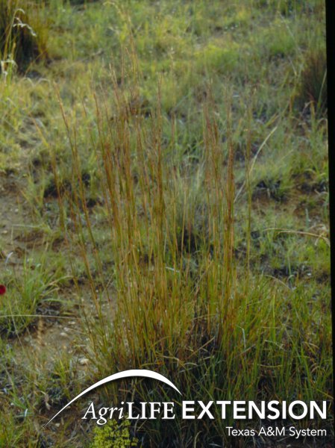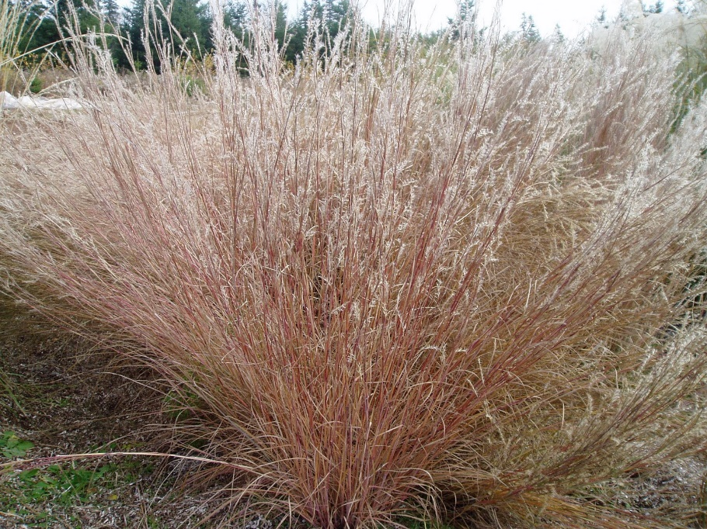

Matthew R. March, MNRD
County Extension Agent- Agriculture & Natural Resources
Polk County | Texas A&M AgriLife Extension Service
602 E Church St Ste 127 Livingston, TX 77351
Phone: (936) 327-6828

Texas A&M AgriLife Extension provides equal opportunities in its programs and employment to all persons, regardless of race, color, sex, religion, national origin, disability, age, genetic information, veteran status, sexual orientation, or gender identity. The Texas A&M University System, U. S. Department of Agriculture, and the County Commissioners Courts of Texas Cooperating. Anyone needing special assistance at an Extension Program should contact the Texas AgriLife Extension Office at (936) 327-6828 at least one week prior to the program or event.

