Bobwhite Quail and the Forest of East Texas, August 3-9
When thinking of bobwhite quail (Colinus virginianus) in Texas images of the rolling mid grass prairies of west Texas or the south Texas brushland immediately come to mind. In contrast the forest of east Texas is rarely viewed as being a region to find bobwhite quail. However, this can be farthest from the truth. If you don’t believe me just ask some of the old timers about the “good old days” of bobwhite quail hunting in east Texas. During the first half of the 1900’s there was still a large population of bobwhite quail in east Texas and certain areas where even well known for producing excellent quail hunting. Bobwhite quail can still be found throughout east Texas but are becoming harder and harder to find due to a variety of reasons, with the likely number one cause being loss of habitat.

I want to first briefly review some additional factors other than habitat that have been suggested as the reason for the decline. These include feral hogs, red imported fire ants, diseases, and parasites. Feral hogs have been showed to impact quail populations on a local scale but are not the reason for population declines on a regional scale. This is because quail populations have also declined in areas where feral hog populations are minimal. In areas with good habitat feral hogs have shown minimal impacts compared to areas with poor habitat where impacts may be greater. Red imported fire ants have demonstrated direct impacts on quail by attacking eggs and chicks. Indirect impacts including reducing the native population of invertebrates, which are an important part of the diet for young chicks. However, quail populations have flourished in areas with red imported fire ants, thus suggesting habitat quality may play a major role in the severity of impacts from red imported fire ants. Research is ongoing on the impact of such diseases as Avian Influenza Virus has on quail populations. Research is also ongoing on helminths (parasitic worms) that can be commonly found in quail. The research into these topics have not reached a decisive conclusion, however it should be noted that preliminary results suggest quality habitat plays in important role in reducing the impacts of disease and parasites.

You may have noticed a trend, bobwhite quail management and reversing their decline is all about managing habitat. When analyzing habitat in the forest of east Texas we first must understand the last 150 plus years of land change that has occurred. Historically, east Texas was a savannah type habitat with a more open canopy that allowed grass and herbaceous growth underneath. Under these historical habitat conditions bobwhite quail thrived. Then as we logged the forest, we created a mecca for bobwhite quail. This may seem odd since we where destroying habitat, but by logging forest we created all cover types bobwhite quail need. Bobwhite quail need basically three types of cover; cover for nesting and protection, bare ground/open space for movement, and grassland for foraging. Logging help to create this patchwork of habitat for a period throughout east Texas. Next we planted pine plantations, allowed regrowth forest to develop a dense woody understory and converted pastures to improved grasses. These types of habitats are a desert for bobwhite quail and is a leading reason why their populations have declined across east Texas.

Even though the forest of east Texas has been transformed several times in the last 150 plus years bobwhite quail still can be found throughout, but their populations are considerably lower and in most places to low to even by noticed or huntable. However, the outlook for bobwhite quail in east Texas can be positive as it has been demonstrated on both public and private lands with proper habitat management bobwhite quail populations can improve. To learn more about bobwhite quail management make sure to attend Polk County Game Management Seminar Series on August 15th where we will take an in depth look at habitat needs and management. The seminar will start at 10:00 at the AgriLife Extension Meeting Room. Please RSVP by August 12th. To RSVP or for more information call 936-327-6828.

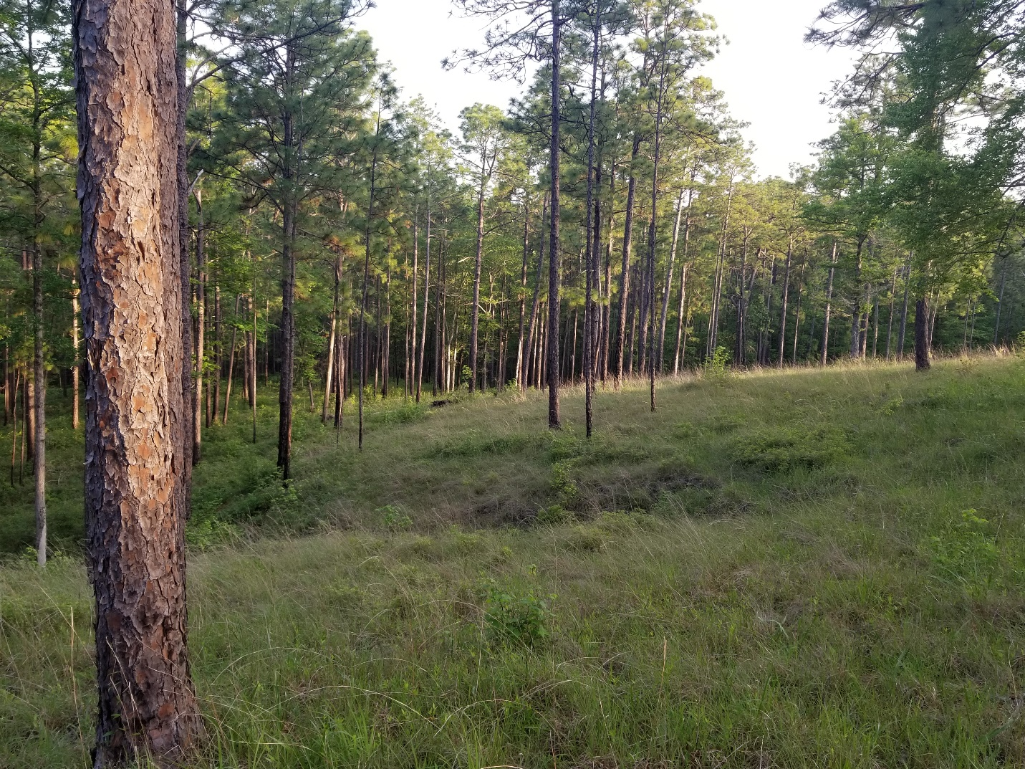
Example of good quail habitat in the Sabine National Forest

Matthew R. March, MNRD
County Extension Agent- Agriculture & Natural Resources
Polk County | Texas A&M AgriLife Extension Service
602 E Church St Ste 127 Livingston, TX 77351
Phone: (936) 327-6828

Natural and Alternative Methods for Red Imported Fire Ant Control, August 10-16
Red Imported Fire ants, commonly known as fire ants, may be the one critter that every homeowner has, and every homeowner wants to get rid of. Thankfully, fire ants can be controlled with relative ease with conventional insecticide products. But, for a variety of reasons, a growing number of homeowners want to control fire ants with non-conventional products and methods such as natural insecticides. Alternative methods are generally classified into 6 categories: natural and biological control, physical and mechanical methods, control devices, home remedies, “organic” botanical insecticides, and inorganic compounds.
Natural and biological control would include introducing a predator of fire ants to help suppress the population. Since fire ants are non-native, they lack any natural predators here in the U.S. Research has been conducted on importing natural predators of fire ants from their native range. Currently, no such predator has shown the ability to suppress or control the population here in Texas. An example would be a parasitic fly that attacks only fire ants that has been released and spreading throughout Texas. Even though research has shown the parasitic fly is doing what it was brought here to do it is having a minimal to no effect on the overall population of fire ants.
A common physical and mechanical method is to pour boiling water on individual mounds. You can expect about 60% of mounds to be eliminated by pouring three gallons of water on each individual mound in the morning when ants are active at the surface. Talcum powder or Teflon tape can be used to create a barrier to protect sensitive areas.
Control devices are any product that does not use chemical insecticides or microorganisms. Consumers should be aware that if a product is labeled as a control device it does not indicate its effectiveness to control fire ants. Most control devices will kill a percentage of ants but are unable to effectively eliminate a colony.
Home remedies are generally ineffective and may or may not be considered “natural or organic” depending on what your definition of “natural or organic” is. Home remedies can include pouring diesel, gasoline, soap solutions, liquid detergent and other non-pesticide products on mounds. Home remedies do not follow manufactures use of their products and are thus not recommended due to the potential to kill grass, other plants, and pollute the soil.
Botanical insecticides are derived from plants and generally work on contact. Pyrethrins are effective and can kill ants within minutes. Some pyrethrins products may be mixed with synthetically produced additives such as PBO, which is generally not accepted as an “organic” product. Rotenone is another botanical based insecticide that attacks the respiratory system of fire ants. Plant oil products such as orange oil contain toxins to fire ants that are typically applied as a mound drench.
Diatomaceous earth would be considered an inorganic compound. Diatomaceous earth generally does not work good outdoors and will not eliminate colonies. Spinosad baits and abamectin baits are products that are developed from compounds created during natural fermentation performed by specific microorganisms in soil.
Every homeowner has fire ants and rather you choose a conventional or non-conventional method to combat this pest is a personal decision. Which ever method you decide on do your research in choose a product that matches your goals. And lastly, the best practice for fire ant control is to first use a sequential broadcast application of a product followed by selective treatment of individual mounds.

Matthew R. March, MNRD
County Extension Agent- Agriculture & Natural Resources
Polk County | Texas A&M AgriLife Extension Service
602 E Church St Ste 127 Livingston, TX 77351
Phone: (936) 327-6828

Bermuda Grass Stem Maggot, August 17-23
If you are a hay producer with Bermuda grass fields, you need to be on the lookout for Bermuda grass stem maggot (Atherigona reversura). Bermuda grass stem maggot is a non-native pest from south Asia that can infests Bermuda grass fields. This pest is a relatively new pest to not only Texas, but across the Southern United States. Bermuda grass stem maggot is of economic importance as it is rapidly spreading westward and can cause damage and reduced yields.
The first reports of Bermuda grass stem maggot came from Georgia in 2010, since that time the pest has now been reported across the south including the first reports in Texas in 2013. Infestations started in Van Zandt, Comanche, and Lavaca counties and have since spread throughout central, eastern, and upper cost regions of Texas. Long before damage is seen in your hay fields an adult Bermuda grass stem maggot will lay eggs on Bermuda grass stems. The adult fly is about the size of horn flies and have a yellow abdomen with a black head. The eggs will then hatch, and a larva or maggot will move to the top plant node, burrow into the stem, and will consume the material within the stem. Maggots are white to yellowish with a black head and are 1/8 – 3/16 inches long. Populations will typically increase during the growing season so highest amount of damage should be expected and late summer through early fall unless management activities are implemented. In a grazing situation top shoots and nodes of Bermuda grass are routinely grazed along with any potential eggs, thus making damage in pasture situations negligible. The same is true in lawn situations where the top shoots are routinely mowed.
An infestation is typically not noticed until damage can be observed. Unfortunately, procedures for monitoring for the adult fly have not yet been developed, so management is reactive instead of proactive. Damage observed is death of the top two or three leaves while the remainder of the plant remains green. This causes a “frost damage appearance” which is typically when producers notice an infestation. Because the maggot kills the top of the stem the growing point is destroyed, and a new shoot must be developed for growth to continue. Many producers may just wait for the grass to recovery with new shoots and assume yield will not suffer. However, the problem with this thought process is in most situations adult flies will lay eggs on the new shoots spreading the infestation. For this reason, once damage is seen in a field, yield should not be expected to increase after that point. Bermuda grass stem maggot is more commonly seen in finer stemmed cultivars, such as coastal, Alicia, Russell, and common Bermuda. It should also be noted that yield reduction from damage is higher when growing conditions are poor.
Since this is a relatively new pest researchers are still trying to figure out the best management options. As of now the best management option is to bale and remove the crop as soon as weather conditions allow after damage is observed. The reasoning for this is yield will not increase significantly after damage is observed. To prevent adult flies from restarting the life cycle on new shoots after harvesting an insecticide should be applied. An application of a pyrethroid insecticide should occur 7 days after cutting or when green up occurs. A single application is usually sufficient, but a second application could occur 5-7 days later.

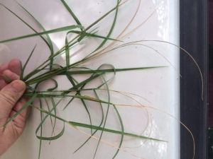
Damage caused by the bermudagrass stem maggot (Photo courtesy of Richard Waligura, Waller County, TX)

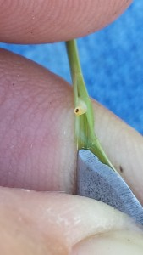
Bermudagrass Stem Maggot (Photo courtesy of Joe Janak)

Matthew R. March, MNRD
County Extension Agent- Agriculture & Natural Resources
Polk County | Texas A&M AgriLife Extension Service
602 E Church St Ste 127 Livingston, TX 77351
Phone: (936) 327-6828

Live Oak Sucker Growth, August 24-30

Live oak trees make a great addition to any yard or neighbor because they are long lived, semi-evergreen, grow too large sizes, produce plentifully shade, and hardy. For these reasons live oaks are found throughout yards and subdivisions in the eastern half of Texas. However, there is one characteristic of live oaks that can become a nuisance and eye sore to many homeowners. Live oak sucker growth is when a tree will sprout an abundance of new trees or sucker growths from the root system. Depending on the severity, hundreds of new growths can be found around the base of the tree.

Instead of relying solely on seeds to germinate and continue the species sucker growths allow live oaks trees to have additionally methods to propagate and spread. Sucker growths play an important role in certain regions of the state, such as in central Texas, where oak trees form motts and become the dominate species. These sucker growths allow the parent tree to from motts and which most of the individual trees are clones. Understanding that sucker growths originate from roots of the parent tree and have a direct connection through the root system to the parent tree is a very important consideration when determining management options. There is also a great deal of variability in sucker growth from tree to tree. Some live oak trees will produce not one sucker growth while other will produce thousands in their lifetime. The correlation between why certain trees are prone to sucker growth is not well understood. Tree nurseries have selected for live oaks that are not prone to sucker growth, thus when planting a tree, you should purchase seedlings from a nursey and not transplant seedlings from your neighbors’ pasture.

Unfortunately, management options are limited for live oak sucker growth. One of the first steps many homeowners want to do is apply an herbicide to the suckers, however this should never be done! Since the suckers are directly attached to the root system of your parent tree any herbicide application stands a high chance of causing damage to the parent tree. Another management option many homeowners attempt is to suffocate the suckers by mowing and then covering with either landscaping plastic, gravel, or mulch. Covering will cause short term success, however the suckers will not die since they are still attached to the parent tree and will eventually poke thorough. There are only three realistic management options in none are very good. The first is to cut down the parent live oak and replace with a new live oak that will hopefully produce less sucker growths. The second is to routinely mow the sucker growths. This option will not get rid of the suckers but will make them less noticeable. The third option is to learn to live with live oak sucker growths.

Live oak sucker growths can be very unappealing in a yard or landscaping. These sucker growths can be a thorn in a side to some homeowners and they will attempt just about everything under the sun to get rid of them. Unfortunately, management options are limited, and homeowners have three options kill the parent tree, mow regularly, or just get used to the eyesore.

Matthew R. March, MNRD
County Extension Agent- Agriculture & Natural Resources
Polk County | Texas A&M AgriLife Extension Service
602 E Church St Ste 127 Livingston, TX 77351
Phone: (936) 327-6828

Texas A&M AgriLife Extension provides equal opportunities in its programs and employment to all persons, regardless of race, color, sex, religion, national origin, disability, age, genetic information, veteran status, sexual orientation, or gender identity. The Texas A&M University System, U. S. Department of Agriculture, and the County Commissioners Courts of Texas Cooperating. Anyone needing special assistance at an Extension Program should contact the Texas AgriLife Extension Office at (936) 327-6828 at least one week prior to the program or event.

