Pecan Nut Casebearer, July 6-12
I receive almost weekly inquiries from individuals wanting to increase crop yields on their pecan trees. I understand landowners’ frustrations; they have what looks like healthy and happy pecan trees that fail to produce a significant if any crop. Nine times out of ten yields can be increased by managing for pecan scab and pecan nut casebearer. Pecan scab is a fungus disease that effects pecan trees throughout the south. Since I have spent time writing about pecan scab this past year, I want to know discuss pecan nut casebearer. Pecan nut casebearer in the most economically important nut infesting insect in Texas. The reason why it is so devasting is the larvae tunnel into nutlets shortly after pollination leading to destruction of all the nutlets in the cluster.

The life cycle of a pecan nut casebearer begins when an adult casebearer moth, which is gray to black, lays eggs on nutlets shortly after pollination occurs. Adult moths are active at night and each female will lay between 50-150 eggs. The eggs are barely visible to the naked eye and are oval and flat. Within 4 to 5 days the eggs will hatch and will begin feeding on buds. After two days the larvae then tunnel into the pecan nutlet, typically at the base, where they will feed for 4 to 5 weeks. The larvae will then complete metamorphosis into adult moths in the nut before emerging and continuing the cycle. This cycle will repeat itself 2-4 times during the growing season. Each cycle is considered a generation, with the first generation beginning in the spring. First generation causes the most damage as the larvae feed on developing nutlets in the spring. Second generation can also cause damage during mid-summer as they feed on nuts. Third and fourth generation typically are not of major concern as they usually feed on shucks if the pecan shell has hardened. Additionally, third and fourth generations sometimes do not feed and will crawl to the base of a dormant bud to build a cocoon to survive the winter.

Scouting is essential for management. First generation should receive the most scouting effort due to their potential damage to yield. Additionally, scouting is necessary because once the larvae enters the nut it is protected form insecticide. Nutlets should be carefully examined for eggs during a two-week period from late April to early May. This date will vary depending on weather. Pheromone traps are also useful in scouting as they can be used to anticipate when eggs will be laid. By using traps to catch and monitor for adult moths you can then predict when to begin checking for eggs on nutlets. Once adults moths are captured you should begin checking for eggs 7 to 10 days later.

By performing scouting and monitoring you will be able to determine if infestation levels justify an insecticide treatment. For commercial production, insecticides with active ingredients of pyrethroid and carbaryl or recommended. For residential and homeowner’s, insecticide options include Spinosad (Green Light Lawn and Garden Spray with Spinosad), carbaryl, malathion, and Bacillus thuringiensis. As a reminder only used products labeled for pecans and always follow the label.

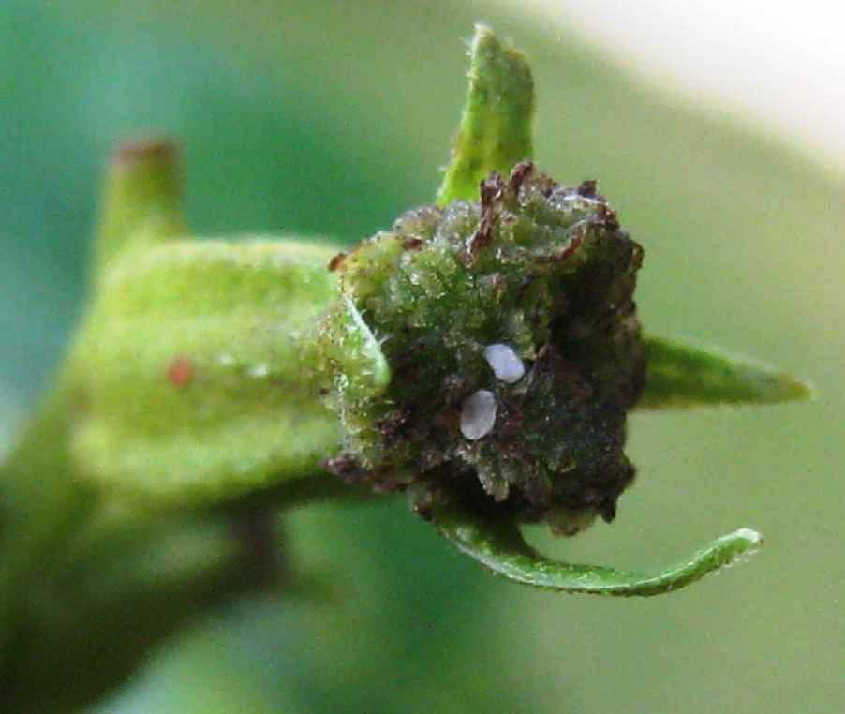
2 white pecan nut casebearer eggs (Image taken from AgriLife)

Matthew R. March, MNRD
County Extension Agent- Agriculture & Natural Resources
Polk County | Texas A&M AgriLife Extension Service
602 E Church St Ste 127 Livingston, TX 77351
Phone: (936) 327-6828

American Beautyberry , July 13-19

American beautyberry (Callicarpa Americana) is a common to abundant understory shrub found from dense to open forest throughout East Texas and the Southern United States. American Beautyberry also goes by other names such as French mulberry or Spanish mulberry. American beautyberry is an easily recognizable attractive plant that is used occasionally in landscaping. However, the plants benefits goes beyond the attractive nature as American beautyberry is a very important plant for a variety of wildlife.

American beautyberry is a fast growing native perennial shrub that can reach heights of ten feet, but is more typically four to six feet tall. Branches will be light gray to reddish with young twigs having white hairs. Leaves are simple, opposite, oval with coarse, saw-toothed margins. Leaves are two to five inches wide and three to nine inches long. Upper sides of leaves may contain minute hairs, while the bottom sides of leaves will be abundantly hairy. Flowers occur in mid spring to early summer and are inconspicuous and can be blue, violet, pink, or white. American beautyberry steals the show come mid to late summer when the fruit matures to form clusters of purple berries that encircle the stems. By fall the leaves drop and most of the berries are consumed by wildlife leaving just bare branches present. American beautyberry can be found in loam, sandy, and shallow upland sites and will become the dominant understory scrub in open pine canopy forest. It can also be found in thickets, right of ways, and along fence rows. Since American beautyberry is considered a pioneer species it is most abundant in open forest and will decrease in numbers as forest become denser and sunlight is blocked. For this reason, disturbances such as prescribed fire, forest thinning, brush management, and clearing of right of ways will create ideal growing conditions.

Besides being aesthetically appealing American beautyberry greatest contribution is its benefit to a variety of wildlife. The purple berries are readily consumed by over forty species of songbirds such as American robin, brown thrasher, purple finch, and eastern towhee. The berries are also on the menu for other forest animals including turkey, quail, armadillos, foxes, opossum, raccoons, and squirrels. Lastly, American beautyberry is an important plant for white tail deer. White tail deer will both consume the berries and browse leaves and young twigs. Crude protein values may run as high as eighteen percent in the spring when the plant is growing new leaves and twigs. American beautyberry is rated as having good browse value making it an important species to consider in a white tail deer management plan. Management would include any activity that allows sunlight to reach the forest floor including brush management, prescribed burn and forest thinning. Highest protein content can be achieved in the spring after a cool season prescribed burn. Cattle will also graze on American beautyberry and if present rotational grazing may be needed to ensure seeds have a chance to ripen.

American beautyberry is one of the most common understory plants found in the eastern third of Texas, especially in open canopy forest. However, their benefit to wildlife is often overlooked and are more well known for their vibrant purple berries. Rather you have a native landscaping in your backyard or own a thousand acre forest every effort should be taken to manage for American beautyberry.

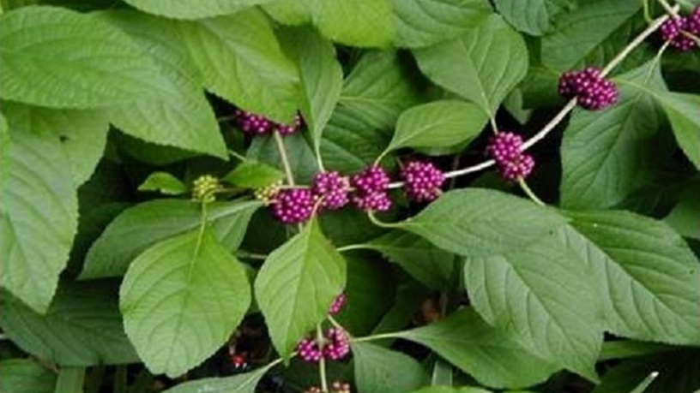
Image taken from USDA

Matthew R. March, MNRD
County Extension Agent- Agriculture & Natural Resources
Polk County | Texas A&M AgriLife Extension Service
602 E Church St Ste 127 Livingston, TX 77351
Phone: (936) 327-6828

Take All Root Rot, July 20-26
One of the most frustrating sights for any homeowner or landscaper is watching a perfectly healthy green lawn begin yellowing, turn brown and eventually develop large dead irregular patches. These symptoms can be a sign of a fungal disease, specifically take all root rot. Take all root rot can severely affect both St. Augustine grass and Bermuda grass. Take all root rot is causes by a fungus, Gaeumannomyces graminis var. graminis. What may be most disturbing is this fungus can be found in lawns across Texas that are both healthy and diseased looking.

The fungus causing take all root rot can be found in the thatch layer of the soil. The thatch layer includes decaying plant material and stolons that can be found along the ground surface. Unlike other fungus diseases, take all root rot is not typically spread by spores. However, it can easily be spread to a new lawn by transferring infected grass, thatch, and soil. Symptoms of the fungus can be seen anytime during the growing season, but is most prevalent during spring and early summer. Environmental stresses such as heat, drought, shade, excess nitrogen, soil compaction, and alkaline soils can exacerbate symptoms. Initial signs of take all root rot is yellowing of foliage followed by foliage turning brown and thinning irregular patches that can range from one to twenty feet. Infected grasses will have discolored nodes, typically yellow, along with shorten blackened roots. Because the fungus effects the roots, infected plants will usually lift out of the soil easily. Take all root rot has similar symptoms to another fungus disease called large patch. However, large patch will occur from fall until early spring compared to take all root rot which is most prevalent in spring and early summer. Additionally, large patch will cause dark brown slimy lesions at the base of leaves. Chinch bug infestation will also demonstrate similar symptoms as take all root rot. In some cases, lawns may be suffering form both a cinch bug infestation and take all root rot.

One of the best management tools for take all root rot is to ensure grass is stress free. This includes but is not limited to proper irrigation, soil aeration, good drainage, proper mowing height of at least two and half inches, and avoiding overapplying nitrogen. After a lawn becomes infected an application of fungicide will be required to regain control. Fungicides should be applied in the spring and fall. Ensure the lawn is watered immediately after application to achieve the best results. Fungicide options include but are not limited to azoxystrobin (Heritage), propiconazole (Banner Maxx), thiophanate-methyl (Cleary's 3336), and myclobutanil (Eagle).

Take all root rot can be devasting to lawns and be very frustrating for homeowners as dead patches are not a desirable sight. However, by recognizing the disease certain steps can be followed to reduce symptoms. First, ensure your lawn is properly cared for to ensure the grass is stress free. Secondly, if the disease is detected an application of fungicide should occur. Lastly, it is a good management practice to apply a preventative fungicide treatment in both the spring and fall.

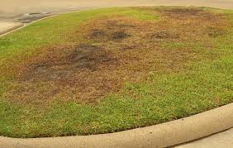
Image taken from aggieturf.tamu.edu

Matthew R. March, MNRD
County Extension Agent- Agriculture & Natural Resources
Polk County | Texas A&M AgriLife Extension Service
602 E Church St Ste 127 Livingston, TX 77351
Phone: (936) 327-6828

Coccidiosis in Poultry, July 27 – August 2

Rather raising poultry commercially or as a hobby one of the most common diseases present in flocks is Coccidiosis. Coccidiosis is an intestinal disease that effects the bird’s health and when left untreated may cause mortality. Coccidiosis can be caused by multiply species of protozoa. Protozoa are a group of single cell microscopic animals that feed on organic material and can be parasitic. Coccidiosis can cause major health and production issues in both chicken and turkey pouts under eight weeks of age. Coccidiosis is caused by multiply species in the genus Eimeria with E. tenella in chickens and E. adenoids in turkeys being the most severe species.

Eimeria have a complex and direct life cycle resulting in fecal to oral route of infection in individual birds. The complete life cycle takes 4-7 days and starts with an infected bird shedding in fecal matter an unsporulated oocyst. An oocyst is basically a cyst that contains and protects a parasitic pathogen. The oocyst can be easily transported to uninfected flocks by vectors such as humans and equipment. When warm and most conditions are met the oocysts will sporulate releasing the protozoa. The protozoa will then be consumed and ingested and eventually travel to a specific location in the intestine. Different species of Eimeria will affect different parts of the intestine. Next, several cycles of reproduction will occur and which the pathogen will multiply and spread. As the infection spreads, gut lesions will develop and can become very severe. These lesions are the reason why Coccidiosis is such an important disease economically, because the lesions reduce feed conversion leading to decreased growth and meat production. Eventually the pathogens will produce mature oocyst which will leave the intestine in the fecal matter repeating the cycle.

General signs of Coccidiosis include reduce growth, chilled appearance, huddling around heat sources, ruffled feathers, bloody diarrhea, dehydration, anemia, and increased mortality if left untreated. The severity of the infection is based on several factors. This includes species of Eimeria, dose, immune status of the bird, and medication status of the flock. Diagnosis of Coccidiosis can only be confirmed by either performing a necropsy, fecal parasitology, and intestinal scrapings. Immunity can be achieved, but immunity is only produced to individual species of Eimeria and will not be passed from hens to chicks.

Management of Coccidiosis includes environmental management and medication. Environmental management includes controlling moisture, avoiding overcrowding, raising birds on wire if possible, composting or cleaning litter, and practicing good biosecurity. Medication consist of either vaccines or anticoccidiostats. Vaccines consist of live oocyst which can complete their life cycle to provide immunity. Vaccination usually occurs in turkey and breeder bird flocks. This is because long term immunity needs to be achieved due to these flocks having a longer production life. In broiler flocks that have a shorter production life anticoccidiostats are administrated to block the growth of Eimeria in the intestine. Resistance can develop overtime so a program which rotates different types of anticoccidostats will help prevent resistance.

Coccidiosis is a major disease found in poultry flocks and is one of the most important due to its economic impacts. Coccidiosis will continue to be a problematic disease, however, know management strategies can be effective in reducing the impact of Coccidiosis. This includes environmental management, vaccination, and anticoccidiostats.

Matthew R. March, MNRD
County Extension Agent- Agriculture & Natural Resources
Polk County | Texas A&M AgriLife Extension Service
602 E Church St Ste 127 Livingston, TX 77351
Phone: (936) 327-6828

Texas A&M AgriLife Extension provides equal opportunities in its programs and employment to all persons, regardless of race, color, sex, religion, national origin, disability, age, genetic information, veteran status, sexual orientation, or gender identity. The Texas A&M University System, U. S. Department of Agriculture, and the County Commissioners Courts of Texas Cooperating. Anyone needing special assistance at an Extension Program should contact the Texas AgriLife Extension Office at (936) 327-6828 at least one week prior to the program or event.

