What is all the buzz about? June 1- 7
Possibly one of the fastest growing agriculture industries in East Texas is bee keeping. Apiculture, which is the technical term for bee keeping is growing in popularity with small landowners, homeowners, and individuals entering the commercial market. Polk County is situated at the heart of honey bee production in East Texas. This is due to variety of factors including mild winters and a smorgasbord of pollinator plants. There has also been a market for locally raised honey that has developed. Because of these reasons, many individuals have gotten caught up in the buzz about bee keeping and have either purchased their own hives or are considering it.
Ironically honey bees, which produce the comb that is processed to make honey, are non-native to North America and are originally from Europe. Native bees go by such names as bumble bees and carpenter bees. Non-native honey bees are social and form colonies and live in hives compared to native bees which are typically not social and live in loose colonies and burrow into trees or the ground. In addition, honey bees readily sting intruders, while native bees are usually not aggressive because they do not have a hive to defend. A large investment is not needed to start bee keeping when considering other agriculture operations such as cattle or hay. In addition, expensive equipment and large tracts of land are not needed. An individual can enter the industry by just raising a few hives in their backyard. Honey bees are divided into three types depending on their role in the hive. Males are drones, while females can either be workers or the queen. Life span is also dependent on the bee’s role. Worker bees can live to several months, drones typically live until they mate, while queens can live 3-4 years. Three broad categories effect honey bee health and they include toxins, both man made and natural, nutrition, and pests. One of the most devastating phenomena is Colony Collapse Disorder and which majority of worker bees in a colony disappear seemingly overnight and leave the healthy queen behind.
If you have caught the buzz and want to learn more about bee keeping, make sure to attend the Honey Bee Conference on June 21st. Topics will be beneficial rather you are a bee keeper, looking to enter the industry, or just wanting education on the subject. Topics will include bee keeping basics, marketing, bee keeping tax exemption, planting for pollinators, and Texas Beekeepers Association. Speakers will be Cary Sims (County Extension Agent), Karla Rudebusch (Rudy’s Honey), Scott Martin (Tyler County Bee Club), Matthew March (County Extension Agent), and Piney Woods Lake Master Naturalists. The Conference will take place at St. Luke’s Episcopal Church in Livingston with registration at 8:30 and the program starting at 9:00. Cost is $20 if RSVP by June 14th and $30 after June 14^{th.} Please RSVP to 936-327-6828. A special thanks is needed for our sponsors: Polk County Farm Bureau, St. Luke’s Episcopal Church, and Polk Ag. Committee.
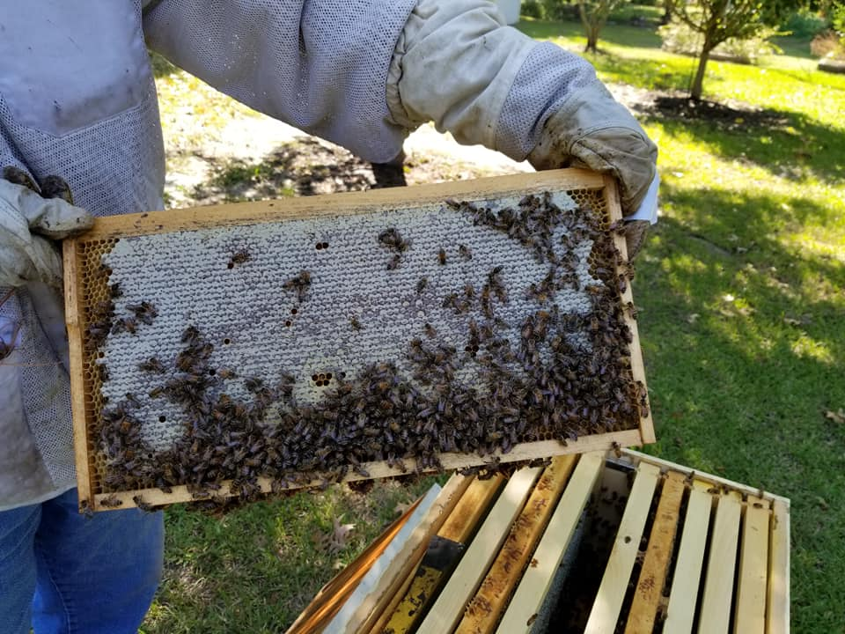
Matthew R. March, MNRD
County Extension Agent- Agriculture & Natural Resources
Polk County | Texas A&M AgriLife Extension Service
602 E Church St Ste 127 Livingston, TX 77351
Phone: (936) 327-6828

Centipede and Millipede Control, June 8-14

During the past month I have received almost daily calls form homeowners worrying about Centipede and/or Millipede invasions around their house, in the garage, or in some cases in the house. Centipedes and Millipedes live around our houses in yards, flower beds, leaf litter and in the woods. Most of the time we pay them no attention because they are not present in large numbers. However, with all the rain we have had the last few months it has forced these critters out of the soil to seek higher ground. Because of this, Centipedes and Millipedes are on the move and, in some cases, have been invading our houses.

Centipedes and Millipedes prefer moist habitat under structures such as stones, logs, litter, mulch, and flower beds. Centipedes spend the winter as adults under the soil and will lay their eggs during warm months. Centipedes can bite with their poison claws and in some species can cause harm with their sharp walking legs. Centipedes live for one to six years compared to Millipedes that can live over ten years. Millipedes are not poisonous but can produce a smelly fluid through glands which can cause skin and eye irritation. Centipedes tend to feed on insects, while Millipedes mostly consume decaying organic matter. Centipedes and Millipedes both have a head with one pair of antennae. However, Centipedes have flattened bodies compared to Millipedes that have cylindrical bodies. Additionally, Centipedes have one pair of legs per body segment, while Millipedes have two pair of legs per body segment. Millipedes with typically curl into a spiral when disturbed.

Before discussing control, it must be noted that Centipedes and Millipedes are typically more of a nuisance than a destructive pest. The first step is environmental control which includes removing potential habitat. This can include firewood, mulch piles, stones, and other structures. A band of gravel around the foundation of the house can act as a barrier. Occasionally turning over mulched beds will allow the mulch to dry out encouraging Centipedes and Millipedes to move away. You should also ensure potential cracks and seals which could allow access into your house are sealed around the foundation. Perimeter sprays can be used around the foundation to provide a barrier. Products with active ingredients of deltamethrin, permethrin, bifenthrin, or cypermethrin should be used. If Centipedes or Millipedes have made it into your home you can treat cracks, cervices, and baseboards with insecticides labeled for in home use with active ingredients of lambda-cyhalothrin, cypermethrin, permethrin, or bifenthrin.

Centipedes and Millipedes are native critters that live in moist soil throughout our region. Most of the time they go unnoticed, but during heavy rainfall events they may seek higher ground around or in our houses. When this occurs remove potential habitat around your house and apply a perimeter spray around your foundation. Just remember, once we receive drier weather Centipedes and Millipedes will retreat into the soil and should no longer be a nuisance.

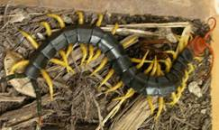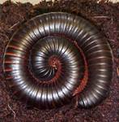
Centipede Millipede
(Photos Courtesy of AgriLife Extension)

Matthew R. March, MNRD
County Extension Agent- Agriculture & Natural Resources
Polk County | Texas A&M AgriLife Extension Service
602 E Church St Ste 127 Livingston, TX 77351
Phone: (936) 327-6828

Rain Gardens, June 15-21
As the population counties to grow in Texas water issues are becoming in ever occurring issue. Population centers continue to expand into rural areas and with the expansion comes impervious surfaces such as roofs and roads. This results in increased storm runoff leading to additional flooding and increased pollutants in creeks, rivers, bays, and eventually the Gulf of Mexico. Many homeowners may feel that storm runoff is too big of an issue to tackle individually; however, this is far from the truth. A growing trend is to construct rain gardens to capture and slowly release rainwater which can be built in a backyard. In addition, rain gardens provide other environmental services such as filtering pollutants and replenishing groundwater. Rain gardens are basically areas that collects rainwater and are planted with water tolerant plants that act as a bio-detention system. Rain gardens should hold water up to several days after a rainfall event, but should not become a permanent pond. Across rain gardens can enhance your landscape around your house and be aesthetically appealing.

Rain gardens can vary in size and can range from very small gardens in the corner of your backyard where water stands to constructing elaborate rain gardens by creating rain-gathering terraces on slopes. When selecting a site, you should consider incorporating the rain garden into existing landscape to ensure it is aesthetically appealing. Rain gardens typically consist of three panting zones with the center area being the wettest, inside edge being drier, and the outside margin being the driest. These zones will need to be considered when determining the planting location of plants based on their water requirements. A rain garden can be bordered with landscape material such as gravel, boulders, or mulch. The lowest spot in a rain garden should be 6-8 inches. If an existing low spot meets this requirement then no excavation is needed. Excavation may be required in some situations especially when developing large rain gardens. Before planting occurs, all sod and weeds should be removed and soil should be prepared, including loosening the soil and adding compost. Mulching is essential in a rain garden as it allows for water to penetrate the soil. A good rule of thumb is to add a mulch layer of 3 inches.

Planting of native plants are preferred since they require little maintenance and added inputs. Native plants will also act as nectar and host plants for butterflies and hummingbirds. When selecting your plants, you should pick a mixture of trees, shrubs, grasses, and flowers. Trees and shrubs should only be used if space permits. A planting design should consider mature height and width, light requirements, and water requirements. Allow plants to slightly overlap when mature to help block out weeds. Popular trees include southern maple, pawpaw, hawthorn, and possum haw holly. Shrubs can include swamp rose, American elderberry, Turk’s cap, and American beautyberry. A plethora of wildflower options exist and include red columbine, spider lily, blue flag iris, Maximilian daisy, and purple coneflower. Don’t forget to add grasses such as gulf muhly grass, switchgrass, inland sea oats, and indian grass. Lastly’ southern maidenhair fern, wood fern, sensitive fern, and royal fern can add some unique characteristics.

Rain gardens are a way to improve the landscaping in your yard, especially in wet or low spots, while providing valuable environmental services. In addition to being ascetically appealing rain gardens are relatively maintenance free after the initial planting.

Matthew R. March, MNRD
County Extension Agent- Agriculture & Natural Resources
Polk County | Texas A&M AgriLife Extension Service
602 E Church St Ste 127 Livingston, TX 77351
Phone: (936) 327-6828

Smut Grass, June 22-28

As we all know Polk County and surrounding Southeast Texas has its fair share of heat, high humidity, and plentifully rainfall. This subtropical climate allows for ideal growing conditions for smut grass (Sporobolus indicus), a non-native invasive grass that can be found in hay fields and pastures throughout Southeast Texas. Smut grass is believed to be a native of Asia, but can now be found throughout southern states and along the eastern seaboard to New York. Smut grass is a warm season perianal that can flower from March to December. It is easily recognized by its “rat tail” seed head that is long and slender which can be upwards of 3 feet long. The seed head contains numerous small seeds that become infected with a fungus causing a black smut to cover the seed head.

Smut grass is a very adaptable plant and can be found on both clayey and sandy soils. In some situations, Smut grass can be so dominant that it can nearly form a monoculture, especially on wet sites that have been disturbed. Smut grass holds little to no wildlife or grazing value. Cattle will eat smut grass if no other forage is available, but this is typically a desperate situation such as during a drought. Additionally, smut grass has little nutritional quality. Smut grass can invade Bahia grass, Bermuda grass, and native grass pastures.

Management using non herbicide treatment such as mowing, prescribed fire, fertility management, and rotational grazing has little effect in control or reduction. Intensive grazing has shown to control smut grass, but is difficult to achieve without overgrazing and causing damage to desirable grasses. Herbicides include two options, Velpar L or a Glyphosate product, however application methods will vary between the two options. Velpar L is considerably more expensive then using a Glyphosate product. Velpar L is labeled for use in both Bahia Grass and Bermuda Grass and is the only product specifically labeled for smut grass. Velpar L achieves good control if applied from spring to early summer when rainfall is adequate. A secondary application the following year has shown to achieve the greatest amount of control. Velpar L can be applied both using a broadcast or individual plant method treatments, but a buffer of 100 feet must be kept from desirable trees to ensure mortality of desirable trees does not occur. Application rates of 2 ¾ to 4 ½ pints per acre with higher rates on textured clay soils. There are no grazing restrictions for Velpar L and harvested hay may be fed 38 days after treatment. A Glyphosate product is a cheaper alternative to Velpar L, however a rope wick applicator or individual plant treatment method must be used. Applications should be when the plant is actively growing. Rates for rope wick applicators is 1:2 mixture with water. Individual plant treatment methods should utilize an application rate of 2.0 to 2.5 oz. per gallon of water.

Smut grass is a non-native invasive grass that has little to no benefit for livestock or wildlife. For this reason, if smut grass is present on your property a management program should be initiated to ensure a monoculture of smut grass does not become established. Management options are limited; however Velpar L and Glyphosate products have demonstrated good control.
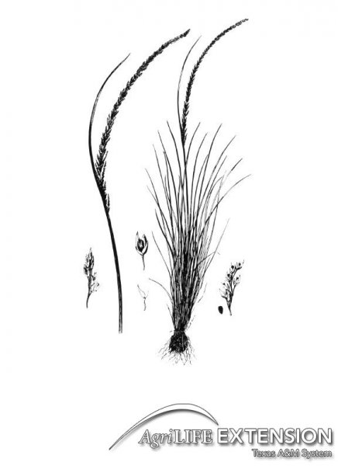
Matthew R. March, MNRD
County Extension Agent- Agriculture & Natural Resources
Polk County | Texas A&M AgriLife Extension Service
602 E Church St Ste 127 Livingston, TX 77351
Phone: (936) 327-6828

Feral Hog Trap Designs, June 29- July 5

Feral Hogs could possibly be one of the smartest most adaptability animals roaming the countryside of Texas. And if anybody would want to disagree with this statement, I would argue that even with our best management strategies feral hogs have continued to spread and multiply due to their ability to learn danger and adapt. This ability has allowed feral hogs to now cover nearly every section of the state. Many landowners think trapping can be successful with minimal management and effort. However, this is furthest from the truth as feral hogs will quickly learn to avoid traps. To counter feral hogs learning to avoid traps, complex corral trap designs and techniques have been developed.

Corral traps are in essences a way to catch the majority of a sounder, or group of hogs, at one time. This is important in feral hog management, because once a hog witness another hog being trapped it then becomes aware of the danger and will likely no longer enter that trap in the future. Thus, it is necessary that when a corral trap door is closed all hogs are inside the corral. Corral traps, which are typically made from hog panels, must be large enough for the entire sounder to fit comfortably inside. T posts are used to secure the hog panels. Traps should be placed under shade trees and around brush to allow for shade and concealment. A head gate can be used as entrance into the trap, but a heart shaped design can also be used. The hog panels are constructed in a heart shape design that creates a chute or narrow point that allow hogs to push into the trap but not push out. If using a head gate, you may want to consider setting up a remote monitoring system. This will allow you to watch via distance on a device such as a phone. Head gates can then be fitted with a latch that is released when you send a signal from your phone or other device. This ensures the trap is not closed until you are satisfied that the entire sounder is enclosed. Lastly, you need to consider a pre bait period. The trap should be pre baited for several days up to weeks before trapping. This allows time for the hogs to get comfortable entering the trap and will help ensure more hogs are trapped. Many professionally trappers routinely move their traps to new locations, reducing the chances of trap avoidance overtime.

To learn more about feral hog trap designs and other management techniques make sure to attend the second seminar of the Polk County Game Management Series. On July 11th we will be learning about feral hog biology, damage, and trapping techniques. Speaker will be Mr. Chris Watts, Wildlife Damage Management Biologist from Texas Wildlife Services. The seminar will begin 10:00 a.m. at the extension meeting room. Light refreshments and coffee will be served. Please RSVP to 936-327-6828 by July 8th.

Matthew R. March, MNRD
County Extension Agent- Agriculture & Natural Resources
Polk County | Texas A&M AgriLife Extension Service
602 E Church St Ste 127 Livingston, TX 77351
Phone: (936) 327-6828

Texas A&M AgriLife Extension provides equal opportunities in its programs and employment to all persons, regardless of race, color, sex, religion, national origin, disability, age, genetic information, veteran status, sexual orientation, or gender identity. The Texas A&M University System, U. S. Department of Agriculture, and the County Commissioners Courts of Texas Cooperating. Anyone needing special assistance at an Extension Program should contact the Texas AgriLife Extension Office at (936) 327-6828 at least one week prior to the program or event.

