Chicken Breeds for the Small Flock Owner, April 6-12
Raising a small flock of chickens can be both an enjoyable and rewarding experience. Many homeowners and small landowners raise small flocks as a hobby and to provide homegrown eggs and meat. If you have been raising chickens for a while you have likely experimented with different breeds and have discovered which breed works best for your growing conditions and expectations. However, for new flock owners a trip to the feed store to purchase chicks can be an overwhelming experience due to the numerous breeds available.
Before choosing a breed, you must first consider the goals for your flock. Do you want chickens that produce eggs efficiently or have a high meat yield? Or do you prefer a breed that can produce eggs and be put in a pot for supper? Chickens that produce eggs proficiently or called egg breeds, while breeds that result in high meat yields or called meat breeds. Breeds that can produce a reputable amount of eggs and meat but to a lesser degree are called dual purpose breeds. Also, there are breeds that are kept for ornamental value due to their unique plumage or other characteristics.
Egg breeds can be divided up between white egg layers, brown egg layers, and tinted egg layers. Leghorns are the most prolific white egg layer breed and are typically white in plumage but less common color varieties such as red and bluff exist. Other white layer breeds include California Whites, Production Blacks, and White Faced Black Spanish. Most of the more common brown egg layer breeds are considered dual purpose breeds. However, there are some cross breeds available such as Production Reds that are very proficient brown egg layers. Popular tinted egg layer breeds are Araucanas (Easter Eggers), Black Sumatras, and Indian Jungle Fowl.
Meat birds have been bred to maximize breast meat yield. Meat birds are called broilers and are decedents of the Cornish Game Hen Breed. The white feather variety of broilers are the most popular, but black and red feather varieties are also available. Cornish Game Hen can still be purchased, but you can expect birds that produce meat yield at a slower rate then modern day broilers.
Dual purpose breeds are some of the most popular breeds for small flock owners. They will provide a steady source of brown eggs, but produce enough breast meat to be worth processing. The most popular dual purpose breeds are Barred Plymouth Rock, Black Australorp, Delaware, Dominique, Jersey Black Giant, New Hampshire Red, Rhode Island Red, Silver Laced Wyandotte, and White Plymouth Rock.
There is a plethora of unique or rare varieties that are kept for ornamental values by small flock owners. Some of the most common breeds are Polish Chickens or crested chickens that have a crest of feathers on the head. Brahmas are large attractive birds with feathers covering the legs compared to Naked Neck that have no feathers on their neck. Lastly, bantam breeds are miniature varieties that look exactly like their larger counterpart.
Now with a little bit of knowledge on chicken breeds you will be able to make an educated purchase when visiting the feed store to start your own small flock.
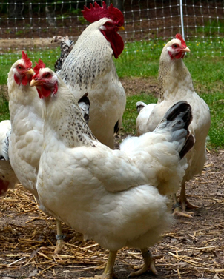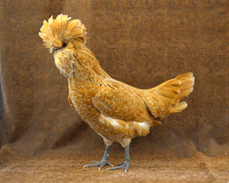
Delaware Polish Crested:
Images taken from Livestock Conservancy
Matthew R. March, MNRD
County Extension Agent- Agriculture & Natural Resources
Polk County | Texas A&M AgriLife Extension Service
602 E Church St Ste 127 Livingston, TX 77351
Phone: (936) 327-6828

Pond Stocking Considerations, April 13-19

With spring now in full force and summer right around the corner many anglers are hitting the water. Stocking of fingerlings is an essential management strategy if you are lucky enough to be an angler with a pond on your property or are considering building a pond. Stocking is necessary to either start or supplement both sport fish and forage (bait) fish populations. There are many fish species available for stocking in East Texas, but each species will have a different effect on fish populations and level of management required.

Catfish are the most self sustaining and require the least amount of management of all game fish species available for stocking. Catfish can survive on almost any food type including plant material, detritus, and bait fish. They also have a higher resistance to warm water temperatures and low oxygen levels. Catfish also respond very well to supplemental feeding and growth will match food availability. In other words, if you want bigger catfish stock more forage or increase supplemental feed. Also, populations can usually sustain themselves through reproduction in most situations. Blue catfish, Hybrid Blue Catfish, and Channel Catfish are typically stocked in ponds and can thrive in small ponds less than an acre.

Largemouth Bass are another popular choice for East Texas Ponds. Native Texas Largemouth Bass and Florida Strain Largemouth Bass are available. Florida Strain Largemouth Bass are known to grow larger then are native strain. Largemouth Bass are very ferocious predators and will consume about anything it can fit in its mouth, including other Largemouth Bass. It requires very extensive management to successfully manage a pond for Largemouth Bass. This includes providing an abundant in appropriate forage source, harvesting the right number of individuals from different size classes, and doing routine surveying. Managing Largemouth Bass is easier in ponds that are at least 2-3 acres or larger. Without proactive management the population will eventually consist of a few very large individuals or an overabundant small stunted population.

Other sport fish species available for stocking include Crappie, Hybrid Striped Bass, Striped Bass, and Sunfish. Crappie, Hybrid Striped Bass, and Striped Bass for the most part do not perform well in smaller shallower ponds compared to Catfish and Largemouth Bass and do best in ponds with deep water. A variety of sunfish species are available for stocking including Bluegill, Copper Nose Bluegill, Hybrid Bluegill, Green Sunfish, and Red Ear Sunfish. Sunfish can be used as a sport fish and forage fish.

Forage fish available for stocking include Bullhead Minnow, Flathead Minnow, Golden Shiner Minnow, and Threadfin Shad. Forage fish are essential for managing your pond as they provide the base of the food chain. Forage fish should be stocked during the initial stocking of the pond and may be required during supplemental stocking if the forage base becomes depleted.

A discussion on pond stocking cannot be concluded without mentioning Grass Carp. Grass Carp are a non native species that can be stocked in ponds to manage aquatic vegetation. Grass Carp live solely on aquatic vegetation and are very effective in aquatic vegetation control. A permit must be obtained from TPWD before stocking your pond with Grass Carp.

Not all ponds will respond the same and the above are general rules of thumb. If you wish to maximize the fish populations in your pond you may want to consider hiring a fisheries biologist as a consultant.

Matthew R. March, MNRD
County Extension Agent- Agriculture & Natural Resources
Polk County | Texas A&M AgriLife Extension Service
602 E Church St Ste 127 Livingston, TX 77351
Phone: (936) 327-6828

Growing Blackberries, April 20-26
Blackberries are an excellent fruit plant of choice for homeowners, small landowners, and commercial producers in Polk County. Blackberries are in improved cultivated variety of the wild blackberries or dewberries that grow in fields, roadsides, and forest opening throughout the Southern United States.
Blackberries are unique and which they are biennial plants that requires two years to complete their life cycle. This results in two types of stems or canes; primocanes and floricanes. Primocanes grow during the current season and floricanes which are one year old are flower bearing and die after crop matures. Cultivated blackberries are divided into two fruiting types. Floricane bearing varieties which flowers and set fruit only on floricanes. Primocane bearing varieties which flower and set fruit on primocanes late in the growing season and then bear on floricanes the following spring. Primocane bearing varieties typically are not adopted to Texas and you should consider planting varieties that where developed in Texas. Both thorny and thorn less varieties are available. With correct management and the right variety blackberries can produce up to 20 years and potentially yield 5-10 pounds per plant or 5,000 to 10,000 pounds per acre a year.
Blackberries should be planted in well drained soils with a pH range of 4.5 to 7.5. Blackberries require minimal amount of winter chill hours to set fruit. If planting on a site that drains slowly you may want to consider planting on raised beds. New stands can be established from root cuttings, bareroot plants, tissue culture, and container plants. Root cuttings and bareroot should be planted in late winter. Tissue culture plants are best planted in spring or fall, while container plants can be planted in fall, winter, and spring. Blackberries require regular watering to produce full size fruit and drip irrigation provides the best method to ensure adequate watering. For most situations, blackberries require annual fertilization of nitrogen and should be applied in a split application. Blackberries do not require trellising, but for best results should either be trellised or planted near a fence or structures. Tips should be regularly pruned back a few inches to encourage many short floricanes to form. Weed control is necessary to prevent competition and disease pressure. Special attention should be taken to keep wild dewberries away from cultivated blackberries. Diseases effecting blackberries include anthracnose, crown gall, double blossom, orange rust, and white drupelet.
Blackberries are typically sold in pick you own farms or hand harvested and sold fresh at local markets. It should be noted that blackberries continue to ripen after harvest and flavor is best when fully mature when the berry is dull black in color. Harvesting may need to occur up to four times a week to prevent loss of ripe fruit.
Blackberries do very well in Polk County and for the most part are easy to grow. If you are looking for an easy to grow and rewarding fruit plant, you cannot go wrong with blackberries.
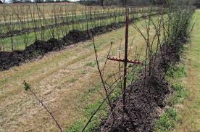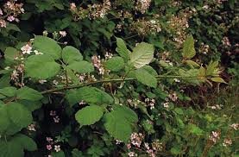

Matthew R. March, MNRD
County Extension Agent- Agriculture & Natural Resources
Polk County | Texas A&M AgriLife Extension Service
602 E Church St Ste 127 Livingston, TX 77351
Phone: (936) 327-6828

Wild Turkey, April 27-May 3

Texas is blessed with having a robust wild turkey population with turkeys being found form the Sabine River in the east to the Davis Mountains in the west. Wild turkeys need four basic habitat requirements; open grassland or understory for foraging, appropriate nesting cover, trees for roosting, and a reliable water source. Because of these basic requirements, wild turkeys are a very adaptable animal that can be found in a variety of habitats not only in Texas, but throughout North America. Wild turkey is an endemic North American species and are native nowhere else in the world. All wild turkey (Meleagris gallopavo) are considered one species, however there are five subspecies. Subspecies are adopted for the different habitat types they are found in, and for this reason there are physical differences between the subspecies.

Texas is home to three subspecies: Eastern, Merriam’s, and Rio Grande. Eastern turkeys are the most abundant and widespread in North America. Eastern turkeys can be found in the forest east of the plain states from Eastern Canada to the Gulf of Mexico and have been transplanted to other areas of the country. Eastern turkeys can be found in 38 states and was historically found in portions of the Post Oak and Pinewoods Ecoregions of East Texas. Eastern turkeys are recognized by large size, chestnut brown tips on tail feathers, and having the longest beards of all the subspecies. Eastern turkeys are also known as being very strong gobblers. Rio Grande turkeys are the main subspecies in Texas and can be found from canyonlands in the panhandle to the brush country of South Texas. Rio Grande turkeys are also at home in Oklahoma, Kansas, Nebraska, and Northern Mexico. Scattered population can also be found along river corridors in other western states. Rio Grande turkeys are smaller in size then eastern turkeys and have tan colored tips on tail feathers. Rio Grande turkeys are adapted for prairie conditions and will travel great distances in one day. Because of this, Rio Grande turkeys have longer legs then other subspecies. Merriam’s turkey is a western mountain subspecies and thrives in the ponderosa pine forest found in the higher elevations of western states. A small population of Merriam’s turkeys can be found in the Davis and Guadalupe Mountains of West Texas. However, most of this population is considered a hybrid with the Rio Grande subspecies. Merriam’s turkeys are the lightest colored of all the subspecies and the tail feathers are white tipped. They also have the shortest beards and spurs and are known to be weak gobblers.

The two subspecies not found in Texas are Gould’s and Osceola. Gould’s turkey numbers are very few and are found in only a handful of mountain ranges in Southern Arizona and New Mexico and Northern Mexico. Gould’s turkeys have long legs, light colored tips on tail feathers and moderate beard and spur lengths. Osceola turkeys are only found in Florida south of the Florida Panhandle. Osceola turkeys are adopted for the swampland in southern Florida. Osceola turkeys are dark in color with dark brown tips on tail feathers, have long legs and very long spurs.

Wild Turkey are a unique species to North America. They are resilient and adaptable birds that can be found in alligator swamps in Florida to snow covered Ponderosa Pine forest in Colorado.

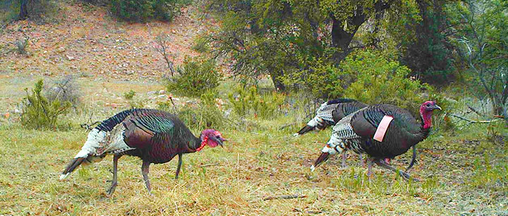
Gould’s Turkeys in New Mexico: Image taken from New Mexico Fish & Game

Matthew R. March, MNRD
County Extension Agent- Agriculture & Natural Resources
Polk County | Texas A&M AgriLife Extension Service
602 E Church St Ste 127 Livingston, TX 77351
Phone: (936) 327-6828

Texas A&M AgriLife Extension provides equal opportunities in its programs and employment to all persons, regardless of race, color, sex, religion, national origin, disability, age, genetic information, veteran status, sexual orientation, or gender identity. The Texas A&M University System, U. S. Department of Agriculture, and the County Commissioners Courts of Texas Cooperating. Anyone needing special assistance at an Extension Program should contact the Texas AgriLife Extension Office at (936) 327-6828 at least one week prior to the program or event.

