**Squash Production, March 2-8**

Squash is one of the most popular vegetables to grow in gardens. This is because squash plants are vigorous growers and prolific producers so only a few plants will produce more than enough squash for an entire family.

Squash is divided between six different types. This includes yellow straighneck, yellow crookneck, zucchini, and scallop. These types are usually grown during the spring and summer seasons. The last two types, acorn and butternut, are typically grown during the late summer and fall season. Squash do not grow well in cool weather and are easily damaged by frost. If planting in a spring garden make sure you plant after all danger of frost has past. Conversely, if planting in a fall garden plant in late summer to ensure crop will mature before the first frost.

Squash varieties for East Texas



Site selection should include sandy fertile soils with a pH between 6.0 and 6.5. Prepare the soil several weeks before planting and add 2-3 inches of organic material such as compost, leaves, or rotted hay. Next, till the organic material into the top 10 inches of soil. Squash should be planted in hills 18 to 48 inches apart on rows 2 to 8 feet apart. Vining squash will need more space than bush types. Plant 5-6 seeds 1 inch deep in each hill and thin to three squash plants per hill after seeds germinate.

Fertilizer can be added and a rule of thumb is 2 to 3 pounds of 10-10-10 fertilizer for each 100 square feet of garden. During the growing season keep the squash weed free and water the plants enough to keep them from wilting. Squash are susceptible to a variety of fungal diseases especially when vegetables are maturing. A fungicide can be used to help control fungal diseases. Insects that cause damage on squash include Squash Vine Borer, Squash Bug, and Cucumber Beetle.

Harvest should occur for yellow and green squash when the vegetable is small, while winter squash should be harvested when the vegetables are full size and skin is hard. Lastly don’t forget squash are excellent sources of Vitamin A and C and can be enjoyed in a variety of ways from fried to baked casseroles.

**Matthew R. March, MNRD**

County Extension Agent- Agriculture & Natural Resources

Polk County | Texas A&M AgriLife Extension Service

602 E Church St Ste 127 Livingston, TX 77351

Phone: (936) 327-6828

**Dogwoods & Redbuds, March 9-15**

Driving down any road in East Texas this time of year will result and seeing two of the most easily identifiable trees that grow in East Texas. These trees are the dogwoods and redbuds. Their showy flowers are a welcomed sight since they represent the end of winter and the start of the woods coming to life with the warming temperatures.

There are actually two species of dogwoods in East Texas. The first is the Flowering Dogwood, *Cornus florida* and the second is Rough Leaf Dogwood, *Cornus drummondii.* Flowering Dogwood steals the shows with what people believe are large white flowers. But actually, what people believe are large white flowers are 4 white bracts that surround numerous small tiny green flowers in the center. Flowering Dogwood is a deciduous tree that is a moderate to slow grower that can reach 40 feet in height. Flowering Dogwood thrives in wood margins in acidic soil with excellent drainage. Wildlife including deer, songbirds, and squirrels eat the berries. Unlike the popular Flowering Dogwood, the Rough Leaf Dogwood has small white flowers in clusters about 3 inches across. Rough Leaf Dogwood also produces showy white berries that are consumed by at least forty species of birds. Rough Leaf Dogwood makes a good ornamental tree due to the white flower and berries produced. Rough Leaf Dogwood is typically a shrub that grows to 20 feet in both woodlands and open areas.

The redbud found in East Texas is the Eastern Redbud, *Cercis Canadensis.* Eastern Redbud is the earliest spring bloomer in the woods. The pink flowers appear prior to leaf growth. Leafs are an attractive heart shape and the tree produces pea like seed pods. The buds and seedpods are both edible. Because of the attractive nature of the flowers, leaves, and seed pods the tree is a popular ornamental. Eastern Redbud is a moderate grower that can reach heights of 30 feet. Eastern Redbud is found in the eastern third of the state roughly east of interstate 35 and north of Victoria. Texas Redbud, *Cercis Canadensis texensis,* a subspecies of Eastern Redbud is found in the central part of the State. Compared to the Eastern Redbud, Texas Redbud has more leathery leaves and a deeper pink flower. Texas Redbud is a moderate to fast growing tree that can reach a height of 25 feet. Texas Redbud thrives in limestone soil found throughout the central and north central part of the state.

Dogwoods and Redbuds are very attractive trees that are a beautiful sight both in the woods and as ornamentals in are yards.

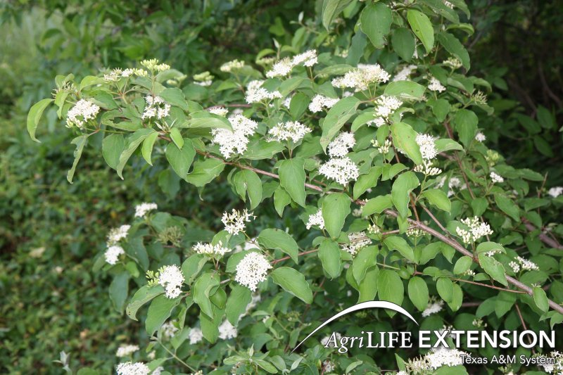

Rough Leaf Dogwood

**Matthew R. March, MNRD**

County Extension Agent- Agriculture & Natural Resources

Polk County | Texas A&M AgriLife Extension Service

602 E Church St Ste 127 Livingston, TX 77351

Phone: (936) 327-6828

­

**How an Egg is Created, March 16-22**

Raising backyard chickens can be a fun and enjoyable experience. Most local producers raise chickens for egg production to provide their families and neighbors with home grown heart healthy nutritious eggs. We tend to take for granted that are laying hens will produce eggs and give little thought into the complex and interesting reproductive structure of laying hens.

Before we go any further into a discussion on the hen reproductive system it must be stated that it does not take a rooster to be present to produce eggs. A hen will naturally produce eggs if feed, water, shelter, temperature, and light hour requirements are met. A hen is born with every ova (which will develop into full size yolks) she will every need in her lifetime. Interestingly, a hen has two ovaries, but only the left one is functional and contains 3,600 to 4,000 ova at birth. The tiny ova are held in place by a stalk. Once the hen reaches maturity ova will systematically enlarge and develop one by one into mature ovum, which at that point is released from the ovary. At the time of release, the mature ovum is the full size yolk of the egg and the rest of the reproductive system adds the egg white and shell. Only one mature ovum will be released at a time, approximately one a day; however, a double yolk egg is the result of two mature ovum being released at once.

The ovum will now spend 25 ½ hours being transported through the sections of the oviduct until the time of laying. The first section is the infundibulum, which is funnel shape and catches the ovum after release. The ovum will only remain in the infundibulum for 15 minutes. Next the albumen (white part of the egg) is added in the Magnum section. It will take 3 hours for the albumen to be added. After the Magnum, the egg enters the Isthmus section for 1 hour and 15 minutes where the inner and outer shell membrane is added. The shell membrane protects the egg contents from outside contamination. The last part of the egg to be added is the shell which occurs in the uterus. This is the longest step in the process in the egg will remain in the uterus for 20 hours and 45 minutes. The egg is typically laid by the hen within 15 minutes of it leaving the uterus.

Next time you are in the chicken coop collecting eggs for your omelet, think of the complex process it took for the hen to produce that egg. It all started over a day ago long before you even steeped inside the chicken coop.

**Matthew R. March, MNRD**

County Extension Agent- Agriculture & Natural Resources

Polk County | Texas A&M AgriLife Extension Service

602 E Church St Ste 127 Livingston, TX 77351

Phone: (936) 327-6828

**What Fruit Tree Should I Plant? March 23-29**

I receive quite a few questions about what kind of fruit tree grows best in Polk County. I also here complaints from homeowners who purchase fruit trees from big box stores and they continually fail to produce fruit. When discussing what fruit trees grow good in Polk County you have to take into effect chill hours. Chill hours is the amount of cold weather needed during winter to break down the trees’ internal growth inhibitors and enable the blooms and leaves to emerge normally in the spring. Polk County averages between 500 to 600 chill hours. Polk County has warm winters compared to more northern areas of Texas and the country that have 1,000 to 2,200 chill hours. Due to the low amount of chill hours many fruit tree species and/or varieties do not perform well in Polk County. Another factor to consider is that most soils in Polk County or sandy and acidic. This is a limiting factor for production in some fruit tree species.

Figs, pears (Asian varieties), persimmons, and pomegranates are excellent fruit tree species for Polk County and under most circumstances will produce fruit. These fruit trees thrive in a variety of soil types including all soil types found in Polk County. Additionally, chill hours received in Polk County are perfect for these fruit trees and are coldest freezes will not cause damage. Fruit trees that are classified as suitable for Polk County include apples, apricots, peaches, plumes, and olives. These fruit trees will grow and produce fruit routinely in Polk County, but will take more management and require planting of varieties that match winter conditions for Polk County. Most apple and plum varieties will not produce due to higher chill hour requirements, but there are several low chill hour varieties that have potential to produce fruit in Polk County. Apricots should not be expected to produce crops annually due to susceptibility from frost damage and wide temperature swings in late winter. Peaches can be grown with success in Polk County, but you must plant varieties that have low to medium chill hour requirements. Lastly, olives have been gaining popularity across Texas and have been grown successfully across south and southwest Texas. Growing condition requirements for olives suggest they should grow well in east Texas, but no research has been conducted to back this up. Lastly, citrus, nectarines, sweet cherries, and plumcots are marginal fruit trees for Polk County. They may grow and produce fruit, but damage and no fruit production should be excepted. Freezes can cause catastrophic damage to citrus and plumcots while chill hours are usually not met for sweet cherries.

By understanding chill and soil type requirements for fruit trees you will be able to select trees that are suitable for Polk County resulting in successful fruit production.

**Matthew R. March, MNRD**

County Extension Agent- Agriculture & Natural Resources

Polk County | Texas A&M AgriLife Extension Service

602 E Church St Ste 127 Livingston, TX 77351

Phone: (936) 327-6828

**Woodpeckers of East Texas, March 30- April 5**

The forest of East Texas and woodpeckers go together naturally. We are blessed with a high diversity of woodpecker species here in both Polk County and East Texas as a result of the mosaic of hardwood and pine forests. East Texas is home to 9 of the 16 species of woodpeckers that have been recorded in Texas. Of those 9 woodpeckers two are endangered and another is considered extirpated in Texas. Identifying woodpeckers is easy and can add to your enjoyment while watching a woodpecker drill a hole.

You can roughly divide woodpeckers into three groups. The first is small to medium size woodpeckers that have white and black barring on wings and back, but does not have a head or crown that is predominately red. This group includes Yellow Bellied Sapsucker, Hairy Woodpecker, Downy Woodpecker, and Red Cockaded Woodpecker. The Yellow Bellied Sapsucker and Red Cockaded Woodpecker have solid barring on the back, while Hairy Woodpecker and Downy Woodpecker have a white stripe down the middle of the back. Hairy Woodpecker and Downy Woodpecker are very similar and the easiest difference is Hairy Woodpecker is approximately 2.5 inches bigger. Yellow Bellied Sapsucker is the only species of woodpeckers in East Texas that cannot be seen year around and is just present during the winter. All of the above species are fairly common except for the Red Cockaded Woodpecker which is found in old growth savannah pine forest which has disappeared across much of East Texas. Because of habitat loss and decreasing numbers, Red Cockaded Woodpecker is an endangered species.

The second group of woodpeckers are medium size and include Red Bellied Woodpecker, Red Headed Woodpecker, and Northern Flicker. These species are common to abundant and can be found in many forest types and also open areas of cities, yards, and parks. Red Bellied Woodpecker has a white and black barring on back and wings with a red crown that goes from beak to barring on back. Red Headed Woodpecker has a solid red head and neck with a solid black then white back. Northern Flicker is a brownish woodpecker with a white rump and flashes of yellow in wings and tail. Northern Flicker can also be seen foraging on the ground.

The last group includes two large woodpecker species that are easily recognizable. The first is Pileated Woodpecker which is crow size with a black back with a prominent red crest. Pileated Woodpecker prefers extensive forest with mature trees. The other species is the endangered Ivory Billed Woodpecker which is similar in appearance to the Pileated Woodpecker except it has white lines down back. The Ivory Billed Woodpecker requires very large extensive stands of mature hardwood forest. Due to habitat loss the bird no longer lives in Texas and was believed to be extinct across the south for over 60 years until possible sightings in Southern Arkansas in 2004.

We are blessed with a high diversity of woodpeckers here in East Texas. But to ensure their continue survival their habitat must be managed to encourage older trees and snags for feeding and nesting. If not, more woodpecker species may follow the same path as the Ivory Billed Woodpecker.

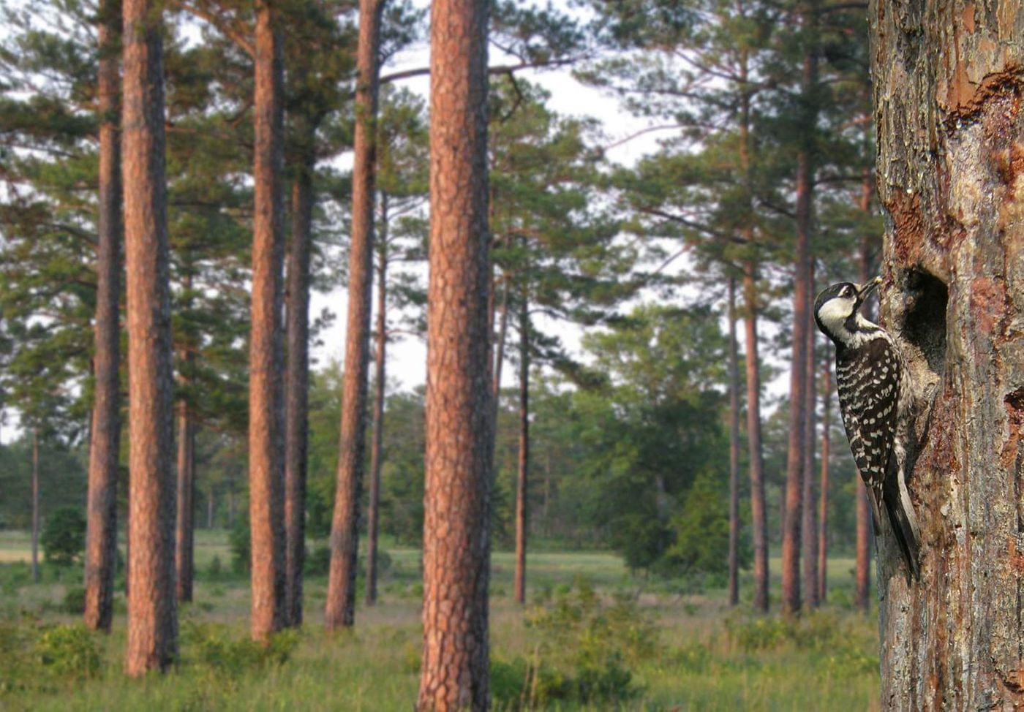

Red Cockaded Woodpecker, Image Credit: USFWS

**Matthew R. March, MNRD**

County Extension Agent- Agriculture & Natural Resources

Polk County | Texas A&M AgriLife Extension Service

602 E Church St Ste 127 Livingston, TX 77351

Phone: (936) 327-6828

**_____________________________________________________________________________________**

**Texas A&M AgriLife Extension provides equal opportunities in its programs and employment to all persons, regardless of race, color, sex, religion, national origin, disability, age, genetic information, veteran status, sexual orientation, or gender identity. The Texas A&M University System, U. S. Department of Agriculture, and the County Commissioners Courts of Texas Cooperating. Anyone needing special assistance at an Extension Program should contact the Texas AgriLife Extension Office at (936) 327-6828 at least one week prior to the program or event.**