Planting a Tree, February 4-10

February is typically a transition month for the weather in Polk County. Cold fronts will still drop the temperatures below freezing, but we will begin to experience warmer weather especially towards the end of the month. For this reason, February is a perfect time to plant a tree. Trees are still in dormancy for winter and will handle the stress of planting better. It will allow the newly planted tree a chance to become established prior to the hot days of summer. If you are interested in planting trees in your yard, AgriLife Extension, Texas Forest Service and the Piney Wood Lakes Chapter of the Master Naturalist will be hosting a free tree giveaway on February 22nd. The tree giveaway will take place at Barney Wiggins Memorial Arena here in Livingston. The event will start at 10 in the morning and will go until all trees are giving away.
If you are planning on getting some free trees at the tree giveaway or planning on purchasing some this spring there are some recommendations you should follow to ensure the best chance of survival for your new tree. You should first select a site that will have enough room for not only the branches, but also the roots when the tree reaches its full size. Next you will need to dig the hole. Many people make the common mistake of digging holes too deep and too narrow which will cause root issues. The hole should be no deeper than the soil in which the tree was grown in and should be at least 3 times the diameter of the root ball or the spread of the roots if it is a bare root tree. If you purchased container trees they should only be stored for a short period of time after purchase. After removing the tree from the container you should ensure the roots are not “potbound” and if so use your fingers or a spade to spread the roots. Do not overly compress the soil when you fill the hole, also you should avoid using your feet and gently compress with your hands. If planting bare root trees you should plant them immediately. Make sure roots remain moist between time of purchasing and planting. To plant, first build a cone of earth in the center of the hole around which to splay the roots. Make sure that when properly seated on this cone the tree is planted so that the trunk flare is clearly visible and the crown, where the roots and top meet, is about two inches above the soil level.
After planting your tree there are some other steps you can do to ensure a healthy tree. First, a root promoting fertilizer can be applied to the planting hole and around the planting hole. Next you can add 2 inches of mulch. Lastly, if the tree is on a windy site you may want to consider staking for a maximum of one year. So don’t forget to come by Barney Wiggins Memorial Arena to get your free trees and to receive expert advice on planting!

Matthew R. March, MNRD
County Extension Agent- Agriculture & Natural Resources
Polk County | Texas A&M AgriLife Extension Service
602 E Church St Ste 127 Livingston, TX 77351
Phone: (936) 327-6828

Common Beef Cattle Breeds, February 11-17

Texas heritage and ranching go hand in hand. As most people know the Texas Longhorn paved the foundation for the ranching industry in Texas going all the way back to the days when Texas was part of Mexico. Since that time numerous beef breeds are now raised in Texas, due to the introduction of new breeds, industry trends, and management techniques. Rather you are a new beef producer or are looking to expand your herd it can be quite a challenge to figure out which breed works for you. This is due to the fact that there are over 250 recognized breeds in the U.S., with 80 of those being readily available to producers.

Most of the more common beef breeds originated in Europe and brought to America. This includes Black Angus, Red Angus, Charolais, Devon, Braunvieh, Herford, Limousin, and Simmental. Black Angus are polled and can be traced to northeastern Scotland from the mid.18th century to the early 19th century. Black Angus are known for carcass quality, maternal characteristics, calving ease, and moderate size. Red Angus can also trace their early development to Scotland, but was not established as a registry in the U.S. until 1954. Red Angus has the same characteristics as Black Angus, but have additional traits of uniformity, good disposition, and an outstanding appetite. Charolais originated in France and are a large frame, white in color and are good produces of milk. Charolais where used in France for draft, milk, and meat. Charolais are very popular in the Texas cattle industry due to their large frame compared to other European cattle and ability to perform under a variety of environmental conditions. Devon originated in southwest England and where originally bred as a dual purpose cattle for both meat and milk. Devon has a long history in North America, with the first individuals reaching the continent only 131 years after Columbus. Devon is red in color, may be polled and are known for fertility, calving ease, docility, hardiness, and ability to adapt to temperature extremes. Braunvieh were imported into the U.S. from Switzerland and are various shades of brown, polled, often have a light colored dorsal stipe and have been selected for beef production and reproduction efficiency. The original Braunvieh in America were also used to establish the American Brown Swiss dairy cattle breed. The Herford breed was established in England and has been a very popular beef breed in Texas. From the late 1800’s to the 1950’s, the Herford was the dominate beef breed not only in Texas but the U.S. Hereford are known for two main traits, high yield of beef and efficiency of production. Limousin are golden-red cattle native to south central France and have been found in cave drawings in these areas estimated to be 20,000 years old. The first Limousin bulls were imported to the U.S. in 1971 and become popular in Oklahoma, Texas, and South Dakota. Limousin is popular among cattleman due to tremendous carcass traits and feed efficiency. Simmental are the oldest and most widely distributed of all beef breeds in the world. They are red and white in color and are known for rapid growth development, outstanding production of milk, and large frame.

Brahman is a very popular beef breed of cattle, but unlike the above breeds originated from India form Bos indicus cattle. There are conflicting reports on how India cattle where introduced to the U.S., but Brahman are easily recognizable by the large hump over the shoulders, curved upwards horns, large ears, and excess skin. Brahman cattle are known for their heat tolerance and ability to thrive in adverse conditions. Because of this, Brahman have been breed with European breeds to create crossbreeds that can thrive in adverse conditions and retain carcass quality, fertility, and milk production characteristics of European breeds. Common crossbreeds found in Texas include Braford, Beefmaster, Black Brangus, Red Brangus, Santa Gertrudis, and Simbrah. One of the more unique crossbreeds developed in the U.S. is Beefalo which is 3/8 Bison and 5/8 Bovine.

Before you begin to build or expand your beef herd, you should do research on different cattle breeds. By doing so you will find a breed that best matches your growing conditions, management techniques, and production goals.

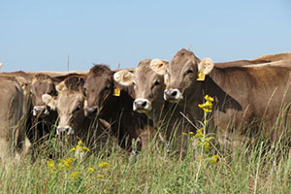
Braunvieh Cattle, image taken from Braunvieh Association

Matthew R. March, MNRD
County Extension Agent- Agriculture & Natural Resources
Polk County | Texas A&M AgriLife Extension Service
602 E Church St Ste 127 Livingston, TX 77351
Phone: (936) 327-6828

Magnesium Deficiency in Tomatoes, February 18-24
With spring gardening now right around the corner many gardeners are gearing up for hopefully a successful year. Tomatoes are one crop that will be an essential in almost every garden. A common disorder in Tomatoes is Magnesium deficiency. By learning the symptoms of magnesium deficiency in tomatoes you will be able to recognize the signs and implement a management strategy.
The main symptom of Magnesium deficiency in tomatoes is interveinal chlorosis which is the yellowing of leaves. Interveinal chlorosis is typically developed overtime due to the high Magnesium requirements of tomatoes during later growth stages. Interveinal chlorosis is typically first observed in the lower older leaves. This is a result of the plant moving Magnesium from the older leaves to new growth when there is a Magnesium deficiency in the soil. The first signs of interveinal chlorosis will be a few localized yellow spots. As Magnesium becomes more limiting, yellowing will intensify and can eventually cause advanced symptoms of dark purplish black spotting. When the deficiency is severe enough it can cause dead spots to occur on the leaves. Symptoms seen with Magnesium deficiency can also be caused by extremely low ph. If your soil pH is below 5.5, toxic quantities of Iron and Manganese can be taken up by the plant. A soil test can be conducted to determine the pH and Magnesium levels in the soil. By conducting a soil test prior to planting you can implement methods to mitigate the problem if the soil test results in a low pH or Magnesium levels.
If you do not recognize a Magnesium deficiency until the tomatoes plants are showing symptoms. Epsom salt, which is composed of Magnesium Sulfate, makes an easy and practical way to increase Magnesium levels in the soil. Epsom salt should be applied at a rate of 2 pounds per 100 gallons of mixed water through drip or leaching irrigation. Epsom salt will not reverse damage that has already occurred but can prevent future interveinal chlorosis in the leaves.
On March 1st , Texas A&M AgriLife Extension will be hosting the East Texas Fruit and Vegetable Conference. The conference will take place at the Pitser Garrison Convention Center located at 601 North 2nd Street in Lufkin. Topics will be of interest for both commercial producers and home gardeners. 3 CEUs will be available to licensed pesticide applicators. Cost is $30 per person or $50 couple prior to Feb. 26th. A $10 late fee will be applied after this date. Make checks payable to ETFVC-South and mail to Texas A&M AgriLife Extension Service Angelina Horticulture Committee 2201 South Medford Dr.Lufkin, TX 75901. For more information contact Cary Sims at 936-634-6414 or cw-sims@tamu.edu.
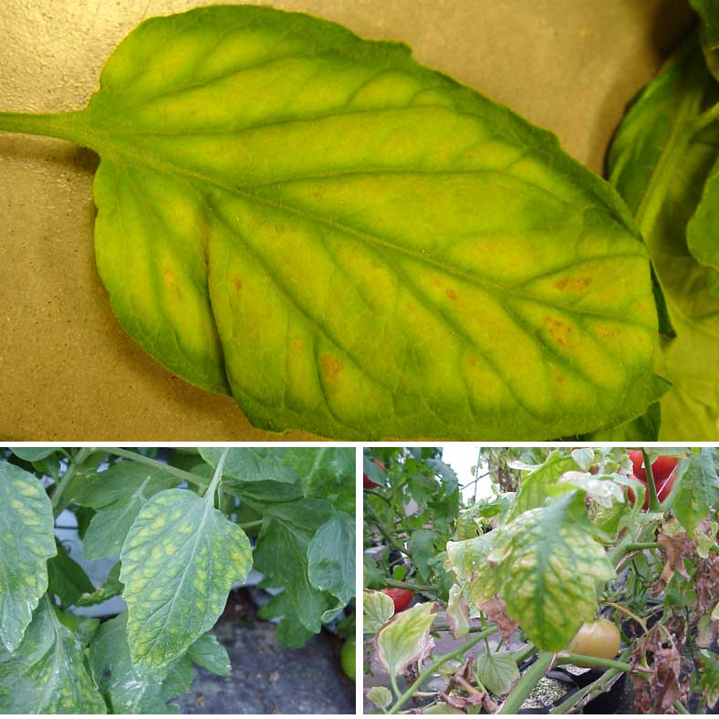
Magnesium deficiency in tomatoes, image taken from Mississippi State Extension

Matthew R. March, MNRD
County Extension Agent- Agriculture & Natural Resources
Polk County | Texas A&M AgriLife Extension Service
602 E Church St Ste 127 Livingston, TX 77351
Phone: (936) 327-6828

Turfgrass selection for Polk County, February 25-March 1

When it comes to adding curb appeal to your house nothing stands out more than a lush green lawn. However, many homeowners spend countless dollars and time attempting to achieve this prefect lawn with little to no success. Homeowners often sod their yard with little consideration for turfgrass species and stick to the standard St. Augustine. St. Augustine is an excellent turfgrass for Polk County, however there are other species that may thrive in your yard and have a better chance of achieving the goal of the perfect lush green lawn.
To determine what turfgrass species will work best for your lawn you must first take into account site conditions. This includes shade or sun, soil depth and quality, amount of traffic, rainfall or irrigation, and level of maintenance. After taking an inventory of site conditions you can then match a turfgrass species that will grow best in your lawn.
There are six species of turfgrass that are well adapted to the growing conditions in Polk County. The most common of these species is St. Augustine. St. Augustine is the most shade tolerant of all the species, however is less drought tolerant than other species. St. Augustine is established from sod and does not tolerate high traffic. Bermudagrass is another vary common turfgrass species. Unlike St. Augustine, it is very tolerant of traffic and drought. Bermudagrass can be established either through seed or from sprigs depending on the variety. If you are looking for a low maintence species that is will adopted for East Texas, Centipedegrass is your best bet. Centipedegrass requires little fertilizer and is slow growing, thus requiring infrequent mowing. Centipedegrass grows well in full sun to light shade. But, the downside of Centipedegrass is it does not tolerate traffic or drought. Centipedegrass can be established from seed and sod. Zoysiagrass is similar adapted to growing conditions as Bermudagrass. However, it requires less fertilizer and will not tolerate heavy traffic when compared to Bermudagrass. Zoysiagrass is not as shade tolerant as St. Augustine. Zoysiagrass is best established from sod. Seashore Paspalum is a unique turfgrass species that can tolerate salinity in both soil and irrigation water. Seashore Paspalum does best when mowing height is one inch. All of the above species mentioned are warm season grasses, meaning they grow during the spring through fall and then go into dormancy after the first freeze. The last turfgrass species suited for Polk County is Ryegrass, a cool season grass. Ryegrass can be over seeded into Bermudagrass in October to provide winter color to your yard when Bermudagrass is dormant during the winter.
If you are wanting a greener healthier lawn, or in the process of establishing a lawn on bare ground consider the different turfgrass species suited for Polk County. Yes, St. Augstine can be a good choice. But, depending on the level of traffic, soil conditions, shade, and level of maintenance there may be other more suitable turfgrass species for your lawn.
Matthew R. March, MNRD
County Extension Agent- Agriculture & Natural Resources
Polk County | Texas A&M AgriLife Extension Service
602 E Church St Ste 127 Livingston, TX 77351
Phone: (936) 327-6828
_____________________________________________________________________________________
Texas A&M AgriLife Extension provides equal opportunities in its programs and employment to all persons, regardless of race, color, sex, religion, national origin, disability, age, genetic information, veteran status, sexual orientation, or gender identity. The Texas A&M University System, U. S. Department of Agriculture, and the County Commissioners Courts of Texas Cooperating. Anyone needing special assistance at an Extension Program should contact the Texas AgriLife Extension Office at (936) 327-6828 at least one week prior to the program or event.

