Citrus Greening Disease, December 3-9
Polk County is too far north to support citrus orchards on a commercial scale due to hard winter freezes that can occasionally kill or damage citrus trees. However, there are many homeowners that have relative success growing citrus trees in their backyards. If you are a homeowner with citrus trees or are considering planting a citrus tree you need to be aware of citrus greening disease.
Citrus greening disease is one of the most serious citrus diseases in the world. The disease can cause catastrophic economic impact to the commercial citrus industry and the disease has no know cures. Citrus greening disease is a bacterial disease caused by the bacterium Candidatus Liberibacter asiaticus, which is spread by the Asian citrus psyllid. The Asian citrus psyllid is an insect about the size of a toothpick and has a distinctive 45-degree angle posture on leaves. As the insects feed on infected trees they become vectors and then carry the disease to uninfected trees. The disease can also be spread by grafting infected wood to an uninfected tree. The disease infects citrus species of plants and their relativities including ornamentals such as orange jasmine, limeberry, box orange, calamodin, and curry plant. Sweet oranges and mandarin oranges are highly susceptible, while sour oranges, grapefruits, and lemons are moderately susceptible. The disease poses no threat to humans and fruit form infected trees are safe to consume. However, the fruit will be misshapen, colored irregularly, fall prematurely, and taste bitter. Other easily recognizable symptoms include yellow or blotchy leaves, thinning of leaves, or twig dieback.
Citrus greening disease is a native disease to Southeast Asia and was first reported in the Rio Grande Valley of Texas in 2012. Since then the disease has spread to other areas along the Texas Gulf Coast including the Houston area and the coastal bend. Because there is no known cure for the disease the only way to prevent the spread is to establish quarantined areas. Texas Department of Agriculture (TDA) has established three quarantined areas. The nearest quarantined area to Polk County is the Gulf Coast quarantined area which includes all areas of Fort Bend, Harris, and Montgomery Counties. It is strictly prohibited to move citrus plants in or out of a quarantined area, except as permitted by TDA.
As a homeowner in Polk County with citrus trees there are several steps you can take to prevent citrus greening disease from spreading. The first is to inspect your trees routinely for either sings of the disease or the Asian citrus psyllid. If you suspect you have an infected plant you should report it immediately to the TDA. Also, if you find the Asian citrus psyllid on your trees you should control the population with an insecticide improved for citrus trees. By inspecting you trees for citrus greening disease you are doing your part to ensure this disease does not spread into Polk County.
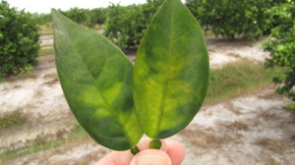
Blotchy leaves may be an indication of citrus greening. (Texas A&M AgriLife photo by Monte Nesbitt)
Matthew R. March, MNRD
County Extension Agent- Agriculture & Natural Resources
Polk County | Texas A&M AgriLife Extension Service
602 E Church St Ste 127 Livingston, TX 77351
Phone: (936) 327-6828

Dutch Elm Disease, December 10-16

American elm trees can make a gorgeous tree in your front yard and add value to your house. However; there is a devastating disease that has marched its way across North America killing American elms and other elm trees in its path. This disease is caused Dutch Elm Diseases (DED).

DED is caused by the vascular pathogen Ophiostoma nuvo-ulmi. The disease was believed to have been brought to North America in the 1930’s from elm logs brought overseas from Europe. Since then the disease has marched across the continent leaving devastating impacts in its aftermath. By 1973 the disease had made its way across the United States from the east coast to the west coast. American elm trees are highly susceptible to the disease while cedar elms and other native Texas elm trees are moderately susceptible. Because of this, most of the impacts in Texas have been minimal because of the prevalence of cedar elm over American elm in Texas. Most of the impacts in Texas have been situated in urban areas in the Dallas Fort Worth area where American elm trees have been planted in landscaping. The largest impact has been in the Flower Mound area where approximately 75 American elm trees have died from DED since 2005.

Trees infected with DED will begin to show effects within weeks. DED will cause individual limbs and branches to rapidly wilt and die. After the first signs of infection the disease will spread rapidly, especially in American elm, and will infect every branch in a tree within 2-3 weeks. Vascular streaking just beneath the bark of infected twigs is used to diagnose DED.

Management of DED is an active surveillance program to detect the disease. Infected trees should be removed to prevent spreading of the disease to uninfected trees. Elimination of root grafts between trees will also help to prevent DED from spreading. DED is also spread through elm bark beetle that feeds on infected trees and then can transfer the disease to healthy trees. Insecticides can be used on elm trees to keep the beetle population down helping to reduce the risk of trees contracting DED. Lastly, if a highly valued tree is infected, intravascular injections can be effective if applied before 5-10% of the crown is showing signs of DED.

DED has wiped out extensive stands of American elm trees in more northern states. However, the disease appears to be not as virulent in Texas. This is possibly due to several causes. Including; warmer weather, smaller stands of American elm trees, and moderately susceptibility of native Texas elms. If you are a homeowner with American elm trees in your yard a monitoring program for DED would be a recommended management practice to prevent the spread of DED.

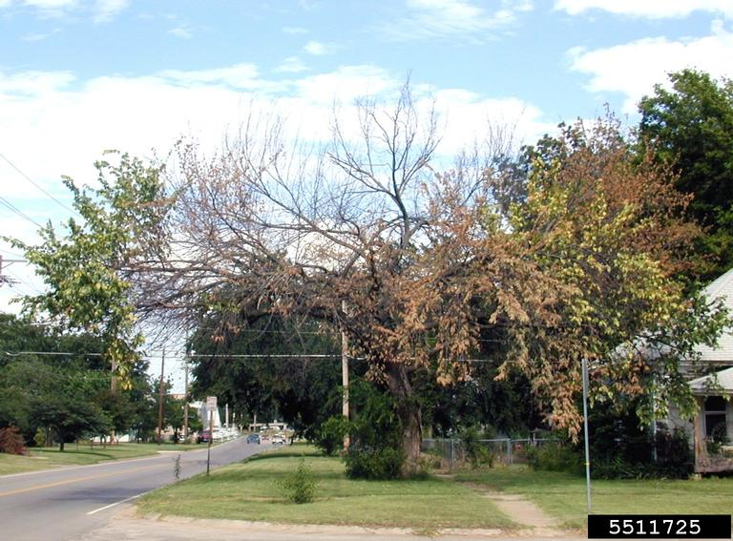
(Photo by South Dakota Department of Agriculture)

Matthew R. March, MNRD
County Extension Agent- Agriculture & Natural Resources
Polk County | Texas A&M AgriLife Extension Service
602 E Church St Ste 127 Livingston, TX 77351
Phone: (936) 327-6828

Spring Native Wildflowers, December 17-23

With the 21st being the first day of winter, Christmas next week, and the weather getting colder the last thing on many peoples mind right now is planting wildflowers for next spring. But, now is the perfect time to plan you native wildflower garden and begin planting.
Planting native wildflowers in your garden is not only aesthetically appealing, but is also a good environmental practice. Native wildflower gardens require less water then traditional ornamentals and also provide food for pollinators such as butterflies, beetles, and hummingbirds. Another plus, both to your pocket book and the environment, is native wildflowers grow very well in the soil already in your yard and don’t require you to add fertilizer. Lastly, if wildflowers are allowed to fully mature they will drop seeds on the ground ensuring you will have more wildflowers for next spring.
You may be asking then why is the dead of winter a good time to plant wildflowers that will be blooming in April. The majority of native wildflowers are annuals that begin germination during late fall through winter. During this time they remain relatively small and will remain in a non-reproductive stage preparing to put on a show in the spring. As the weather begins to warm in the spring the wildflowers transfer into a reproductive stage and which they will shoot up a stalk with flowers, this is called the inflorescence. At this time is when wildflowers become easily visible; however the wildflowers may have germinated as early as 4-6 months earlier. This is the reason why you should plant native wildflower seeds during this time of year to match their life cycle. If you wait till March or April it is too late and the seeds may not germinate and if they do the plants will likely die due to heat and lack of rain before they begin to bloom.
You can purchase native wildflower seeds from business that specialize in selling native plants. A quick google search will reveal several businesses here in Texas. These businesses will typically sell seed packs with multiple species that are specific to certain areas of the state or country. Purchase a seed pack that has species that grow here in East Texas. Also, you should match the species growing requirements with the soil and sunlight with the conditions to where you will be planting. Native wildflower seeds are typically very small and don’t require little more than just soil contact to germinate. Ideal planting conditions would be to break up the ground and remove other vegetation. Then spread the seeds across the soil and lightly rake the seeds into the soil. However, breaking up the ground is not a requirement. Typically you will not need to water the seeds. The area should not be mowed as you will mow the wildflowers down before they begin to bloom.
Hopefully if you follow the above steps you should have a gorgeous native windflower garden this spring. Just remember to let the flowers remain standing and fully mature after they bloom to allow time for the seeds to drop, thus ensuring native wildflowers again next year.
Matthew R. March, MNRD
County Extension Agent- Agriculture & Natural Resources
Polk County | Texas A&M AgriLife Extension Service
602 E Church St Ste 127 Livingston, TX 77351
Phone: (936) 327-6828

Dairy Goats, December 24-30
When you think of Texas agriculture the first images that come to mind are typically large agriculture operations. Rather that is a ranch with a 1,000 cow beef herd or cotton fields that stretch to the horizon. The image that does not come to mind is small scale dairy goat operations. However, this industry is growing not only in Texas but across the country.
Across the country 1 of 10 goat operations focus primarily on milk production. California and
Wisconsin account for approximately ¼ of U.S. goat milk production. In these states, dairy goat milk production usually occurs in converted dairy cattle parlors that require significant startup cost. These farms will produce grade A dairy that is sold in retail stores. However; there are still other options if you want to start a dairy goat operation in Texas with smaller startup cost that is geared to niche markets. The market outlook for dairy goat’s products in niche markets is growing and this includes farmers markets, specialty stores, etc.
Dairy goats are seasonal breeders and the breeding season runs from late summer through early winter. Gestation period is five months and after kidding the doe will producer milk for 10 months before a two month dry period. A dairy goat will produce more pounds of milk per pound of feed consumed then when compared to dairy cows. A dairy goat will consume 6 pounds of feed a day and will produce 4-7 pounds of milk. The average doe will produce between 1,200-1,600 pounds of milk a year and offspring two kids. Dairy goats require to be milked twice a day. There are six major dairy goat breeds: Saanen, Nubian, Toggenburg, LaMancha, Oberhasli, and Alphine. Nubian is known as an all-purpose breed that is useful for milk, meat, and hide. If wanting a breed that produces high butterfat content, the LaMancha is an excellent choice. Toggenburg and Saanen are both high milk producers. Milk can either be processed by a processor, but for most producers in Texas they choose to process their own milk. Goat milk can be sold as fluid milk or used to make ice cream or cheese. There is also a growing market for soap made from dairy goat milk.
Marketing is the biggest hurdle for producers looking to enter the dairy goat industry. Many first time producers will have to take the risk of developing their own marketing strategy and finding costumers.
The dairy goat industry in Texas may not be as big as beef cattle or cotton, but it is a growing industry that is carving out a niche market. Dairy goats are not suitable for every agricultural producer, but can be the perfect fit for small agriculture operations.
Matthew R. March, MNRD
County Extension Agent- Agriculture & Natural Resources
Polk County | Texas A&M AgriLife Extension Service
602 E Church St Ste 127 Livingston, TX 77351
Phone: (936) 327-6828

_____________________________________________________________________________________

Texas A&M AgriLife Extension provides equal opportunities in its programs and employment to all persons, regardless of race, color, sex, religion, national origin, disability, age, genetic information, veteran status, sexual orientation, or gender identity. The Texas A&M University System, U. S. Department of Agriculture, and the County Commissioners Courts of Texas Cooperating. Anyone needing special assistance at an Extension Program should contact the Texas AgriLife Extension Office at (936) 327-6828 at least one week prior to the program or event.

