Pecan Fungus Diseases, November 5-11
Rather cooked into a tasty pecan pie or enjoyed in its natural state pecans are the nut of choice for many Texans. This is not only because pecans are delicious, but they are grown successfully throughout most of Texas. However, there are three diseases that can wipe out a pecan crop both on a commercial scale and as a homeowner with one tree. These three diseases are pecan scab, powdery mildew, and downy spot. All of these diseases are caused by fungus.

Pecan scab is very destructive and can be found on leaves, twigs, and the husk. This disease is so destructive, because infected nuts will fall prematurely or will not grow to full size. The fungus causes a small, circular, and olive green to black scabs. These scabs can become numerous, especially on the husk and can eventually blacken the entire husk. Pecan scab can lead to other fungi becoming established causing additional decay.

Powdery mildew is an occasional problem, especially during favorable conditions. Powdery mildew is recognized by a white dusty covering on the surface of developing nuts and shoots. Early infections during nut development can result in reduction of nut size, while late season infections have only minor effect on nut quality.

Downy spot only causes infections on leaves during late to mid-summer. Downy spot can be identified by pale green to white spots on the leaves that are 1/8 to 1/4 inch. Spots will develop a faded appearance and infected leaves will drop from the tree.

All three of these fungus diseases have the same long term management practices. For commercial growers they have the option of using large commercial sprayers to treat these diseases effectively; however this is unpractical from an economic standpoint for homeowners. It is also unpractical for homeowners to use small sprayers, because for the fungicide to be effective it must cover every surface of the tree. Homeowners can hire commercial sprayers for hire, but there are other options. If you are thinking about planting a pecan tree plant a variety that is resistant to these fungus diseases. Another option is a preventive program that encourages good sanitation practices. These practices are to remove and destroy fallen leaves, shucks, and nuts each winter. These materials allow the fungus spores a head start in establishing new infections during the next growing season. Homeowners should also practice selective pruning during winter of damaged limbs. If the tree is stressed it can allow for these fungal diseases to spread quickly so proper fertilization and irrigation should be practiced.

Many homeowners feel frustrated year after year when their pecan crop is destroyed or damaged by these fungal diseases. Homeowners look for the quick fix, but in reality this is not possible. A good management plan that removes plant material on the ground, proper pruning, and reduces stress in the tree can lead to decreased outbreaks of these diseases.

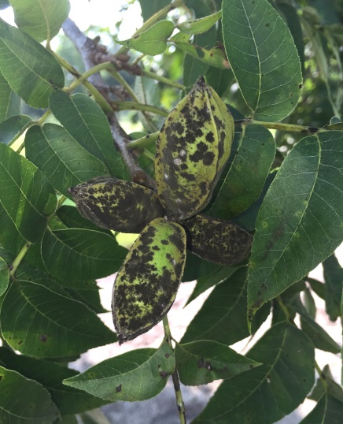
(Pecan Scab)

Matthew R. March, MNRD
County Extension Agent- Agriculture & Natural Resources
Polk County | Texas A&M AgriLife Extension Service
602 E Church St Ste 127 Livingston, TX 77351
Phone: (936) 327-6828

Chronic Wasting Disease, November 12-18

November marks the beginning of general white-tailed deer gun season across Texas. Deer hunters will begin their annual pilgrimage to deer stands across the state. Rather that stand is hours away in a remote location or in their own backyard every hunter needs to realize a disease that is present here in some areas of Texas. This disease is chronic wasting disease (CWD). CWD is a fatal disease that affects some members of the cervid (deer) family. CWD is economically important because it can cause population declines in deer herds, but also shifts in age structures. This could potentially have a huge impact on deer hunting in Texas. There is no known evidence that CWD can be transmitted to humans, but when cleaning deer hunters should follow proper food handling procedures. These procedures would be wearing latex gloves, washing hands, and avoiding sawing through neurological tissue.
CWD belongs in a family that is classified as transmissible spongiform encephalopathies (TSEs) and is believed to be spread by prions, which are misfolded proteins. CWD is similar to other TSEs include bovine spongiform encephalopathy in cattle, scrapie in sheep, and Creutzfeldt-Jakob disease in humans. CWD affects the nervous system and has no known cure and will eventually lead to death. Prior to death, sick individuals will experience symptoms such as emaciation, excessive salivation, lack of muscle coordination, difficulty in swallowing, excessive thirst, and excessive urination. Individuals may also lose their fear of humans, stagger, and have a dull expression. However, many of these symptoms don’t appear until later stages and an infected animal can be spreading the disease while still appearing healthy. CWD can have an incubation period of up to four years before showing symptoms. A laboratory test post-mortem of brain and lymph nodes is the only true way to determine diagnosis of CWD.
CWD is spread through shedding of prions through infected animal’s saliva, urine, blood, and feces. These prions can infect other individuals through either direct contact or indirectly through the environment. Prions can remain in the environment for extended periods of time. CWD can spread to new areas either through natural movement of sick individuals or human assisted movement of live deer or carcass parts.
CWD was first reported in mule deer from Colorado in 1967 and by 1981 was identified in Elk. It was reported in Texas in 2012 in mule deer. It has now been reported in white-tailed deer in Texas. TPWD has developed endemic zones in some regions of the state that have specific rules regulating removal of certain carcass parts to reduce the spread. TPWD has also developed a testing program across the state to test harvested deer. To learn more about endemic zones, rules regulating transport of harvested deer, and having your harvested deer tested you can visit https://tpwd.texas.gov/huntwild/wild/diseases/cwd/ or contact your local TPWD biologist.
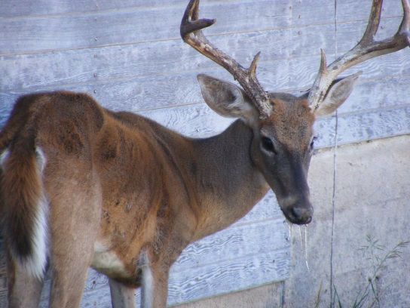
Photo: Warden Micheal Hopper, Kansas Department of Wildlife, Parks & Tourism
Matthew R. March, MNRD
County Extension Agent- Agriculture & Natural Resources
Polk County | Texas A&M AgriLife Extension Service
602 E Church St Ste 127 Livingston, TX 77351
Phone: (936) 327-6828

Turkey Production, November 19-25

Whole turkey is a mainstay for many families holiday dinners, but many people don’t realize that they consume turkey products throughout the year. In fact, whole turkeys, specifically for the holidays, are a very small portion of turkey sales or percentage of production. Many consumers also do not have a good understanding of the structure of turkey production in the U.S.
Commercial turkey production in the U.S. is vertically integrated. Due to the large cost associated with turkey production, (feed mills, hatcheries, marketing, transportation, labor, etc.) vertical integration allows for turkey production to be economical, thus keeping prices low for consumers. Companies such as Cargill and Butterball own all aspects of turkey production except at the farm level. Turkey companies still depend on local, usually family farms to raise and care for the turkeys from one day old until they reach market size. These farmers receive poults, young turkeys, from the company hatchery. Farmers also receive feed from the company, which ensures that the turkeys are receiving a feed that matches its nutritional demands. Throughout the entire grow out period farmers are giving advice from professional technicians. Turkeys are housed in large ventilated houses that allow for protection from predators and have the ability to control the climate. This allows for increased production keeping cost low for consumers.
The broad breasted white turkey is the breed utilized for commercial turkey production in the U.S. This breed has been bred to select for large breast meat yields and white feathers, which is preferred by consumers in the U.S. Hens and toms are raised in separate houses to better match their nutritional demands. Toms are raised to 24 weeks of age and will weigh between 40-45 lbs. Hens are raised to 16-20 weeks of age and will weigh between 18-30 lbs. Due to the large size of breast meat on toms, natural breeding is difficult and all commercial turkeys are artificially inseminated.
Turkey production has increased from 3.2 million turkeys slaughtered in 1910 to 245 million slaughtered in 2017. Last year 7.5 billion pounds was produced compared to 1.75 billion pounds in 1967. This is due to the large improvements in production through selection, breeding, housing, feed, and technology. Only 10-15% of turkeys slaughtered will remain as a whole carcass, mostly for consumption during the holidays. The other 85-90% is further processed into lunch meats, pizza toppings, etc. Because of this, the average American will consume 20lbs of turkey in a year. There is also an export market of dark meat.
Now that you have a better understanding of commercial turkey production in the U.S. you can educate the rest of your family while enjoying a delicious healthy turkey this holiday season!
Matthew R. March, MNRD
County Extension Agent- Agriculture & Natural Resources
Polk County | Texas A&M AgriLife Extension Service
602 E Church St Ste 127 Livingston, TX 77351
Phone: (936) 327-6828

East Texas Pine Forest, November 26- December 2
East Texas is known for its vast pine forest, but did you know that there are three different native pine tree species in East Texas. These species are Longleaf Pine (Pinus palustris), Shortleaf Pine (Pinus echinata), and Loblolly Pine (Pinus taeda). These species are found in different densities throughout East Texas.
The pine forest of East Texas is the far western extension of the southern pine belt of the United States or more technically known as the south central plains. The East Texas pine forest covers an area roughly bound by Texarkana in the northeast southwestward to Tyler, then south along the Trinity River. The pine forest extends westward across the Trinity River around the Huntsville area and then continues south to North Houston and then extends eastward to the Beaumont area. The pine forest of East Texas can be further divided into three ecological regions; tertiary uplands, southern tertiary uplands, and flatwoods.
The tertiary uplands include all areas north of a line that stretches from roughly Crockett, Nacogdoches, and northern Sabine County. This region is moderately sloping and is marked by typically well drained soils that are sandy to loamy. Pine trees are less dense and in some areas oak trees are denser then pines compared to the other two regions to the south. Longleaf pines are mostly absent from this area, while loblolly and shortleaf pines are common. South of the tertiary uplands are the southern tertiary uplands. Most of the southern tertiary uplands have very sandy soils and are rolling compared to the flatwoods to the south. Southern tertiary uplands were historically characterized by expansive longleaf pine savannah forest on sand ridges and uplands with loblolly pines replacing longleaf pines on wetter sites. Shortleaf pines are less abundant in the southern tertiary uplands. The last ecoregion is the flatwoods which consist of the flat poorly drained clay soils that extends across the southern reaches of East Texas. Loblolly pines are present in the flatwoods, however, historically the region was marked be vast longleaf pine forest savannahs and bottomland hardwood forest. The Big Thicket National Forest is found in the flatwoods region. Discussing the pine forest of East Texas cannot be discussed without noting that fire was a natural occurrence that historically shaped East Texas. Fire allowed for a more open savannah forest with a grass understory compared to the thick understory found throughout East Texas today. Polk County is in the southern tertiary uplands region except for a small section of the county south of Livingston including the Goodrich area which is located in the flatwoods.
Next time you are traveling through East Texas see if you can notice a difference in pine forest type depending on what ecological region you are in. Angelina and Sabine National Forests are a good place to see Longleaf Pine savannahs in the southern territory uplands, while driving south from Livingston to Beaumont you will transverse the Flatwoods. Around the Tyler area is a good example of tertiary uplands with steeper hills and forest consisting of just as many oaks as shortleaf and loblolly pines.
Matthew R. March, MNRD
County Extension Agent- Agriculture & Natural Resources
Polk County | Texas A&M AgriLife Extension Service
602 E Church St Ste 127 Livingston, TX 77351
Phone: (936) 327-6828

