On the Track to Better Health….

May 2016 BLT Newsletter
Food Substitutes and Your Health

Recipe or ingredient substitution is an excellent way to enjoy the foods you love most while making the dish healthier. There are many ways to create healthy alternatives to some of our favorite—not so healthy—meals by substituting an ingredient or two. These substitutes won’t sacrifice the flavor of the dish, so let’s explore some alternatives.

- One simple substitution is using applesauce in place of butter, shortening or oils.
- When using a recipe that calls for regular ground beef, try using lean ground beef or lean ground turkey. When considering whether to purchase lean ground meats, don’t be discouraged by a higher price. Leaner meats will yield more meat after cooking while also containing less saturated fat and fewer calories.
- Skim or 1% milk can be used in place of whole milk.
- Use whole-wheat flour for half of the recipe and all-purpose flour for the other half as a substitute for all-purpose (plain) flour.
- Sugar can be substituted by reducing the amount of sugar by one-half. If the recipe isn’t sweet enough, use cinnamon, nutmeg, or vanilla.
- Recipes that call for sour cream can be just as tasty if the sour cream is replaced with plain fat-free or low-fat yogurt.
- Two-egg whites can substitute for one whole egg.
- Whole-grain bread and whole-wheat pasta can be substituted for white bread and white (enriched) pasta.
These and other steps can help you enjoy your favorite dishes with confidence knowing you’re also putting more nutritious foods on your family’s table. For more information on food substitutes, contact us at Better Living for Texans.

Local Events

Recipe of the month:
Applesauce Loaf Cake
Makes: 16 servings
Total Cost: $3.20
Serving Cost: $0.20
Cinnamon, nutmeg, and toasted walnuts make this loaf cake taste as great as it smells.

Ingredients
1/2 cup walnuts (chopped)
1 1/2 cups applesauce
1 egg
1 cup sugar
2 tablespoons vegetable oil
1 teaspoon vanilla extract
2 cups all-purpose flour (or substitute with 1 cup whole wheat flour and 1 cup all purpose flour)
2 teaspoons baking soda
1/2 teaspoon cinnamon (ground)
1/2 teaspoon nutmeg (ground)
1 cup raisins

Directions
1. Wash hands well with soap and warm water.
2. Pre-heat the oven to 350 degrees. Grease 2 (8x4x2 inch) loaf pans.
3. Toast walnuts in an ungreased skillet pan. Stir while heating on medium-low heat for 5-7 minutes. They are done when they are brown and smell nutty. Set aside to cool.
4. Mix applesauce, egg, sugar, oil and vanilla in a large bowl.
5. Mix flour, baking soda, cinnamon, and nutmeg together in a smaller bowl.

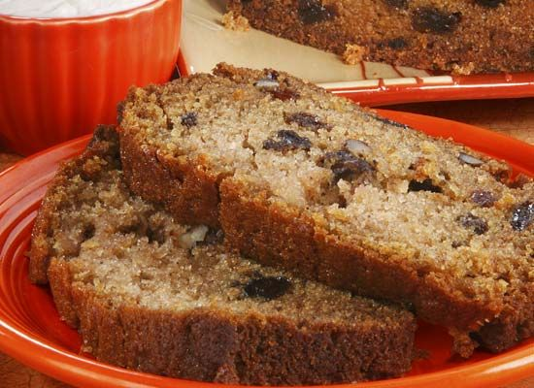

6. Pour flour mixture into applesauce mixture.
7. Stir in raisins and cooled toasted nuts.
8. Pour half of the batter into each greased pan. Bake for 45-55 minutes.
9. Remove cakes from the oven. Cool for 10 minutes. Remove from pans to finish cooling. For best taste, let cakes cool a few hours before serving.

