January – A Good Time to Prune or is it?
December 26, 2019
John A. Krogue

Well, the holidays are over. it’s January and cold, so it’s a great time to get out work off some calories and trim the trees and shrubs in my yard. We may be intimidated by the maxim: it is better not to prune than to prune incorrectly. However, now is a great time for pruning and understanding which plants should not be pruned now so we can plan for the future.

But before starting let’s look at the tools we may need and some of the dangers. The tools required for pruning shrubs and smaller trees are shown in the photo and from left to right: pruning shears, lopping shears, and a combination pole saw and pruner. The pruning shears are great for shrubs and bushes and are used for branches up to ½” inch in diameter. The lopping shears are used for limbs from ½” to 2” in diameter. The combination pole saw, and pruner is used for limbs that are harder to reach. A pruning saw or bow saw is used on branches larger than 2” or for removing old dead wood. Care must be taken when trimming branches larger than 2” to avoid injuring ourselves or the tree.

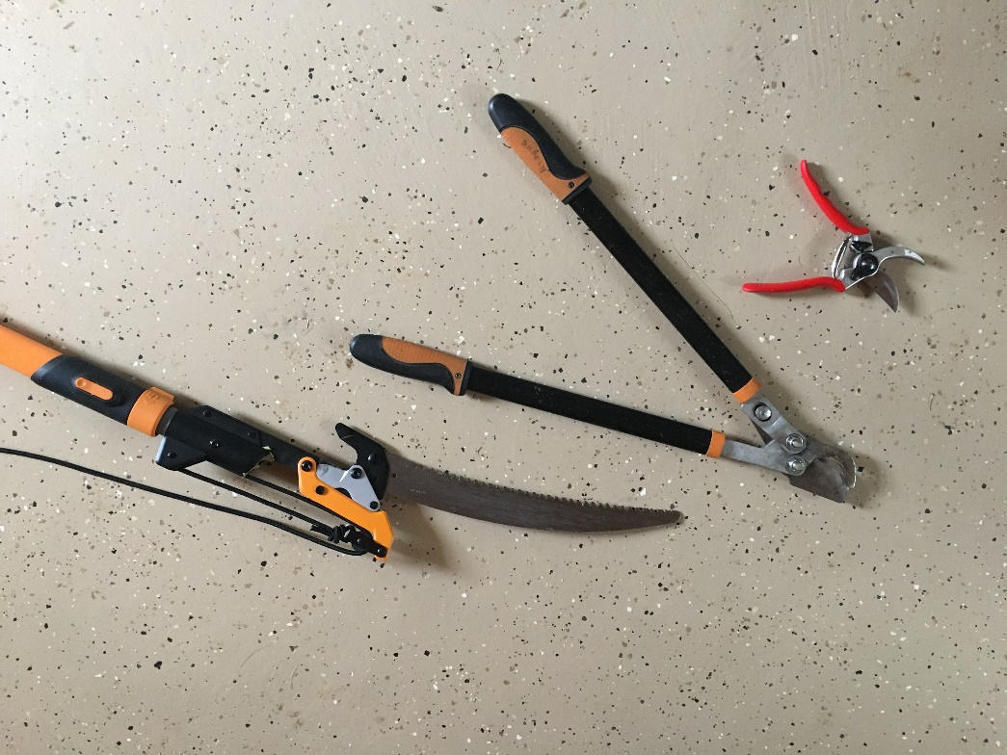

There are only a few reasons to prune. One reason would be to train a plant to grow as you want it. Another would be to maintain the plant’s health. You also prune to improve the quality of flowers, fruit, foliage or stems. The other reason is to restrict growth. Sometimes we get ourselves in trouble before we even begin by our choices of plants and where we place them.

We can save ourselves a lot of trouble by choosing and matching the plant to the space that we have available. If a shrub that wants to be ten feet tall and five feet wide ends up in a space that allows only an eight-foot height and a three-foot width, neither the plant nor we will be happy. It will not look good in the space and over pruning to keep it within its bounds does not make it pretty. There are many resources online and in nurseries that will give the expected full-grown dimensions of the plant. And be specific with the plant purchased. A specific plant may have a different mature size and shape than one with a very similar name. Although the plant may look small when planted, as it matures you will be far more satisfied with the beauty and natural appearance, than with having to constantly fight the plant by pruning.

Most of the time when we plant trees they are small and take years to reach their mature size. During this time it is important to train them with selective pruning. For example, as the tree grows we may wish to mow or walk underneath, but we need to let limbs on the small tree grow to sustain the tree growth. So over time will trim the lower branches until we have the clearance that we desire. Generally, waiting to trim the limb until it is about 1” is a good rule of thumb. The goal for most young trees is to maintain a single dominant central leader growing upward. This will likely require trimming away secondary branches that want to compete or take over. It will also require thinning branches to maintain good spacing between branches and symmetry among the branches. The goal is to produce a tree like it would be in a forest surrounded by other trees. There is an excellent article on “Pruning Young Trees” available on the Texas A&M forest Service website at http://tfsweb.tamu.edu. This provides details on the methods used to trim trees.

Another example of pre-planning is planting a hedge. When it is planted the plants will optimally be about one to two feet tall. Once planted they should be trimmed back to about eight inches. This starts it off right to provide low branching. Each year before the buds break for the next season trim back about half of the new growth considering the final shape desired. It is also best not to plan for square sides and flat tops. The sides of the hedge should slope in as it gets taller and be rounded at the top. This constant effort will produce a wonderful hedge. If one waits a couple years and then tries to get it into the desired shape it may turn into a nightmare.

Now is a great time to pruning many trees and shrubs. Many shade trees like oak, pecan, elm, and maple are ready to be pruned. Summer flowering trees like desert willow should be pruned in January and February. Shrubs that flower in summer can also be pruned at this time. These would include hydrangea, Texas sage, butterfly bush, possumhaw holly, etc.

However, now is not the time to prune spring flowering shrubs. These shrubs are going to flower based upon last year’s growth. Some examples of these are redbud, Japanese quince, honeysuckle, and some climbing and rambling rose species. The time to prune these trees is after they flower in the spring.

The time for pruning narrow-leaved evergreens like those that have needles is in April. Broad-leaved evergreens like azaleas, holies and gardenias require very little pruning. Pruning should only be used in the dormant season to improve shaping or remove old and weak stems.

The main fruit tree in this area are peach trees. It is best to prune when they are in the pink bud stage. This happens after the buds have formed and they are just beginning to open.

Pruning is a great way to get outside, enjoy nature and work off some frustration and energy. You can access excellent information on online at https://aggie-horticulture.tamu.edu/earthkind or at your local nursery or gardening center.

