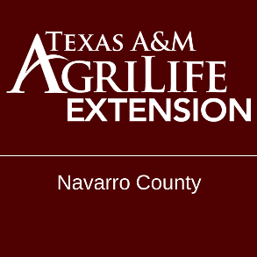
Navarro County ANR Newsletter – November 2020 Issue 4
Andrew Lewis
County Extension Agent – Ag & Natural Resources
Navarro County
313 West 3rd Ave
Corsicana, Texas 75110
903-654-3075

Fertilization of Winter Pasture
Fertilization of winter pasture should be based on a soil test to maximize forage production and prevent applying more fertilizer than is needed. Nitrogen fertilization of small grain and small grain-ryegrass mixtures can be split in 2 to 4 equal applications during the growing season. Two applications are often sufficient in Central Texas with lower rainfall and heavier textured soils. Three or four applications are required on the sandy soils in East Texas because of low nutrient holding capacity and high rainfall. Phosphorus and potassium can be applied at planting. If more than 75 to 80 lbs/acre of potassium are needed on sandy soils in East Texas, it is recommended to split into an autumn and late winter application because of leaching.
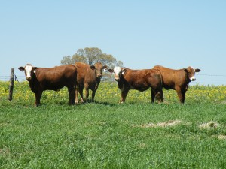
Nitrogen fertilization of overseeded ryegrass is usually split in 2 to 3 applications. Phosphorus and potassium, if needed, can be applied at planting. The initial N application should be delayed until after the ryegrass is established to reduce N utilization by the warm season grass and possible leaching in sandy soils. Additional N can be applied in mid winter and early spring.

Fertilization of Winter Pasture
Overseeded clover-ryegrass may not receive any N or up to 2 applications, depending on the amount of early forage needed. Without N, sufficient forage for grazing will not likely be available until February or early March, depending on location. The most common program is a single application in December to enhance ryegrass production during the winter when there is very little clover growth. Maximum forage production is obtained with 2 applications of N, one after the ryegrass and clover are up and a second in midwinter. Nitrogen should not be applied in the spring if there is a good clover stand. Phosphorus and potassium can be applied at planting or shortly after planting.
Dr. Vanessa Corriher-Olson
Forage Extension Specialist
Soil & Crop Sciences
Overton, TX
vacorriher@ag.tamu.edu
Texas A&M AgriLife Extension
Cotton Variety Trial

On October 9th we harvested our cotton variety trial hosted by Reed Agriculture. Some preliminary data has been compiled but we are waiting on the final data information to be released be for publishing in our newsletter. A big thank you to Reed Agriculture for Hosting the trail this year. AGRICULTURE CONTROLLED ENVIRONMENT CONFERENCE
CEU & PESTICIDE / HERBICIDE NEWS

USE OF PARAQUAT PRODUCTS:
Training is being required by the EPA for the use of any paraquat product. This training is strictly online, and the training module can be accessed at: https://campus.extension.org/enrol/index.php?id=1660. This training applies to all paraquat applications, and to use you must be a licensed applicator. The word “use “in this rule applies to all activities occurring before applications (mixing & loading), applying the pesticide, and other related activities including, but not limited to storage of open containers, transporting open containers, cleaning equipment, disposing of excess pesticides, spray mix, wash water, pesticide containers, and any other materials containing paraquat

UPCOMING EVENTS, PROGRAMS, MEETINGS

December 10, 2020: District 8 Farm & Ranch Seminar $50
8 Hour CEU Program
7:00 am – 4:00 pm at Navarro County Youth Expo
Call Office to RSVP
Anytime: Algae and Floating Aquatic Plant Identification and Control
https://agrilifelearn.tamu.edu/product?catalog=WFSC-003&fbclid=IwAR1RS8geZmRz89sqs-GGx7eknCuHTDGPUOwnt3Y1Tnh0zov4B8WiUEe78mk
Private Applicators License Course:
https://agrilifelearn.tamu.edu/product?catalog=AGCH-015

HOW TO CONTACT US
Find us online: https://navarro.agrilife.org/
Find us on Facebook: @NAVCOANR
Call us: 903-654-3075
Email us: Andrew.lewis@ag.tamu.edu
Give us a call or email to get added to our email and mailing list.

