Texas A&M AgriLife Extension





TEXAS PECAN PEST

MANAGEMENT NEWSLETTER

**July 12, 2019 No. 19-5**

**Bill Ree, Extension Program Specialist III – IPM**

**Texas A&M AgriLife Extension**

**1470 William D. Fitch Parkway, 2150 TAMU**

**College Station, TX 77843-2150**

**979-458-0335 – office**

[**w-ree@tamu.edu**](mailto:w-ree@tamu.edu)

**\*\*\*\*\*\*\*\*\*\*\*\*\*\*\*\*\*\*\*\*\*\*\*\*\*\*\*\*\*\*\*\*\*\*\*\*\*\*\*\***

**TEXAS PECAN GROWERS ASSOCIATION**

**\*\*\*\*\*\*\*\*\*\*\*\*\*\*\*\*\*\*\*\*\*\*\*\*\*\*\*\*\*\*\*\*\*\*\*\*\*\*\*\***

**TEXAS PECAN GROWERS ASSOCIATION**

**4348 Carter Creek, Suite 101 Bryan, TX 77802**

**Ph: 979-846-3285; Fax: 979-846-1752**

[**pecans@tpga.org**](mailto:pecans@tpga.org)

[**www.tpga.org**](http://www.tpga.org)

[**https://www.facebook.com/PecanSouth**](https://www.facebook.com/PecanSouth)

**https://www.facebook.com/TexasPecanGrowers**

**\*\*\*\*\*\*\*\*\*\*\*\*\*\*\*\*\*\*\*\*\*\*\*\*\*\*\*\*\*\*\*\*\*\*\*\*\*\*\***

**STATE CONFERENCE**

The state TPGA conference is just around the corner (July 14 – 17th). Just a reminder that there will be some CEU’s provided during the conference and if you plan on obtaining the CEU’s you will need your pesticide license number. As in the past, the sign in sheets will be in the room where the presentations are given. Also, I will have a booth in the exhibit area so during the breaks come by for a visit.

**INSECTS**

As we enter this second half of the season there are several pests that need to be monitored: Yellow and black aphids, scorch mites, stink bug/leaffooted bugs, pecan weevil, second and third generation walnut caterpillar to name a few, plus various potential wildlife issues.

Black aphids: Watch for this aphid to build up in crowed areas of the orchard and in the

interior of the canopy. A characteristic sign of an ongoing infestation will be the rectangular yellow blotches on the leaflets. Black pecan aphids can be found on both the upper and lower leaf surfaces. The Texas A&M treatment threshold is an average of 3 aphids per compound leaf.

Walnut caterpillar: Watch for the next generation to occur on foliage which was not damaged by the previous generation. Walnut caterpillar prefers more mature foliage so regrowth from previous defoliation will not be at the right stage of maturity for the next generation. Texas can have two to three generations per year with 245 frost free days being an approximated dividing line between two and three.

Stink bugs/Leaffooted Bugs: You need to be a detective for this group. Pecan is only a feeding host for adult stink bugs so populations will move into an orchard from outside food sources.

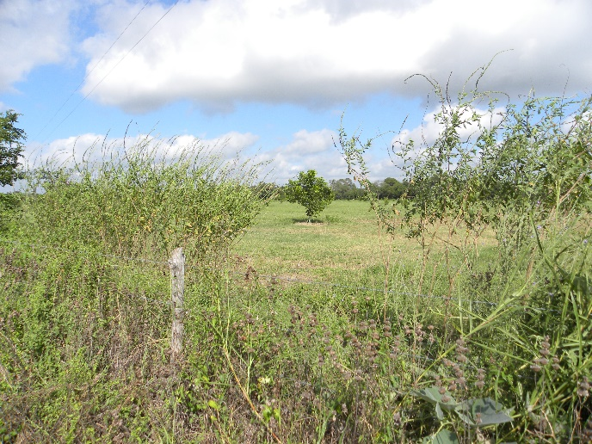

Figure 1*. Gaura parviflora* around a pecan orchard

One of my favorite weeds to monitor and collect stink bugs and leaffooted bugs is *Gaura parviflora* shown in the picture above. Brown stink bugs and the leaffooted bug *Leptoglosssus phyllopus* are common on this weed.

The biggest threat from these insects is when the pecans are in the water stage but feeding can occur after shuck split.

Pecan Leaf Scorch Mite

I have a lot of respect for mites. The best defense against mites is to recognize a problem before it gets out of hand. Mites tend to like hot dry dust conditions so I like to check trees near the dirt roads and turn rows.

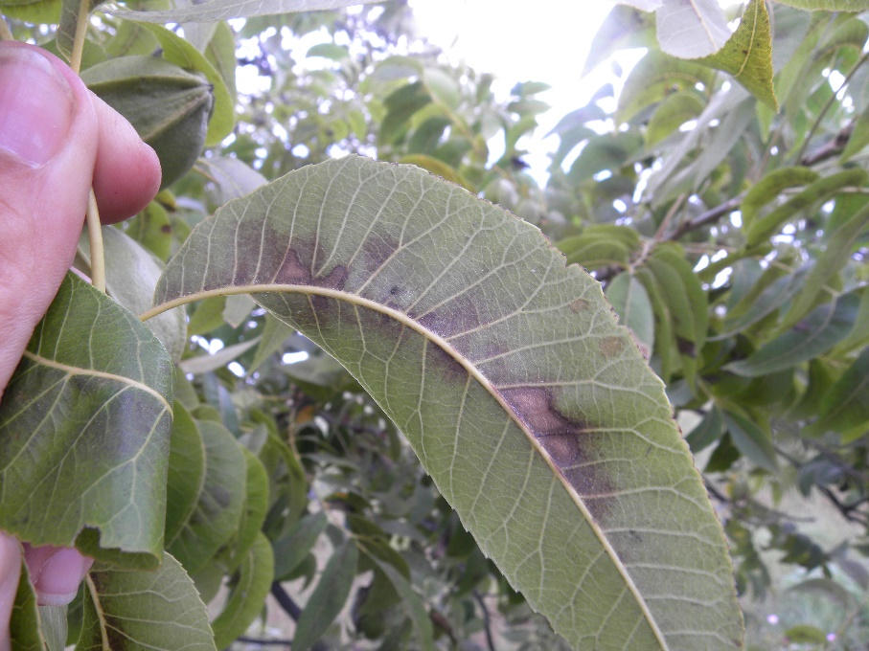

Damage is characterized by a bronzing or browning along the central leaf vein as shown in the picture. Also, mites can be easily seen with the aid of a 10x loop. Recommended miticides can be found at the end of this letter.

Hickory Shuckworm

Treatments for HSW start when pecans reach the half-shell hardening stage. For early maturing cultivars such as Pawnee, Kanza, Mandan this can occur in late July.

We do not have treatment thresholds for HSW so applications are made on the fact that there was a problem the previous season. Recommended products are the same products recommended for pecan nut casebearer.

Pecan Weevil

The map below shows our most current distribution map for pecan weevil. If you feel that you have weevil and your county is not shown on the map please let me know.

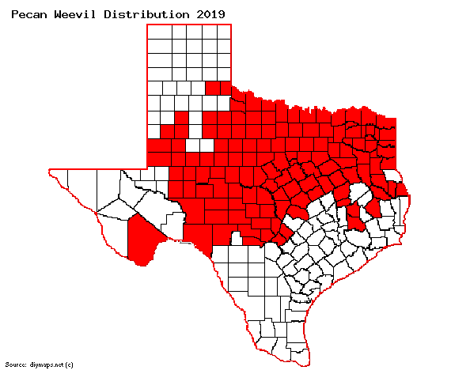

**CROP PREDICTION**

Ben Littlepage Memorial

Pecan Gussetimate

Tri-State meeting

June 21, New Roads, LA

Million/lbs

|  |  |
| --- | --- |
| Alabama | 1.5 |
| Arizona | 30.0 |
| Arkansas | 1.5 |
| California | 4.5 |
| FL, NC, SC | 2.5 |
| Georgia | 62.0 |
| KS, MO | 3.0 |
| Mississippi | 4.0 |
| Louisiana | 8.0 |
| New Mexico | 85.0 |
| Oklahoma | 28.0 |
| Texas | 36.0 |
| **Total** | **266.0** |

**STATE/REGIONAL MEETINGS**

**July 14-17, 2019**

**Texas Pecan Growers Conference and Trade Show**

**Frisco, TX**

**Contact: TPGA @: 979-846-3285 or pecans@tpga**

**\*\*\*\*\*\*\*\*\*\*\*\*\*\*\*\*\*\*\*\*\*\*\*\*\*\*\*\*\*\*\*\*\*\*\*\***

**The information given herein is for educational purposes only. References to commercial products or trade names are made with the understanding that no endorsement by the Texas A&M AgriLife Extension Service is implied.** **The members of Texas A&M AgriLife will provide equal opportunities in programs and activities, education, and employment to all persons regardless of race, color, sex, religion, national origin, age, disability, genetic information, veteran status, sexual orientation or gender identity and will strive to achieve full and equal employment opportunity throughout Texas A&M AgriLife. The Texas A&M University System, U.S. Department of Agriculture, and the County Commissioners Courts of Texas Cooperating**

