Texas A&M AgriLife Extension





TEXAS PECAN PEST

MANAGEMENT NEWSLETTER

**June 13, 2019, No. 19-4**

**Bill Ree, Extension Program Specialist III – IPM**

**Texas A&M AgriLife Extension**

**1470 William D. Fitch Parkway, 2150 TAMU**

**College Station, TX 77843-2150**

**979-458-0335 – office**

[**w-ree@tamu.edu**](mailto:w-ree@tamu.edu)

**\*\*\*\*\*\*\*\*\*\*\*\*\*\*\*\*\*\*\*\*\*\*\*\*\*\*\*\*\*\*\*\*\*\*\*\*\*\*\*\***

**TEXAS PECAN GROWERS ASSOCIATION**

**\*\*\*\*\*\*\*\*\*\*\*\*\*\*\*\*\*\*\*\*\*\*\*\*\*\*\*\*\*\*\*\*\*\*\*\*\*\*\*\***

**TEXAS PECAN GROWERS ASSOCIATION**

**4348 Carter Creek, Suite 101 Bryan, TX 77802**

**Ph: 979-846-3285; Fax: 979-846-1752**

[**pecans@tpga.org**](mailto:pecans@tpga.org)

[**www.tpga.org**](http://www.tpga.org)

[**https://www.facebook.com/PecanSouth**](https://www.facebook.com/PecanSouth)

**https://www.facebook.com/TexasPecanGrowers**

**\*\*\*\*\*\*\*\*\*\*\*\*\*\*\*\*\*\*\*\*\*\*\*\*\*\*\*\*\*\*\*\*\*\*\*\*\*\*\***

**INSECTS**

**2nd generation PNC**. Treatments for second generation PNC have started in the College Station area this week. In most years second generation is not much of a threat, however, if you have a light crop where 30 or 40 percent or less of the terminals have clusters then second generation can be an issue.

The second generation is approximately 42 days after the first but to get a better handle on activity the PNC pheromone trap can be used to detect the onset of the second generation flight. In addition to using the pheromone trap, I also look at first generation damage to help me get an idea on the status of what is happening.

Finding nuts that have empty pupal skins will tell you that emergence has started and nuts that still have pupae obviously tell me that there are more to come. According to Bilsing’s publication, the pupal stage of the second generation lasts 9 days and there is a 2 to 3 day pre-ovipositon period.

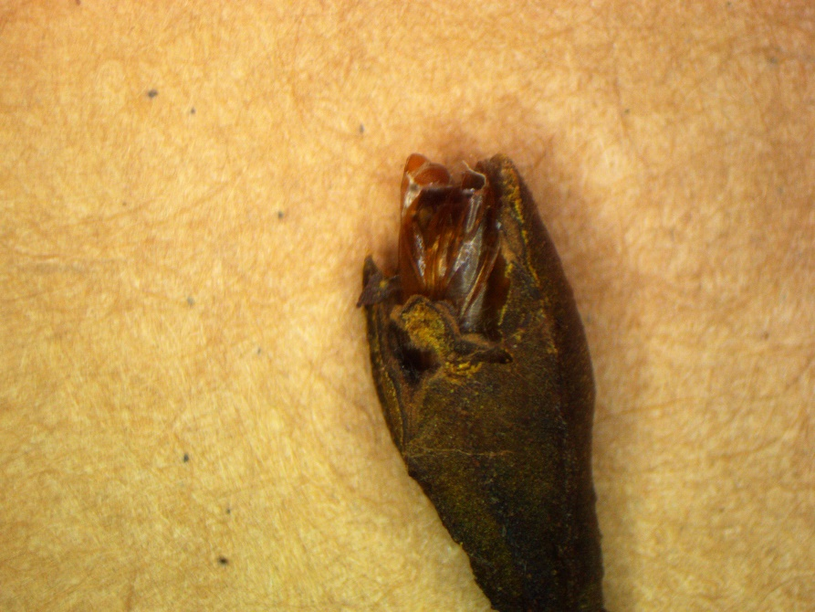

Figure 1. Empty PNC pupal case.

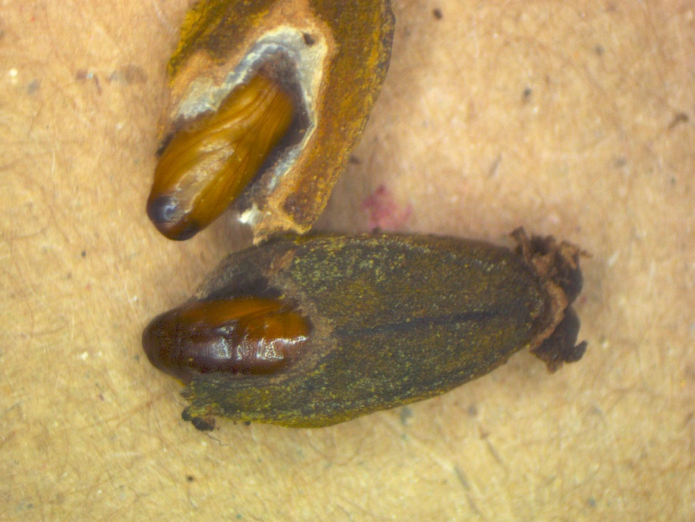

Figure 2. PNC pupae.

Early stage pupae will be the jade green color of the larvae but pupae will darken to a dark brown as they mature.

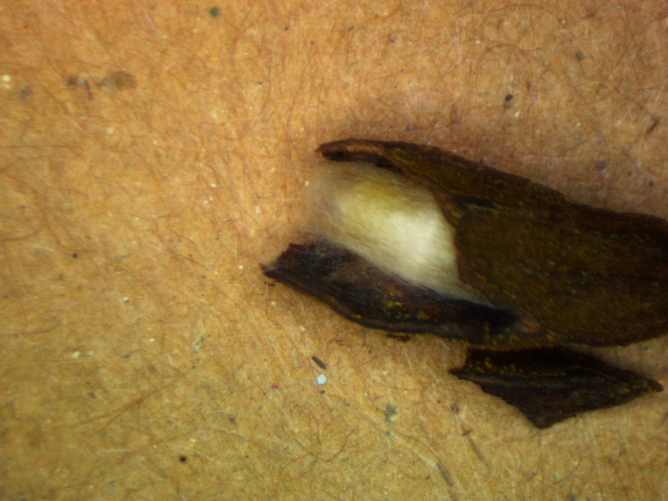

Figure 3. Pupal case of Hymenoptera parasite.

According to research by G. A. Gunasena and M. K. Harris, (1983, 1984) larvae and pupae of the pecan nut casebearer are attacked by at least 24 species of parasites. Pupae of these parasites are commonly observed and most will have a white pupal case as shown in Figure 3. Present parasitism of first summer generation was observed to be as high as 41% in a Brazos county orchard in 1983.

**Fall webworm**

I have yet to see fall webworm as a serious issue in commercial orchards, especially those treated with methoxyfenizide.

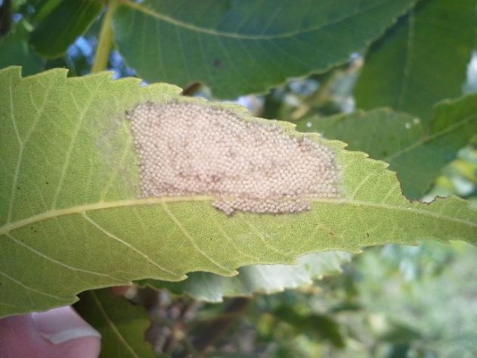

Figure 4. Fall webworm egg mass

Most of the inquires I receive for this insect are from the urban areas. Management of FWW can be achieved by: removing webs; tearing open webs to allow predator access or spraying an insecticide. Fall webworm egg masses differ from walnut caterpillar in that they are covered with scales from the female moth and are usually two or three layers deep.

**Walnut sphinx caterpillar**

Back in 2012 there was an outbreak of this insect in Central TX (Comanche county area) that caused some significant defoliation of mature trees. I have received one report from north Texas to date of an infestation on some young trees.

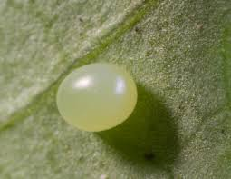

Figure 5. Walnut sphinx moth egg

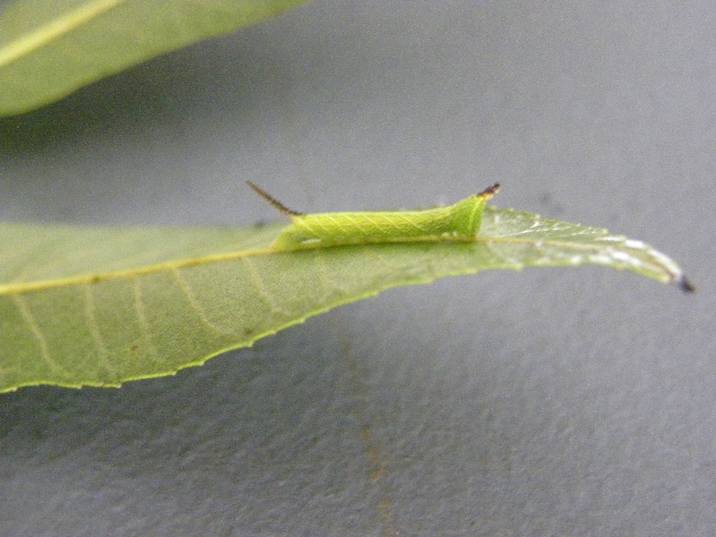

Figure 6. Early instar walnut sphinx caterpillar

This species of caterpillar belongs to the Lepidoptera family Sphingidae and feeds on alder (Alnus), hickory (Carya), hazelnut (Corylus), beech (Fagus), walnut (Juglans), and hop-hornbeam (Ostrya) species. Walnut sphinx caterpillars have the characteristic “horn” at the end of the abdomen and are related to those hornworms you find in your garden. The larvae have a unique anti-predator adaption of making a whistling sound when disturbed. Eggs are laid on the foliage as single eggs and foliage damage can resemble that of the walnut caterpillar, however, the damage has more of a ragged appearance as compared to that of the walnut caterpillar. Also, unlike walnut caterpillar which requires more mature foliage for larval feeding, I have observed walnut sphinx larvae feeding on new growth from recently defoliated trees.

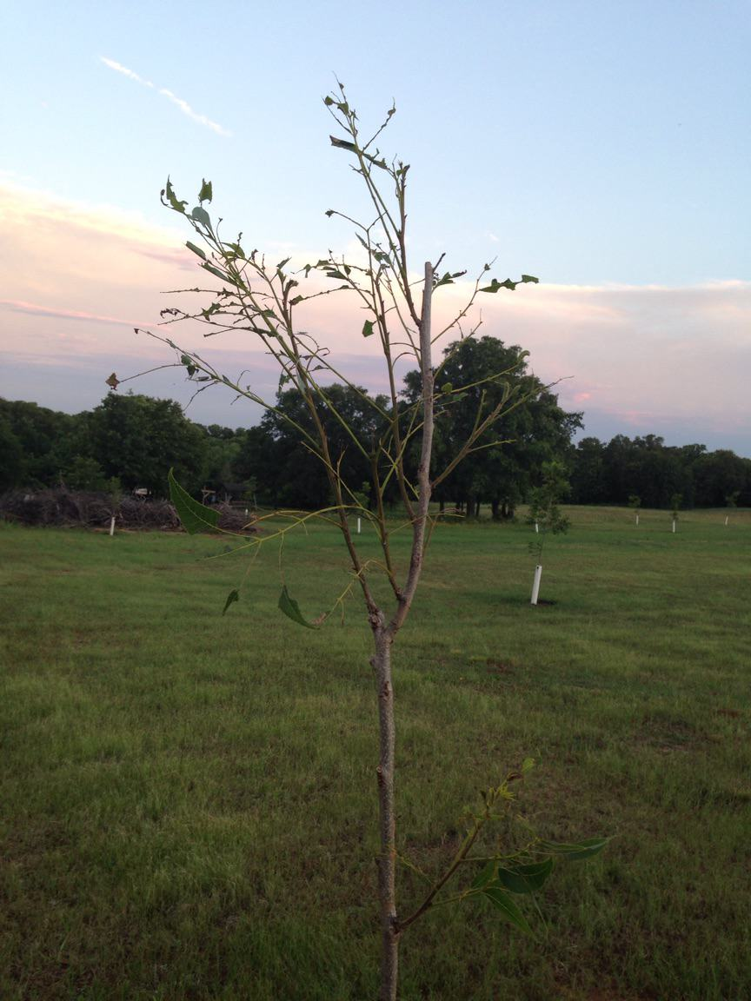

Figure 7. Walnut sphinx caterpillar damage

**Walnut Caterpillar**

The best defense for preventing defoliation from this insect is to recognize a problem before it is too late. Watch for defoliated terminals, and cast skins on the trunk. Insecticides recommended for Lepidoptera pests can be found in the table at the

end of this letter.

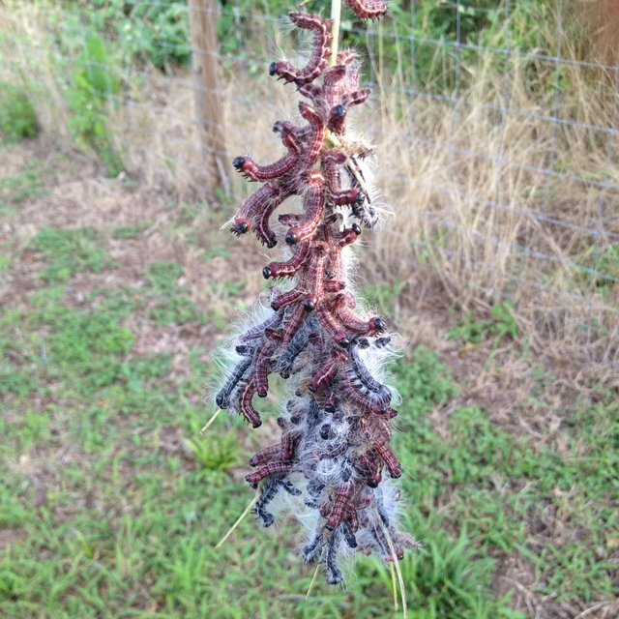

Figure .Colony of walnut caterpillars.

Although trees will re-foliate after defoliation, the impact of defoliation can/will severely impact the crop.

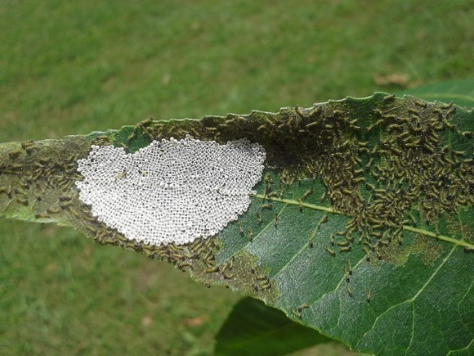

Figure 9. Egg mass with first instar larvae.

**STATE/REGIONAL MEETINGS**

**June 20-21, 2019**

Tri-State ArkLaMiss Pecan Conference

New Roads, LA

Contact: lapga.com

**July 14-17, 2019**

**Texas Pecan Growers Conference and Trade Show**

**Frisco, TX**

**Contact: TPGA @: 979-846-3285 or pecans@tpga**

**\*\*\*\*\*\*\*\*\*\*\*\*\*\*\*\*\*\*\*\*\*\*\*\*\*\*\*\*\*\*\*\*\*\*\*\***

**The information given herein is for educational purposes only. References to commercial products or trade names are made with the understanding that no endorsement by the Texas A&M AgriLife Extension Service is implied.** **The members of Texas A&M AgriLife will provide equal opportunities in programs and activities, education, and employment to all persons regardless of race, color, sex, religion, national origin, age, disability, genetic information, veteran status, sexual orientation or gender identity and will strive to achieve full and equal employment opportunity throughout Texas A&M AgriLife. The Texas A&M University System, U.S. Department of Agriculture, and the County Commissioners Courts of Texas Cooperating**

