Texas A&M AgriLife Extension





TEXAS PECAN PEST

MANAGEMENT NEWSLETTER

**May 16, 2019, No. 19-3**

**Bill Ree, Extension Program Specialist III – IPM**

**Texas A&M AgriLife Extension**

**1470 William D. Fitch Parkway, 2150 TAMU**

**College Station, TX 77843-2150**

**979-458-0335 – office**

[**w-ree@tamu.edu**](mailto:w-ree@tamu.edu)

**\*\*\*\*\*\*\*\*\*\*\*\*\*\*\*\*\*\*\*\*\*\*\*\*\*\*\*\*\*\*\*\*\*\*\*\*\*\*\*\***

**TEXAS PECAN GROWERS ASSOCIATION**

**\*\*\*\*\*\*\*\*\*\*\*\*\*\*\*\*\*\*\*\*\*\*\*\*\*\*\*\*\*\*\*\*\*\*\*\*\*\*\*\***

**TEXAS PECAN GROWERS ASSOCIATION**

**4348 Carter Creek, Suite 101 Bryan, TX 77802**

**Ph: 979-846-3285; Fax: 979-846-1752**

[**pecans@tpga.org**](mailto:pecans@tpga.org)

[**www.tpga.org**](http://www.tpga.org)

[**https://www.facebook.com/PecanSouth**](https://www.facebook.com/PecanSouth)

**https://www.facebook.com/TexasPecanGrowers**

**\*\*\*\*\*\*\*\*\*\*\*\*\*\*\*\*\*\*\*\*\*\*\*\*\*\*\*\*\*\*\*\*\*\*\*\*\*\*\***

**Clarification of organizations**

Over the past couple weeks I have received some questions regarding the different pecan organizations and their missions. Below are brief outlines for the Texas Pecan Growers Association, Texas Pecan Board and the American Pecan Council.

**Texas Pecan Growers Association**

Founded in 1921, **Texas Pecan Growers Association** (TPGA) is a voluntary organization with members expanding across the state of Texas, as well as nationwide and other countries. TPGA supports the pecan industry through education, research and promotion projects. Some of those projects include support of research and extension programs, grant work, organizing the annual TPGA Conference & Trade Show, and giving Texas pecans a voice across the industry. TPGA also owns Pecan South magazine, the pecan industry’s leading publication.

**Texas Pecan Board** (TPB) <https://www.texaspecanboard.com/> is a statewide Texas commodity program approved by Texas pecan growers in 1998. TPB collects 0.5 cents per pound sold of all Texas pecans and uses that money for research, education, and promotion. TPB’s objective is to increase the awareness of Texas pecans through retail buyers, foodservice operators, food manufacturers, consumer media, and consumer food influencers.

**American Pecan Council** (APC) <https://americanpecan.com/> is the Federal Marketing Order for pecans, founded in 2016 to showcase the benefits, uses, and history of America’s native tree nut. APC has 17 members and 17 alternates to represent both growers and shellers. APC collects 3 cents per pound sold of improved pecan varieties and 2 cents per pound sold of native or substandard pecans. APC’s goal is to increase and build demand for American Pecans.

**INSECTS**

**PNC Forecast Model**

I am excited to announce that the PNC Forecast Model has been revived. And credit for this new life is “ is due to work by Dr. Allen Knutson, Texas A&M AgriLife Extension and Marvin Harris and Andrew Birt, Texas A&M Agrilife Research, and Joe LaForest, Southern IPM Center,”

The new model can be accessed at:

[https://pecan.ipmpipe.org/Maps/pncForecastMap](https://urldefense.proofpoint.com/v2/url?u=https-3A__pecan.ipmpipe.org_Maps_pncForecastMap&d=DwMFAg&c=r_tSStIHV2ie60z4DgB-pQ&r=kLHh8yJBRH0qZIqWLXm2EddUjT6jBvQQ90YAG205sK0&m=7T55arAUrkH6a2VDoA1MtIfXvudIKkbl-QTP9wErWyM&s=0AKghJSbB4gUObuU7vL6mBTrMTajfoCBBuvali2_jvw&e=)

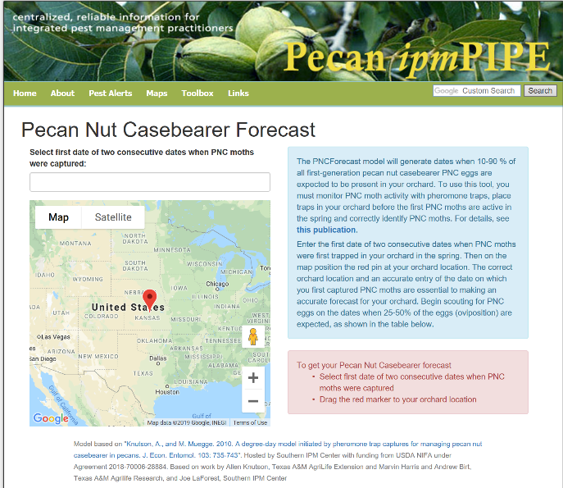

Figure . Home page for PNCForecast model

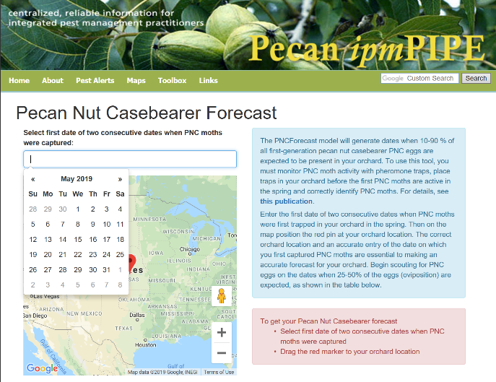

Figure .Home page with drop down calendar for entering first significant trap catch date

This model allows producers that are using PNC pheromone traps to obtain most likely dates for: 10, 25, 50, 70 and 90 percent completion of eggs lay with recommended scouting dates between 25 and 50 completion.

In Figure 3, the example is for first catch date of April 25, 2019, College Station, TX. The prediction for example is most likely dates for 25 percent egg lay is May 6 and 50 percent is May 9th.

Although time has passed for producers in central and southern, TX to use this for this year we would like to hear back from producers on how accurate they feel the predictions for their respective area were.

If you have any comments on accuracy and or user friendliness, please email Dr. Knutson, [Allen.Knutson@ag.tamu.edu](mailto:Allen.Knutson@ag.tamu.edu) and myself [w-ree@tamu.edu](mailto:w-ree@tamu.edu)

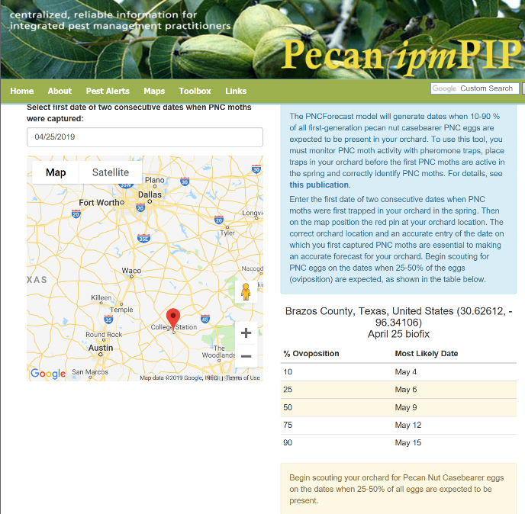

Figure . Example for predictions for College Station for first trap catch date of April 25.

**First Generation PNC**

Weather issues have plagued many producers treating for first generation PNC. Either it was raining or the orchard floor was too wet to get in and this situation has caused some growers to treat by air. Aerial application does pay for itself but I encourage follow up scouting after treatment.

I have also encouraged producers with light to moderate crops to use the pheromone traps to monitor the second generation flight. Eggs from the second generation will be laid on the side of the nutlet and are still findable as shown in the picture below.

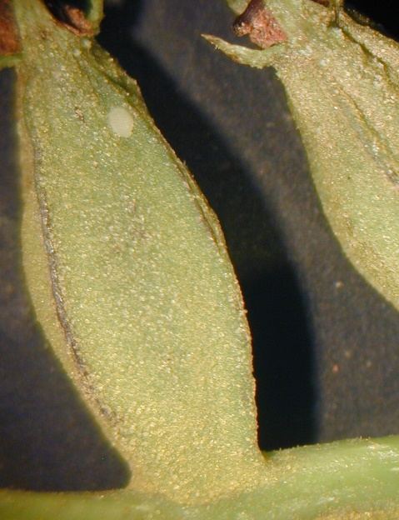

Figure 4. PNC egg on side of nutlet.

**Walnut Caterpillar**

Just a heads up on this pest. Based on dates of observed damage in past years and time required for egg maturity and larval development I am betting that walnut caterpillar egg lay is under way here in Texas.

The best defense for preventing defoliation from walnut caterpillar is to recognize a problem before it gets out of hand. Although trees will re-foliate after defoliation, the impact of defoliation can severely impact the crop.

Early indications of activity can include finding egg masses, defoliated terminals, frass (droppings) on sidewalks and orchard floor and observing cast skins from molting on tree trunks.

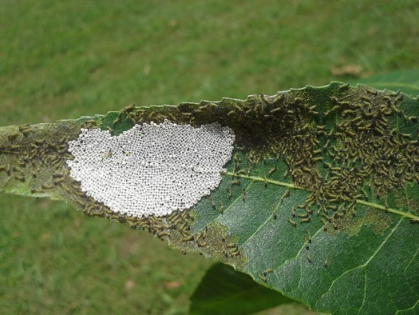

Figure 5. Egg mass with first instar larvae.

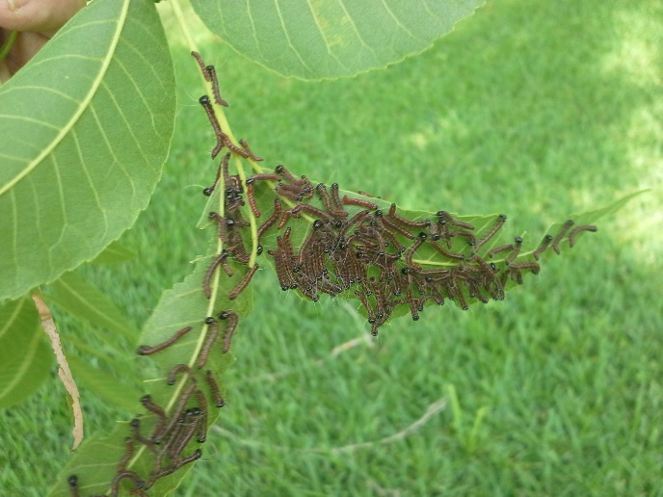

Figure 6. Small colony of third instar larvae

Insecticides recommended for management can be found in the table at the end of this letter.

**STATE/REGIONAL MEETINGS**

**June 12-14, 2019**

Oklahoma Pecan Growers Conference

Ardmore Convention Center

Ardmore, OK

Contact: Deann Smith @ [OPGAtreasure@gmail.com](mailto:OPGAtreasure@gmail.com) or

405-273-1235

**June 20-21, 2019**

Tri-State ArkLaMiss Pecan Conference

New Roads, LA

Contact: lapga.com

**July 14-17, 2019**

**Texas Pecan Growers Conference and Trade Show**

**Frisco, TX**

**Contact: TPGA @: 979-846-3285 or pecans@tpga**

**\*\*\*\*\*\*\*\*\*\*\*\*\*\*\*\*\*\*\*\*\*\*\*\*\*\*\*\*\*\*\*\*\*\*\*\***

**The information given herein is for educational purposes only. References to commercial products or trade names are made with the understanding that no endorsement by the Texas A&M AgriLife Extension Service is implied.** **The members of Texas A&M AgriLife will provide equal opportunities in programs and activities, education, and employment to all persons regardless of race, color, sex, religion, national origin, age, disability, genetic information, veteran status, sexual orientation or gender identity and will strive to achieve full and equal employment opportunity throughout Texas A&M AgriLife. The Texas A&M University System, U.S. Department of Agriculture, and the County Commissioners Courts of Texas Cooperating**

