Texas A&M AgriLife Extension





TEXAS PECAN PEST

MANAGEMENT NEWSLETTER

**April 29, 2019, No. 19-2**

**Bill Ree, Extension Program Specialist III – IPM**

**AgriLife Extension South Campus**

**1470 William D. Fitch Parkway, 2150 TAMU**

**College Station, TX 77843-2150**

**979-458-0335 – office**

[**w-ree@tamu.edu**](mailto:w-ree@tamu.edu)

**\*\*\*\*\*\*\*\*\*\*\*\*\*\*\*\*\*\*\*\*\*\*\*\*\*\*\*\*\*\*\*\*\*\*\*\*\*\*\*\***

**TEXAS PECAN GROWERS ASSOCIATION**

**\*\*\*\*\*\*\*\*\*\*\*\*\*\*\*\*\*\*\*\*\*\*\*\*\*\*\*\*\*\*\*\*\*\*\*\*\*\*\*\***

**TEXAS PECAN GROWERS ASSOCIATION**

**4348 Carter Creek, Suite 101 Bryan, TX 77802**

**Ph: 979-846-3285; Fax: 979-846-1752**

[**pecans@tpga.org**](mailto:pecans@tpga.org) **,** [**www.tpga.org**](http://www.tpga.org)

[**https://www.facebook.com/PecanSouth**](https://www.facebook.com/PecanSouth)

**https://www.facebook.com/TexasPecanGrowers**

**\*\*\*\*\*\*\*\*\*\*\*\*\*\*\*\*\*\*\*\*\*\*\*\*\*\*\*\*\*\*\*\*\*\*\*\*\*\*\***

**INSECTS**

**Pecan Nut Casebearer**

Anyone in the pecan business should know the importance of monitoring and management of PNC. The impact of first generation PNC can range from beneficial with light infestations thinning an overloaded crop to 100 percent crop loss. As a commodity, we are fortunate in that we have an excellent monitoring tool with the PNC pheromone trap and excellent insecticides for management when needed. Data from PNC pheromone traps allow producers to anticipate events of egg lay (oviposition) and nut entry.

From the time of first significant catch, which is the date of the first catch of two consecutive collection dates, egg lay begins in 7 to 10 days while nut entry will start 12 to 16 days after first significant catch.

For more information on PNC activity and trap monitoring check out the PNC

information in our commercial pecan insect

guide at: <http://www.texasinsects.org/tree-crops.html>

Although the pheromone is for PNC we often find other “intruders” in the trap with pecan bud moth being the most common. PNC adults will have a dark band near the base of the wings (where the wings attach to the body) while bud moth will have more of a modeled appearance as shown in the pictures below.

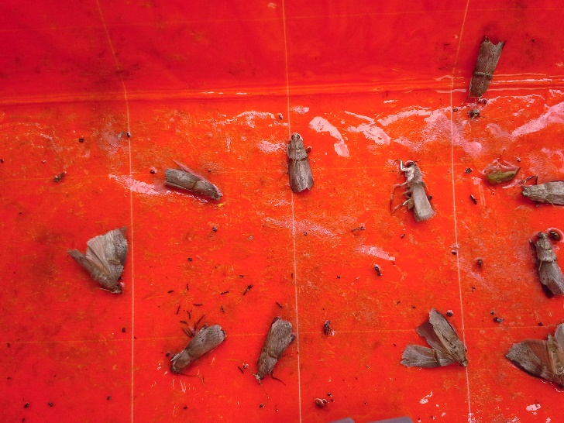

Figure .PNC adults

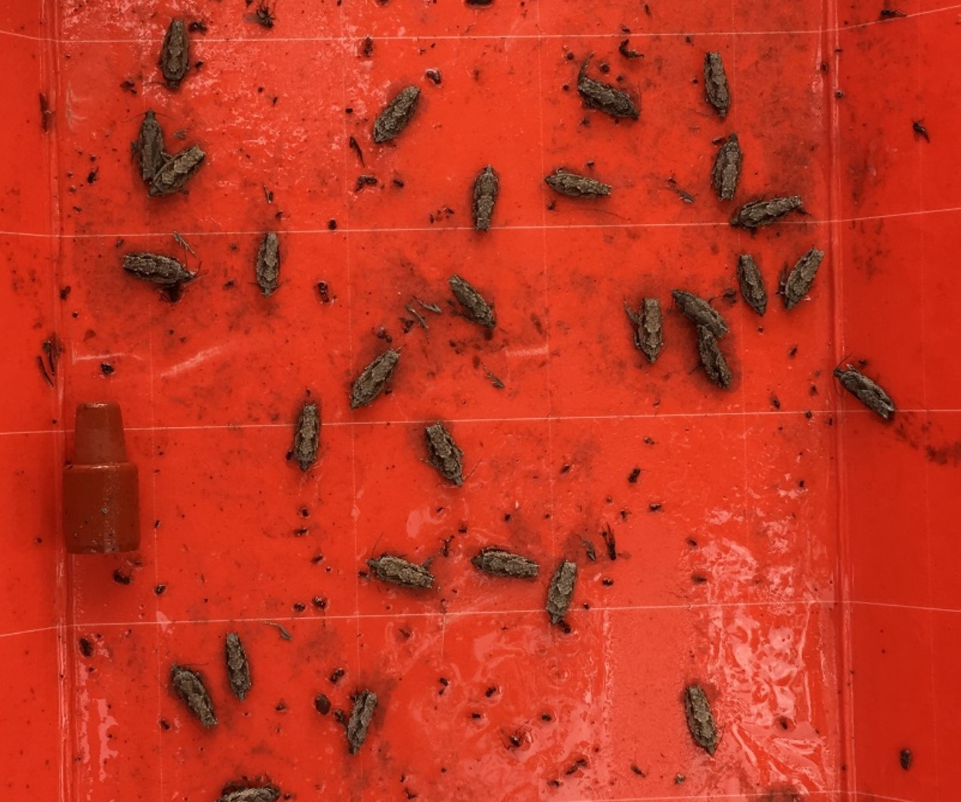

Figure . Pecan bud moth adults

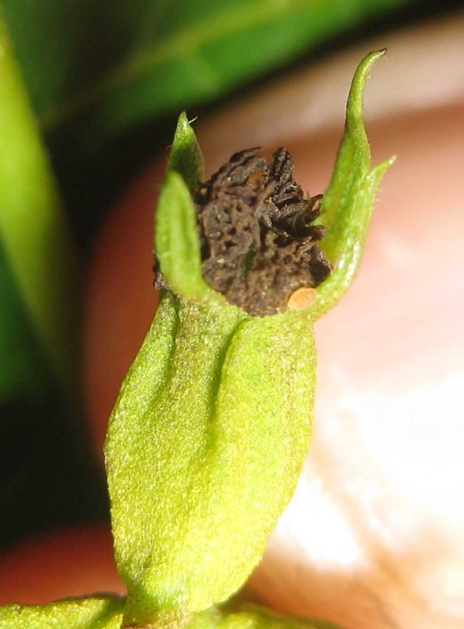

Figure . PNC egg

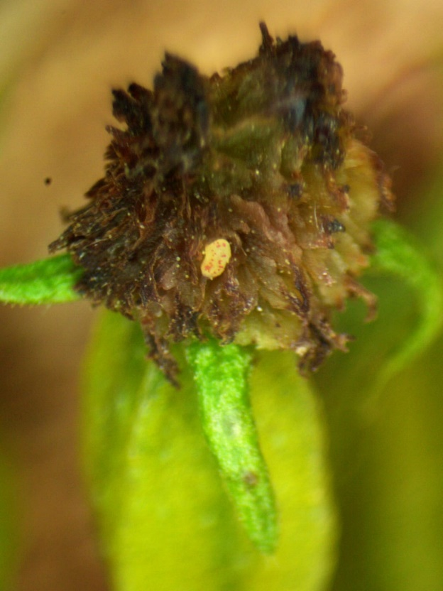

Figure . PNC egg

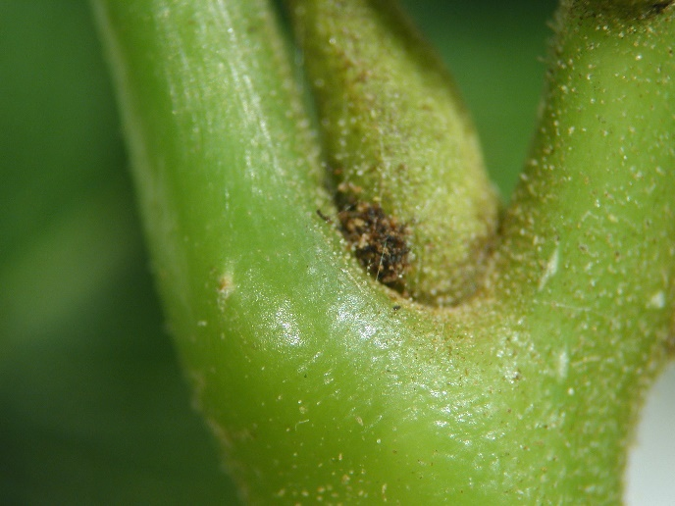

Figure . Frass on secondary bud

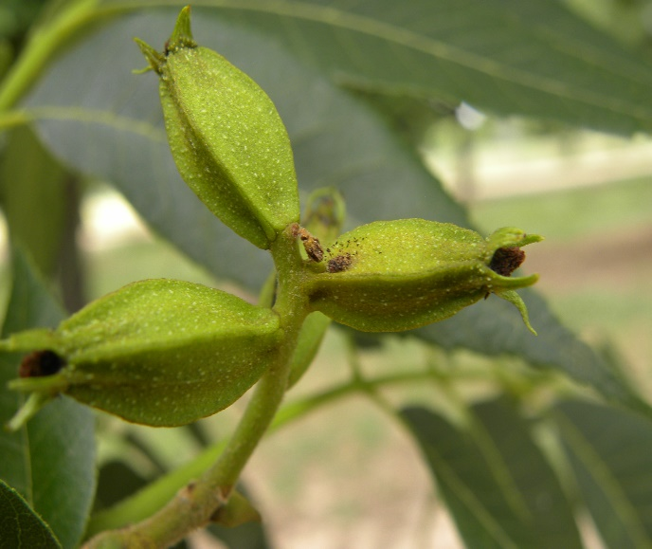

Figure . Frass on nutlet indication infestation

As a general rule egg development takes 3 to 5 days then there is a one to two day period of bud feeding prior to nut entry.

Unfortunately the pecan IPMpipe pecan nut casebearer forecast model is not working so we have to go back to our knowledge of basic biology to determine egg lay and nut entry.

When to start treatment can depend on how many days it takes a producer to treat his/her orchard. Some can get around in one afternoon and can afford a later start date possibly around the date of first entry while others may take 10 – 14 days and will have to start early.

Insecticides recommended for PNC can be found in the table at the end of this letter.

One scouting tip that I have learned over the years is that I flag different PNC events such as egg lay, bud feeding or even entry while scouting. I record date, what was found and location on the cluster as shown in picture below. By having this record you can come back to that cluster at a later date to check on progress and to make sure that there is no nut entry after treatment.

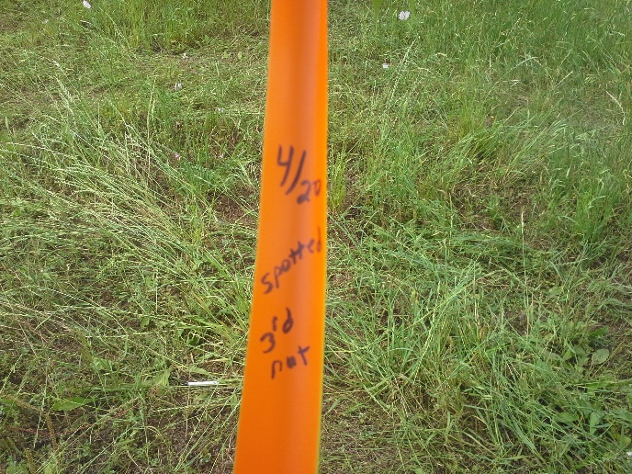

Figure . Flagged event on a nut cluster. There was s spotted egg on the third nut on April 20th.

**2019 COUNTY/ STATE/REGIONAL MEETINGS/EVENTS**

**TX COUNTY MEETINGS/FIELD DAYS**

**April 30, 2019**

Andrews County

Contact: Andrews County office

@: 432-524-1421

**May 2, 2019**

Clay County

Contact: Clay County office @: 940-538-5653

**May 6, 2019**

San Saba County

Contact San Saba County Office @: 325-372-5416

**May 8, 2019**

Colorado/Fayette County Field Day

8:30 AM Holman Parish Hall 9937 FM 155

La Grange TX

**STATE/REGIONAL MEETINGS**

**June 12-14, 2019**

Oklahoma Pecan Growers Conference

Ardmore Convention Center

Ardmore, OK

Contact: Deann Smith @ [OPGAtreasure@gmail.com](mailto:OPGAtreasure@gmail.com) or

405-273-1235

**June 20-21, 2019**

Tri-State ArkLaMiss Pecan Conference

New Roads, LA

Contact: lapga.com

**July 14-17, 2019**

**Texas Pecan Growers Conference and Trade Show**

**Frisco, TX**

**Contact: TPGA @: 979-846-3285 or pecans@tpga**

**\*\*\*\*\*\*\*\*\*\*\*\*\*\*\*\*\*\*\*\*\*\*\*\*\*\*\*\*\*\*\*\*\*\*\*\***

**The information given herein is for educational purposes only. References to commercial products or trade names are made with the understanding that no endorsement by the Texas A&M AgriLife Extension Service is implied.** **The members of Texas A&M AgriLife will provide equal opportunities in programs and activities, education, and employment to all persons regardless of race, color, sex, religion, national origin, age, disability, genetic information, veteran status, sexual orientation or gender identity and will strive to achieve full and equal employment opportunity throughout Texas A&M AgriLife. The Texas A&M University System, U.S. Department of Agriculture, and the County Commissioners Courts of Texas Cooperating**

