Texas A&M AgriLife Extension





TEXAS PECAN PEST

MANAGEMENT NEWSLETTER

**Bill Ree, Extension Program Specialist III - IPM (Pecan)**

**P.O. Box 2150, Bryan, TX 77806-2150 April 28, 2016**

**Ph: 979-845-6800 #16-4**

**Email:** [**w-ree@tamu.edu**](mailto:w-ree@tamu.edu)

[**http://pecan.ipmPIPE.org**](http://pecan.ipmPIPE.org)

**\*\*\*\*\*\*\*\*\*\*\*\*\*\*\*\*\*\*\*\*\*\*\*\*\*\*\*\*\*\*\*\*\*\*\*\*\*\*\*\*\*\*\*\***

**TEXAS PECAN GROWERS ASSOCIATION**

**4348 Carter Creek, Suite 101 Bryan, TX 77802**

**Ph: 979-846-3285; Fax: 979-846-1752**

**Email:** [**pecans@tpga.org**](mailto:pecans@tpga.org)

[**www.tpga.org**](http://www.tpga.org)

**\*\*\*\*\*\*\*\*\*\*\*\*\*\*\*\*\*\*\*\*\*\*\*\*\*\*\*\*\*\*\*\*\*\*\*\*\*\*\*\*\*\*\*\*\***

**GENERAL**

It is hard to make a general comment about the weather across Texas but it is safe to say that many areas have had rain and unfortunately too much for some producers. With all the moisture it is going to be important to stay on top of pecan scab so fungicides need to be added to the zinc sprays. Based on the number of calls and emails I had earlier this week PNC activity really picked up over this past weekend (April 23- 24). For producers running PNC traps you can use the PNCForecast model located under the Map link of <http://pecan.ipmpipe.org> for a prediction of egg laying events.

**INSECTS**

**Pecan Nut Casebearer:** PNC is THE insect of importance right now. Although the pheromone is for pecan nut casebearer I am still receiving reports of PNC imposters in traps, mostly pecan bud moth, figure 3, but also mesquite bean moth, figure 4. The key ID feature for PNC is the dark band near where the wings attach to the body. Pecan bud moth has more of a mottled color while the mesquite bean moth has narrow white and dark streaking.

For commercial producers, recommended insecticides which can be found in our Extension commercial guide are: Bt,(numerous brand names); methoxyfenozide (Intrepid 2F); spinetoram (Delegate); spinosad (SpinTor, Success and Entrust); tebufnizide (Confirm 2F); chlorantraniliprole (Altacor); mehtoxyfenozide + spinetoram (Intrepid Edge) and flubendimate (Belt). All of these products are cleared for grazing EXCEPT Confirm. Before using any insecticide always consult the label for rates, pests and restrictions.

The Texas commercial pecan insect control guide can be found at: <http://www.texasinsects.org/tree-crops.html>

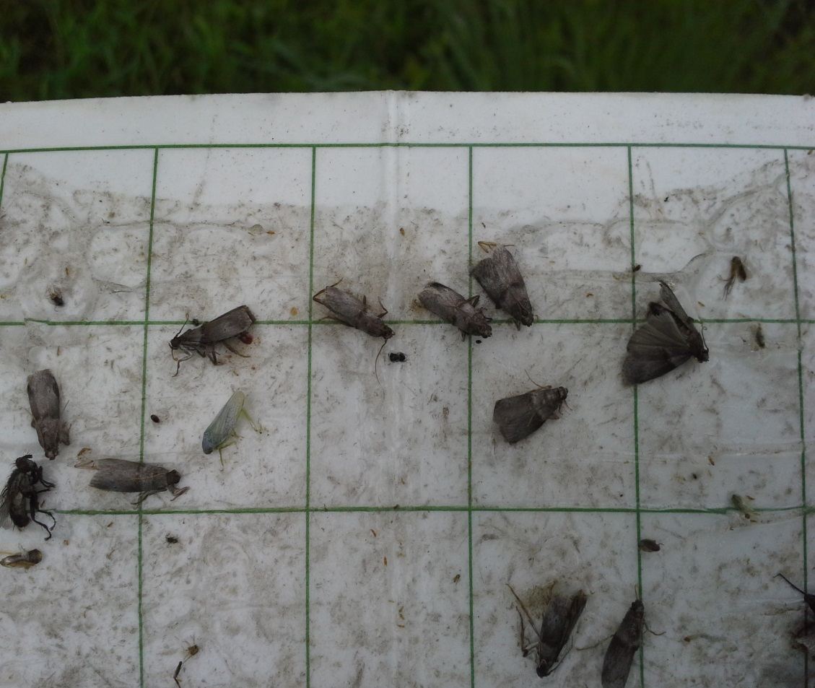

Figure 1. PNC adults in pheromone trap

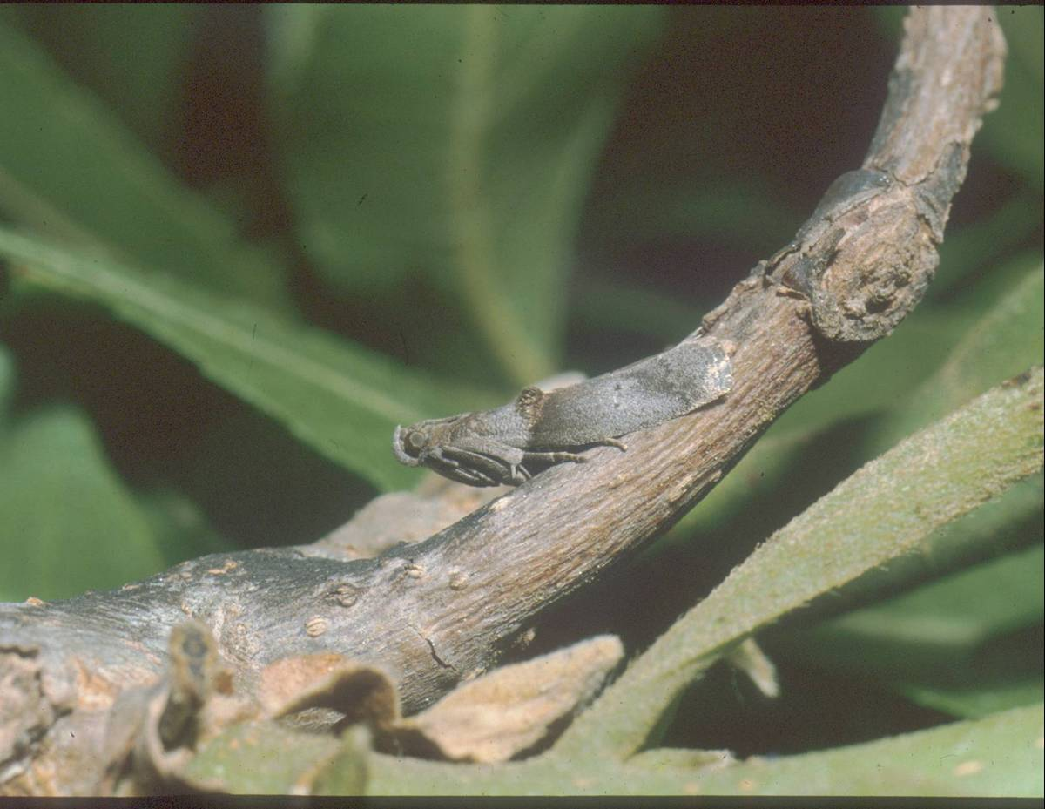

Figure . Adult PNC

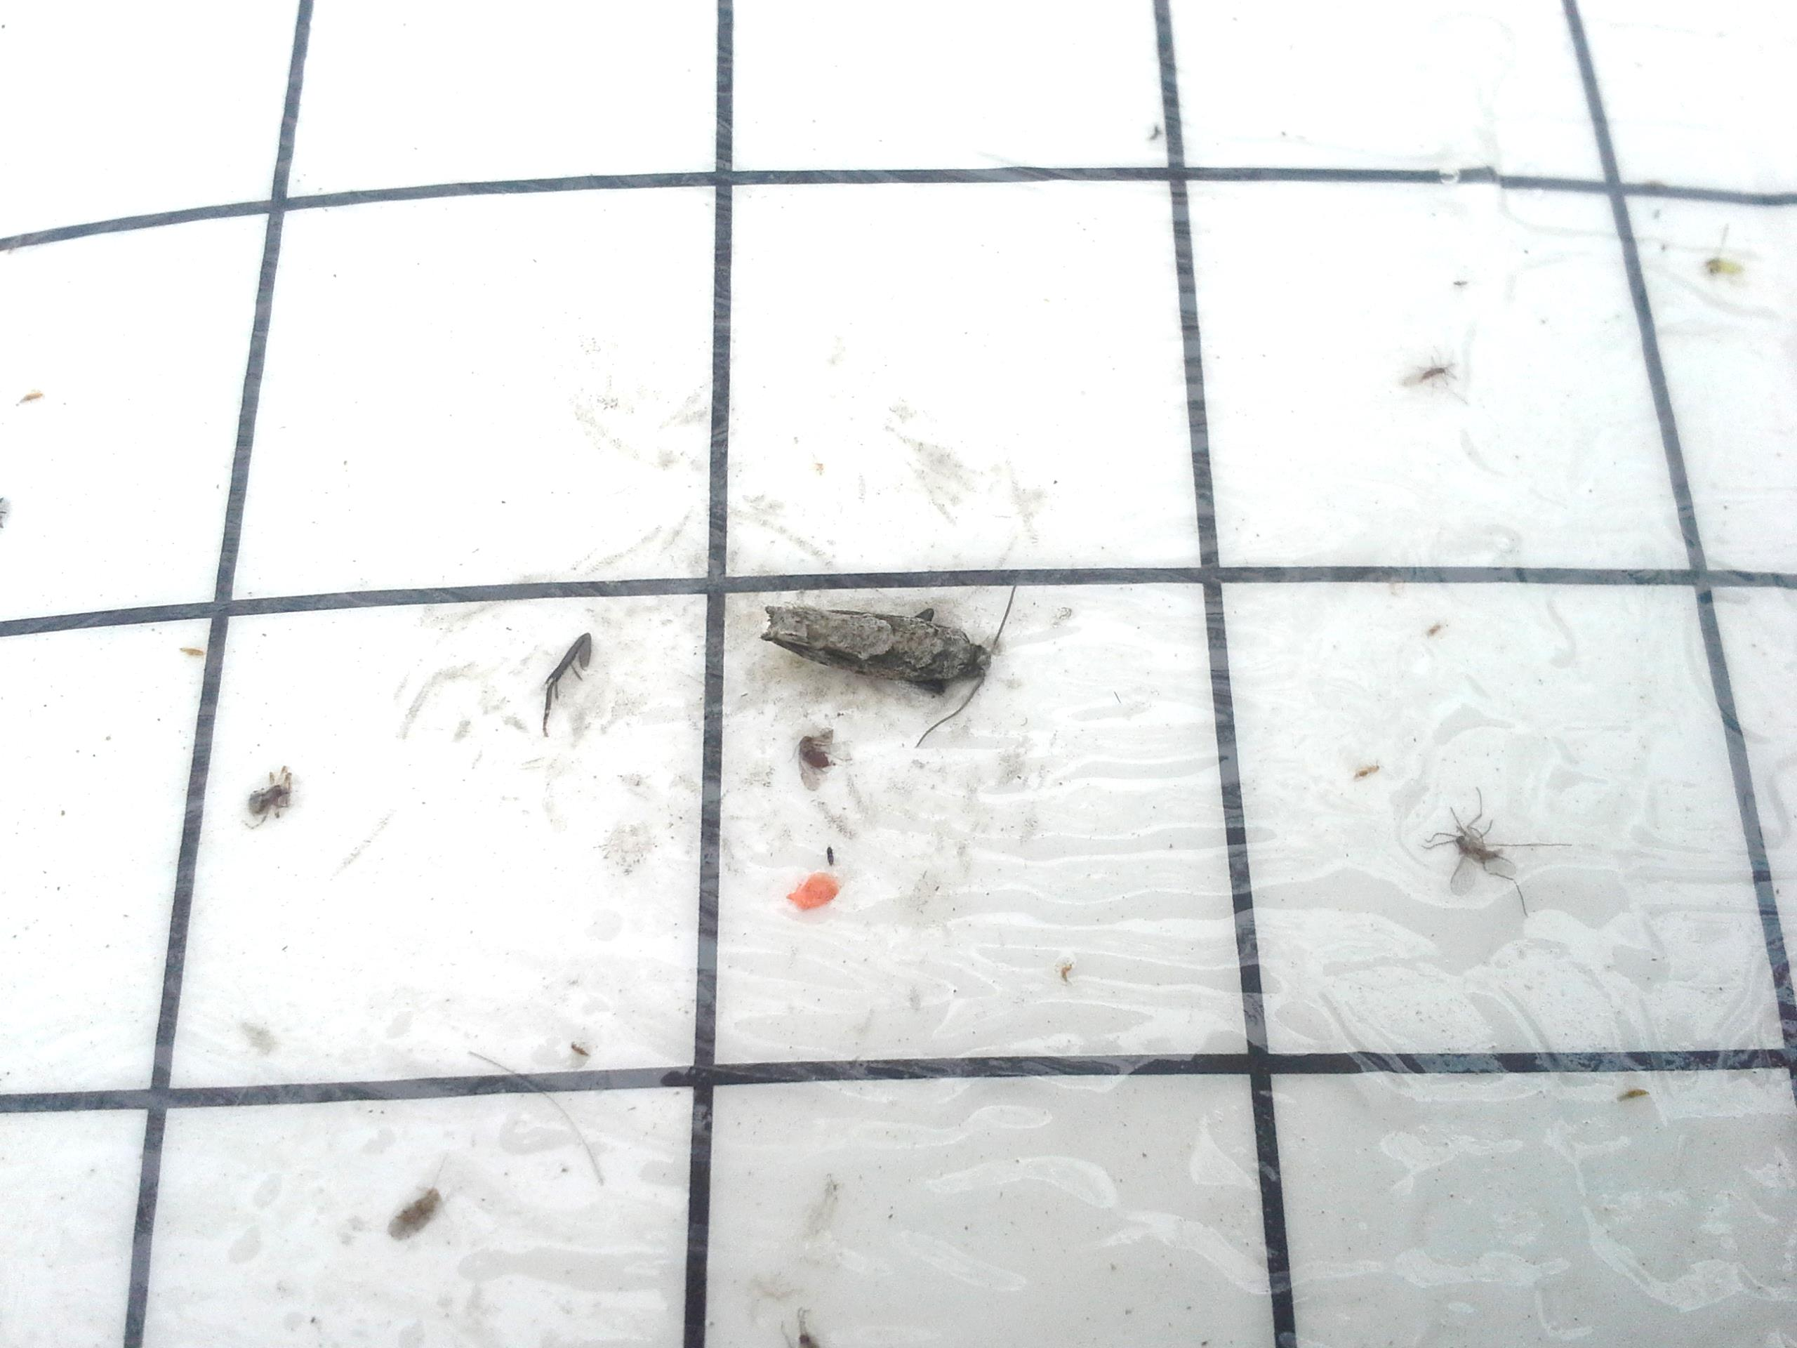

Figure 3. Pecan bud moth

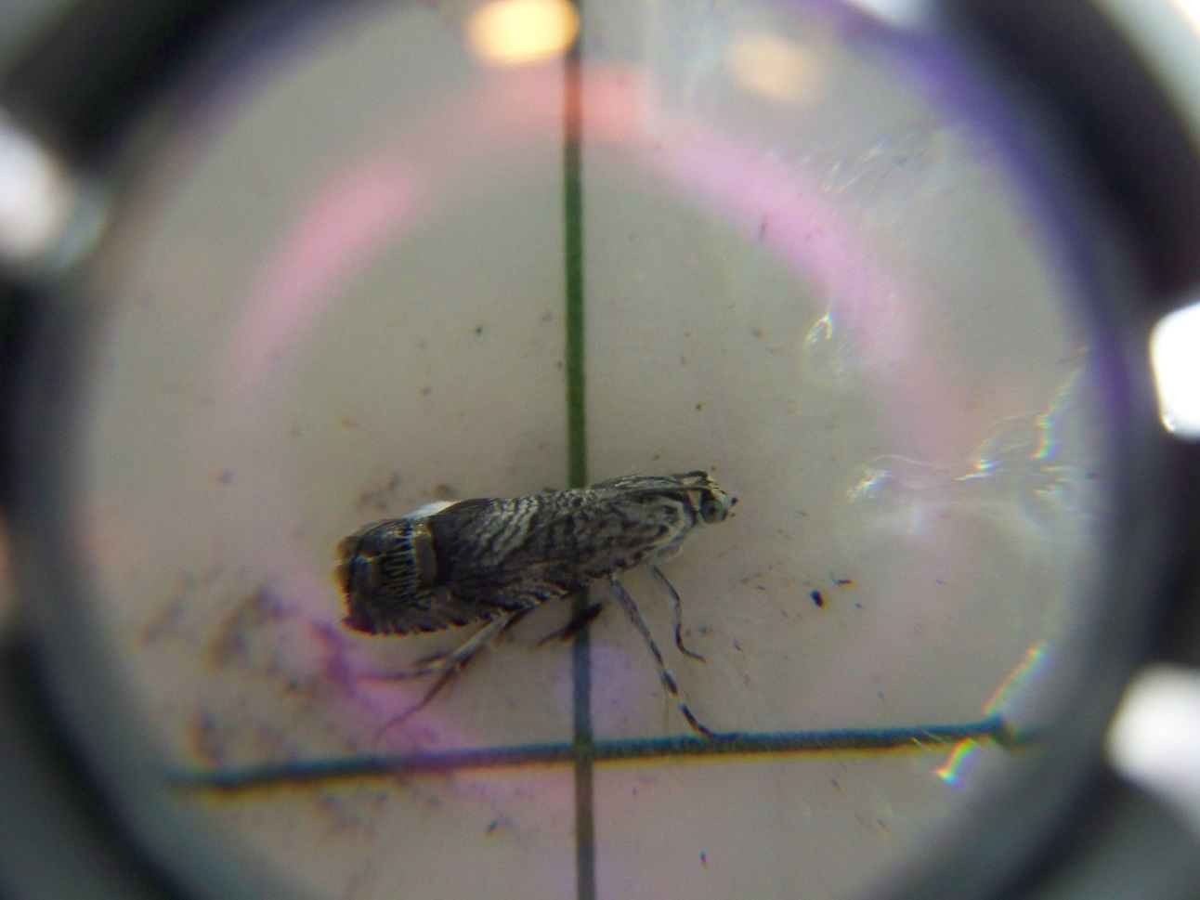

Figure 4. Mesquite bean moth

<http://www.texasinsects.org/tree-crops.html>

**STATE/REGIONAL MEETINGS, 2016**

The following are meetings that I am aware of to date.

**April 29, 2016**

Fannin county field day

Contact: Cody Maxwell, CEA-Ag

@903-583-7453

[cody.maxwell@ag.tamu.edu](mailto:cody.maxwell@ag.tamu.edu)

**May 2, 2016**

San Saba county field day

Contact: Neal Alexander, CEA-Ag

@325-372-5416

neal.alexander@ag.tamu.edu

**May 5, 2016**

Midland County field day

Contact: Jeff Floyd, CEA-Hort

@ 432-498-4071

[jeff.floyd@ag.tamu.edu](mailto:jeff.floyd@ag.tamu.edu)

**May 12, 2016**

Clay County field day

Contact: Bill Holcombe, CEA-Ag

@ 940-538-5042

[wcholcombe@ag.tamu.edu](mailto:wcholcombe@ag.tamu.edu)

**State Meetings**

**June 2-4, 2016**

Oklahoma Pecan Growers Conference

Tulsa, OK

Contact: Amanda Early @ [Amanda.early@okstate.edu](mailto:Amanda.early@okstate.edu) or 405-744-8800

**June 16-17, 2016**

TriState Pecan Convention

Best Western Inn & Suites

Alexandria, LA

Contact: Stephen Norman

[pecans@rosaliepecans.com](mailto:pecans@rosaliepecans.com) or 318-448-3139

**July 10-13, 2016**

**TPGA annual conference and trade show**

**San Marcos, TX**

**Contact: TPGA @ 979-846-3285**

**\*\*\*\*\*\*\*\*\*\*\*\*\*\*\*\*\*\*\*\*\*\*\*\*\*\*\*\*\*\*\*\*\*\*\*\*\*\*\*\*\*\*\*\*\***

**The information given herein is for educational purposes only. References to commercial products or trade names are made with the understanding that no endorsement by the Texas A&M AgriLife Extension Service is implied.**

**Educational programs of the Texas A&M AgriLife Extension Service are open to all people without regard to race, color, religion, sex, national origin, age, disability, genetic information or veteran status.**

**The Texas A&M University System, U.S. Department of Agriculture, and the County Commissioners Courts of Texas Cooperating**

.