Example-My 4-H Poultry Story and Photo Portfolio
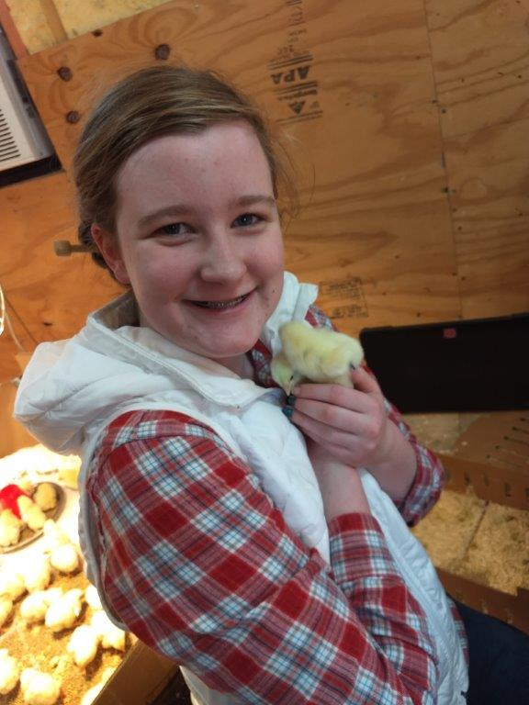
I was born in the city. A city known for its traffic, Mexican Freetail bats, being the Live Music Capital of the World, “Longhorns”, and home to the state Capitol. Its famous slogan, “Keep Austin Weird”, is a pretty solid description of the city, its people and the constant bustle of activity. A far cry from where I would live, the place that I love, and call home. My name is Kendal Workman. I was born in Austin, Texas. I lived there with my dad, mom and three little brothers. In Austin, we had unlimited access to activities and events. For extracurricular activities our family tried out the typical variety of things that kids do. My parents signed me up for things like swim lessons, gymnastics, piano lessons, and softball. All great activities, however, I never quite had a passion for any of them.
With my new broilers
When I was in second grade my parents bought a beautiful piece of property in Leon County. This was to be our family ranch get away. We immediately started remodeling the small old farmhouse on the property. For months, every Friday, we would make the three-hour drive from Austin to the ranch to work on the house. Every Sunday evening, we would return to Austin. And every Sunday everyone in the family would dread making that trip back home. We loved the country life so much. We loved the wide-open space to run, climbing magnificent oak trees, exploring, fishing, and seeing the stars at night. And then, one weekend the remodel was finished, and we stayed our first time in the “new” old farmhouse. We hadn’t bought any furniture for the house yet, so we slept on some mattresses on the floor, set up a card table and chairs in the kitchen, and ate off paper plates. It was almost like camping indoors. It was a great time! That Sunday trip back to Austin was especially sad for everyone. It was evident that my family really wanted to live in Leon County. It came as quite a surprise to my brothers and me the following week when my parents announced to us that we would be selling our house in Austin and moving to Jewett. Within four months, the “new” old farmhouse became our new home and we transitioned to the country life.
During my third-grade year, is when I finally found my passion of chickens. My family decided to raise a small flock of egg layers so our family could enjoy fresh eggs. As the oldest child, I had the responsibility of watering, feeding, and collecting the eggs. This was one chore that I did not complain about! I loved talking to the chickens and gaining their trust so that they would eat feed from my hands. As life on the ranch went on, I learned that I was old enough to participate in 4-H. I was very interested in this opportunity because I love animals. So, in fourth grade I attended my first 4-H meeting. I knew that I wanted to raise a show animal for the county fair, however, I didn’t know what animal to choose. My mom decided that because our family had four small children at home, it would be best to start out my first year with an “easier” animal. In our lack of knowledge about raising show birds, we decided that the best choice would be broilers. We look back now and laugh about how we thought raising show broilers would be easy!
Our family knew absolutely nothing about raising show broilers, but I ordered my first set of 25 birds for the county show, and then we set out to find out as much as we could about broilers. My mom helped me research show broilers on the internet and we attended a seminar at Producers Cooperative in Bryan. I learned a lot about raising broilers from that seminar and my research. Then our family worked together to build an enclosed chicken house. That first year was exciting because I made the sale with my birds.
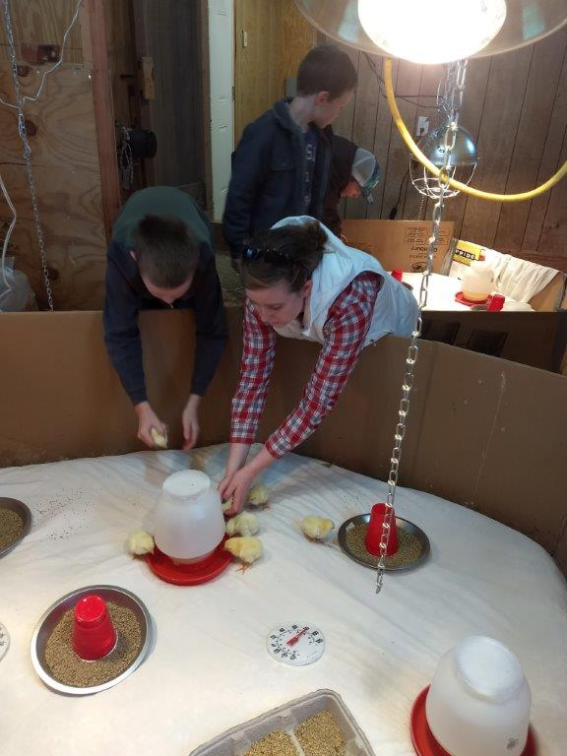
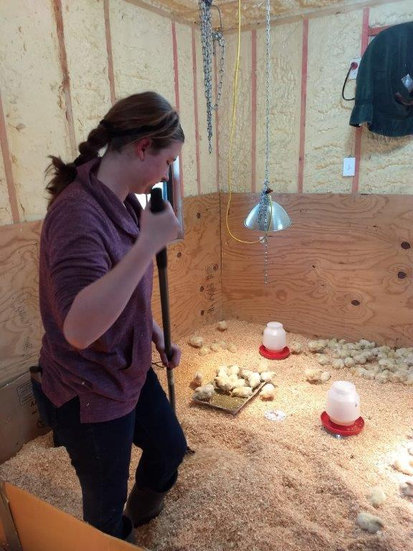
Over the last seven years of raising show broilers, my program has changed in many ways. Some years have been more successful than others. Each year has been a unique experience, and I am always learning and trying to improve my program. One year all the county birds had a respiratory virus and many birds died. I was thankful to have birds that survived to take to the show. Another year the raising period was a long 54 days. Those birds were huge, some weighing over 13 pounds! One way I try to improve is by changing my feed program. Every year I follow the same routine for set up, but I try different ratios of feed and supplements. The last two years I have won Reserve Champion at the county show, so I plan on sticking with my current feed schedule. This year, I chose to use the information that I learned that first year. The week before my birds arrived, I worked to set up my chicken house with a brooder, clean shavings, heat lamps, feeders, waterers, and fresh feed. It was very exciting when the broilers finally arrived for the 48-day project. I went to the broiler house as often as possible and worked very hard. I know that it is very helpful to stay organized, so I prepared a daily schedule that includes feed and temperature needs for the birds.
Putting chicks in their new home!
A daily chore is stirring the shavings
In addition, I have found out that there are many things that affect growing quality birds. This includes feed selection, bedding, space, and sound environment. However, there are four critical factors that are important: temperature control, fresh feed, fresh water, and ventilation. Controlling the temperature of the broiler house is very important for growth. If the broilers get too hot or too cold, they will stop eating and will not grow well. The broilers are received as tiny chicks and they need to be very warm. As they grow bigger, the temperature must be reduced. We use heat lamps on chains so that we can raise and lower the lamps to adjust the temperature. In addition, on really cold nights, we use small thermostat-controlled heaters. By the end of the project, the birds are very large and need to be kept cool, so we have windows that we can open to let in cool air. Fresh feed and water are also very important for growth. Broilers always need to have access to fresh feed and water. Ventilation is another key element to raising show broilers. The broiler’s waste puts off ammonia. This ammonia can cause health issues for the birds, so we use a ventilation fan to keep fresh air circulating in the broiler house. In addition to ventilation we keep clean fresh shavings under the birds.
This year has provided me with many new experiences. I had two major impacts to my broiler program. Each broiler is wing banded and any broiler used for the show must have its wing band intact. Unfortunately, 10% of the birds lost their wing band in the first week. I was disappointed but determined to work hard with the rest of the birds. Another problem this year is that we had three severe storms that impacted my broiler program. While none of our selected birds were lost, winds destroyed the shelter for our cull birds and we lost several birds to the storms. We will work this next year to design and build a more secure structure for our cull birds.
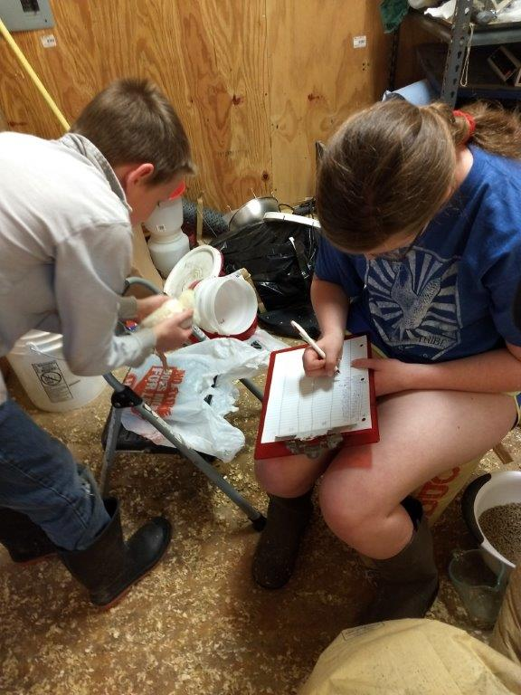
Raising broilers is an intense family project. One impactful change to my broiler project is my brothers. Over the past five years, I have shown broilers with only one of my brothers at a time. This is the first year that I have shown with two of my brothers. We really had to learn about cooperation and teamwork. My brothers and I worked to come up with a plan, so everyone knew when to go out to the coop. We would rotate throughout the day checking the temperature, sprinkling feed in broiler trays and making the birds get up to eat. When it was time to change the broilers water and feed, we would all go out to the coop and work on it together. Additionally, we shared the responsibility of feeding and watering the culled birds. Next year should be interesting because I will be showing with all three of my little brothers. I think I may get a lesson in patience!
Weighing and culling birds
One big change that we have made is an expansion to our chicken house. With more of my brothers showing every year, and all three of them showing with me next year, we knew that we would need more birds, in turn needing a bigger coop. My dad is in the construction business, so we were able to build the addition ourselves. It was great for me because I was able to work with him and gain that experience. After we finished adding on, my dad hired an insulation company that spray foamed our broiler coop. Having the coop insulated helps so much with temperature control and we can now raise more broilers.
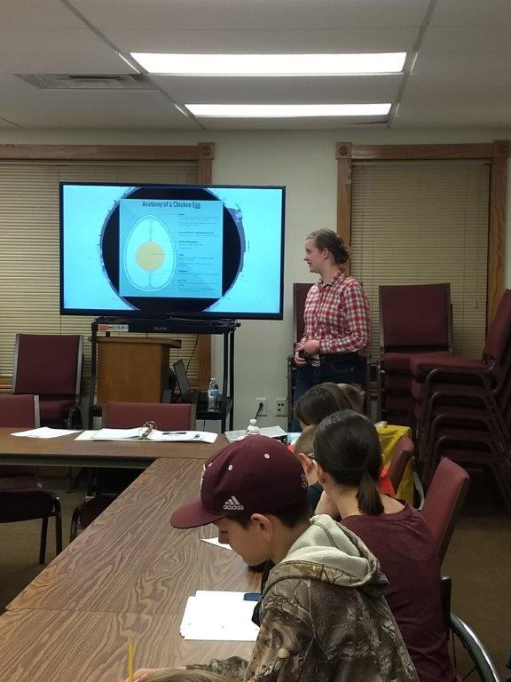
I have learned many lessons through raising show broilers. That first year my mom spent a lot of time working with me and training me on how to raise the best broilers I could. This training has helped me to have confidence in my abilities to do a large task!
Giving a Lesson on Eggs at Poultry Judging Practice
Over the years I have learned new things by attending several poultry judging and poultry raising workshops. One workshop really made a lasting impact on me. This past December I attended the Texas A&M University Fall Poultry Judging Workshop. At this workshop I learned carcass grading, meat identification, processed meat grading, and interior and exterior egg grading. This was the first time I had been to a workshop like this, and I loved it! I also learned about career opportunities in the poultry field and have decided that I would really like to pursue a degree in Poultry Science at Texas A&M University. The staff and students that ran the workshop were so knowledgeable and helpful! It was a great experience for me! After attending the workshop, I wanted to find a way to become more involved with poultry and share the information I have learned with others.
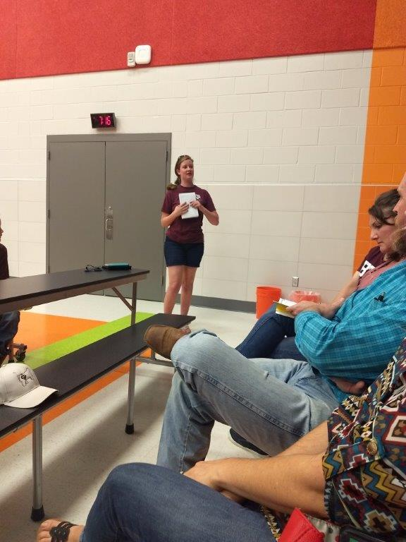
I recently talked with my Ag Extension agents and they told me about more opportunities through 4-H. With their encouragement, and my mother’s support, I started our county’s first 4-H poultry judging team. I serve as the teen leader. My role is to coordinate with the 4-H County Extension Agents, prepare materials, present at the meetings, and help coordinate participation in competitions. I am very happy with the amount of interest from the 4-H members in our county. It is a great opportunity for me to get to know other students in our county who show broilers, too. Currently, we have monthly meetings and we are learning so many things. Currently I am the teen leader for our county poultry judging team and I volunteer as the teen poultry project leader for the Centerville 4-H Club. I give monthly reports on upcoming poultry events and I encourage others to become more involved in raising show broilers. I also enjoy helping others with their show broilers. For example, last year I was able to help a young family friend get started with her first set of broilers. I gave her pointers and made sure she had a good feeding program. This year, I was able to attend her county fair and help her by holding one of her birds in the show ring. I was also able to help some of the exhibitors at my county fair this year. In addition to my pen of birds, two other pens of birds were required to stay at the show barn for three days until the sale. I was able to help by checking on their birds throughout those days and make sure they had fresh feed, water and shavings.
Giving the Poultry Project Report at the Centerville 4-H Meeting
I have also learned about the responsibilities of managing money. One of the great things about showing broilers and any animals in general is it you learn how to be responsible with money. I can calculate the cost and amount of feed needed and purchase the correct amount of feed. Every year, I keep a detailed account of all the feed I need to buy and the cost per bird, so I know how much feed I need to purchase for the next year. Then I can compare my cost of feed, shavings, electrolytes, feeders and waterers and then can look at my profit. My parents and I decided that I would save the money that I earned from raising boilers for college. I also have the experience of opening my own bank account and depositing checks and maintaining my quarterly bank statements.
I am with my birds though the entire process, from when I get them as baby chicks to the final processing. Another lesson I have learned is how to process chickens. As a family, we process our birds for meat at home. We invite some of our family friends, who do not show birds, to help in the processing and in return for their help we share the processed birds. My dad invested in bird processing equipment which helps make the process run smoother. We have cones where the chickens drain out and scalders in which we dip the chickens in hot water to make the feathers come off easier. Then we have an electric plucker that is a rotating drum with rubber nipples all along the inside. By rotating the drum and spraying water inside, the feathers easily come off the recently scalded chicken. After the chickens are defeathered, then we have a large stainless-steel table where we have a line of people eviscerating and cutting off extremities. Then we ice the birds down and package them for the freezer.
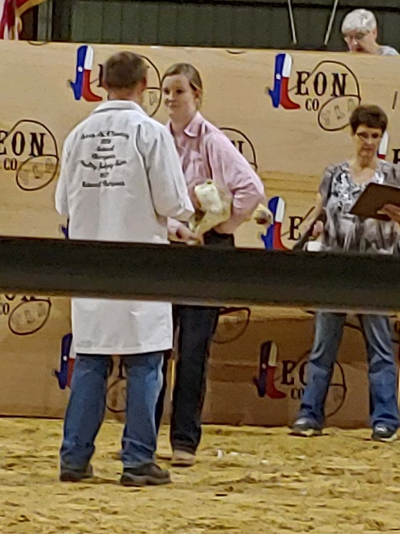
One area that I would like to continue my learning is preparing for showmanship. The first time I did showmanship, when I was younger, I was nervous going into the show ring. And having to wait until my turn was nerve racking. When it was my turn and the judge was talking to me, I found out very quickly that I had no reason to be nervous. All the judges that I have had over the years have made me feel at ease. One of the things that I have noticed that each judge has their own style of questioning for showmanship. So, I always try to be prepared for any type of question. I have won four showmanship buckles showing broilers, including Reserve Champion Senior Showmanship this year, however I still want to improve my skills and learn more about showing broilers.
2019 Showmanship
Raising show broilers is not a year-round project for me, but I am still raising a backyard flock of egg layers. I purchased 25 additional chicks this spring. I have raised these birds in a brooder, and now that they have grown larger, I have introduced them to my older flock. With more layers, that lay blue, green, and brown eggs, I hope to have eggs for my family and enough eggs to sell and save the money for my college fund.
I have grown and learned so much from my broiler project and I know there is more to come. I was recently selected to attend the 2019 Texas A&M University Poultry Institute for Youth this summer. I am looking forward to participating, meeting new people, and learning new things.
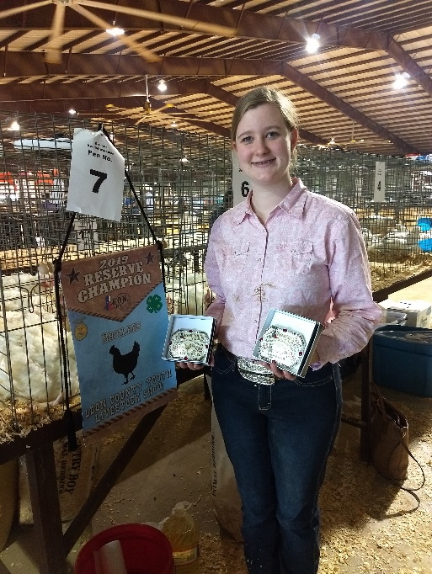
While raising show broilers is very hard work, it is so much fun! And by participating in 4-H I am developing lifelong skills. Also, because of the wonderful 4-H opportunities, I am more comfortable with meeting new people and talking in front of groups. 4-H has made me all around more confident in everything I do. I am so thankful for the opportunities and skills that I have learned through raising show broilers and participating in 4-H. I look forward to many more adventures. I was born in the city, but I am so thankful that my family made Leon County home.
2019 Leon County Youth Livestock Show Reserve Champion Broilers and Reserve Champion Senior Showmanship

