My 4-H & STEM Story
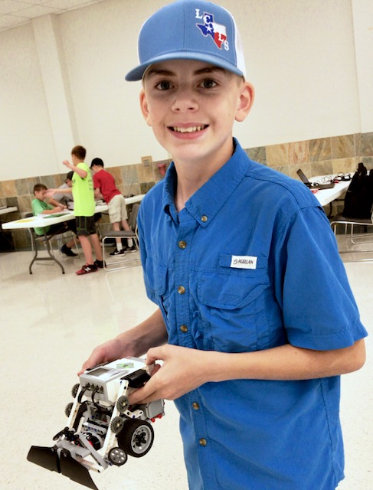
Sometimes the best things happen by accident. Last summer my older brother was attending lots of 4-H camps and activities, so my mom started looking for things I could do. Long story short, she contacted a childhood friend who happens to be an Extension Agent and the next thing I knew I was at Robotics Camp. Howdy! My name is Caleb Rappolee, I am 13 years old and live in Leon County with my parents, Steven and Cassie and my two brothers, Cole and Cooper. This was my fifth year to participate in the 4-H program. The first two years I showed rabbits and I placed 9th and 6th. The past three years I have shown a steer, but this year, I jumped into 4-H with both feet. Not only did I raise and show a steer, I competed in Ag Product ID, Livestock Judging, Consumer Decision Making, Photography, Leaders 4 Life, Fashion, and Nutrition Quiz Bowl. Though I participated in several projects, my main project was Robotics.
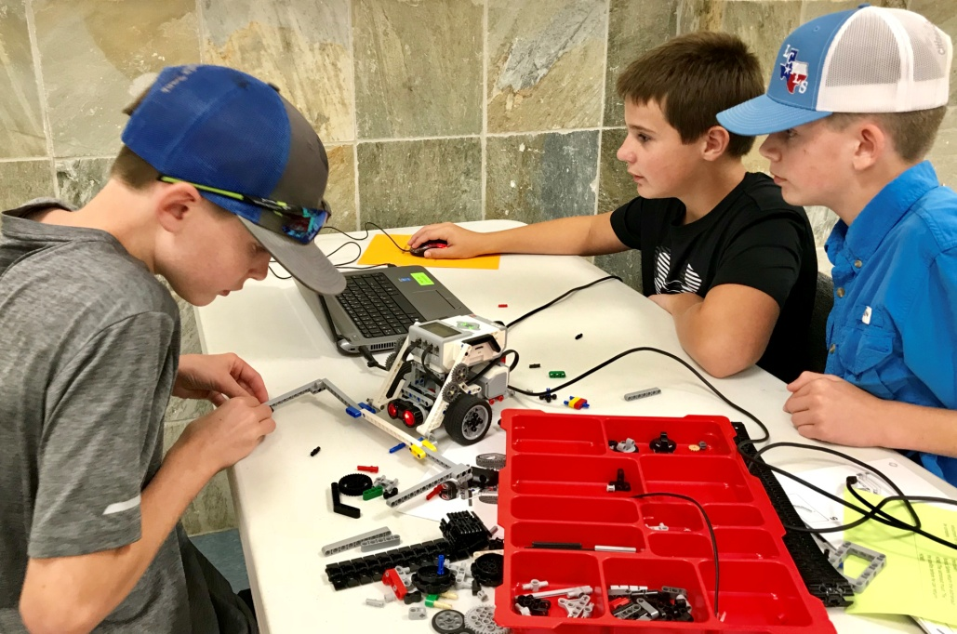
In July 2018 I invited two of my friends to attend a camp in Walker County that introduced us to a new project, 4-H Robotics. Before attending the camp I had no experience or knowledge of Robotics. However, after spending 8 hours diving in to Lego EV3 building and programming, I realized that I really enjoyed this activity and had lots of success. After the camp, my friends and I were very excited about Robotics, and I told my mom how much fun it was to program and wanted to learn more!
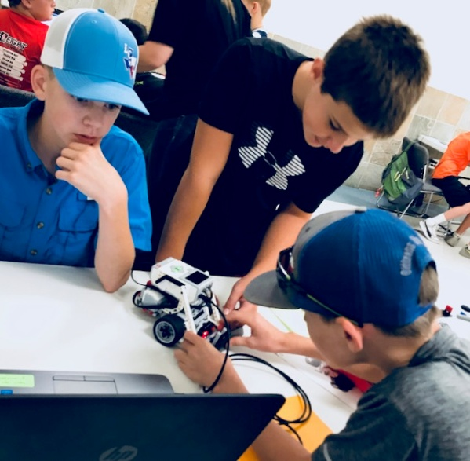
Once I discovered that our club did not have a Robotics team, my mom and I decided to start one. She volunteered to be the project leader, and I served as a teen leader. In August, at our county-wide 4-H Kickoff event, we put together a Robotics booth with a tri-fold board with pictures and handouts. Also, I programmed a demonstration for the robot to perform for the interested students that stopped by our booth. We did the same at our first club meeting, promoting this new project to the Centerville club and answering questions from parents and interested students. We then began having practices every other week and 12 members had joined our team by the end of the year.
At first, the only computer we had to use for programming was our old laptop and a few tablets owned by the county. After a few practices struggling to get the tablets to work properly, we realized that we needed to get new computers. So we went to a local bank and secured donations for the new computers. We found a great deal Black Friday deal at Sam’s Club and were able to purchase three new computers; one for each age division. Once we had acquired them, I was responsible for downloading the EV3 program to the laptops and for having the bots and computers charged at practices. We were very thankful for these computers! We took a special photo of all of our team members and we all signed a thank-you note, which I delivered to the donor.
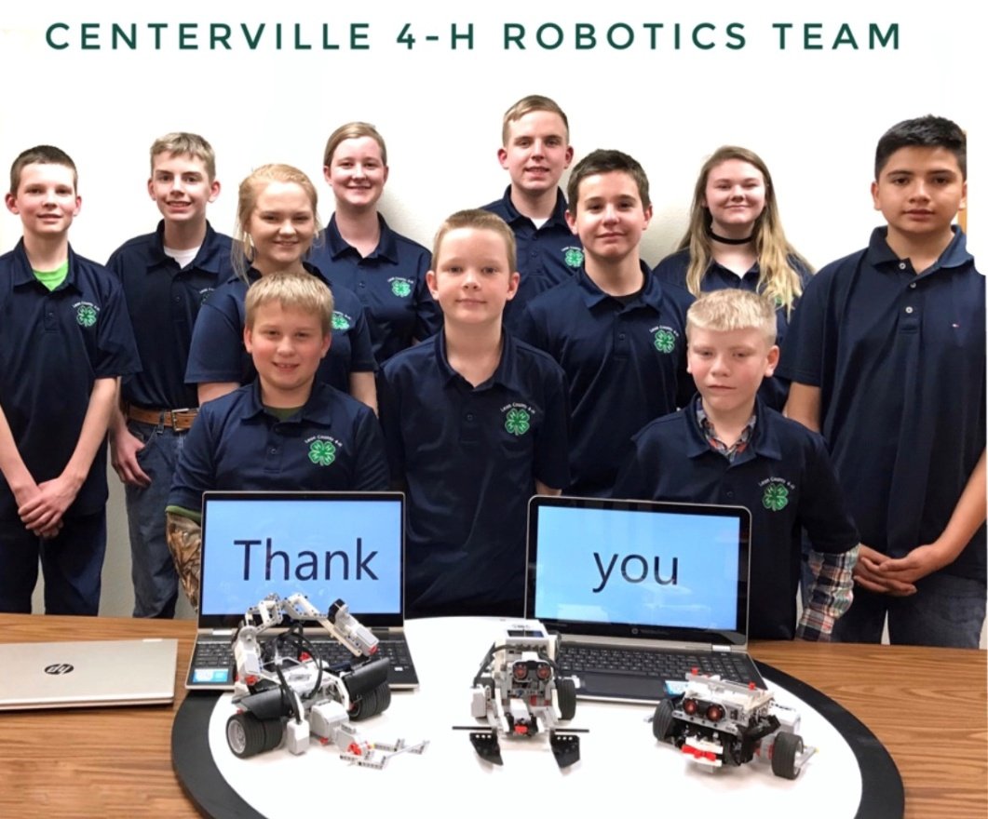

There are two different types of Robotics competitions: task-oriented and sumo bot. Task-oriented contest require math, measuring, critical thinking and numerous adjustments during the contest. However, Sumo Bot contest might my favorite because it is an exciting, head-to-head competition. In preparing for task-oriented contests, I would spend hours researching program techniques and collaborating with my friend and his dad, who we recruited to help my mom serve as a project leader. We would then bring that knowledge back to the team and teach the juniors and seniors what we had learned. My mom would always say that she is “just the adult in the room that settled disputes and transported us to contests, but doesn’t know anything about programming”. This turned out to be not so bad because at the first contest, at the Heart of Texas Fair, all the adults were asked to leave the room and the students were completely on their own to solve problems. Unfortunately, I was unable to attend this contest because it was the same day as one of my Ag Product ID contests. I was excited when I found out my teammates placed 4th in their very first contest! In December there was a contest in Brazos Valley that I was able to attend. It was very exciting and the atmosphere with all the other teams and robots made it even more fun. We learned new tips and tricks by talking to older students we meet at the contest and my team placed 3rd. Throughout the year my friends and I discovered that we have different strengths and weaknesses. Some were better at building and construction design, while others were better at programming. Teamwork is very important in the Robotic project because members have to get along and listen to each other’s ideas and you have to realize you can’t do it all.
The next contest was State Roundup in June, which gave us plenty of time to prepare for the sumo bot competition. Even though I wouldn’t be able to attend the state Robotics contest because of state Ag Product ID being the same day, I continued to help the team prepare. When the day of the contest came, I rushed over to the Robotics room as soon as the results for Agriculture Product Identification were announced-in which I placed 3rd-was over. Thankfully I made it in time to watch most of the rounds and cheer on my friends from the stands. The team ended up placing 9th, which we thought was pretty good for our first year.
Overall my experience in the 4-H Robotics project was positive, fun and definitely a learning experience. I’m very proud of myself and my teammates for starting a new project in our club and putting ourselves out there. Our county will have a 4-H float and 4-H booth on the town’s square during the 4th of July celebration. My brother and I will participate and provide flyers and other information about Robotics. Also, I plan to volunteer at the Robotics day camp that I attended last year; however, this year I will be a Teen Leader and help other beginner students. My goal for our Robotics project is to get more kids involved and attend more contests throughout the year. Excitement is contagious and I think our successful participation in other competitions will lead to more conversation and interest in the Robotics project in our club and our county.

