Lavaca County 4-H Update April 29, 2022

https://lavaca.agrilife.org/ and https://www.facebook.com/LavacaCounty4H
This Photo by Unknown Author is licensed under CC BY-NC
County Council Meeting
May 9, 2022
6:30 p.m.
Extension Office
Agenda Items include officer elections, review of by-laws, and banquet planning. We will also collect any remaining Wild Fire Relief gift cards and encouragement cards and create a letter to send to Eastland County.

Why Complete a Record Book????

Record book Completion is a very important part of being an active 4-H member. Record books should be completed by all members each year they are in 4-H. In order to hold office on the County Council, candidates must have completed a record book the year prior. This is true for several of the clubs in the county, as well. Additionally, the awards (which come with cash prizes) require that you complete a record book. Last year no one applied for our Bronze Star Award (Junior Members). At this year’s council meeting, there will be six clubs without eligible representation during officer elections because they do not have delegates that completed books. If you need help getting started or want someone to review what you have please reach out to Natalie at natalie.knesek@ag.tamu.edu. Record books open the door to many leadership opportunities in 4-H and help pave the road to applying for scholarships in the future.

Make Sure Your Project is a Project!
In order for a project to be a project, you should have at least six learning experiences that are each at least thirty minutes long. Learning experiences include field trips, hands-on learning of new tasks, reading books and watching videos with an objective to learn about a topic, and participating in workshops and activities. Additionally, your project should involve some leadership, some community service, and you should have “shown” your project in some way. This does not mean you have to have entered a competition.
Record Books will be due to the Extension Office by 5:00 p.m. on Monday, June 13, 2022.

Ambassador Activities and Project Opportunities – Several Due May 1

Several of the Ambassador Applications are currently open. Serving as a Project Ambassador is a State Level Leadership Opportunity for Senior Level Members. If you are going to be in the 9th-12th grade next year, take a look at the Ambassador page on the Texas 4-H Website and see what opportunities are available for you. Many of the applications are due on May 1.

The Healthy Texas Youth Ambassadors have an active role in helping Natalie with Health and Wellness education in Lavaca County. Don’t let this opportunity or any of the others you might be interested in slip by you.
Check it all out at https://texas4-h.tamu.edu/ambassadors/.

Club Chartering and Final Meetings of the Year
Attendance at your May meetings is more important than it is even at the beginning of the year. Every year at the end of the year, club managers do paperwork to charter the club for the next year. This is the time of year that officers are elected, by-law revisions are approved, and clubs have their finances reviewed. Club Chartering documents have been emailed to the club managers and will be due by June 13th.

Leadership Lab
Date: June 15 – 17, 2022
Location: – Victoria, TX
Entry/Registration: April 11 – May 27, 2022
Late Registration: May 28 – June 3, 2022
Registration Fee: Youth – $200.00; Adult Leaders and County Extension Agents – $175.00

D11 Leadership Lab Event Information
D11 Lab Agenda

We will need adult chaperones to attend lab. Natalie plans to attend but transportation is going to be needed throughout the duration of lab, so other parents may be needed as well.

State Round-Up and Lead Academy
State 4-H Round-up will be held on the campus of Texas A&M University the week of June 6-10. There are a lot of great opportunities for senior level (high school) 4-H members to participate in workshops and invitational competitions. To check out all of the great opportunities go to
https://texas4-h.tamu.edu/events/roundup/

There are fun assemblies planned for each evening. The Thursday evening Feature Concert will be Kody West in Reed Arena.

LEAD Academy will be held on the Wednesday and Thursday of Round-Up. LEAD Academy has great workshop opportunities for both members and adult volunteers.

Photography Judging Team
This is an invitational (open) contest at Roundup that all senior members can compete in. It will take place on Tuesday, June 7. Details can be found on the Roundup web page: https://texas4-h.tamu.edu/events/roundup/ If you are interested in entering photography judging contact Natalie. We would like to have a team!

Ag Product ID
Another great invitational contest is Ag Product ID. Simply put, there are agriculture products –could be t-bone steak, an avocado, or even a piece of mohair. Participants identify the product and answer multiple choice questions about the products. There are study guides available. Check out this and other invitational contests using the link above.

Accommodations for State Round-Up: Natalie has a 3 bedroom 2 bath VRBO home booked with space for six more people! Sharing a house gives you the ability to do laundry, save money by not eating every meal out, and gives more living space than that of a hotel room. If you are interested in sharing the house for one or more nights let Natalie know. The cost per room per night is $100.

Adult Volunteer Enrollment: If as a parent you plan to attend any events this summer – 4-H Round Up, Jr. Lab, Leadership Lab, 4-H Camps, etc. you must be enrolled on 4-H online. Adult volunteer enrollment includes completing the trainings and screening. Please verify that your enrollment is complete.

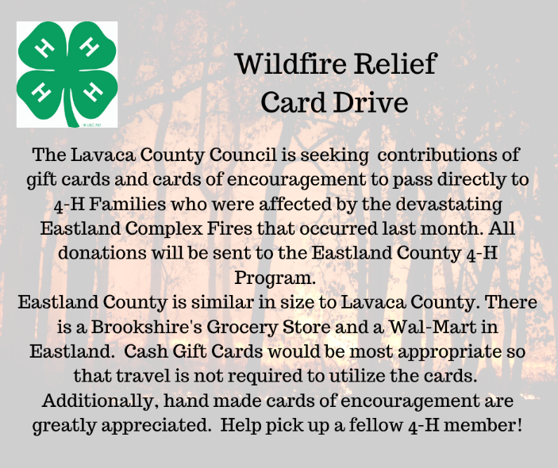
Coastal Bend Sportfishing Day

Information for the 2021 – 2022 Coastal Bend Sportfishing Day is now available on the event website: https://d114-h.tamu.edu/coastal-bend-4-h-sportfishing-day/

The event will be held Tuesday, July 19, 2022, in Rockport, TX. The event is open to D11 4-H youth in grades 3 through 7 grades as of September 1, 2021.

Registration will be open on 4-H Online from May 2 – June 17, 2022. There is no late registration.

Please share this information with your 4-H families.

State Fair of Texas Broiler Orders
State Fair of Texas broiler orders are due in the Extension Office by May 20 using the attached order form. Birds are $1.50 each. The minimum order per exhibitor/family is 25 birds, with a maximum of 75 birds, in increments of 25.

National 4-H Congress Application Now Open

National 4-H Congress will be held Friday, November 25th through Tuesday, November 29th at the Hyatt Regency in
Atlanta, Georgia. National 4-H Congress is the flagship event of the National 4-H program. Each year a National Design Team of Extension educators, 4-H youth, and 4-H adult volunteers analyze current youth issues and determine the most effective ways to address them. The program combines a variety of fun and exciting educational, recreational, and networking opportunities. The program combines sessions, seminars, discussion groups, and a service-learning experience. The nation’s most outstanding community leaders, speakers, and educators present the most current and timely information available.

OBJECTIVES:
- To improve the ability of teen 4-H youth to express themselves in written and verbal forms of communication that are necessary and important “life skills” for today and in the future.
- To increase the awareness of the importance of Leadership, Citizenship, and Community Service in 4-H Youth Development.

WHO SHOULD APPLY:
- Youth with significant leadership accomplishments and potential.
- Youth who have demonstrated the ability to perform academically at or above grade level; passing all course work and eligible to participate in extra-curricular activities.
- Youth who possess the maturity to interact with other youth from different regions, cultures, experiences, and beliefs.
- Youth in grades 9-12 at time of event, November 25-29, 2022.
- Youth must still be in high school during the time of the trip.
- Any youth participating in a youth development program which Texas A&M AgriLife Extension or Prairie View Cooperative Extension Program is a partner; (including 4-H clubs, short-term groups, school curriculum enrichment
and ENP-Y programs).

4 More Campaign

Texas 4-H is launching a new membership campaign. Members who recruit others to join can earn incentives! Between now and September 1, new members should tell us at the office who recruited them. After September 1, the new members will be able to put the name of the person who recruited them in their enrollment on 4-H online.
Incentives:
1 new member – 4-H More T-Shirt
2 new members – Membership Fee Waived
3 new members – leather portfolio
4 new members – state recognition and branded backpack

Texas 4-H Center

Summer Staff
If you know of a young adult seeking summer employment the 4-H Center is currently hiring. There may be opportunity for internship credit, as well. If you know of someone who may be interested have them contact natalie.knesek@ag.tamu.edu for more information.

Registration for summer camps is open! We have added a page to our county website where you can access the parent handbook and the summer camp guide. Go to https://lavaca.agrilife.org/4-h/texas-4-h-conference-center/ to access the parent handbook and summer camp guide. The Texas 4-H Center is located in the heart of Texas on Lake Brownwood. The 4-H Center brings together kids from across the state to learn project skills, build character, and make life long friendships. Don’t miss out!

Reimbursement for Select Activities
The policy and reimbursement form are now available on the county website. Go to http://counties.agrilife.org/lavaca/files/2022/01/Lavaca-County-4-H-Reimbursement-Policy-and- Forms.pdf to access the policy and forms.

Have you read The Clover? Check it out here:
https://texas4-h.tamu.edu/wp-content/uploads/management_clover_guide_21_22.pdf

Remember, also, to read the weekly e-mails you receive from Texas 4-H as they often have opportunities that do not get mentioned in this update.
This update is sent via email to all actively enrolled members and leaders. It is also posted on the county website. If you know of someone who is not receiving the updates, please have them check their Spam folders and their enrollment. Thanks!

Texas A&M AgriLife Extension provides equal opportunities in its programs and employment to all persons, regardless of race, color, sex, religion, national origin, disability, age, genetic information, veteran status, sexual orientation, or gender identity. The Texas A&M University System, U.S. Department of Agriculture, and the County Commissioners Courts of Texas Cooperating

Individuals with disabilities who require an auxiliary aid, service or accommodation in order to participate in any Extension activity, are encouraged to contact the County Extension Office (361)798-2221 to determine how reasonable accommodations can be made.

