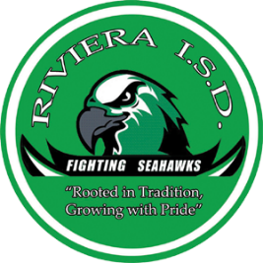
203 Seahawk Drive
Riviera, Texas 78379
(361)296-4441
kschubert@rivieraisd.us

June 4, 2019

Dear State Sheep and Goat Exhibitors,

This letter is in reference to exhibiting a goat or lamb at the 2020 major shows. Members interested must have their project validated under the Texas Sheep and Goat Validation Program.

Attached is an order form to be filled out by each family, providing that the exhibitors are blood siblings, legally adopted siblings, or step siblings and reside in the same county.

If ordering a breeding sheep or breeding goat tag- please be sure to include a copy of the animal’s registration papers to their tag order. This ensures that all paperwork is correct on the day of validation.

Please completely fill out and return the attached form along with a check or money order (non-refundable) payable to Riviera FFA no later than Wednesday, August 28th.

No extra tags will be ordered! No tags will be ordered without payment.

Validation will take place on Monday, October 28, 2019 in the Riviera Ag Shop from 5-7pm.

If you have any questions please contact me at 361-296-4441 or by email at kschubert@rivieraisd.us.

Thank you,

Kathleen Schubert
Riviera FFA Advisor

Enclosure

