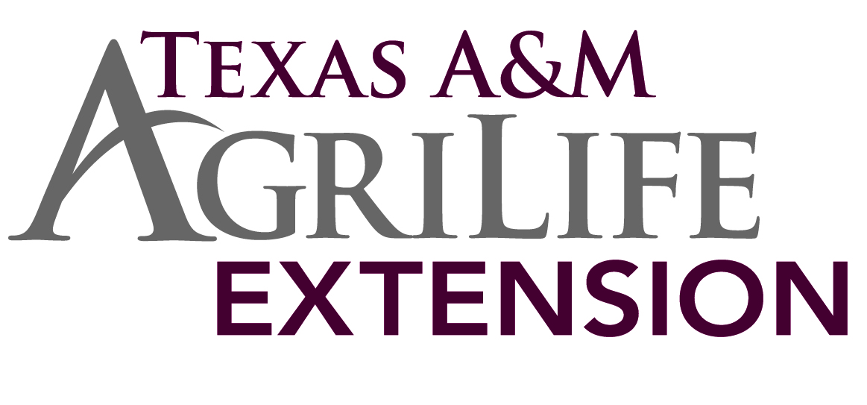
Veterinary Feed Directive Information for 2017
On January 1, 2017 livestock producers will no longer be able to purchase feeds over the counter that contain antimicrobials deemed with importance for human health. Instead, to buy and use feeds containing those microbial products, livestock producers must be authorized by a licensed veterinarian who is operating under the Food and Drug Administration’s revised Veterinary Feed Directive or VFD rule.
This VFD rule has been in effect in the past 20 years but it affected a small number of producers and just a few microbial products on the market. As of January 1, changes to the rule will mean that it will impact most livestock producers and apply to many different types of microbial products. The antimicrobials will be covered by the VFD because they are important for human health.
Also after January 1, 2017 livestock drug product sponsors will have removed the claims of growth promotion, and feed efficiency from the labels of medically important microbial products. In cooperation with CVM, they are currently changing labels for their products at this present time.
In order to purchase a VFD a livestock producer must have a VFD order issued by a licensed veterinarian, operating under a veterinarian client patient relationship to use a feed with medically important antimicrobial products. The feed distributor that the producer works with must receive the order before releasing the VFD feed to the livestock producer. The veterinarian for instance gives the livestock producer a second copy of the feed order containing the antimicrobials. This is just one copy for the producer to provide to the feed distributor, or the veterinarian could actually just give the order directly to the feed distributor.
Finally the livestock producer must use the VFD feeds only in accordance with the VFD order. In other words the livestock producer can feed only during the time period specified by that feed ordered. Feeding livestock besides those livestock indicated by the VFD order or feeding them beyond the expiration date of the VFD order is considered “extra label ‘’ use of feed. This is illegal use of a VFD. If the order for the present VFD itself expires and continued treatment is deemed necessary. Then the livestock producer must receive a new VFD order from his or her veterinarian.
If there are any questions about this new law please contact your Jim Hogg County AgriLife Extension Office.
Matthew Dudley- Agriculture and Natural Resource County Extension Agent

