Texas A&M AgriLife Extension





TEXAS PECAN PEST

MANAGEMENT NEWSLETTER

**March 27, 2019, No. 19-1**

**Bill Ree, Extension Program Specialist III – IPM**

**AgriLife Extension South Campus**

**1470 William D. Fitch Parkway, 2150 TAMU**

**College Station, TX 77843-2150**

**979-458-0335 – office**

[**w-ree@tamu.edu**](mailto:w-ree@tamu.edu)

**\*\*\*\*\*\*\*\*\*\*\*\*\*\*\*\*\*\*\*\*\*\*\*\*\*\*\*\*\*\*\*\*\*\*\*\*\*\*\*\***

**TEXAS PECAN GROWERS ASSOCIATION**

**\*\*\*\*\*\*\*\*\*\*\*\*\*\*\*\*\*\*\*\*\*\*\*\*\*\*\*\*\*\*\*\*\*\*\*\*\*\*\*\***

**TEXAS PECAN GROWERS ASSOCIATION**

**4348 Carter Creek, Suite 101 Bryan, TX 77802**

**Ph: 979-846-3285; Fax: 979-846-1752**

[**pecans@tpga.org**](mailto:pecans@tpga.org) **,** [**www.tpga.org**](http://www.tpga.org)

**\*\*\*\*\*\*\*\*\*\*\*\*\*\*\*\*\*\*\*\*\*\*\*\*\*\*\*\*\*\*\*\*\*\*\*\*\*\*\***

This is the first pecan IPM newsletter for 2019. If you do not wish to receive this letter please send a note and I’ll remove you from the mailing list. I am also open for any pest related topics that you might want to have addressed.

**NOTICE OF RETIREMENT**

After what will be 38+ years of Extension entomology I have decided to retire August 31, 2019. To help with getting this position filled in a timely manner, my administration needs to hear from producers and members of the pecan industry on the importance of this pecan IPM position. If you would like to express your thoughts and concerns, you can send your letters to the Texas Pecan Growers Associations at:

[pecans@tpga.org](mailto:pecans@tpga.org)

(979)846-3285

Texas Pecan Growers Assn.

4348 Carter Creek Pkwy Suite 101

Bryan, TX 77802

**INSECTS**

**Phylloxera**

For producers that observed galls, Fig 1, on new pecan growth last season, treatment time is here or fast approaching, depending on your location. Insecticide applications should be applied when there is approximately 1 to 2 inches of new growth as shown in Fig 3. Treatments need to be made only to those trees that had galls last season. If you are unsure about activity, the orangish-yellow crawlers, Fig 2 can be seen with the aid of a 10X lens. Recommended insecticides can be found in the table at the end of this letter.

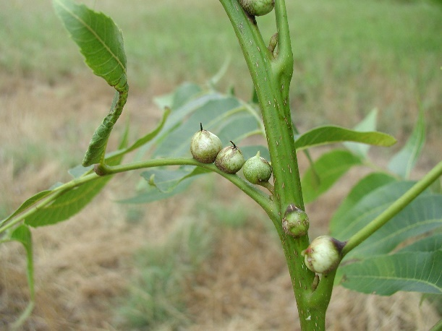

Figure . Pecan stem phylloxera galls.

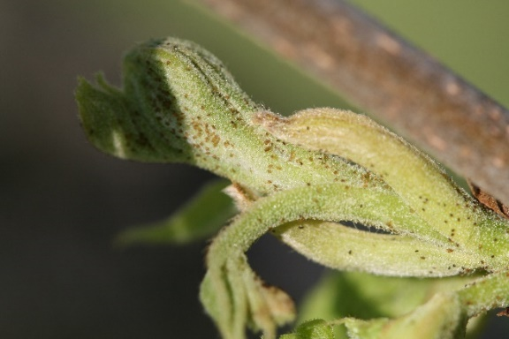

Figure . Yellowish orange phylloxera crawlers on new growth. Photo credit; Dr. Mike Hall (retired)

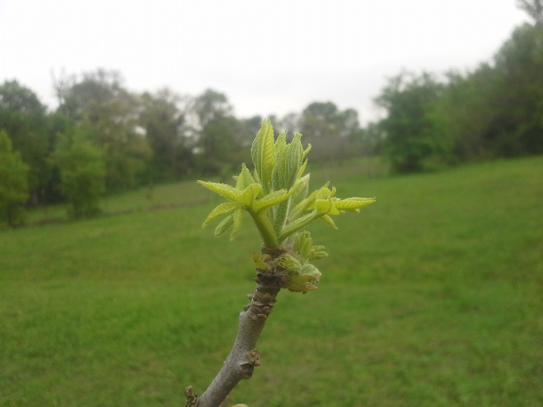

Figure . Stage of new growth for phylloxera treatments

**Obscure Scale**

Pecan is considered an oil sensitive crop and therefore oil treatments for obscure scale should only be made during the dormant season. However, if you missed the opportunity for a dormant oil treatment you can still achieve some control by treating for the crawler stage. To monitor for crawler activity I have had good luck using double-sided sticky tape, secured with a pushpin to tree trunks and branches. When crawlers are observed a treatment with a contact insecticide can help reduce the spread of this insect.

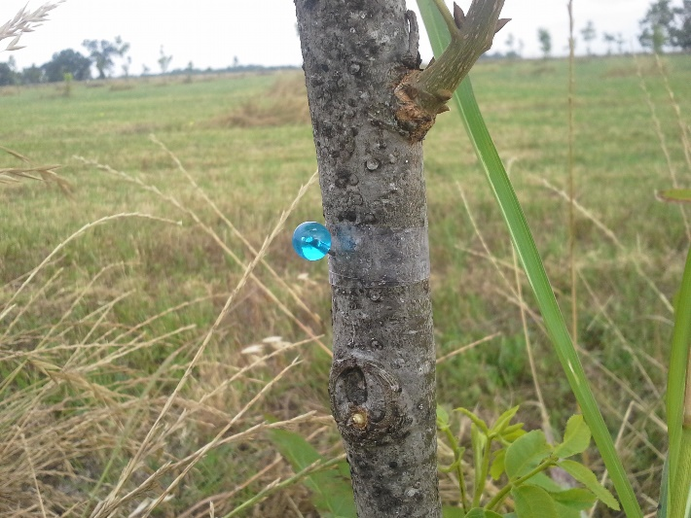

Figure . Double-sided sticky tape secured with pushpin to monitor for scale crawlers.

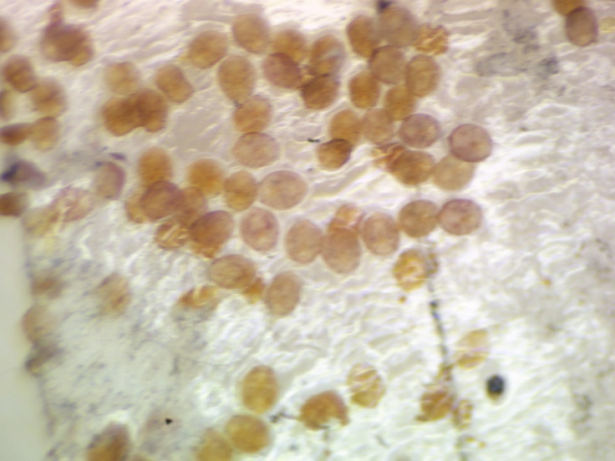

Figure . Obscure scale crawlers collected on sticky tape band

**Borers**

Borer issues on pecan are always a secondary problem caused by some type of stress or injury. Injury could be the result of freeze damage, sun scald, rodents, equipment injury

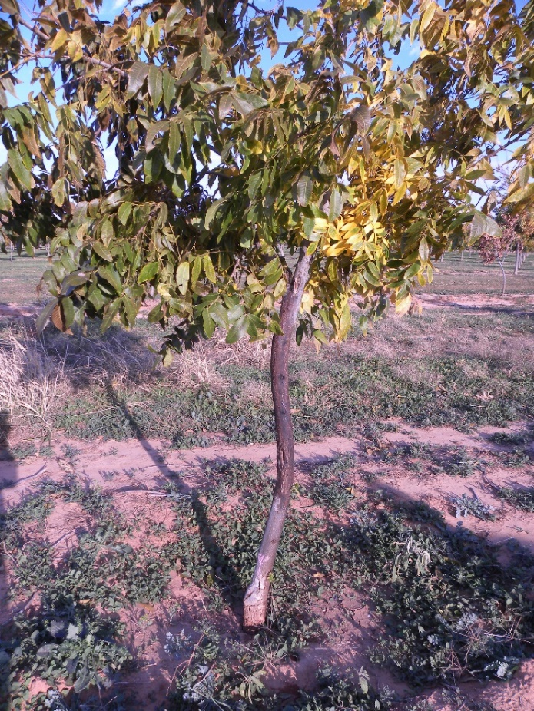

Figure . Young pecan tree showing oozing as the result of borer infestation due to freeze damage

or from other insects.

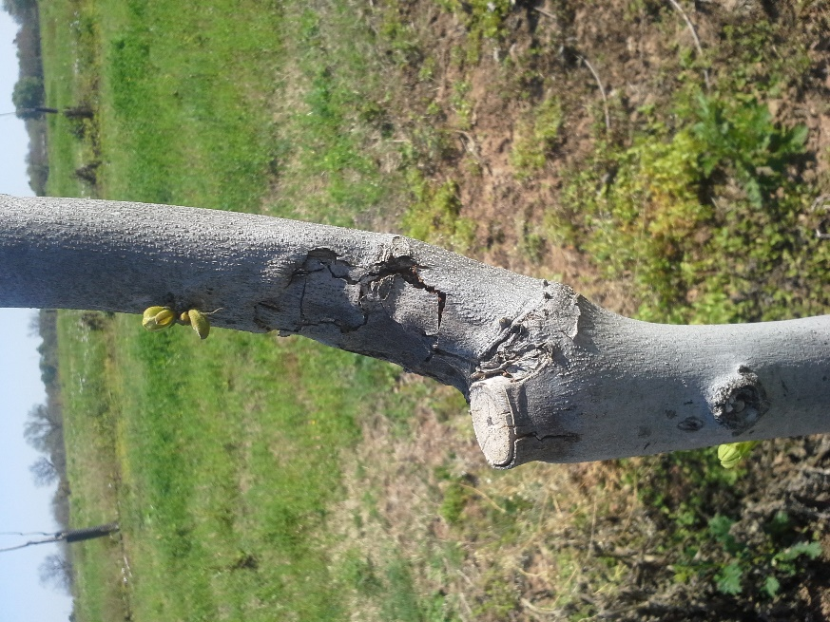

Figure . Young pecan tree showing signs of flat-headed apple tree borer injury. (Cracked and sunken area)

There are numerous insects that can attack the woody portion of the tree and a good reference for these insects is “A Guide to the Insect Borers, Pruners and Girdlers of Pecan and Hickory” by J. D. Solomon and J. A. Payne. This publication can be found at:

<https://www.srs.fs.usda.gov/pubs/gtr/gtr_so064.pdf>

In all the literature I have read on “borer” management, the first recommendation is to promote good tree vigor. Other additional management options include the use of systemic imidacloprid applications and trunk sprays with contact insecticides when adult beetles are observed on tree trunks.

**Pecan Nut Casebearer**

Anyone in the pecan business knows the importance of monitoring and management of PNC and we as a commodity are fortunate in that we have an excellent monitoring tool with the PNC pheromone trap. Using the pheromone trap

The following are a few businesses that I am aware of that sell PNC traps and lures. Texas A&M AgriLife Extension recommends 3 traps for 50 acres or less and at least 5 traps for orchards larger than 50 acres. Traps should be placed in the orchard 20 - 30 days prior to an average spray date to ensure that the start of the initial adult flight is detected.

**Great Lakes IPM**

7563 N Crystal RD

Vestaburg, MI 48891

(800) 235-0285

glipm@greatlakesipm.com

<https://www.greatlakesipm.com/>

[**ISCA Technologies / Moritor Technologies**](http://www.iscatech.com/exec/)   
P.O. Box 5266   
Riverside, California 92517  
Tel: 951-686-5008  
Fax: 815-346-1722  
email: [info@iscatech.com](mailto:info@iscatech.com)  
Web: [www.iscatech.com](http://www.iscatech.com)

[**Oliver Pecan Co. Inc.**](http://www.oliverpecan.com/%20)  
1402 W. Wallace, San Saba, TX 76877  
800-657-9291  
E-mail: [soliver@centex.net](mailto:soliver@centex.net)

[**Pape Pecan House**](http://www.papepecan.com)  
P.O. Box 1281  
101 S. Hwy 123 Bypass  
Seguin, TX 78155  
Ph:  830-379-7442

**Southern Nut 'n Tree Equipment, Inc and PPI**  
324 SH 16 South  
Goldthwaite, TX 76844  
1-800-527-1825  
Fax: 325-938-5490  
E-mail: [sales@pecans.com](mailto:sales@pecans.com)

[**Trece**](http://www.trece.com) **– for bulk orders only**  
P.O. Box 129  
Adair, OK 74330  
Ph: 918-785-3061  
Fax: 918-785-3063  
Email: [custserv@trece.com](mailto:custserv@trece.com)  
Order Center: 866-785-1313

<http://www.trece.com>

**Granulate Ambrosia Beetle**

**Aka: Asian Ambrosia beetle**

I first observed this insect in the early 1990’s infesting pecans in Anderson County, TX. The Granulate ambrosia beetle, *Xylosandrus crassiusculus* is an invasive ambrosia beetle that was first detected in the United States in the mid 1970’s infesting peaches in South Carolina.

This beetle attacks a wide range of deciduous trees, which unfortunately includes pecan and is present in the eastern half of Texas.

Infestation usually first become apparent in the spring when newly infested trees either fail to leaf out or the tree leafs out but the new foliage soon wilts.

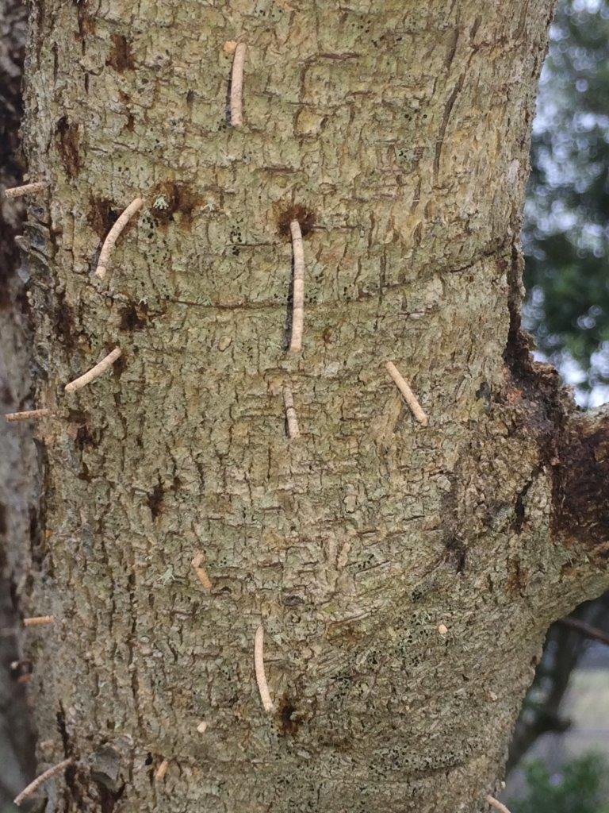

Figure 8. Toothpick like structures created by female ambrosia beetles.

Infestations also have a characteristic “toothpick” of frass that sticks out about ½ to 1 ½ inches as shown in the attached picture. These infestations are usually on the main trunk or scaffold limbs but can even occur on exposed roots. Infestations start in the spring with a mated female beetle initiating an attack on a host plant. These female ambrosia beetles carry spores of a fungus with them which they inoculate their galleries. The female lays eggs in her gallery and the adult beetle and the larvae feed on the fungus rather than the tree. Upon completion of larval development males mate with their sisters and only mated females exit the host plant to start the cycle again. Males are not capable of flight

Trees that are heavily infested, as shown in the pictures will die and should be removed. However, under light infestations, trees can survive. Removed trees should be destroyed (burned, chipped, buried, etc.) rather than just tossed on a brush pile. If anyone observes this type of damage I would like to hear about it.

**2019 COUNTY/ STATE/REGIONAL MEETINGS/EVENTS**

**TX COUNTY MEETINGS/FIELD DAYS**

**April 2,**

Mills County Central TX Pecan meeting

Contact: Mills Co. office @ 325-648-2650

**April 9, 2019**

Williamson County

Contact: Williamson County office @ 512-943-3300

**April 11, 2019** (AM)

Erath County

Contact: Erath County office @ 254-965-1460

**April 11, 2019** (PM)

Parker County

Contact: Parker County office @ 817-598-6168

**April 25, 2019**

Guadalupe County

Guadalupe County office @: 830-303-3889

**April 30, 2019**

Andrews County

Contact: Andrews County office @: 432-524-1421

**May 2, 2019**

Clay County

Contact: Clay County office @: 940-538-5653

**May 6, 2019**

San Saba County

Contact San Saba County Office @: 325-372-5416

**STATE/REGIONAL MEETINGS**

**June 12-14, 2019**

Oklahoma Pecan Growers Conference

Ardmore Convention Center

Ardmore, OK

Contact: Deann Smith @ [OPGAtreasure@gmail.com](mailto:OPGAtreasure@gmail.com) or

405-273-1235

**June 20-21, 2019**

Tri-State ArkLaMiss Pecan Conference

New Roads, LA

Contact: lapga.com

**July 14-17, 2019**

**Texas Pecan Growers Conference and Trade Show**

**Frisco, TX**

**Contact: TPGA @: 979-846-3285 or pecans@tpga**

**\*\*\*\*\*\*\*\*\*\*\*\*\*\*\*\*\*\*\*\*\*\*\*\*\*\*\*\*\*\*\*\*\*\*\*\***

**The information given herein is for educational purposes only. References to commercial products or trade names are made with the understanding that no endorsement by the Texas A&M AgriLife Extension Service is implied.** **The members of Texas A&M AgriLife will provide equal opportunities in programs and activities, education, and employment to all persons regardless of race, color, sex, religion, national origin, age, disability, genetic information, veteran status, sexual orientation or gender identity and will strive to achieve full and equal employment opportunity throughout Texas A&M AgriLife. The Texas A&M University System, U.S. Department of Agriculture, and the County Commissioners Courts of Texas Cooperating**

