**GARDENING FACT SHEET**

**RECOMMENDED FRUIT AND NUT VARIETIES**

**HARDIN COUNTY AND VICINITY**

Many types of fruits and nuts grow well in h9me orchards in Hardin County. The first key to a successful harvest is to select varieties best suited to our subtropical climate. One of the most important considerations in selecting an appropriate plant is its temperature requirements.

Citrus trees are subtropical to tropical in nature and many may suffer severe damage or even death in freezing temperatures. However, several types of citrus are sufficiently cold hardy to areas of the county. Planting citrus trees on the south and southeast sides of the house or in other sheltered locations will provide some protection from northwesterly cold fronts.

Aside from knowing how much cold a plant can stand, it is also important to know how much cold it needs. Stone and pome fruit trees need a period of winter rest or dormancy, when temperatures are between 32 F and 45 F for flowers and leaf buds to develop normally. When enough chilling accumulates, the buds are ready to grow in response to warm temperatures. If the buds do not rece3ive sufficient chilling temperatures during winter to completely release dormancy, trees may develop physiological symptoms such as delayed and extended bloom, delayed foliation; reduced fruit set and reduced fruit quality.

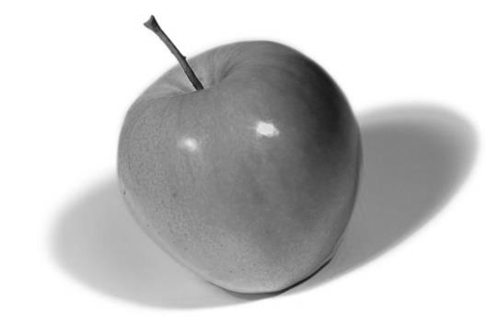Different species and varieties of stone and pome fruit trees have different chilling requirements. It is important to know the chilling requirements of the varieties you select and to select varieties with chilling requirements most closely matched to your area of the county. Thus, knowing your local chill hours is helpful for selecting the right tree.

**Apple**

Most varieties require cross-pollination; for maximum production plant two varieties. Exercise caution in purchasing mail order apple trees propagated in other regions of the country since the bloom cycle may not be synchronous. Rootstocks are very important. Several new rootstocks developed through a 30-year rootstock breeding program show promising results for Texas apple growers. Look for apples grafted onto Mark or preferably, one of the new Cornell-Geneva rootstocks, which are all fireblight resistant. Some of the most promising include Geneva 65, Geneva 16, Geneva 11, Geneva 41, Geneva 935, and Geneva 202.

**ANNA**-Large crops; sweet and crisp; stores two months; self-fruitful, but better production if pollinated by Dorsett Golden; bears late June; 200 chill hours.

**BENI SHOGUN FUJI**- Fewer chill hours required than Fuji and sweeter too; pinkish in color; self-fruitful; 500 chill hours.

**DORSETT GOLDEN**-Sweet, crisp, very flavorful; large and firm; Golden Delicious type; stores two months; very low chill requirement; pollinator for Anna; 100 chill ours

**FUJI**- from Japan; a sweet, crisp, very flavorful apple; ripens mid-September; dull reddish orange skin, sometimes russetted; self-fruitful; 550 chill hours.

**GALA**- Wonderful dessert apple from New Zealand; crisp, nice blend of sweetness and tartness, with rich flavor; reddish orange over yellow skin; early harvest; self-fruitful; 550 chill hours.

**HUDSON’S GOLDEN GEM**-An heirloom apple introduced in 1831 by the Hudson Wholesale Nurseries of Tangent, Oregon; probably the largest high quality russet apple; very crunchy and flavored with an unusual hint of pear; 550 chill hours

**IRAZU**- Large, green Israel introduction; very good production; blooms mid-March; self-fruitful; 550 chill hours

**MUTSU**- Crisp, very flavorful, very large, very late; pick green or yellow; stores four months; 600 chill hours.

**SUNDOWNER**- From the same hybridizing program as Pink Lady; yellow fruit with light pink cast over it; large, good as a dessert apple; white flesh; harvest in mid-September; self-fruitful; 500 chill hours or more.

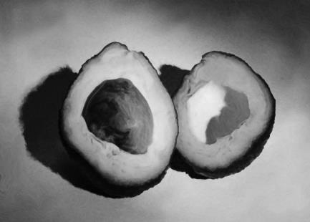

**Avocado**

**JOEY-**Found in Uvalde County where it has been producing for more than 25 years; medium size black fruit; ripens in late September

**PRYOR**-Original tree is in Uvalde and is very old; smaller size green fruit; good flavor

**OPAL**-Originated in Uvalde; medium size, beautiful green fruit; pear shaped

**PANCHO-**Cold tolerant; may be difficult to find, but worth having if available

**WILMA-**Originated near Pearsall; bears large black fruit that is long and cylindrical.

**Bay Laurel**

**LAURUS NOBILIS**- The culinary bay; evergreen tree to 12 feet( in Galveston and Fort Bend Counties); farther north, protect from deep or long lasting freezes (below 30 F); wonderful for flavoring soup, stews, roasts, turkey, pork, etc.

**Berries**

***Blackberries***

**APACHE**-Thornless blackberry from the University of Arkansas breeding program; medium size; fruit is sweet and firm; plants have upright growth habit.

**ARAPAHOE**- Thornless; early ripening; great sweet berry on very productive vines; bush type

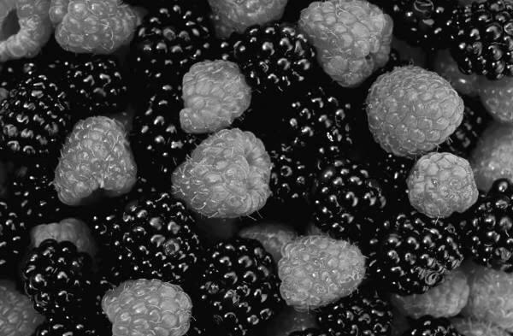**BRISON-** very thorny; upright; very heavy production; large, sweet, firm; small seed

**KIOWA**-Thorny; produces larges (three inches long, 12 grams) of the Arkansas varieties; yields large quantities of flavorful berries for approximately six weeks; grows five to six feet tall with a four-to-eight foot spread; blooms earlier and longer than other blackberries.

**NAVAHO**-Genetically thornless; very firm berry; stores well; excellent flavor; ripens late

**OUACHITA**-thornless; large size berry; sweet; holds up well after harvest; vigorous vines.

**ROSBOROUGH**-Thorny; upright; heavy production; large, firm berry; small seed; much sweeter than Brazos

**SHAWNEE**-Thorny; large, high quality, excellent sweet flavor; fast growing erect canes; long season with heavy production

***Other Berries***

**BOYSENBERRY**- Thorny; purple berry; sweet, good flavor; very small seed; cross of blackberry, raspberry and Logan berry.

**LOGANBERRY**- thorny; large; tart berry; excellent for jam and cobbler; cross of red raspberry and blackberry

**YOUNGBERRY**-Thornless; very large, purple blackberry; wonderful flavor; ripens in May; cross of blackberry and dewberry; a gourmet treat.

**Citrus**

Citrus produces the best fruit yields for or area and requires little care. There are an infinite number of varieties, all generally grafted onto Poncirus trifoliate or its sport P.trifoliata ‘Flying Dragon’ in order to improve tolerance to our soils and to give some size control, as well as to induce early bearing. Many alternate rootstocks are also used. A recent pest is the leaf miner, which does require some type of pesticide application if you wish to have attractive and healthy trees. We recommend planting only virus-free plants from reputable growers or grafted trees with virus-free scions obtained from the Texas A&M University-Kingsville Citrus Center in Weslaco.

**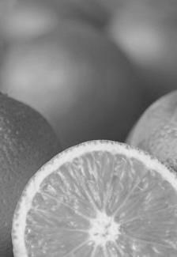*Citrangequat***

**THOMASVILLE-**very cold hardy, 15 F; sour, makes a great citrus drink; also makes an excellent rootstock.

Grapefruit

**BLOOMSWEET**-A cross between a pummelo and a sour orange; an excellent, hardy grapefruit; large and yellow with thinner skin; very juicy with sweet pale flesh and a unique flavor of grapefruit and orange; easy to peel and segment; ripens November-December.

**COCKTAIL**-A cross between the Frua mandarin and the pummelo; approximately three inches in diameter; white fleshed; seedy; extra sweet; very juicy; very mellow, low acid flavor makes it perfect for juicing.

**GOLDEN**-matures later in the season than their pink cousins; mild flavorful taste with very few seeds; blonde, thin skin; yellow to amber flesh; very juicy.

**RIO RED-**Large fruit; smooth, thin yellow rind blushed red when mature; flesh deep red and juicy with few seeds; ripens mid-to late November; holds well on the tree until March.

**MARSH**-until recently, the most widely grown grapefruit variety in Florida; still popular in the domestic and export fresh market; fruit is commercially seedless with pale yellow flesh and large open cavity in the fruit center; the major grapefruit variety for processing.

***Kumquat***

**MEIWA**- large, very sweet kumquat with a skin and fruit that is excellent for eating; very ornamental; a heavy bearer; survives 17 F or below.

**NAGAMI-** Small evergreen tree, very ornamental; bears profusely nearly year-round; slow growing; upright form to eight feet tall by six feet wide; more tart than Meiwa and much less seedy.

***Lemon***

**MEYER IMPROVED**-Grown from indexed stock; a very good tasting lemon; not very cold hardy, to 25 F; good as a container plant; virus free.

***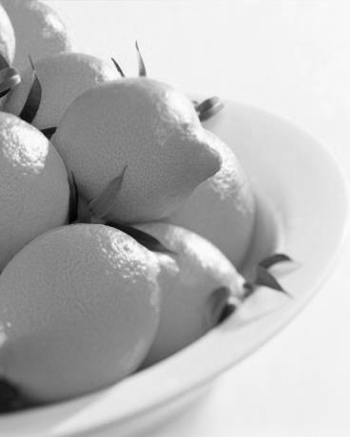*PONDEROSA**- Medium size vigorous, open-growing tree with large leaves and many thorns; new growth bronzy purple; huge fruit (sometimes more than two pounds); thick yellow rind; very acidic and seedy; ripens early to mid-October; holds well on the tree.

**UJUKITSU**-A Japanese cross between an orange and lemon, with exceptionally tasty mild flavors; a unique tasting fruit.

**VARIEGATED PINK EUREKA**- Vigorous, open-growing tree with green/yellow/white variegation; makes a very attractive landscape plant; fruit is often ribbed and slightly smaller than Eureka; young fruit is variegated yellow and pink, gradually fading to yellow; interior flesh is light pink.

***Lemonquat***

**LEMONQUAT**- Highly attractive, small to medium size tree, with elongated, deep green leaves; hybrid of a lemon and sour kumquat; small, pear-shaped fruit, with a smooth yellowish rind; tart flesh is orange-yellow with many seeds; ripens early to mid-November; holds well on the tree.

***Limequat***

**EUSTIS**-Cross between Key lime and Meiwa kumquat; excellent lime substitute; fairly cold tolerant

**LAKELAND**-yellow-orange fruit on bushes three feet tall; highly productive

**TAVARES**-larger than Eustis; cross between Mexican lime and Nagami kumquat; few seeds; lime-like flavor; small, compact tree with tiny leave; highly productive; very cold tolerant

***Mandarin***

**CLEOPATRA**-a low spreading shrub or bush tree with dark green, shiny leaves; bears fragrant white flowers, followed by a tart, navel-marked, deep reddish orange fruit.

**ATLAS HONEY**- also called the Murcott, from an old Tangor variety, a hybrid between a Mediterranean and a King mandarin; fruit has a deep orange exterior; thin skinned; glossy texture; slightly flat in shape with no neck; very juicy; peels and segments easily; many seeds; edible in late October

**CLEMENTINE HONEY**- A very popular mandarin; produces high yields of a nearly seedless sweet, tender, juicy, acidic fruit; matures late fall into winter; sensitive to freezing winter weather.

**KISHU SEEDLESS MANDARIN**-Small to medium size tree with dwarfing characteristics; small to medium size fruit; thin, bright orange easy-to-peel rind; sweet juicy, mild flavored; seedless; ripens November through December

**MANDARIN-**Delicious; easy to peel; sweet; easy to grow; great as a large container plant; if planted out, protect from a hard freeze; very fragrant white flowers.

**PONG KOA**- A large fruit for a mandarin; outstanding quality; very uniform in shape, size and yellow-orange color; fairly thin peel; crisp, sweet, juicy and very full flavored; hardy to 25 F; Phythoptera resistant.

**RIO HONEY**- A clementine mandarin hybrid; produces a very sweet, three-to four-inch, flattish oval fruit with just a few seeds; has a “zipper” skin; a heavy bearer; forms a graceful, pendulous tree with lance-shaped leaves.

***Mandelo***

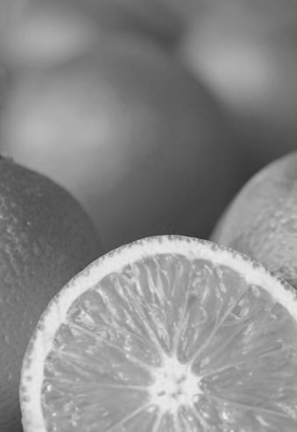**MANDELO**-A cross between mandarin and pommelo; sweet fine flavor and white flesh; very juicy; more cold hardy than a grapefruit, but not quite as hardy as a mandarin.

***Orange***

**AMBERSWEET**-can be peeled more easily than other oranges; resembles a navel orange in size and appearance and has a good orange rind and dark orange juice color at maturity; trees moderately cold hardy and fruit can be harvested prior to damaging freezes; introduced in 1989; three-eighths tangerine, one-eighth grapefruit and one-half sweet orange; tastes like a round orange.

**CALAMONDIN**-Small kumquat size fruit; excellent sour juice; very decorative plant; great for fish and lemonade; hardy into the teens.

**CARA CARA PINK NAVAL**-medium fruit; deep orange skin with reddish flesh; interior is extremely sweet with a relatively low acid content; few to no seeds; used for salads because of its near-crimson flesh; ripens November to May.

**MARRS EARLY**- juicy, seedless navel orange of low acidity; heavy crops of medium size fruit; exhibits a tendency to alternate bearing ;grown for the fresh market; the home grown ones are much tastier than store bought.

**MORO BLOOD ORANGE**- most colorful of all the blood oranges; exterior shows a bright red blush; internal color deep red mixed with orange; juice equally dark and sweet; fruits medium size; easy to peel; usually seedless; one of the most delicious of all oranges.

**NAVEL ORANGE**-medium to large, round-headed tree with deep green foliage; fruit is large with moderately thick, orange rind and pronounced navel at blossom end; rich flavor, with nicely balanced sugar and acid; very juicy and seedless; moderately easy to peel and separate into segments; ripens early to mid-November; holds will on the tree until end of January.

**PARSON BROWN**- The fruits have a deep orange interior and a rich flavor; 10 to 20 seeds per fruit; skin is thick and has a slightly pebbled peel; fruit color is excellent and makes a great juice; can be planted in ground or containers. If grown in a pot, it will only reach eight feet tall.

**REPUBLIC OF TEXAS-** Documented back to 1847 near Angleton, Texas; medium to large round orange; very flavorful; ugly fruit; very cold tolerant; a great sweet orange that everyone should grow.

**RUBY BLOOD**-Medium size; sweet and very juicy; second only to Moro

***Orangequat***

**NIPPON**- Cross between kumquat and Satsuma; tart fruit; makes good citrus drink

***Satsuma***

**ARMSTRONG EARLY**- Ripens in September; exquisite flavor; excellent production; small tree; hardy to 20 F or lower. “Every backyard on the Texas Gulf Coast should have one” (Bonnie Childers, 1992)

**BC-** Large; great taste; loose skin; hardy to 20 F or lower; a personal selection from Bonnie Childers of Lumberton, who has been responsible for the largest number of important and distinctive Satsuma cultivars in Texas.

**BIG EARLY-** large fruited with few seeds, reddish orange loose peel with orange flesh; matures October-November.

**BROWN SELECT SATSUMA**- Medium size spreading tree with deep green foliage; slightly more cold hardy than the Owari; medium size, bright orange fruit, often with a slightly bumpy rind; extremely sweet, sprightly flavor; seedless; very easy to peel; breaks off into segments; ripens one to two weeks before the Owari (early to mid-October) Fruit is often ready to eat when rind is still green. Fruit holds well on the tree until end of December. Kids love them.

**DOBASHI BENI-** Similar to Owari but with a reddish tinge on the skin; “zipper: skin; seedless

**KIMBROUGH**-Very good flavor; slightly more cold hardy than other Satsuma varieties. It has its origins in Louisiana and was discovered after a killer freeze that destroyed much of the Louisiana Satsuma crop.

**MIHO SATSUMA-** medium size, slightly upright growing tree with deep green foliage; extremely cold hardy; medium size, bright red orange fruit; smooth, thin leathery rind; extremely sweet, sprightly flavor; seedless; easy to peel; ripens late September to early October; often ready to eat when rind is still green; fruit holds will on the tree until late December. Kids love them.

**OKITSU-** tree growth more vigorous than other Satsuma’s; October maturing fruit stores better than other varieties.

**OWARI-** the original Satsuma; very good flavor; great production, tree moderately vigorous but slow growing; medium-small, spreading and drooping; hardy to 22 F or lower; may have as many as six seeds per fruit, but rarely present; ripens late November. As maturity passes the neck increases in size and the rind roughens and loosens.

**SATSUMA BC2**- A delicious early maturing Satsuma; a seedling of “Armstrong Early, “ collected by Bonnie Childers; quite cold hardy, down into the low 20’s.

**SATSUMA SATSUMA**- A hybrid Satsuma mandarin from unknown origin that has proven itself in the Port Arthur area; large fruit; loose, bumpy skin; rich flavor; fairly small tree; survives well to 20 F or lower.

**SETO SATSUMA-** Medium size spreading tree with deep green foliage that is extremely cold hardy; medium size, flat, bright red orange fruit with a smooth thin rind; fruit has an extremely sweet, sprightly flavor and is seedless; very easy to peel and breaks off into segments; ripens late September to early October and is often ready to eat when rind is still green; fruit holds well on the tree until late December. Kids love them.

**VERMILLION-** a very high quality Satsuma found in Louisiana; a bud sport of Owari; ripens early November.

***Tangerine***

**CHANGSHA-** Very cold hardy with small to medium size fruit and lots of seeds; matures to approximately 10 to 15 feet if not frozen back from a hard freeze; will come back from the roots as it is not grafted; hardy to approximately 15 F.

**KAT MANDARIN**-The original tangerine; small fruit; small seeds; sour taste makes a good drink or great to put on fish, etc. C:\Users\Agent\AppData\Local\Microsoft\Windows\Temporary Internet Files\Content.IE5\4A3LQZPA\MC900246115[1].wmf

**TONKAN**- Medium to large fruit; deep orange and somewhat wrinkled; juicy and rich with a sweet flavor; stores and ships well.

**PAGE**- Hybrid of Minneola tangelo and Clementine mandarin; small fruit is three-fourths tangerine and one-fourth grapefruit; outstanding quality; used as a standard of excellence in fruit quality ratings; matures early in most years (October); holds well on tree with some fruit harvested as late as February.

**SUNBURST TANGERINE**- Medium size, upright growing tree; medium size fruit with a thin, bright, orange is-red rind; fairly easy to peel; few seeds; ripens early to mid-November; holds well on the tree until mid –to late January.

***Miscellaneous Citrus***

**CHANDLER PUMMELO**-medium to large size tree with big, dark green, winged leaves; very very large fruit that is typically roundish with a slightly pointed neck; rind is smooth, thick and yellow; flesh is pink, sweet and mostly seedless; ripens early to mid-November; holds will on the tree until January.

**ORTANIQUE TANGOR**- Fruit very juicy with sweet orange overtones; normally has a very thin rind; fairly cold hardy. This cross between an range and tangerine has a delicious unique flavor, hence its name : OR(ORANGE) TAN(TANGERINE) IQUE(UNIQUE)

**UMATILLA TANGOR**- A large fruited cross between a tangerine and an orange that looks like an overgrown tangerine with a slightly rough reddish-orange skin; easy to peel; has lots of seeds; spicy tart-sweet flavor similar to an orange.

**YUZU**- Fruits are acidic and moderately juicy with pleasant citrus aroma; can be used as a lemon substitute; grown as a rootstock for other citrus varieties and for its fruit; fruit shape is flattened and irregular with a yellow-orange, easy-peel rind; seeds are large and numerous; more cold hardy than Satsuma.

**Fig**

**BANANA-**Medium size, yellow fig with pale strawberry flesh; very sweet, full flavor, no bitterness; closed eye; low spreading tree; good production; good cold tolerance; one of the very best; grown in Seabrook, Texas since around 1910.

**CELESTE**-One of the best for our area; purple-brown skin, pink flesh; medium fruit with excellent flavor; closed eye; very cold hardy.

**DEANNA**- Large, yellowish green color with a pink interior; closed eye; does very well in this area

**LSU PURPLE-** Released in 1991 by Louisiana State University; medium size (approximately 20 per pound); glossy reddish to dark purple; white flesh with light strawberry pulp; very good mild flavor; high sugar content; closed eye; very cold hardy and very resistant to nematodes; bears young; when mature will have three distinct crops—a light crop in early spring, heavy main crop in early July and a later crop often lasting into December.

**Grapes and Muscadines**

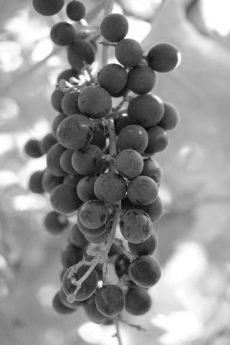**BLACK BEAUTY MUSCADINE**-Black female; 23 percent sugar; dry scar; large fruit; skin edible; ripens uniformly; large cluster; very vigorous; one of the best black varieties; ripens mid—to late season.

**DARLENE MUSCADINE**- Bronze female; the best of the bronze scuppernongs; consistently large size throughout vines; not erratic; 24 percent sugar; dry scar; melting pulp; excellent quality.

**FRY MUSCADINE**- Bronze female; 21 percent sugar; very large fruit and clusters; excellent quality even before fully ripe; ripens over whole season.

**GRANNY VAL MUSCADINE-** Bronze self-fertile; 16 percent sugar; very large fruit and clusters; excellent quality even before fully ripe; ripens over whole season.

**ISON MUSCADINE**-Black self-fertile; 19 percent sugar; very productive; ripens uniformly; large cluster; dry scar; early to midseason; best black pollinator; very disease resistant.

**SUPREME MUSCADINE-**Black female; best of the black scuppernongs; many people have changed their minds choosing supreme over bronze; the largest muscadine developed at this time; very heavy producer; 23 percent sugar; ripens mid-to late season; very vigorous; skin edible; large cluster; disease resistant; dry scar.

**SWEET JENNY MUSCADINE**- Bronze female; 23 percent sugar; large clusters; vigorous; disease resistant; early to midseason.

***Bunch Grapes***

**MORTENSEN HARDY GRAPES**- (American x Vitis vinifera). A super table grape that performs beautifully in the Houston area; the size of a quarter; green with pink blush; excellent taste with few seeds; a vigorous vine; resistant to Pierce’s disease; ripens mid-August

***Table Grapes***

**HIMROD-** Small, white seedless; a cross of the Thompson seedless and Ontario; will grow and produce in more humid areas than the Thompson seedless.

**FLAME SEEDLESS**- A red skin seedless with firm flesh; very productive; good eating quality.

**Jujube**

**TIGER TOOTH**- Considered one of the best jujube out there; vigorous tree; long fruit has crisp texture like an apple; mild flavor; quite sweet; a heavy producer every year.

**LI-** Fruit is almost round, three to four inches long; ripens well on kitchen counter or in the refrigerator; cold hardy to Ohio; a heavy producer. Some like to eat this cultivar green straight off the tree, but most prefer to pick the fruit when amber spots appear or wait until the fruit is completely brown.

**SO-** an unusually shaped and contorted tree with good fruit, but is not a heavy bearer.

**SHERWOOD-** A upright tree with very large jujubes; sets heavily if other jujubes are nearby or grafted to it.

**Mulberry**

**PAKISTAN**-Long (three inches), firm, red to black, sweet fruit; non-staining juice; month-long early summer harvest/ fruit used fresh and for pies, jams and jellies; large, vigorous, disease resistant tree; protect from late freezes once it leafs out; best suited for warmer areas.

**Nectarine**

**ARTIC STAR WHITE**- Earliest to ripen of the new low acid, super-sweet white nectarines; rave reviews in trial tastings; beautiful dark red skin, snow-white semi-freestone flesh; ripens mid-June, four to five weeks ahead of Artic Rose; self-fruitful; low winter chilling requirement; 300 chill hours.

**DOUBLE DELIGHT**- Sensational new, midseason, yellow freestone; showy pink, double flowers; heavy bearing tree; superb dark red-skinned fruit is sweet, with rich flavor; self-fruitful; 650 chill hours.

**KARLA ROSE**- White fleshed nectarine; listed at 600 chill hours but regularly does well in the Houston area.

**PANAMINT**-Attractive red-skinned yellow freestone; aromatic, intensely flavored, nice acid-sugar balance; dependable, long-time favorite in warm winter southern California climates; late July-early August; self-fruitful; 250 chill hours.

**SUNMIST**-A white fleshed nectarine; semi-clingstone variety with nicely shaped medium to large fruit; firm flesh; dull purple skin; highly resistant to bacterial spot; 300 chill hours.

**SUNRAYCER-**A delicious nectarine from Australia; heavy fruiting, large, three-inch; yellow meat with good taste; high bud set with an excellent resistance to bacterial leaf spot; 275 chill hours.

**Paw Paw**

Rumored to have been George Washington’s favorite desert, most paw paws, except the small, unpleasant tasting Louisiana varieties, are marginal fruit in Houston because of high chill requirement. Paw paws are slow growing, deciduous, pyramidal shaped trees with large tropical looking leaves. If you are determined to grow them in our area, one of these might do well for you.

**REBECCA’S PAW PAW**- Fruit has custard-like texture; harvest when skin turns greenish yellow; best in rich, deep, moist soil; hardy to -20 F; late season fruit; plant two varieties for pollination.

**MANGO**- Large and very delicious with yellow flesh reminiscent of a mango; lower chill than other paw paws.

**PROLIFIC**- Heavy bearing, precocious tree; early season fruit; fruit has custard-like texture and delicious banana-like flavor; harvest just as skin turns greenish-yellow and frit begins to soften, around September; grows best in rich, deep, moist soil; hardy to -20 F; plant two varieties for cross pollination.

**SUNFLOWER**- Fruit has custard-like texture; harvest when skin turns greenish-yellow; best in rich, deep, moist soil; hardy to -20 F; early season fruit; plant two varieties for pollination.

**WELLS**-Very large fruit (up to one pound); have custard-like texture and delicious, banana like flavor; harvest September-October; best in rich, deep, moist soil; hardy to -20 F; plant two varieties for cross-pollination.

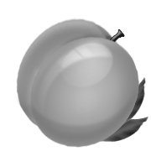**Peach**

Peaches should be grafted onto Nemaguard or one of the newer resistant rootstocks to help prevent root knot nematode damage. Most catalogues sell peaches on northern rootstocks such as Halford, which do not do well in the Hardin County Area.

**EARLIGRANDE**- Medium to large; yellow skin with a red blush; firm, excellent flavor, fine texture, yellow flesh; semi-freestone; heavy producer; excellent quality; 200 chill hours.

**EVA’S PRIDE-** Large, firm, delicious yellow freestone; self-fruitful; ripens midway between Maypride and **Midpride;** low chill hours of 100-200.

**FLORDAKING**- Medium size, yellow flesh; slight oval shaped peach with small tip and firm flesh; fruit ripens approximately 65-70 days after full bloom; 450 chill hours.

**GALAXY**- Known as a “flat”, “saucer” or “doughnut-type” peach because of its round, squat appearance; approximately three inches in diameter and up to one third pound in weight; has light cream skin with a red blush; white fleshed with a sweet taste and firm texture described as “melting”; chill hours are low, but it is too new on the market to have yet been determined.

**MAYPRIDE**- Delicious fruit; the best low chill peach for its season; larger than other early peaches, it ripens in May; large showy, pink blossoms; self-fruitful; 175-200 chill hours

**MIDPRIDE-** Exceptional flavor and dessert quality; best yellow freestone for warm winter climate of Houston; midseason ripening; self-fruitful; 250 chill hours.

**RED BARON**- Showy double red blossoms; large, juicy firm, richly flavored yellow freestone fruit (rated a 10); ripens from mid-June to mid-July; self-fruitful; 250-300 chill hours.

**RIO GRANDE-** Large, freestone yellow flesh; ripens June to July; excellent peach for warmer areas of Texas; 450 chill hours.

**TEX KING**- Large, firm yellow flesh; ripens May to June; Texas A&M introduction; 400 chill hours.

**TROPIC BEAUTY**-Early bearing, semi-freestone; good quality, sweet and juicy; self-fruitful; 150 chill hours.

**TROPIC SNOW**- Excellent tasting (rated a 10) white meat freestone; pale yellow skin with red blush; large fruit that ripens in early May; 150-200 chill hours; self-fruitful.

**TROPIC SWEET**- Super quality; yellow meat, large and very sweet; productive, strong tree; self-fruitful; 150 chill hours.

**UFO**-The “flying saucer” peach; this is an excellent backyard variety that everyone should have; firm texture; ripens well on the tree; 300 chill hours.

**Asian Pear**

**20TH CENTURY**- Wonderful fruit; juicy, sweet, flavorful, crisp like an apple; keeps well; heavy bearing small tree; self-fruitful or pollinate by Shineseiki; 500 chill hours.

YA LEE- The most widely grown pear in the world and one of the few pyriform Asian pears; 250 chill hours.

**European Pear**

**ACRES HOME**- very precocious, often bearing at three years with highly rated, large, uniform and attractive pyriform fruit; mild citric acid flavor with some crunchiness; fairly but not totally blight resistant; tree has a spreading shape; 400 chill hours.

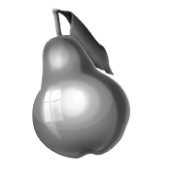**AYERS**-very high quality; good blight resistance; ripens in mid-to late August; bears in seven to nine years; yellow with red blush; partially self-fruitful; 600 chill hours.

**BALDWIN-** Blooms with Tennessee, Flordahome or Hood, which it needs for pollination; very large pear (one pound or more); smooth skin, green/yellow when ripe with creamy white flesh; a great pear for eating fresh; 250 chill hours.

**HOOD-** Greenish-white fruit; buttery smooth with a creamy white pulp known by its sweet taste and crisp texture so often found in homegrown pears; one of the earliest blooming pear trees.

**SOUTHERN BARTLETT**- Excellent quality pear; 400 chill hours.

**SOUTHERN QUEEN-** a russeted pear with total resistance to fireblight; 300 chill hours.

TENNESSEE- Great flavor; great blight resistance; excellent storage; bears in five to six years; pollinate with Hood or Atlas Super Orient; 400 chill hours.

**WARREN**-Excellent quality dessert pear; highly resistant to fireblight; medium to large, long-necked fruit with pale green skin, sometimes blushed red; smooth flesh is juicy and buttery with superb flavor; good keeper; bears fruit in eight to ten years; self-fruitful; 600 chill hours.

**Pecan**

**CHOCTAW**- High oil content; 60 percent kernel; thin hull; large attractive; well adapted to Houston; the best “yard” tree; average 45 per pound; bears in late October.

**JACKSON**- Outstanding; very large, high quality nut; averages 33 nuts per pound with 54 percent kernel; high disease resistance; bears early November in five to six years.

**MORELAND-** A strictly first class pecan variety; nuts are medium-large, average 50 per pound, oblong, with a very thin shell; beautiful tree with large foliage; bears early September.

**OCONEE**- Released in 1989 for use in southern U.S. pecan belt; nut is elliptic with obtuse apex and base; round in cross section; large nut, 48 per pound, with 56 percent kernel; excellent survival rate when subjected to cold weather; excellent cracking quality.

**PAWNEE-** Very large nut with high kernel percentage and early maturity in mid-September; good high density planting; average 40 per pound.

**SUMNER-** Soft shell, early bearing, medium size and good quality nuts; suited for close space planting.

**Persimmon**

**EUREKA**-a vigorous producer; bright orange fruit, as large as tea cups; astringent until ripe; starts bearing around the third year; begins to ripen in October and continues late in December; semi-dwarf tree.

**FUYU**- Orange with light orange flesh; large, sweet tasting, flat shaped fruit; practically pest free; very hardy, attractive tree; firm, non-astringent; thin to develop good size fruit; 200 chill hours.

**GIOMBO**- Large fruit/ very productive; excellent taste; custard type, eat with a spoon; the most cold hardy; self-fruitful; astringent.

**HIRATANENASHI-** Flat, seedless and very sweet; top quality; vigorous spreading tree; astringent.

**ICHIKIKIJIRO**-flat, orange fruit with very good flavor, somewhat smaller then the Fuyu; fairly small tree; great for small yards; good quality; non-astringent.

**MATSOMOTOWASEFUYU**- Flat, orange fruit, fairly large; very good quality; very good production on a vigorous spreading tree; non-astringent.

**SAIJO**- Small bell-pepper-shaped fruit; sweet and juicy; medium size tree; fruit stores well; a good producer; astringent

**SURUGA**- Red, semi-flat fruit, somewhat smaller than the Fuyu; very sweet, excellent taste; vigorous, slightly upright tree; non-astringent.

**Plum**

**GOLDEN CHICASAW**-A great rootstock and also a great plum; slightly tart; large, gold and very prolific; will grow almost anywhere for 50 years or longer; self-fruitful.

**GULF BEAUTY-** Very early production; larger than Gulf Ruby; bright red skin; yellow flesh; very disease resistant; excellent production over a four to five week period; super quality; 250 chill hours.

**GULF BLAZE**- Released only four years ago with Gulf Beauty; blooms approximately March 1 (two weeks later than Gulf Beauty); light red skin, yellow flesh; production scattered over five to six weeks; excellent disease resistance; very good fresh eating; 250 chill hours.

**GULF ROSE**- Red fleshed plum; resistant to bacterial disease; 275 chill hours.

C:\Users\Agent\AppData\Local\Microsoft\Windows\Temporary Internet Files\Content.IE5\A0NKPZOQ\MC900036394[1].wmf**INCA-** Introduced in 1919; heart-shaped; skin is a beautiful golden color with magenta specks and a magenta blush around the stem end when ripe; flesh is rich, dense, and crisp; explosive flavor with a balance of tartness and sweetness; 250 chill hours.

**METHLEY-** Juicy, sweet, red flesh; mild flavor; reddish purple skin; harvest in June; attractive tree; heavy bearing and vigorous; 250 chill hours

**SANTA ROSA-** A large purplish plum; amber-colored flesh- a popular variety for home and market use; ripens late June.

**SEGUNDO**- A cross of wild and domesticated plums; tough and disease resistant; red skin and orange-red flesh coupled with a great flavor; clingstone; needs a pollinator; ripens mid-June; 450 chill hours.

**SHIRLEY**- A good size blue plum, approximately two and one-half inches; a well-known older variety; heavy producer; good pollinator for Inca; 500 chill hours.

**ST. LUKE-** Beautiful red leaf ornamental tree with a bonus; very good small to medium, sweet and juicy fruit; very heavy producer; fabulous when in bloom; 500-600 chill hours.

**Pomegranate**

**BALGAL**- Large, tomato-red fruit; very productive large decorative tree; very small fruit cells; sweet, excellent for juice; a favorite in Florida

**CLOUD**- From the University of California, Davis; medium size fruit with a greed red color; juice sweet and white

**EVERSWEET**- Large, round, light red; very sweet; a very good producer; good ornamental shrub.

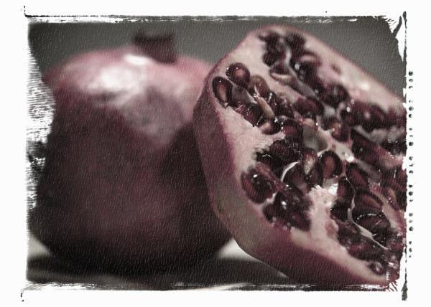**SWEET**- Fruit has a red blush on greenish skin when ripe; sweeter than most varieties.